**ACTIVITY 1**

**Worksheet**

Fill in the blanks.

1. Renal transplant is a fairly _____________ operation.
2. Waste products in plants are _____________ to parts of the plants, e.g. leaves, petals, fruits and bark.
3. In animals, waste products are removed from the body by _________ __________ systems.
4. Plant oils are _________ products which produce the _________ in leaves.
5. The patients of kidney failure need ___________ to prevent their body from rejecting the new kidney.

Mark True / False.

1. Human beings can live with one kidney. _______
2. In the dialysis machine, a coil of cellophane tubing is not used. _______
3. In dialysis, urea and waste products are removed from blood. ________
4. Renal failure patients should eat a protein-rich diet. ________
5. There is no need to tissue match the donor kidney in transplant operation. _______

**ACTIVITY 2**

Give reasons. Answer any two.

**Q1)** Do you think the skin should be called an excretory organ?

**A:**

**Q2)** Describe how the blood is filtered when it passes through a kidney nephron.

**A:**

**Q3)** Do you think kidney transplants are easy and common operations? Are there enough kidney transplant centres?

**A:**

**Pakistan School , Kingdom of Bahrain**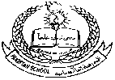

**E- Support and Learning Material / Session 2020-2021**

**Subject: General Science Grade : 8th**

**Book: Oxford Secondary Science 3 FIRST TERM**

**Unit 2: Pg. No: 14-6 THIRD WEEK: DAY 1**

**Kidneys and Excretion:**

**Topic: Kidney Failure**

**Questions & Answers**

**Q1)** Describe renal arteries.

**A:** Renal arteries carry blood from the heart to the kidneys. These arteries take a very large volume of blood to the kidneys to be filtered. Renal arteries carry oxygenated blood from the heart to the kidneys.

**Q2)** Describe renal veins.

**A:** Renal veins are veins that carry deoxygenated blood from the kidneys. They drain the kidneys and also connect kidneys to the inferior vena cava. They enter the kidneys and are separated into two parts.

**Q3)** What are precautionary measures while using the dialysis machine?

**A:** A patient of kidney failure is attached to the machine twice a week. The patient must be careful about the diet. They should consume a protein-free diet.

**Q4)** Why are there not enough renal dialysis centres?

**A:** Kidney machines are in short supply. They are very expensive and need costly membranes, filters and liquid. They also need skilled people to operate the machines.

**Q5)** Describe renal transplant.

**A:** Kidney transplant is an option for treatment in case both kidneys fail. If a patient is able to get a kidney from another person, transplant can be done.

**Q6)** What are the precautions while accepting a donor kidney?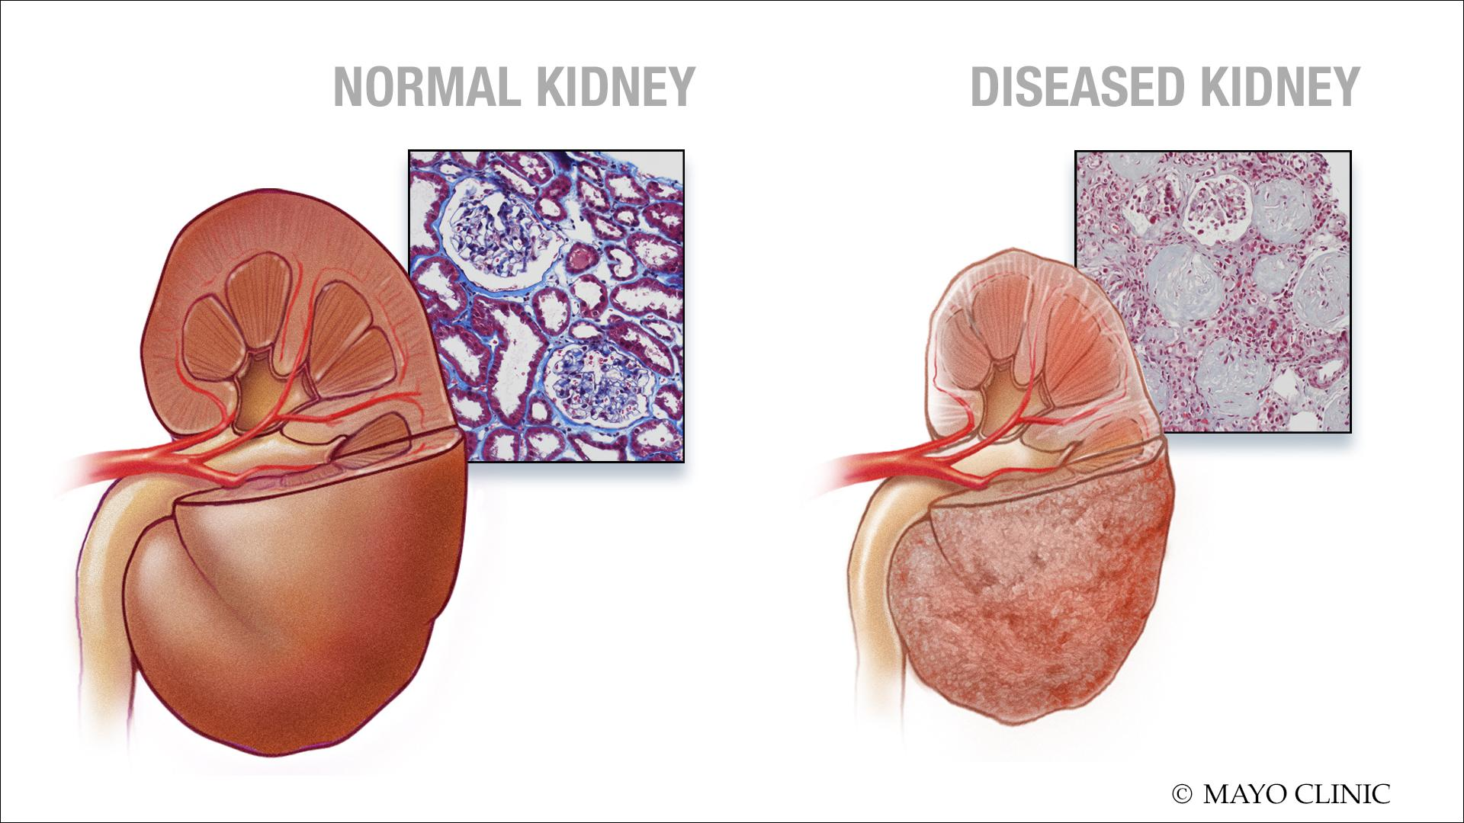

**A:** A donor kidney has to be tissue matched. This means that it must be very similar to the original kidney. This is why, many relatives of patients give them their kidneys because 1) relatives’ kidneys are similar and 2) relatives know they can lead a normal life even with one kidney.