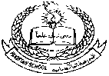**Pakistan School , Kingdom of Bahrain**

**E- Support and Learning Material**

**Subject: Math Name:________________________ Grade : 1 ( )**

* **Topic # 3. Addition within Tens**

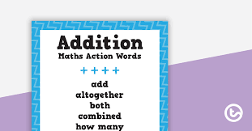

**For Example:**

|  |  |  |
| --- | --- | --- |
| a. | **5**  **+ 3**  **8** | **8**  **5 + 3 =** |
| b. | **3**  **+ 3**  **6** | **6**  **3 + 3 =** |
| c. | **7**  **+ 0**  **7** | **7**  **7 + 0 =** |

**Worksheets Addition (Activity-1)**

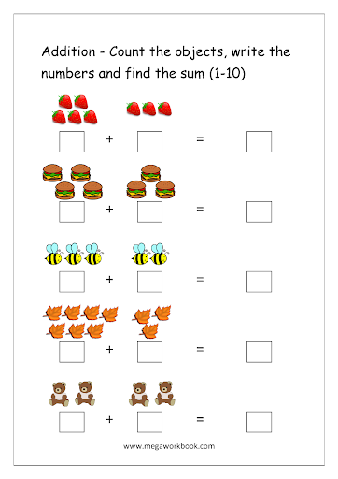

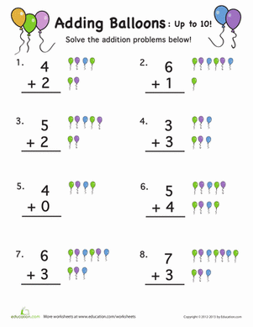**(Activity-2)**

* **Solve the following sums. (Activity-3)**

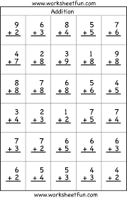

* **Addition Word Problem.**
* **(Example)**

1. **There are 4 birds sitting on a tree. 2 more birds join them. How many birds are there altogether?**

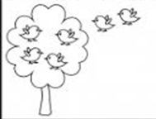

Working

4

+ 2

6

2

**Solution: sitting on the tree, more join them**

4

6

**There are birds altogether.**

* **Solve the following word Problems.**

1. **Fatima has 5 dogs and 4 cats. How many animals does she have altogether?**

Working

**Solution: **

**Dogs**

**Cats**

**Fatima has animals altogether.**

**\*\*\*\*\*\*\*\*\*\*\*\*\*\*\*\*\*\*\*\*\*\*\*\*\*\*\*\*\*\*\*\*\*\*\*\*\*\*\*\*\*\*\*\*\*\***

1. **Ali has 5 toy cars and 4 toy bicycles. How many toys does Ali have altogether?**

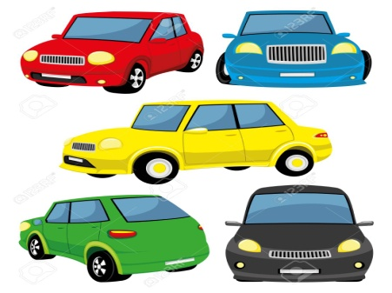 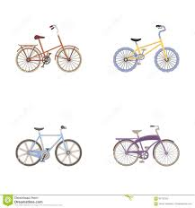

Working

**Solution:**

**toy cars**

**toy bicycles**

**Ali has toys altogether.**

***\*Note: HW: Solve word problems of book page# 28, 30, 31, 32 (Q2), (1 pages per day)***