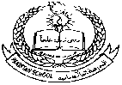 **Pakistan School , Kingdom of Bahrain**

**E- Support and Learning Material**

**Subject: Math Name:________________________ Grade : 3 ( )**

**Date: / /**

**Topic 3: Even and odd numbers. (Activity # 1)**

**Remember even number always ends with (0,2,4,6,8).**

**Q1. Sort out even numbers and write in the house.**

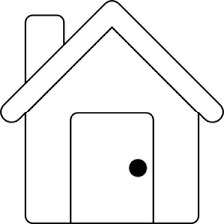

**Q2: Colour the numbers which are not odd.**

**2656**

**2314**

**3215**

**2648**

**2637**

**2645**

**1990**

**2020**

**2009**

**2172**

**Q3. Fill in the next missing even number.**

**a. 2464 , ________________ , 2468 , _______________**

**b. 3246 , ________________ , 3250 , _______________**

**c. 4122 , ________________ , 4126 , _____________**

** Pakistan School , Kingdom of Bahrain**

**E- Support and Learning Material**

**Subject: Math Name:________________________ Grade : 3 ( )**

**Date: / /**

**Topic 3: Even and odd numbers. (Activity # 2)**

**Remember odd number always ends with (1,3,5,7,9).**

**Q1. Circle the odd numbers.**

**Q2. Write the missing next missing odd number.**

**a. 3231 , ______________ , 3135 , ________________**

**b. 2554 , ______________ , 2556 , ________________**

**c. 4460 , ______________ , 4462 , ________________**

**Q3. Sort out odd numbers and write in the tree.**



** Pakistan School, Kingdom of Bahrain**

**Subject: Maths E- Support and Learning Material**

**Class : 3( ) Name:___________________**

**Topic: Even and odd numbers Date: / /**

**Activity No :3**

**Q1: Sort out numbers in even and odd numbers.**

**2134 1267 8101 3125 2660 4112**

**660 3803 2011 2200**

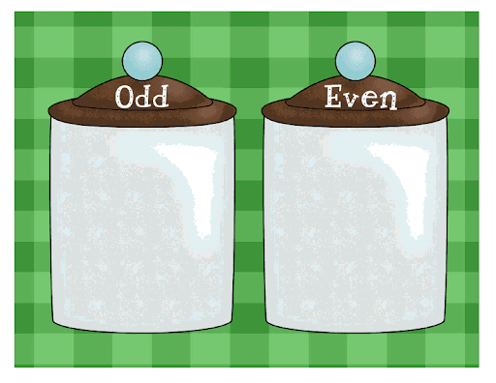

**Q2: Circle the following.**

**(a): The biggest odd number 2334 , 1112 , 2323 , 2211**

**(b): The smallest even number 2000 , 618 , 1111 , 5550**

**(c): The smallest odd number 6 , 51 , 831 , 1005**

**(d): The biggest even number 4120 , 467 , 216 , 4501**

**Q3: Colour the block having most odd numbers in yellow . Also write the odd**

**number of that block.**

**8846 9199 555**

**1121 1131 1045**

**2100 6122 133**

**1132 1006 1371**

**21 46 119**

**4167 1220 1390**

**Odd number: ___ Odd number: ____ Odd number: ____**

**The odd number are :**