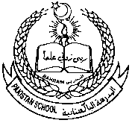 Pakistan school , Isa town kingdom of Bahrain

E-support and learning Material / session 2020-2021

Subject :Science Grade :3 Book : simply science 3

**Unit No:2:solids ,liquids and how they can be separated**

**Topic:1: Grouping materials. Pg.14 & 15 Assignment:4**

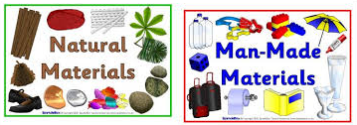

Q1. Answer the following questions.

a.what are natural materials?

Ans. Materials that we get from plants , animals and from the ground are called natural materials.

b. What are Artificial or man-made materials?

Ans. Artificial materials are made by mixing natural materials together and changing them.

c.Name any five natural materials.

Ans.cotton , rocks, leather , wood and sand.

d.Name any five man-made materials.

Ans.Plastic, cement , nylon, paper and glass.

**Home work:**

**Name and paste three natural materials from ground. Or**

**Name and paste three natural materials from plants.**



**Pakistan school ,Isa town kingdom of Bahrain**

**E-support and learning Material / session 2020-2021**

Subject :Science Grade :3 Book : simply science 3

**Unit No:2:solids ,liquids and how they can be separated**

**Topic:1: Grouping materials. Pg .14 & 15**

**Worksheet :1**

Q1. Colour natural materials with green and man-made materials with red.

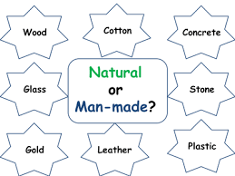

**Q2.Write whether the statement is true or false.**

1.cotton and leather are natural materials._______

2.We oil and water materials from ground._______

3.Paper and plastic is a natural material._______

4.All materials are natural materials.______



**Pakistan school ,Isa town kingdom of Bahrain**

**E-support and learning Material / session 2020-2021**

Subject :Science Grade :3 Book : simply science 3

**Topic:1: Grouping materials. Pg .14 & 15**

**Worksheet :2**

**Q1.Look at the pictures below. Which materials are these objects made of.**

|  |  |  |  |
| --- | --- | --- | --- |
| **object** | **Plant** | **Animal** | **Rocks / minerals from ground** |
| Free Pic Of A Pencil, Download Free Clip Art, Free Clip Art on ... |  |  |  |
| Car Tyres - Buy Branded Car Tyres Online at Best Prices In India ... |  |  |  |
| How to Buy a Belt: 14 Steps (with Pictures) - wikiHow |  |  |  |
|  |  |  |  |



**Pakistan school ,Isa town kingdom of Bahrain**

**E-support and learning Material / session 2020-2021**

Subject :Science Grade :3 Book : simply science 3

**Topic:1: Grouping materials. Pg .14 & 15**

**Worksheet :3**

