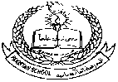 **Pakistan School , Kingdom of Bahrain**

**E- Support and Learning Material / Session 2020-2021**

**Subject:Science Grade : 1 Week:2**

**Book: Science FIRST TERM** Page No : 4

**Unit # 1: LIFE AND LIVING lesson 2: Animal babies**

**Vocabulary words:**

1. Butterflies
2. Parents
3. Frogs
4. Hatch
5. Eaten
6. Shape
7. Protect
8. Family

**Answer the following questions:**

1. **Which animals have the same shape as their parents?**

**Ans:** Cat , dog.

1. **Which animals do not look after their babies?**

**Ans:** Frogs , butterflies.

1. **Which animals look after their babies?**

**Ans:** Cat , sheep.

**Worksheet 1:**

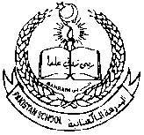**Pakistan School -Kingdom Of Bahrain**

**Grade 1-Science week:2**

**Topic: Animal babies**

**Name:________________ Class: _____________ Date:_________________**

**Q1: Write T for true and F for the false statements.**

1. All animals grow. ( )
2. Animals need food and water to stay alive. ( )
3. Animals do not die. ( )
4. Some animals feed their babies on milk. ( )
5. All animals look after their babies. ( )

**Q2: Fill in the blanks with suitable words.**

**(mother, parents , eggs, grow)**

1. Animals have to
2. Frogs lay there and do not look after their babies.
3. Some animals have same shape as their
4. A baby elephants stay close to its

**Worksheet 2:**

**Pakistan School -Kingdom Of Bahrain**

**Grade 1-Science Week:2**

**Topic: Animal babies**

**Name:________________ Class: _____________ Date:_________________**

**Q1: Match the following animals with their babies.**

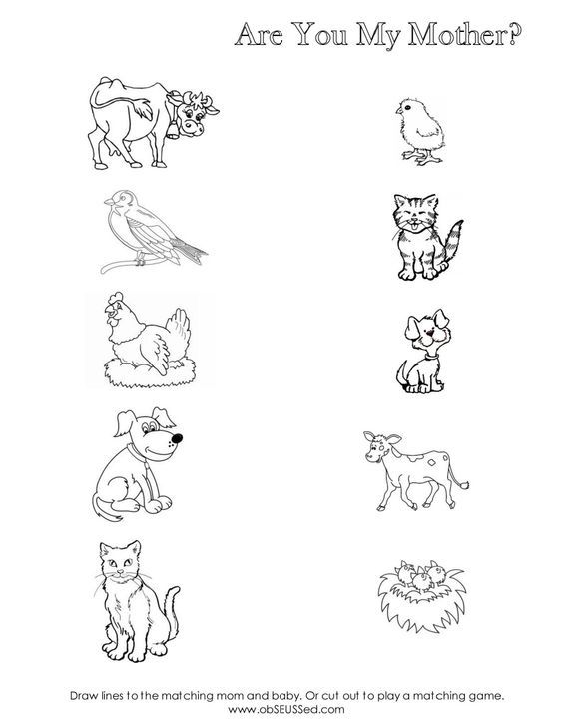

**Worksheet 3:**

**Pakistan School - Kingdom Of Bahrain**

**Grade 1-Science week:2**

**Topic: Animal babies**

**Name:________________ Class: _____________ Date:_________________**

