**Worksheet 1:**

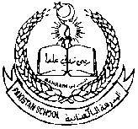**Pakistan School -Kingdom Of Bahrain**

**Grade 1-Science assignment: 3**

**Topic: Human babies/plants are alive**

**Name:________________ Class: _____________ Date:_________________**

**ACTIVIY 1 and 2**

**Q1: Fill in the blanks with suitable words.**

**( food , slowly , alive , seed , water )**

1)Babies __________________learns walk and talk.

2) _____________ , exercise and rest help us to grow.

3)Plants are _______________.

4)Plants need_________________ to grow.

5)Plants are produced from _________________.

**Q2:Choose the correct answers to complete these sentences:**

1. Babies need to prepare their food. (adults, children)
2. Food, exercise and rest help us to .(grow , sleep)
3. Plants give us . (food, mud)
4. Plants need water to . (grow, die)

**Q3: Write T for true and F for the false statements.**

1. Small babies start to walk at the age of five months. ( )
2. Plants do need water to grow. ( )
3. We change as we get older. ( )
4. A tree is a large woody plant. ( )

**Worksheet 2:**

**Pakistan School, -Kingdom Of Bahrain**

**Grade 1-Science**

**Topic: Plants are alive Assignment :3**

Q1: Colour the picture and write one sentence about it.

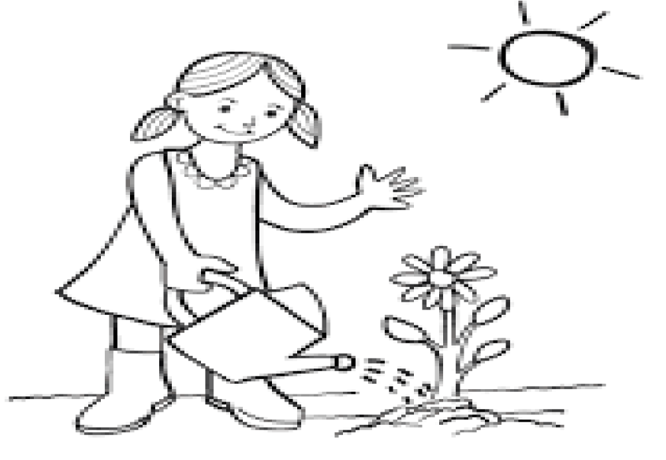

**Q2.Name the things plants need to grow.**

**( air , soil , water , sunlight)**

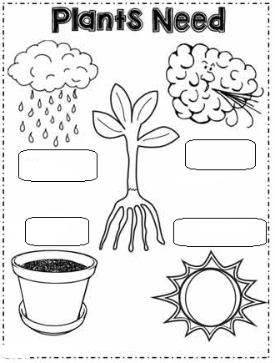

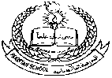**Pakistan School , Kingdom of Bahrain**

**E- Support and Learning Material / Session 2020-2021**

**Subject:Science Grade : 1 Assignment:3**

**Unit # 1: LIFE AND LIVING lesson 3: Human babies/plants are alive**

**Vocabulary words:**

1. Crying
2. Adults
3. Bigger
4. Young
5. Exercise
6. Sunlight
7. Soil
8. Water
9. air

**Answer the following questions:**

1. **How do babies learn to talk?**

**Ans:** Babies learn to talk slowly.

1. **What do plants give us?**

Ans: Plants give us fruits and vegetables.

1. **What is the colour of leaves?**

Ans: Leaves are green in colour.

1. **How plants are produced?**

Ans: Plants are produced from seeds.