** PAKISTAN SCHOOL-KINGDOM OF BAHRAIN**

**E-support and Learning Material**

**Science worksheet Topic : 4( five senses)**

**Class : HKG ( ) Assignment: 3 Name: _________________**

**Q1.Color and match five senses.**

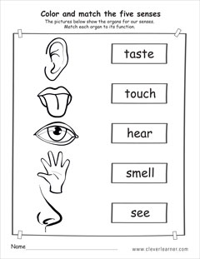

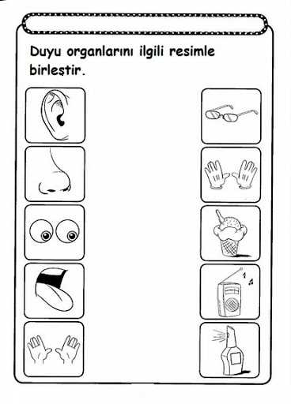Q2.Match the pictures to the correct senses.

Q3.Choose and write the senses below:

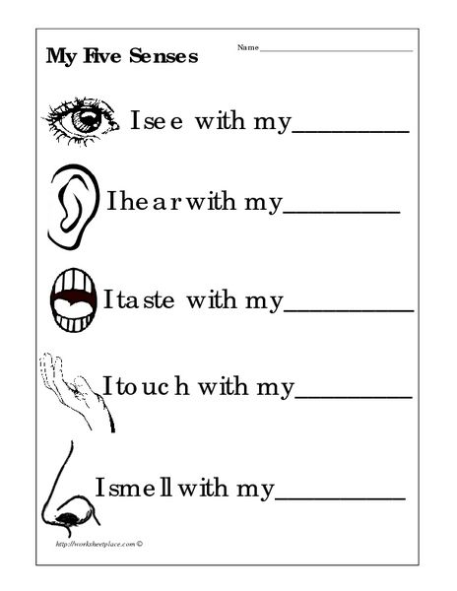 (nose , eyes , hand , ear , tongue)

**Do Science book pg : 8 , 9**