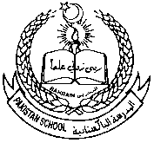 **Pakistan school ,Isa town kingdom of Bahrain**

**E-support and learning Material / session 2020-2021**

**Subject :Science Grade :3 Assignment :3**

**Unit No:1: Moving and growing**

**Topic:2: Muscles, joints and movement pgs :8---11**

**Worksheet:1**

**Q1. Sort out voluntary and involuntary muscles in the column below.**

**Finger muscles , heart muscles , leg muscles , jaw muscles ,stomach muscles ,arm muscles**

|  |  |
| --- | --- |
| Voluntary muscles | Involuntary muscles |
|  |  |

**Q2 . Choose the correct answer.**

1.muscles work in ______________________. ( pair , alone )

2.An Earthworm has __________________ sets of muscles .( three , two)

3.When muscles contract they become _____________________. ( Short , long )

Q3. Fill in the blanks with suitable word.

( Voluntary , bones , involuntary )

1.Muscles that we cannot control by thinking are called ___________________ muscles.

2.Muscles that work automatically and we cannot control are called _______________ muscles.

3.Voluntary muscles are joined to the ___________________.



**Pakistan school ,Isa town kingdom of Bahrain**

**E-support and learning Material / session 2020-2021**

**Subject :Science Grade :3 Book : simply science 3**

**Topic: Muscles, joints and movement pgs :8---11**

**Worksheet: 2**

Q1.Label the joints with the help of given words.

**( Elbow joint , wrist joint , shoulder joint , hip joint , ankle joint , knee joint )**

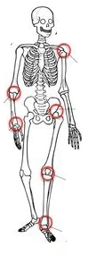

**Q2. Choose correct joint that help to produce the following movements.**

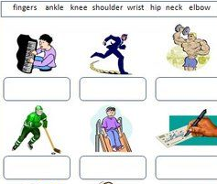

 **Pakistan school ,Isa town kingdom of Bahrain**

**E-support and learning Material / session 2020-2021**

**Subject :Science Grade :3 Assignment :3**

**Unit No:1: Moving and growing**

**Topic: Muscles, joints and movement pgs :8---11**

**Q1.Answer the following questions.**

b.what do muscle do when do when they work ? 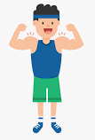

ans.muscles work by contracting.

b.How many muscles does an earthworm have

ans.two muscles.

c.Roughly how many muscles do you have in your body?

Ans.650 muscles.

d.what do we call the muscles that you do not have to think about?

Ans.involuntary muscles.

e.where is the strongest muscle in your body?

Ans.it is one of the muscles use to bite our food.

f.What are tendon?

Ans.Muscles are fastened to bones by tough cords called tendons.

g.what is a joint? 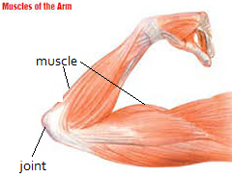

Ans.A joint is a meeting point of two bones.

**Home work:** write two things that help to make our muscles strong.

**oR** Search and write whether eye muscles are voluntary or involuntary muscles.

Or Write why do muscles have to work in pair?

*Learn Q/ Ans from notes