**Activity 1**

**Write true or false:**

**1. The sun warms the earth. T/F**

**2. At -18C⁰ oceans would freeze and no living thing would be able to survive. T/F**

**3. We do not need greenhouse effect. T/F**

**Activity 2**

**Fill in the blanks with suitable words.**

**1. …………………………... Of the people in the world live in low-lying coastal areas.**

**2. Average temperatures could rise by………………….……….. in next hundred years.**

**3. Each large tree ………………..……. is used to fill weather balloons and mode.**

**Activity 3**

**Give one word answers:**

* **Name of the gas which traps heat in the atmosphere?**
* **____________________________________________________**
* **What would be the average temperature on the earth without greenhouse effect?**
* **_____________________________________________________**
* **When trees are burnt, which gas is produced more in the air?**

**______________________________________________________**

**Pakistan School , Kingdom of Bahrain**

**E- Support and Learning Material / Session 2020-2021**

**Subject: G.Science Grade :4 FIRST TERM**

**Assignment :3**

**Unit 2: Gases around us. Pg. No: ___20__**

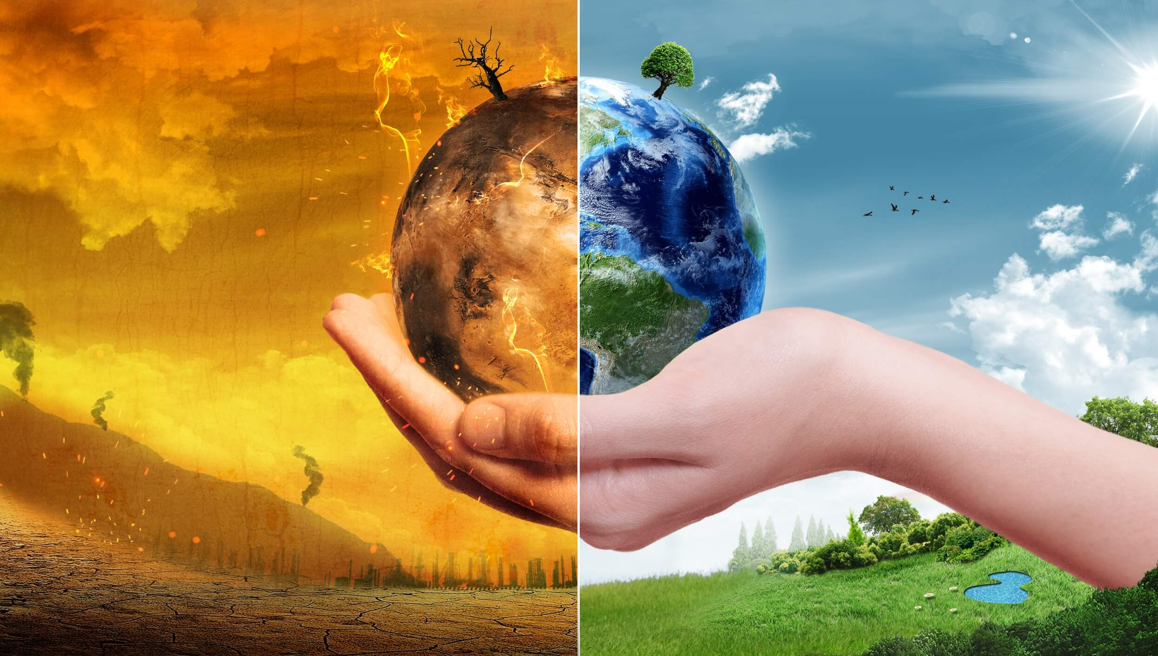 **Topic: Carbon dioxide and global warming.**

**(A) Short questions answers.**

**Q.1 what is greenhouse effect? How it affect our world?**

**Ans: The greenhouse effect is a process that occurs when gases in earth’s atmosphere trap the sun’s heat.**

**The greenhouse is one of the things that make earth a comfortable place to live.**

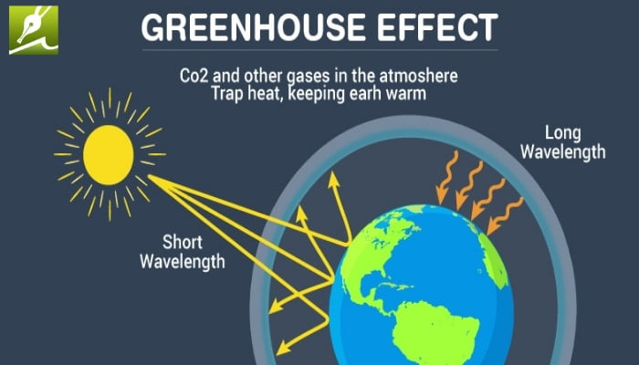

**Q.2 In your own words, describe the causes of global warming and what effects it is likely to have?**

**Ans: Cause…..Burning fuel such as coal, wood and oils.**

**Effects…… (1) More severe weather including floods.**

**(2) Extinction of many plants and animals species.**

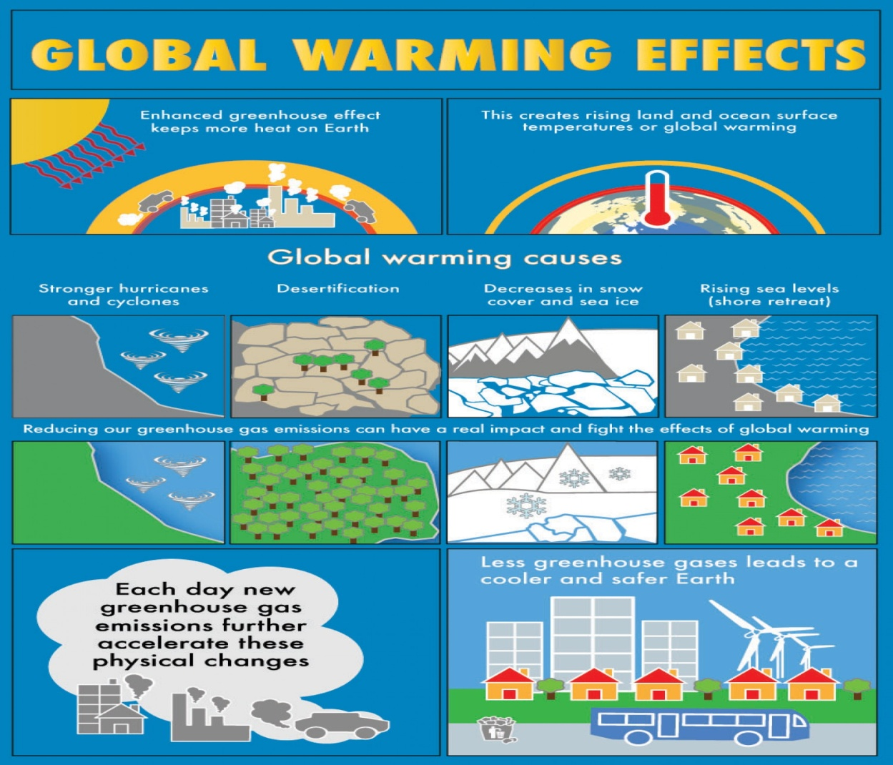

**Q.3 What is meant by global warming?**

**Ans: The gradual increase in the average temperature of the earth cause by in green house gases.**

**Q.4 Why glaciers are melting?**

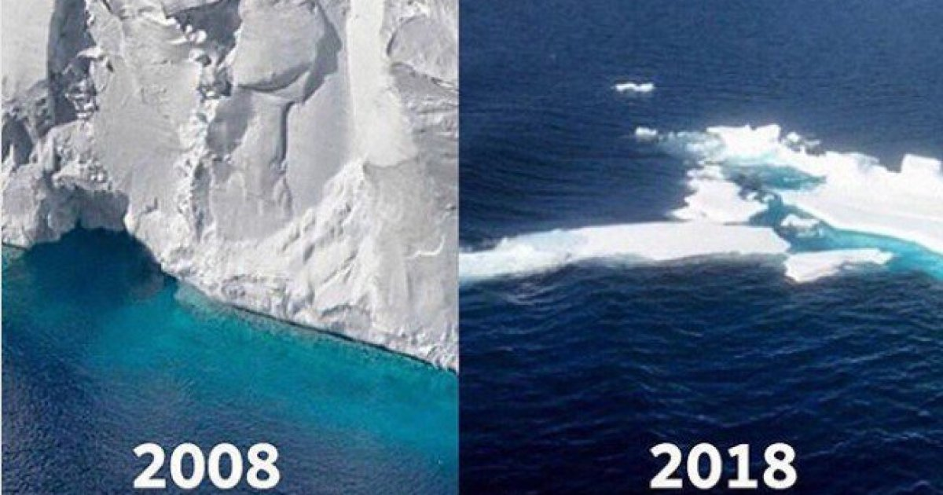**Ans: Melting of glaciers are due to global warming. Many of the world ‘s Glaciers are start to melt .one of them is Himalayas which supply water of many of rivers in Pakistan and China.**

**Q .5.How could factories and power stations reduce the amount of carbon dioxide they produce?**

**Ans: There are many ways to reduce the amount of carbon dioxide, including**

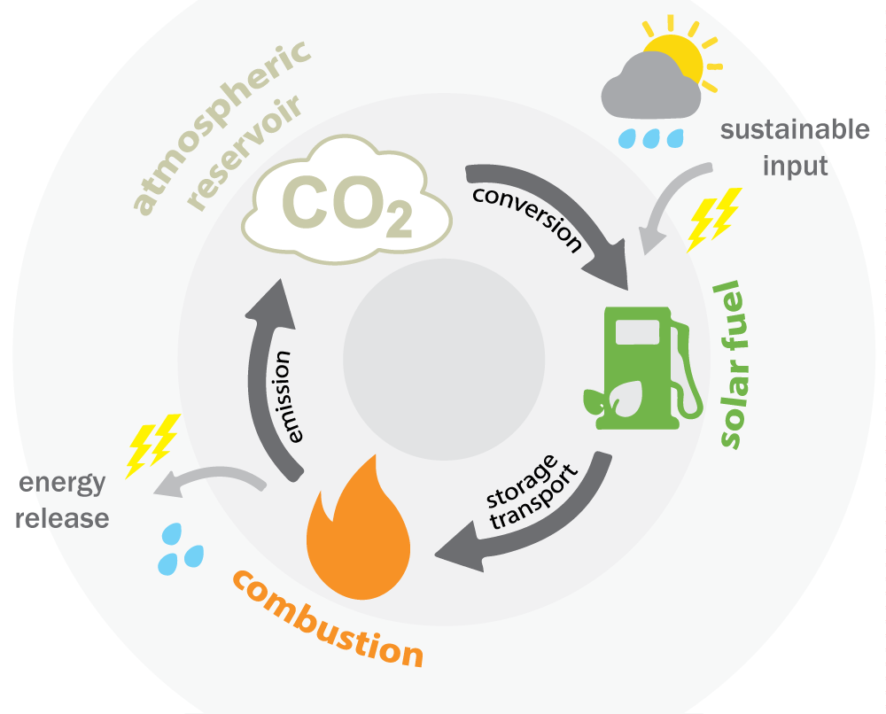 **1)Fuel switching.**

** 2) Recycling of materials.**

**(B) .MCQS**

**Choose the correct answer from the given option.**

**1 . Average temperature on earth is ………….**

**(a) - 18C⁰ (b) - 17C⁰ (c) - 16C⁰ (d) - 15C⁰**

**2. Scientists think that world average temp could rise ……………… by 4 to5⁰ in next hundred years.**

**(a) 4⁰ to5⁰ (b) 3⁰ to5⁰ (c) 1⁰ to5⁰ (d) None**

**3 . we breathe out ………...**

**(a) Nitrogen (b) Carbon (c) Oxygen (d) None**

**4. A large tree removes about……………..kg of carbon dioxide**

**(a) 134 (b) 136 (c) 139 (d) None**

**5. Oxygen gas turns into a liquid if it is cooled below minus ………….**

**(a) 183 C⁰ (b) 148C⁰ (c) 149C⁰ (d) 145C⁰**

**ANS;1..-18⁰ 2..4⁰ to5⁰ 3..carbon dioxide 4..136 5.. 183 C⁰**