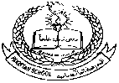**Pakistan School , Kingdom of Bahrain**

**E- Support and Learning Material / Session 2020-2021**

**Subject: Science Week:2 Day:1 Grade : 7th**

**Book: Oxford Secondary Science book 2 FIRST TERM**

**Chapter 02:Respiration and Energy from food**  **Pg. No: 9.10,11**

**TOPIC 1: The Human Respiratory System Notes**

**Short Question and answers:**

**Q.1 What is respiration?**

**Ans.** Respiration is the process by which energy is released from the food.

**Q.2 What is difference between aerobic respiration and anaerobic respiration?**

**Ans.** Aerobic respiration takes place in the presence of oxygen and anaerobic respiration takes place without oxygen.

**Q.3 Why do you breath faster and your heart rate increases when you run?**

**Ans.** You breath faster and your heart rate increases when you run because the body needs more energy for respiration. The faster rate of breathing gets oxygen into the lungs faster and releases carbon dioxide and water vapour to the air more quickly.The heart pumps faster to speed up the supply of oxygen and dissolved food to the muscles cells and to carry away the waste products for respiration.

**Q.4 Make a list of all parts of the body that air flows through on its way to lungs.**

**Ans.** The parts of the body the air flows through on its way to lungs are

1.mouth/nose 2.nasal cavity 3. Voice box( larynx) 4.wind pipe (trachea)

5. bronchus plural brochi 6. Alveoli (air sacs)

**Q.5 Where exchange of gases takes place ?**

**Ans.** Exchange of gases takes place in alveoli( air sacs).

**Activity :** Label the parts of Human respiratory system:

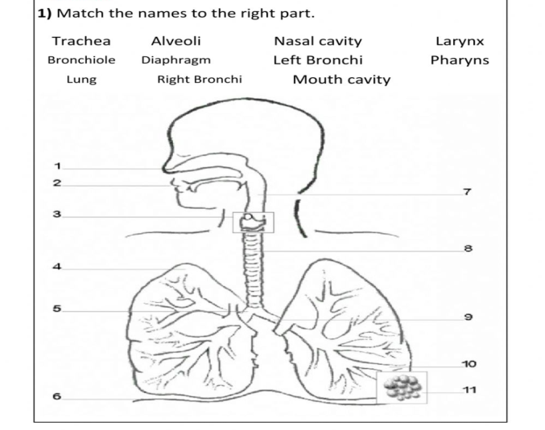

**Pakistan School , Kingdom of Bahrain**

**E- Support and Learning Material / Session 2020-2021**

**Subject: Science Week:2 Day:2 Grade : 7th**

**Book: Oxford Secondary Science book 2 FIRST TERM**

**Chapter 02:Respiration and Energy from food**  **Pg. No: 11.12**

**TOPIC 1 : The Human Respiratory System Notes**

**Q.1 What is the difference between breathing and respiration?**

**Ans.**

|  |  |
| --- | --- |
| Breathing  Breathing is the movement of air into and out of the lungs in order to obtain oxygen and remove carbon dioxide and waste materials. | Respiration  Respiration is the process by which energy is released from food by using oxygen  Respiration occurs in the lungs. |

**Q.2 Write the equation for the process of respiration?**

**Ans**. Food +Oxygen → carbon dioxide +water +energy

Q.3 **What is the composition of air inhaled by a person** ?

Ans. The air inhaled by a person contains 78% nitrogen , 21% oxygen, 0.03% carbon dioxide ,inert gases 1%

**Q.4 What is the composition of air exhaled by a person** ?

Ans. The air exhaled by a person contains 78% nitrogen , 16% oxygen, 4% carbon dioxide ,inert gases 1%

**Q.5 Explain the functions of diaphragm and the intercostal muscles in breathing.**

**Ans.** When we breathe the shape of the chest changes .these changes are brought about by the muscles of ribs and diaphragm.Each pair of ribs has muscles called intercostal muscles, between them.Toghter the intercostal muscles and the muscles of the diaphragm can make the volume of chest cavity larger or smaller .

When we breathe in or inhale the diaphragm is pulled down and the rib cage is pulled upwards. The space inside the chest gets bigger .Air rushes into the lung to fill up the extra space

When we breathe out or exhale the muscles relax. The diaphragm moves upward and the rib cage is lowered.The space in the chest gets smaller and air is forced out of the lungs.

**Q.6 Why is it better to breathe through your nose than through your mouth**

**Ans.** It is better to breath in through your nose than mouth because hairs and mucus in the nose and nasal cavity filter dust and germs from air. If you breath in through the mouth, dirty dry and cold air enter your lungs.

**Solve any one activity:**

**Activity 1:**

**Fill in the blanks:**

1. Energy is released from food in a process called _______________________.
2. When we breath out the diaphragm muscles moves ___________.
3. Each pair of ribs have ____________________ muscles.
4. Inhaled air contains _______________ % oxygen.
5. If you breath in through the mouth _____________________ air enters your lungs.

**Activity 2:**

**Multiple Choice Questions:**

1.Respiration occurs in the :

a. lungs b. red blood cells c. nasal cavity d. heart

2. The gas which is passed out of the lungs unchanged is :

a. oxygen b. nitrogen c. carbon dioxide d. water vapours

3. when you breath in your ribs move:

a. down and in b. up and out c. up and in d. down and out

4.The exchange of gases takes place in

a. wind pipe b. ribs c. alveoli d.layrynx

5. Sound is produced when air passes through

a. ribs b. bronchus c. alveoli d. voice box (larynx)

**Activity 03:**

**Write one word answer:**

Q.1 It is the tube that carries air to the lungs.

Ans ________________

Q.2These are little sacs where exchange of gases takes place.

Ans._________________

Q.3 These are large muscles which help you to fill and empty your lungs.

Ans._____________________.