Pakistan School- Isa Town - Kingdom of Bahrain-

Grade I – English

Naming Words ( Nouns )

Activity Sheet

Name: ______________________________________ Class: _______Date: _________

Naming Words.

A word used to name a person , place , animal or a thing is called a

naming word or a noun. Examples:



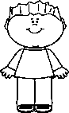

Persons: mother , father , brother , sister , Ali , Sana.

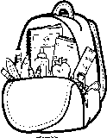 Places: school , Bahrain , Pakistan , garden , zoo , hospital.

 Animals: cat , dog , bird , fish , horse , cow , sheep , rabbit.

Things: ball , car , apple , bag , chair , table , pen , book , orange.

I – Circle the Nouns in the given sentences.

|  |  |
| --- | --- |
| 1. The dog is running | 2. I am going to the garden. |
| 3. The book is on the table. | 4. The cat is very hungry. |

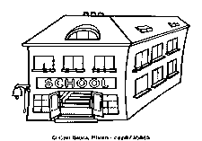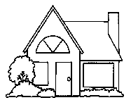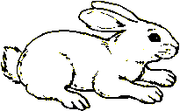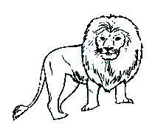

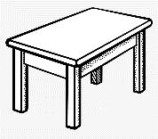

lion pencil school teacher rabbit house Ahmed table

|  |  |  |  |
| --- | --- | --- | --- |
| **Person** | **Place** | **Animal** | **Thing** |
| 1. | 1. | 1. | 1. |
| 2. | 2. | 2. | 2. |

**GRAMMAR CLUB** **Unit 2: One rabbit , two rabbits** **Grade: 1**

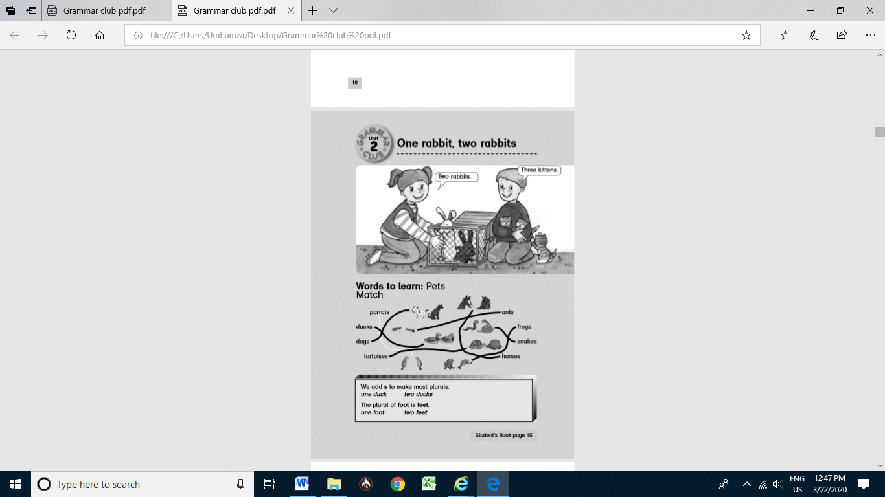

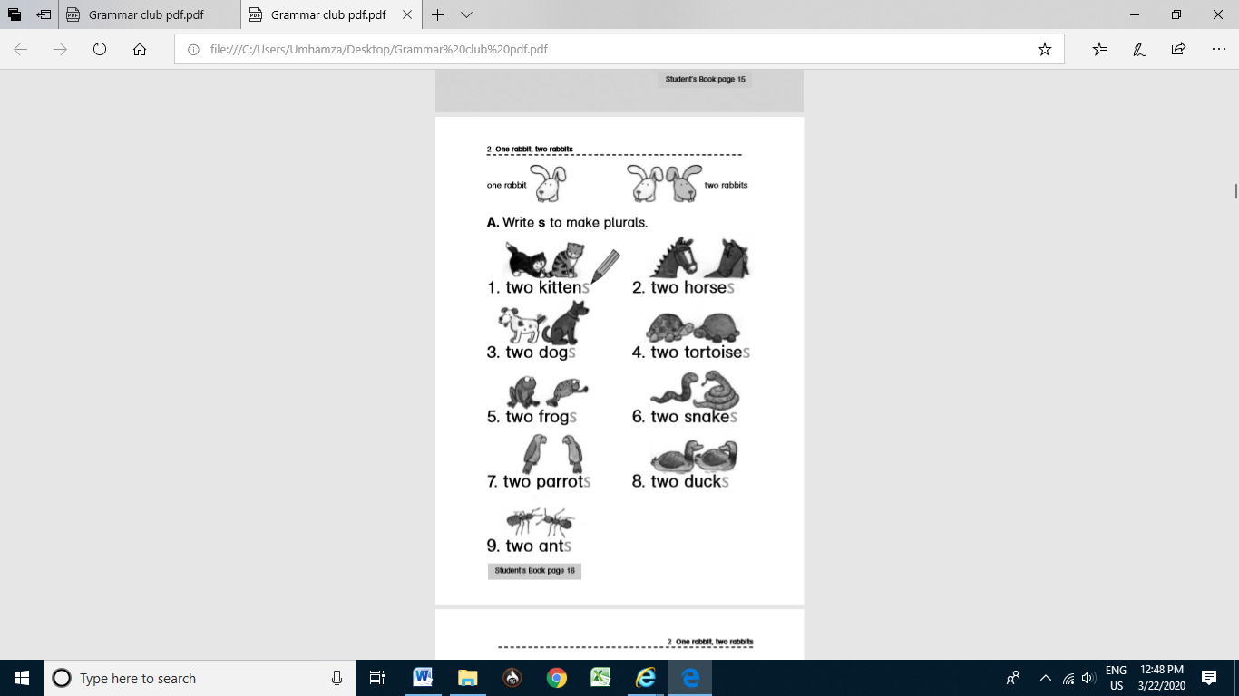

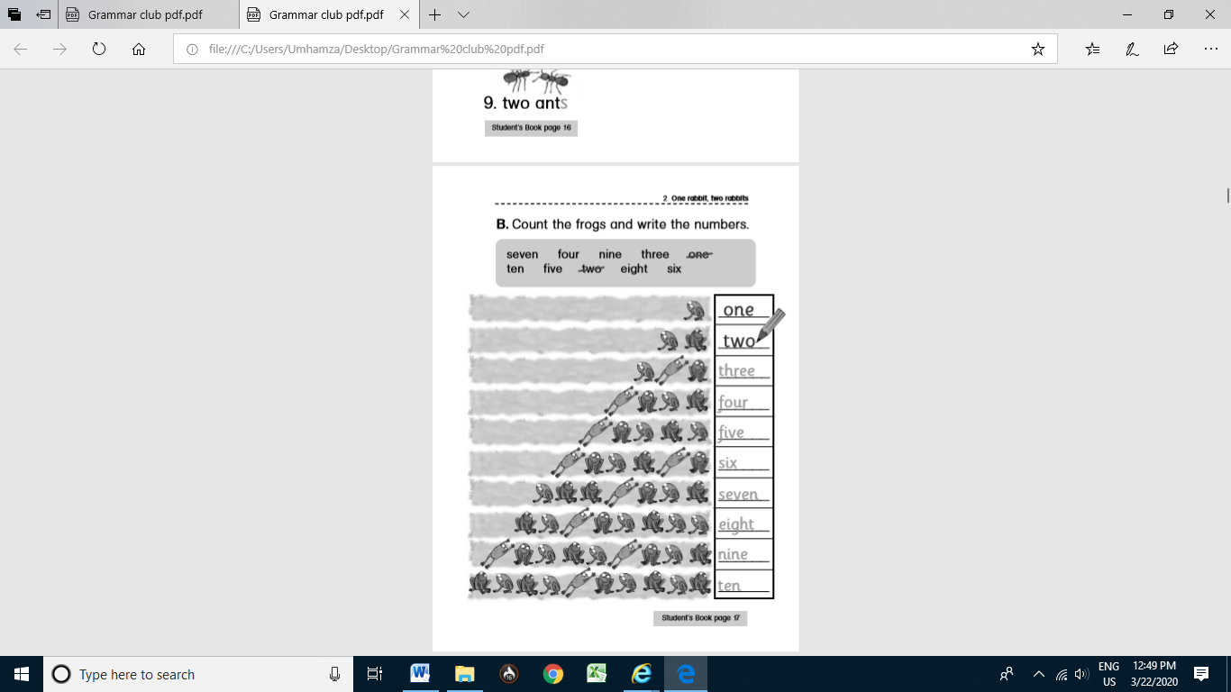

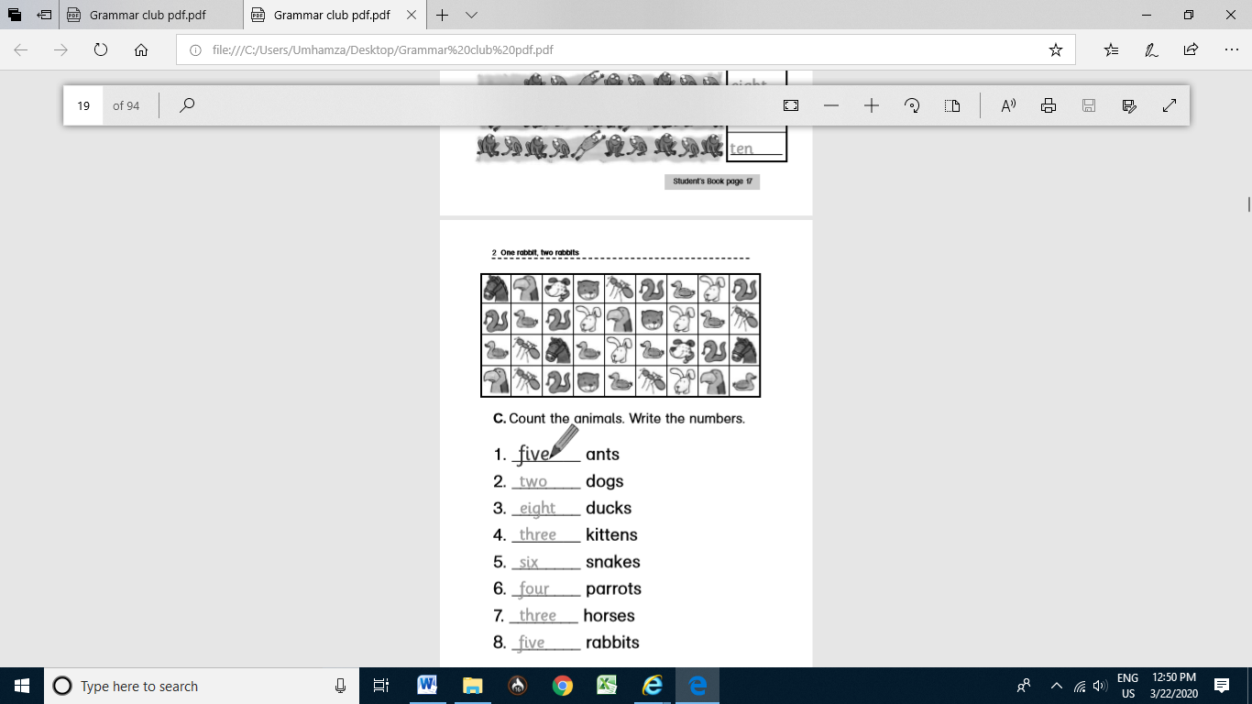

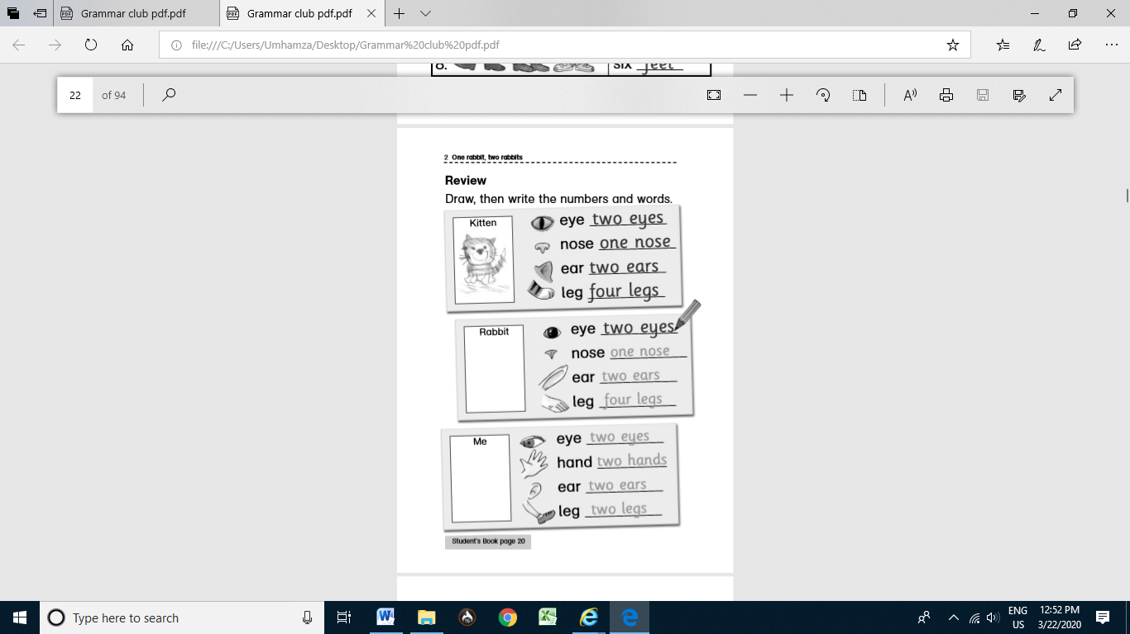

|  |  |  |  |  |
| --- | --- | --- | --- | --- |
| **Rubric:** | **Ex.** | **Go.** | **Sat.** | **NI** |
| **Content Accuracy** | **1** | **2** | **3** | **4** |
| **Creativity** | **1** | **2** | **3** | **4** |
| **Completeness** | **1** | **2** | **3** | **4** |
| **Neatness** | **1** | **2** | **3** | **4** |
| **1-Excellent 2- Good 3- Satisfactory**  **4- Needs improvement** | | | | |