**Pakistan School , Ministry of Education , Kingdom of Bahrain**

**E-Support and Learning /Session 2020-2021**

**Subject : English - Grade : I**

p-a-n-d -a

[](https://www.google.com/url?sa=i&url=https://creazilla.com/nodes/6267-panda-with-bamboo-clipart&psig=AOvVaw3YGF29ddU7NaIxbnmbcPX1&ust=1584685424704000&source=images&cd=vfe&ved=0CAIQjRxqFwoTCIij0LDzpegCFQAAAAAdAAAAABAD)

**Speaking Skills:**

1. **Vocabulary words:**

b-e-a-r

bear

f-o-r-e-s-t

forest

[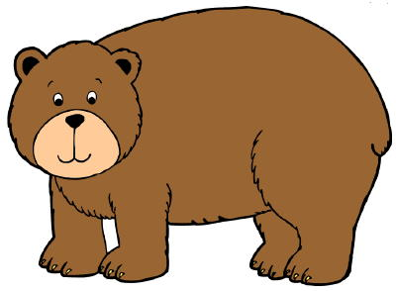](https://www.google.com/url?sa=i&url=https://clipartart.com/categories/free-bear-clipart-images.html&psig=AOvVaw3fbVwzbHIUhDKKnJOTc-yf&ust=1584685834624000&source=images&cd=vfe&ved=0CAIQjRxqFwoTCNiGyPr0pegCFQAAAAAdAAAAABAD)[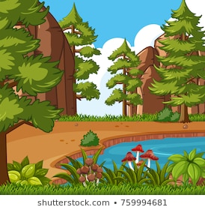](https://www.google.com/url?sa=i&url=https://www.shutterstock.com/search/forest%2Bclipart&psig=AOvVaw0_Tz_xNYAe1a0amMyn9ILs&ust=1584686109396000&source=images&cd=vfe&ved=0CAIQjRxqFwoTCMDIiPj1pegCFQAAAAAdAAAAABAD)

m-o-u-n-t-a-i-n

mountain

b-a-m-b-o-o

bamboo

[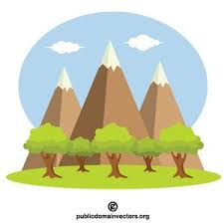](https://www.google.com/url?sa=i&url=https://publicdomainvectors.org/en/tag/mountain&psig=AOvVaw1isGlmxAghtKjgF84H4SPE&ust=1584686783672000&source=images&cd=vfe&ved=0CAIQjRxqFwoTCICipbn4pegCFQAAAAAdAAAAABAD)[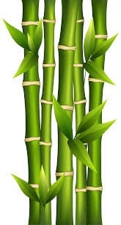](https://www.google.com/url?sa=i&url=https://clipartart.com/categories/small-bamboo-clipart.html&psig=AOvVaw2sYxUKJmPkEdSztT5wFqax&ust=1584686634052000&source=images&cd=vfe&ved=0CAIQjRxqFwoTCJiggfH3pegCFQAAAAAdAAAAABAD)

[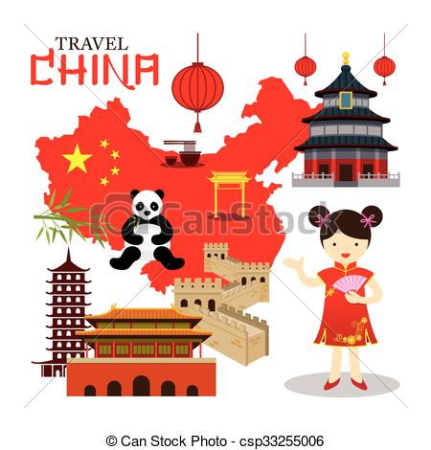](https://www.google.com/url?sa=i&url=https://clipartstation.com/china-clipart-2-3/&psig=AOvVaw0ZjAgWp9fCNQ8ZKbTUSV1u&ust=1584687764479000&source=images&cd=vfe&ved=0CAIQjRxqFwoTCPi29Iz8pegCFQAAAAAdAAAAABAJ)[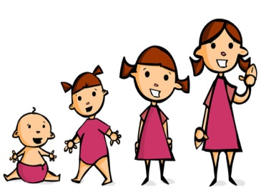](https://www.google.com/url?sa=i&url=https://www.clipart.email/clipart/child-growing-clipart-19848.html&psig=AOvVaw11ZgH2dJk9aAvnf11n7a6y&ust=1584686904347000&source=images&cd=vfe&ved=0CAIQjRxqFwoTCLiq9vP4pegCFQAAAAAdAAAAABAZ)

C-h-i-n-a

China

g-r-o-w

grow

1. **Vocabulary words**

c-l-o-u-d-s

clouds

w-a-t-e-r

water

[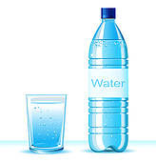](https://www.google.com/url?sa=i&url=https://webcomicms.net/clipart-9247345-bottled-water-clipart&psig=AOvVaw2DaQjVxx5ZM3BsoVIcQmVE&ust=1584945842142000&source=images&cd=vfe&ved=0CAIQjRxqFwoTCIjBhsy9regCFQAAAAAdAAAAABAJ)

[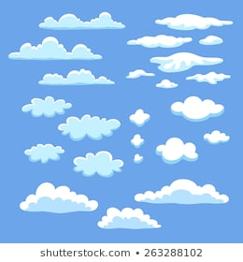](https://www.google.com/url?sa=i&url=https://www.shutterstock.com/search/clipart%2Bclouds&psig=AOvVaw11Jcad-1_J--jkuT8L25zn&ust=1584945980975000&source=images&cd=vfe&ved=0CAIQjRxqFwoTCMCzhYi-regCFQAAAAAdAAAAABAD)

p-e-o-p-l-e

people

d-r-o-p-s

drops

[](https://www.google.com/url?sa=i&url=https://www.kissclipart.com/employee-transparent-clipart-royalty-free-employee-0f3928/&psig=AOvVaw2YDIgDQFqWNjnEXAokbIos&ust=1584946085901000&source=images&cd=vfe&ved=0CAIQjRxqFwoTCKCTnLi-regCFQAAAAAdAAAAABAJ)[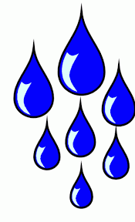](https://www.google.com/url?sa=i&url=http://niceclipart.com/10247/drops.html/drops-clipart-3&psig=AOvVaw32Zf7qRXy7XlXo42HcpMJq&ust=1584945767314000&source=images&cd=vfe&ved=0CAIQjRxqFwoTCOD0lJ69regCFQAAAAAdAAAAABAD)

p-l-a-n-t-s

plants

a-n-i-m-a-l-s

animals

[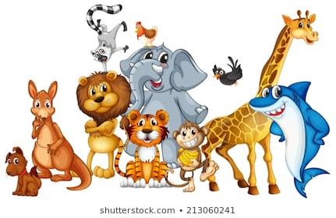](https://www.google.com/url?sa=i&url=https://www.shutterstock.com/search/animals%2Bclipart&psig=AOvVaw1mTVpm6MY47k9nOa6HXE2h&ust=1584946310138000&source=images&cd=vfe&ved=0CAIQjRxqFwoTCKCAi6G_regCFQAAAAAdAAAAABAO)[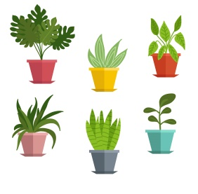](https://www.google.com/url?sa=i&url=https://clipartart.com/categories/clipart-potted-plants.html&psig=AOvVaw1K4UrxC1ZSLoeZzFyI7Lgg&ust=1584946211533000&source=images&cd=vfe&ved=0CAIQjRxqFwoTCKjZt_G-regCFQAAAAAdAAAAABAD)

b -i-n

bin

[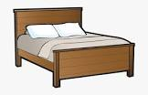](https://www.google.com/url?q=https://www.kindpng.com/imgv/ihJRxTh_bed-frame-clipart-png-download-bed-frame-clipart/&sa=U&ved=2ahUKEwjfxvzyrfnpAhWFilwKHcLGBRYQqoUBMAN6BAgREAE&usg=AOvVaw0E2D6Q0XnIbburQzmk6zmt)[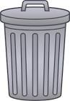](http://www.google.com/url?q=http://clipart-library.com/bin-cliparts.html&sa=U&ved=2ahUKEwiJh6TJrvnpAhWklFwKHWRQCxsQqoUBMAB6BAgEEAE&usg=AOvVaw2sMAE-XVYhrtSLf-6sd4hh)

b – e - d

bed

b - o - x

box

[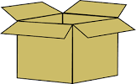](http://www.google.com/url?q=http://clipart-library.com/boxes-cliparts.html&sa=U&ved=2ahUKEwjjhODIr_npAhWwQEEAHTGQCBkQqoUBMAJ6BAgQEAE&usg=AOvVaw3fbWlzaQ-IM5XLabAD74m5)

b – o – o -k

book

[](http://www.google.com/url?q=https://clipartart.com/categories/book-clipart-free-school.html&sa=U&ved=2ahUKEwiGm9T-rvnpAhXPTsAKHdxqCBwQqoUBMAF6BAgSEAE&usg=AOvVaw0kQGLGh-ZJlWNMs6MTFyTd)

[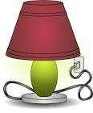](http://www.google.com/url?q=http://clipart-library.com/lamps-cliparts.html&sa=U&ved=2ahUKEwiWt7nCsPnpAhXIX8AKHbjRCBwQqoUBMAB6BAgCEAE&usg=AOvVaw1wM0Ydw1P7xtzcf-hp9FiF)[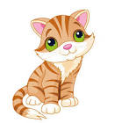](http://www.google.com/url?q=https://clipartart.com/categories/cat-clipart-png.html&sa=U&ved=2ahUKEwjH6YelsPnpAhULCsAKHYLqDhQQqoUBMAZ6BAgTEAE&usg=AOvVaw020xRnPIREM-EZn9tEZebJ)

l- a- m- p

lamp

c – a - t

cat

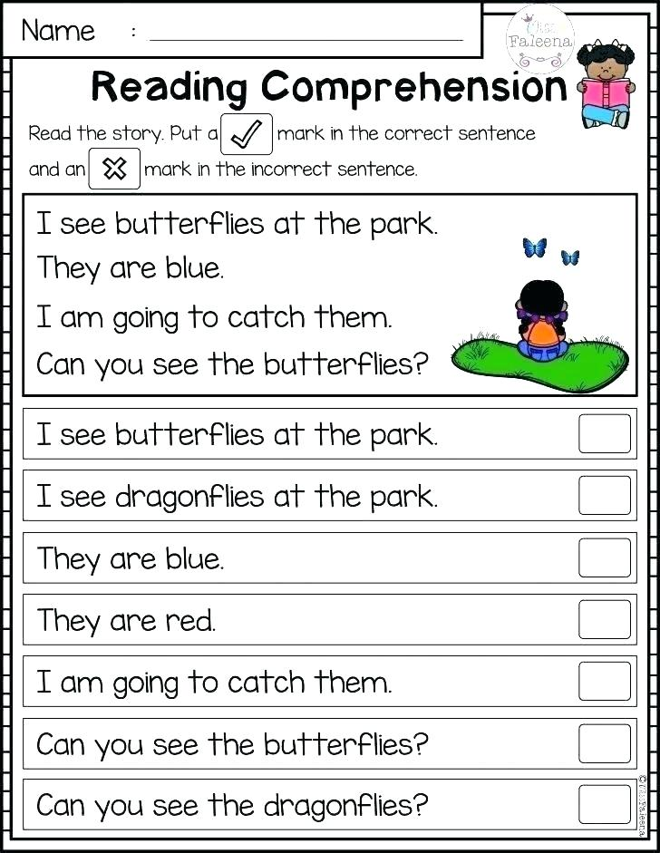

[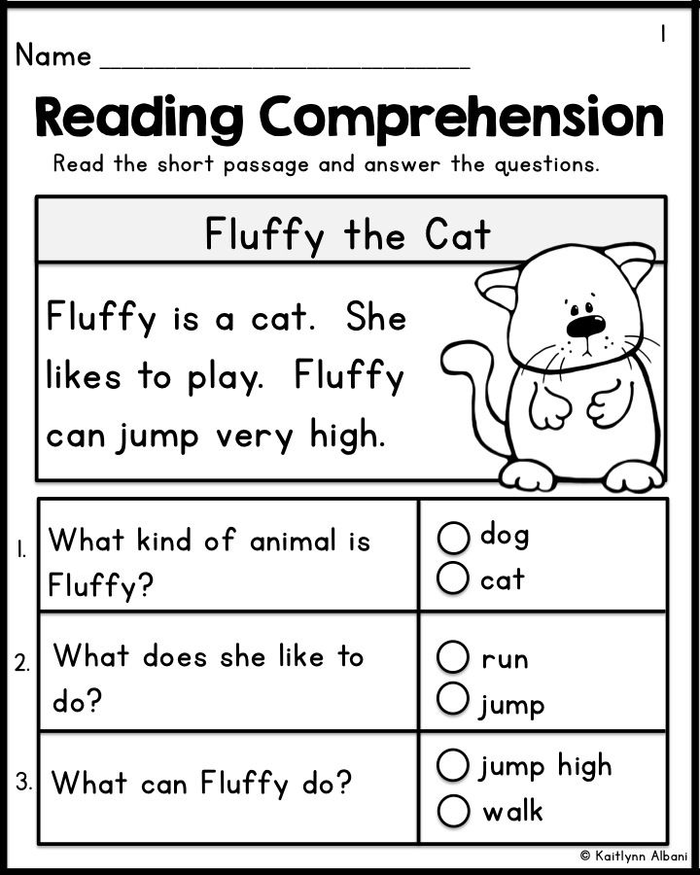](https://www.google.com/url?sa=i&rct=j&q=&esrc=s&source=images&cd=&ved=2ahUKEwjV-9280NPkAhUwxoUKHWxNCe4QjRx6BAgBEAQ&url=https://www.pinterest.com/pin/489625790719653639/&psig=AOvVaw1ejxyHvTbDv1ex5JFKE8wz&ust=1568664411199917)

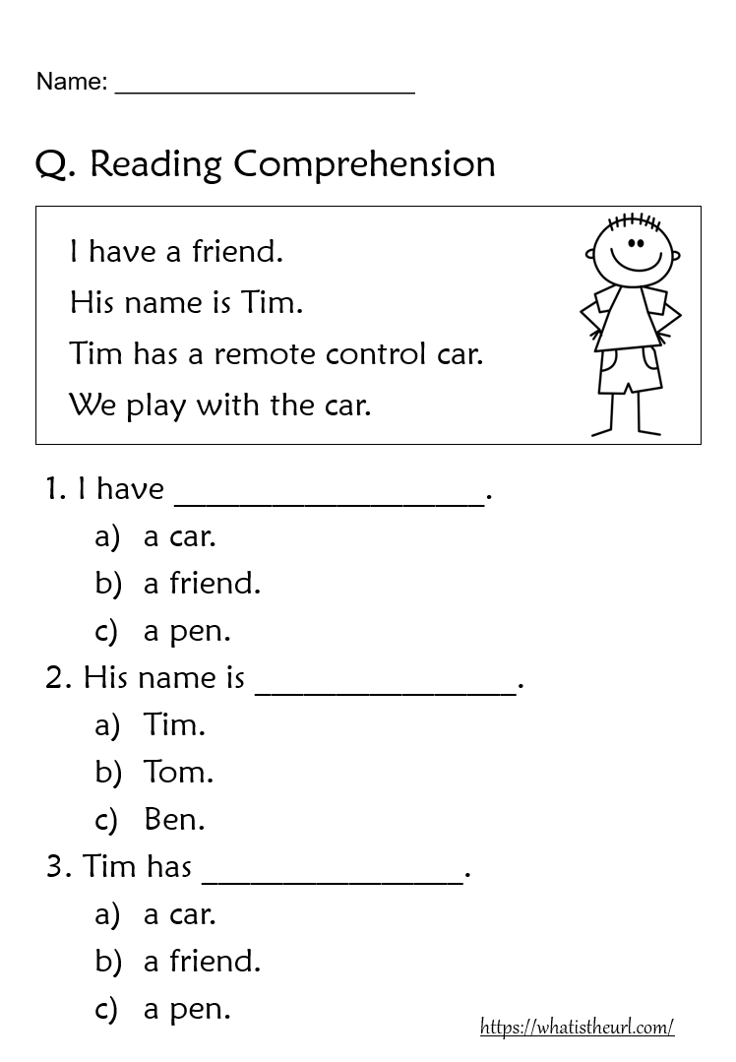

|  |  |  |  |  |
| --- | --- | --- | --- | --- |
| **Rubric:** | **Ex.** | **Go.** | **Sat.** | **NI** |
| **Content Accuracy** | **1** | **2** | **3** | **4** |
| **Creativity** | **1** | **2** | **3** | **4** |
| **Completeness** | **1** | **2** | **3** | **4** |
| **Neatness** | **1** | **2** | **3** | **4** |
| **1-Excellent 2- Good 3- Satisfactory**  **4- Needs improvement** | | | | |