**Pakistan School, Kingdom of Bahrain**

**E- Support and Learning Material / Session 2020-2021**

**Subject: English Grade: 10**

**Unit 2 : Chinese New Year**

**Pg. 18 Ex. A: Give the meanings of the following words:**

|  |  |  |  |
| --- | --- | --- | --- |
| **Words** | **Meanings** | **Words** | **Meanings** |
| **gatherings** | **meeting in groups** | **partake** | **to participate** |
| **customary** | **any usual practice** | **traits** | **characteristics** |
| **thoroughly** | **carefully** | **reinvigorate** | **to strengthen** |
| **commonplace** | **to be ordinary or regular** |  |  |

**Pg. 19 Ex. B: Form a noun from the given words:**

|  |  |  |  |
| --- | --- | --- | --- |
| **celebrate** | **celebration** | **decorate** | **decoration** |
| **gather** | **gathering** | **encourage** | **encouragement** |
| **symbolic** | **Symbol** |  |  |
| **prosper** | **prosperity** |  |  |

**Reading & Comprehension**

**Pg.19-20 Ex.A:Choose the correct option.**

**1.Chinese New Year falls somewhere between January 21st and February 20th .**

**2. Paragraph 1 gives specific details of new year celebrations.**

**3. It is customary for families to thoroughly clean their houses before the first day of the New Year.**

**4. Hanging up signs and posters on the doors and windows means luck and happiness.**

**5. Envelopes are not to be opened until the recipient has left the house of the giver.**

**Pg.20 Ex.B. Answer the following questions:**

**(i) When does Chinese New Year start?**

**Ans: Chinese New Year is a festival that celebrates the beginning of a new year and onset of Spring. Chinese New Year is never on the same day each year. It typically falls somewhere between January 21st and February 20th.**

**(ii) Why is Chinese New Year never on the same day each year?**

**Ans: The Chinese follow lunar calendar which is based on the phases of the moon and has a shorter cycle than the sun. Therefore, the Chinese New Year is never on the same day each year. It typically falls somewhere between January 21st and February20th.**

**(iii) Why do Chinese families do through cleaning of their houses before New Year's Day?**

**Ans: Prior to the first day of the New Year it is customary for Chinese families to thoroughly clean their houses. Doing this is said to clear out any bad luck from the previous year and to make the house ready to accept good luck for the coming year. All cleaning must be done before New Year’s Day so there is no chance of accidentally throwing out the good fortune of the New Year.**

**(iv) Which colour is not allowed and which colour is encouraged on Chinese New Year? Why?**

**Ans: Wearing black is not allowed due to its association with death, however, wearing red is encouraged as the colour is associated with warding off bad spirits. Red envelopes given to children by adults symbolize wealth and prosperity for the coming year.**

**(v) What do decorations on doors and windows symbolize?**

**Ans: Chinese hang up signs and posters on doors and windows with the Chinese character fu written on them, which means luck and happiness. The right side of the character is a pictogram of a jar. The inverted character implies the "pouring out" of the jar of good fortune on those coming through the door!**

**(vi) What is the significance of New Year's Eve dinner?**

**Ans: The New Year's Eve dinner named as "Nian Ye Fan" is the most important dinner for the Chinese. Normally, this is a family reunion dinner, especially for those with family members away from home. It helps Chinese families to sit together and mend their bonds. It is typical for a Chinese family to make eight to nine dishes for dinner because in Chinese language the word ‘’eight’’ means ‘’prosperity’’ and ‘’ nine’’ means ‘’long lasting’’.**

**(vii) What do the little red envelopes filled with money symbolize?**

**Ans: Chinese people love the colour red. It is a traditional practice for adults to give children little red envelopes filled with money. These red envelopes filled with money are called "yasui qian" and symbolize wealth, happiness and prosperity for the coming year.**

**(viii) What is the importance of Chinese New Year for Chinese families?**

**Ans: Chinese New Year is very important for Chinese families. This is the time when the family members strive to be with their near and dear ones; they regard this as a time to usher out the old year and welcome the new, with great festivities and merrymaking.**

**Grammar :**

**Collective Nouns**

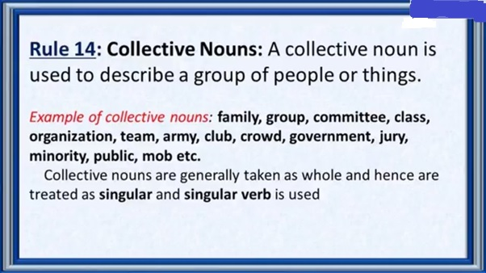

**Pg.21 Ex. A: Fill in the blanks with correct collective nouns:**

**1. It is typical for a Chinese family to make eight to nine dishes for the New Year’s Eve dinner.**

**2. The audience applauded heartily at the end of the concert.**

**3. The class has just had a physics lesson.**

**4. The gang of robbers was arrested by the police.**

**5. A crowd of people gathered at the accident sight.**

**6. The committee took many important decisions at its monthly meeting.**

**7. The crew of Pakistan Air Force looked smart in their uniforms.**

**Use of must / mustn’t**

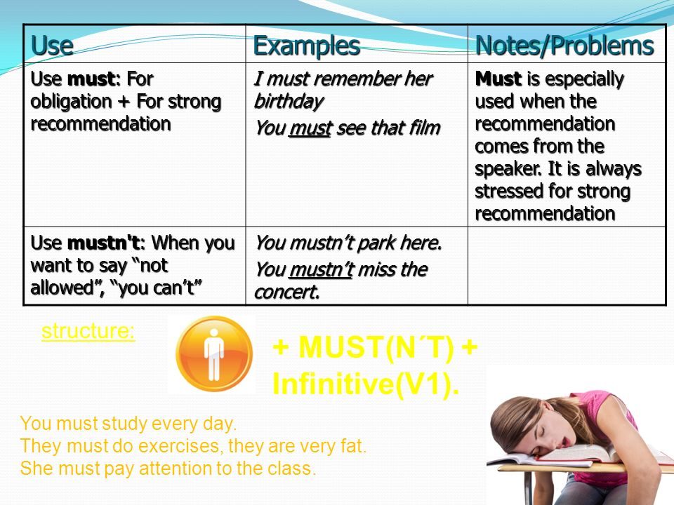

**Pg.21 Ex.B:Fill in the blanks with must or mustn’t :**

**1. She mustn’t eat so much sugar.**

**2. Students must pass an entrance examination to study at this school.**

**3. You mustn’t watch so much television.**

**4. He must take some medicine for that cough.**

**5. Visitors mustn’t smoke.**

**Present Indefinite Tense and Present Continuous Tense**

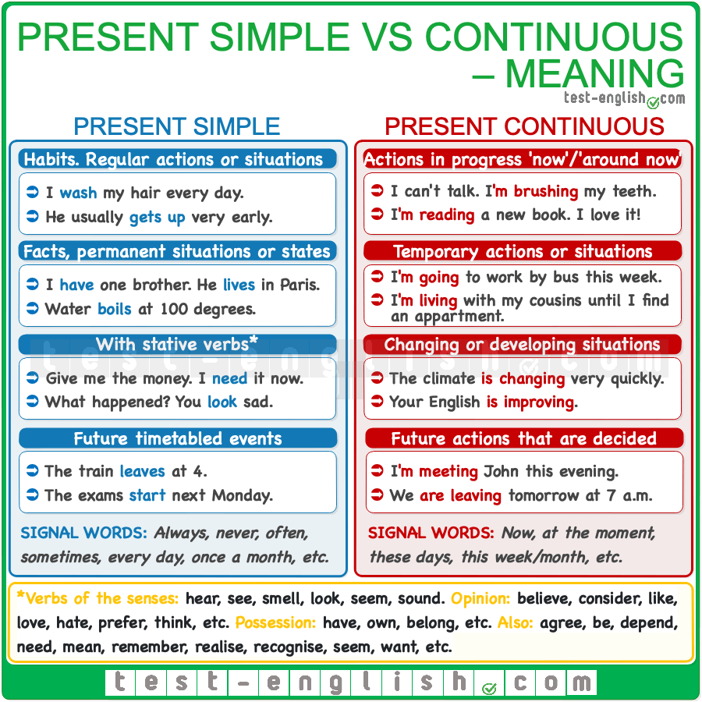

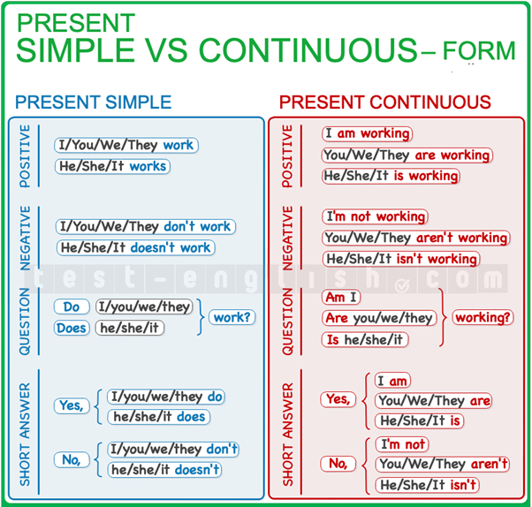

**Pg.21 Ex. C: Make the present indefinite tense or present continuous tense sentences.**

**1. You don’t like chocolate.**

**2. She is not studying at the moment.**

**3. They do not eat rice everyday.**

**4. We are not playing now.**

**5. It rains a lot here.**

**6. I am going on holiday tomorrow.**

**HOMEWORK:**

**1. Surf internet to find names of the animals Chinese years are named after.**

**2. Collect information about two more festivals that are celebrated around the world.**

**Subject: English WORKSHEET Grade: 10**

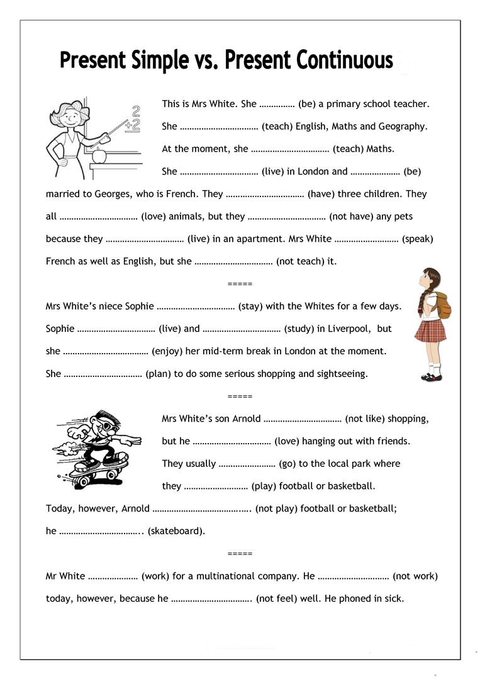

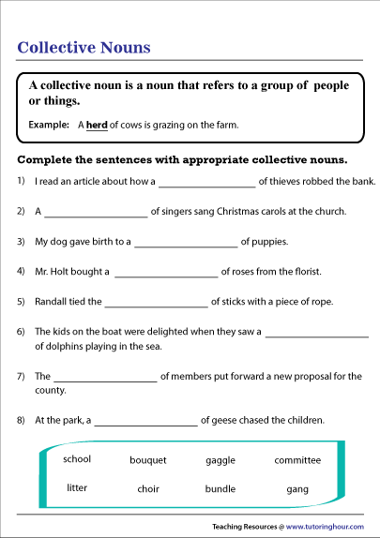

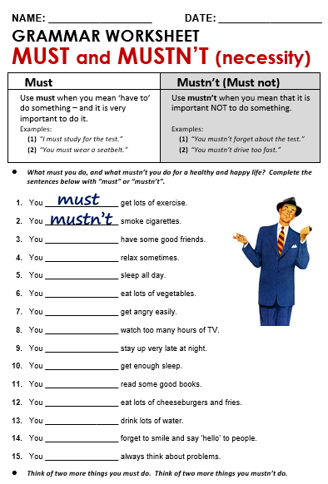

|  |  |  |  |  |
| --- | --- | --- | --- | --- |
| **Rubric:** | **Ex.** | **Go.** | **Sat.** | **NI** |
| **Content Accuracy** | **1** | **2** | **3** | **4** |
| **Creativity** | **1** | **2** | **3** | **4** |
| **Completeness** | **1** | **2** | **3** | **4** |
| **Neatness** | **1** | **2** | **3** | **4** |
| **1-Excellent 2- Good 3- Satisfactory**  **4- Needs improvement** | | | | |