**Pakistan School , Kingdom of Bahrain**

**E- Support and Learning Material / Session 2020-2021**

**Subject: English Grade : 10**

**English Textbook- 10 First Term**

**Unit 3 : Try Again**

**Central Idea of the poem:**

**"Try Again"** is a simple, reflective and moralizing poem gleaned by the pen of a British poet, William Edward Hickson. In this poem, the poet tells us the importance of trying again in case we fail in doing something due to some adverse circumstances. He says that we should continue trying again till we succeed.This poem gives us a message of hope, courage, hard work, perseverance and optimism. We should always keep this message in mind to be crowned with victory in our lives.

**Paraphrasing:**

***Stanza # 1***

***Try again" is a  message that cannot be ignored. We must always pay attention to this message. If, due to adverse circumstances, we fail in our first effort, we should not be discouraged. Rather, we should make better efforts to reach our goal. We must demonstrate that we have firmness to bear the loss. Then we should come forward with a new spirit. We should be steadfast in our efforts without any fear. If we do so, we will be succeeded. Thus we should not neglect the lesson "Try again".***

***Stanza # 2***

***In this stanza, the poet, W.E. Hickson says that we may fail in our attempts or efforts for one time or two but if we keep on struggling, we will finally win. What we need to do is to keep on working and not to get disappointed and be persistent in striving. It is not a matter of shame to work and work. Though, we have failed in our preceding efforts, we should not feel discouraged. What we need to do in such a situation is "try again".***

***Stanza # 3***

***In this stanza, the poet says that if you feel you can not accomplish your task in one effort, make another one with the considerable force. There will be a time when you will enjoy the fruit of your labour. What you need to do is to keep on working. You must know that if all people can do their jobs, you can also do yours. What you need is to be persistent in making efforts. The only thing you must keep in mind is that you should never get disappointed. You just need to continue working till you succeed.***

***Pg. 29 Ex. A : Answer the following questions:***

**Q 1:   What does the word  ‘’ persevere’’   mean?**

**Ans:  The  word persevere mean persist  steadily in an action  or belief.**

**Q 2:  ‘’If” we strive, it is no disgrace’’ explain this sentence?**

**Ans:   It mean if we strive  after failure there is no disgrace  in it.**

**Q 3:  Why is the poet repeating  the sentence ‘’try again’’?**

**Ans:  The poet repeat again and again the sentence  to make us aware of importance of trying again.**

**Q 4: What is the lesson taught in the first stanza?**

**Ans: It is taught that no mater  if you fail once or twice  you shall not give up trying again. There is no shame, no disgrace even if we do not win the race. We should trying again to get success.**

**Q 5: What can we learn from failure?**

**Ans : we come to know about our weakness and shortcomings  from our failure. After over comings these hurdles, we can get success.**

**Q 6: How is failure not a disgrace?**

**Ans : Wise man learn from there failure, try again get success and  become respectable. In this respect, failure is not a disgrace.**

**Q 7: How  many  time we should try and why?**

**Ans:  We should  always keep trying  till we achieve our goal.**

**i) How can we learn from failure?**

Ans. Everyone fails in life. While failure hurts at the time, it is a part of life's design - a divine chisel. Failure is a temporary detour or delay, not defeat. It teaches us the lesson of courage. It urges us to take more daring steps to reach our goal.

**ii) How is failure not a disgrace?**

Ans. Everyone fails in life. While failure hurts at the time, it is a part of life's design - a divine chisel. Failure is a temporary detour or delay, not defeat. To leave working after failure is surely a disgrace. But if failure urges us to take more daring and steady steps, it is no disgrace then.

***Pg. 29 Ex. B Find synonyms of the following words:***

|  |  |  |  |
| --- | --- | --- | --- |
| ***courage*** | ***bravery*** | ***hard*** | ***difficult*** |
| ***conquer*** | ***win*** | ***reward*** | ***award*** |
| ***disgrace*** | ***insult*** |  |  |

***Pg.30 Ex. B Select the choice that explains the meaning of the simile as it is used in the sentences****:*

|  |  |  |  |  |  |
| --- | --- | --- | --- | --- | --- |
| ***1*** | ***(B) I was cozy in my bed.*** | ***2*** | ***(A) The new teacher was nice.*** | ***3*** | ***( C) The leader knew a lot of things.*** |
| ***4*** | ***(C) The shopping center was really busy.*** | ***5*** | ***(B) Danish was acting childish.*** | ***6*** | ***(B) Mohsin was angry*** |

***Pg. 31 Ex. C Fill in the blanks to make similes:***

|  |  |  |  |  |  |
| --- | --- | --- | --- | --- | --- |
| ***1*** | ***As slow as a turtle*** | ***2*** | ***As quiet as a mouse*** | ***3*** | ***As black as night*** |
| ***4*** | ***As tall as a giraffe*** | ***5*** | ***As sour as a lemon*** | ***6*** | ***As sweet as honey*** |

***Pg. 31 Ex. D Read the poem again and find out the example of alliteration:***

***Pg. 32 Ex. A Fill in the blanks with correct pronouns:***

|  |  |  |  |
| --- | --- | --- | --- |
| ***1. I*** | ***2. We*** | ***3. you , us*** | ***4. it , it , her , she*** |
| ***5. me , it*** | ***6. he , him*** | ***7. you , them ,they*** |  |

***Pg. 32 Ex. B Select a personal pronoun that agrees with the subject of each sentence:***

|  |  |  |  |
| --- | --- | --- | --- |
| ***1. his*** | ***2. they*** | ***3. their*** | ***4. they*** |
| ***5. their*** | ***6. its*** | ***7. they*** | ***8. his*** |

***Pg. 33 Ex. C Complete the sentences by supplying the correct degrees of adjectives:***

|  |  |  |  |
| --- | --- | --- | --- |
| ***1. best*** | ***2. faster , faster*** | ***3. more tired*** | ***4. expensive , more cheaper*** |
| ***5. luckiest*** |  |  |  |

***Pg. 34 Ex. D Arrange the adjectives following the correct order:***

|  |  |  |
| --- | --- | --- |
| ***1. a huge gray*** | ***2. blue , medium , rubber*** | ***3. a few , triangular , dark chocolate*** |
| ***4. enormous , rock*** | ***5. five , square,thin crust*** |  |

***Pg. 35 Ex: E Pick out the adjective phrase in each sentence:***

|  |  |  |
| --- | --- | --- |
| ***1. with a strange device*** | ***2. The principal of this school*** | ***3. The decision of the judges*** |
| ***4. covered with snow*** | ***5. The runner in rear*** |  |

***Pg. 35 Ex. F Put in ‘’will’’ or ‘’be going to’’ in these sentences:***

|  |  |  |  |
| --- | --- | --- | --- |
| ***1. will*** | ***2. will*** | ***3. will*** | ***4. will*** |
| ***5. will*** | ***6. will*** | ***7. am going to*** |  |

***Subject: English WORKSHEET GRADE:10***

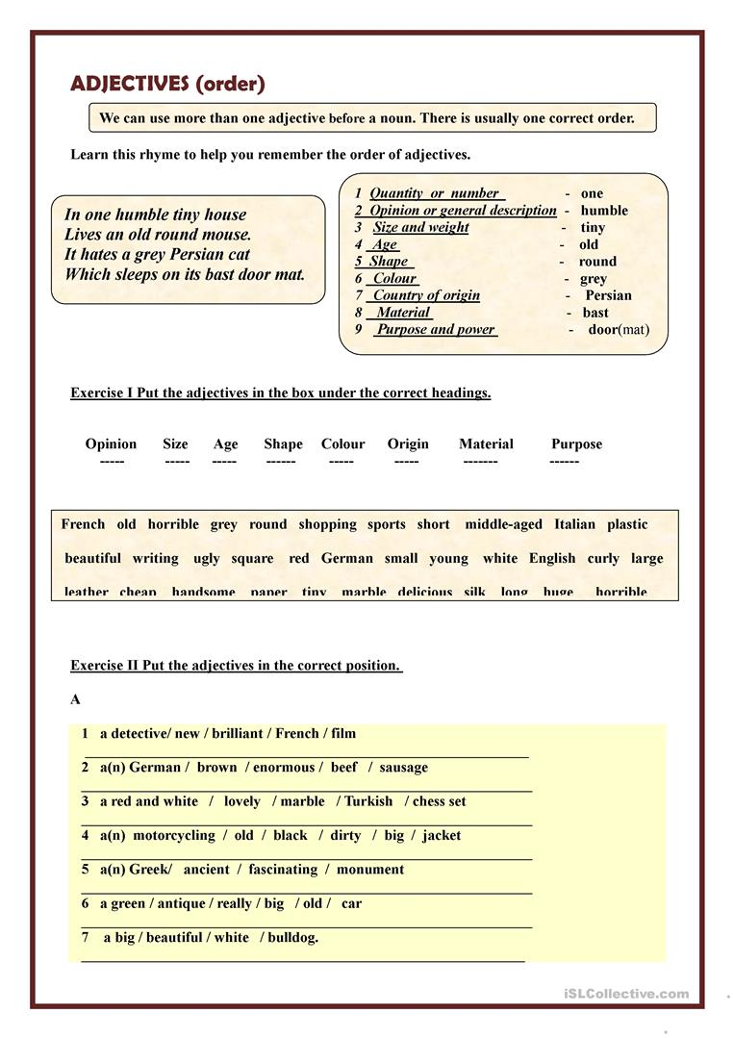

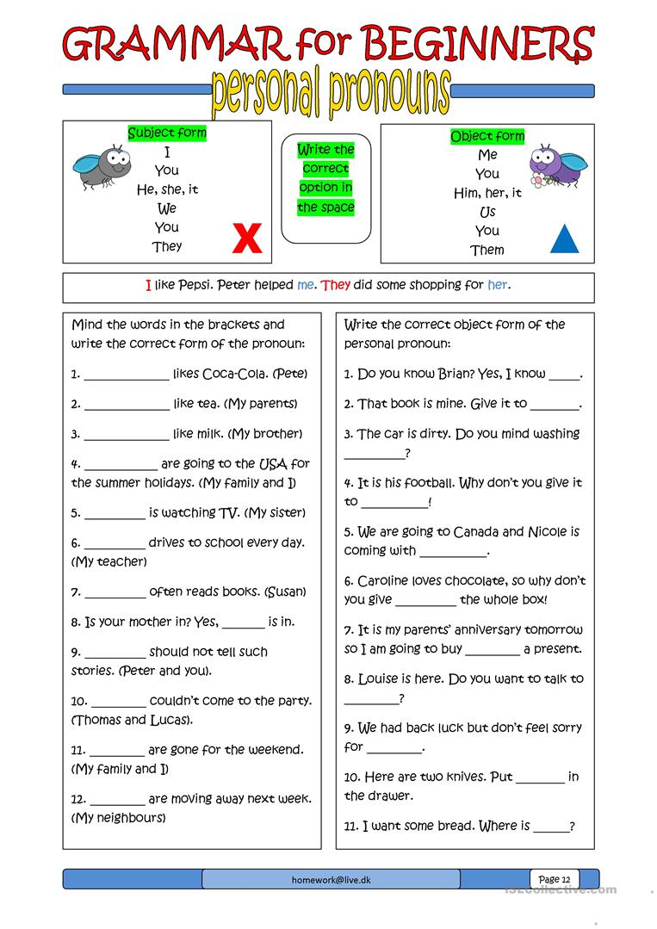

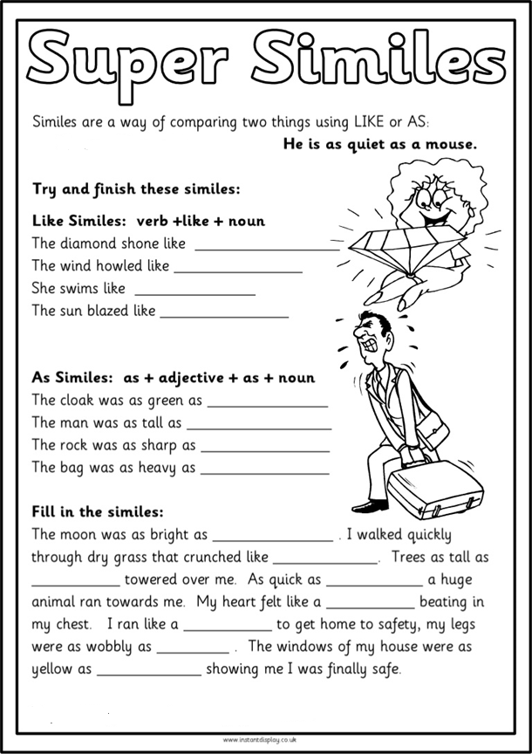

|  |  |  |  |  |
| --- | --- | --- | --- | --- |
| **Rubric:** | **Ex.** | **Go.** | **Sat.** | **NI** |
| **Content Accuracy** | **1** | **2** | **3** | **4** |
| **Creativity** | **1** | **2** | **3** | **4** |
| **Completeness** | **1** | **2** | **3** | **4** |
| **Neatness** | **1** | **2** | **3** | **4** |
| **1-Excellent 2- Good 3- Satisfactory**  **4- Needs improvement** | | | | |