**Pakistan School , Kingdom of Bahrain**

**E- Support and Learning Material / Session 2020-2021**

**Subject: English Grade : 11**

**English Textbook-11**

**Unit 1.3: September , the First Day of School – Howard Nemerov**

**ParaphrasingL**

**Stanza 1:**

**(My child and I ....... time letting go)**  
My son and I proceed to school holding each other's on the way. And when I leave him at door of first grade classroom, he cries for a while. BUT he is brave and bold. He let me go. My selfish tears remind me how bitterly I had wept before the same door long time ago. I may have tough time to leave my son in school.

**Stanza 2:**

**(Each fall the children ...... down before it)**  
The children have to get trough and face whatever goes on in the school together, either good or bad. Every child has to tolerate his or her difficulties alone. Learning is very valuable but not easy It is unconditional to learn the alphabets (a. b, c) and the figures (1, 2, 3). There are twenty six alphabets and ten digits.  
  
Beside these a number of other things, either visible or cannot be seen. The process of learning is random and so commanding that seen and unseen worlds are bow before it.

**Stanza 3:**

**(As Joseph's dream ...... of it in the end)**  
As Joseph saw in a dream that bundle of wheat and stars are bowed down to him. He was a little boy at that time. When his brothers came to know his dream, all of them began to hate him. The greater part of his life spend to fix the complicated relations.

**Stanza 4:**

**(My child has disappeared ......... not need to know)**  
My son has disappeared behind the door of classroom. Should I hope to live to see him coming out after completing his school. Maybe it take years but I know what I wish him to be. I am not sure about his outcome of success. I hope that my son will find father-like figures among his teachers who will take care of him. I do not know how he will look and I do not need to know.

**Stanza 5:**

**(Even our tears ..... in the end)**  
Even the tears that we shed lack true spirit and sincerity. It is just a custom. I pray that great kindness may come of it in the end.

**Questions and Answers:**

**Q.1. How does the allusion to Joseph in this poem enrich the meaning of the poem?**  
**Ans:** The poet refers to the dream of the Prophet Joseph who suffered a lot at the hands of his real brothers. But at last great kindness and success came of it in the end. In the same way, the father hopes for great kindness for his son whom he leaves at the gate of the school.

**Q.2. What were the feelings of the father taking his son to school?**  
**Ans:** The father is a little worried about his son. He thinks that he would leave his son alone. He remembers his own childhood and the first day his father left him at school. He too cried. The poet then hopes for the best for his son. He is optimistic that his son will find a friendly environment at school.  
**Q.3. What are the writer's views about learning?**  
**Ans:**The writer thinks that learning is valuable but difficult. It is unconditional to learn alphabets and the numbers. The process of learning is random and you have to command both visible and invisible things. The children must tolerate the hardships in order to learn in real sense.  
**Q.4. What did Joseph see in his dream and what was his brothers' reaction to his dream?**

**Ans:**Joseph saw that bundle of wheat and stars are bowed down to him. When his brothers came to know his dream, they began to hate him. They were actually jealous of his bright fate. For the rest of the life, Joseph kept trying to fix the complicated relations.  
**Q.5. What were the feelings of the father after leaving his son in school?**  
**Ans:**The father hopes for success and kindness for his son. When his son had disappeared behind classroom doors, he wishes for his success. He prays that he must live to see his son completing his studies. He hopes that he finds helpful and friendly teachers in the school.

**Q.6. Why the first day of school is special for both the child and the parents?**  
**Ans:** The first day of is special for the child because the deep attachment with parents will not allow him to part from his parents. The child is not ready to see off his parents whom he loves and who loves him. The parents have the same feelings. They find it hard to leave their children alone at school away from their eyes. That's is why the first day is the day of feelings and emotions.  
  
**Q.7. What should be the role of the teachers for first-day students?  
Ans: The teachers should treat them kindly and affectionately. The teachers should show fatherly feelings to them. The first day is the day of trial for both the child and the teacher. As the parents hope for a friendly environment, the teachers should handle the feelings and attitudes of new students with love and affection.**

**WORKSHEET**

**Read the stanza and answer the following questions:**

**My child has disappeared**

**Behind the schoolroom door. And should I live**

**To see his coming forth, a life away,**

**I know my hope, but do not know its form**

**Nor hope to know it . May the fathers he finds**

**Among his teachers have a care of him.**

**Questions:**

**1. Where has the child disappeared?**

**2. What kind of teachers the father hopes for his child?**

**3. Name the poem from which this stanza has been extracted. Name the poet also.**

**Grammar: Present Indefinite Tense**



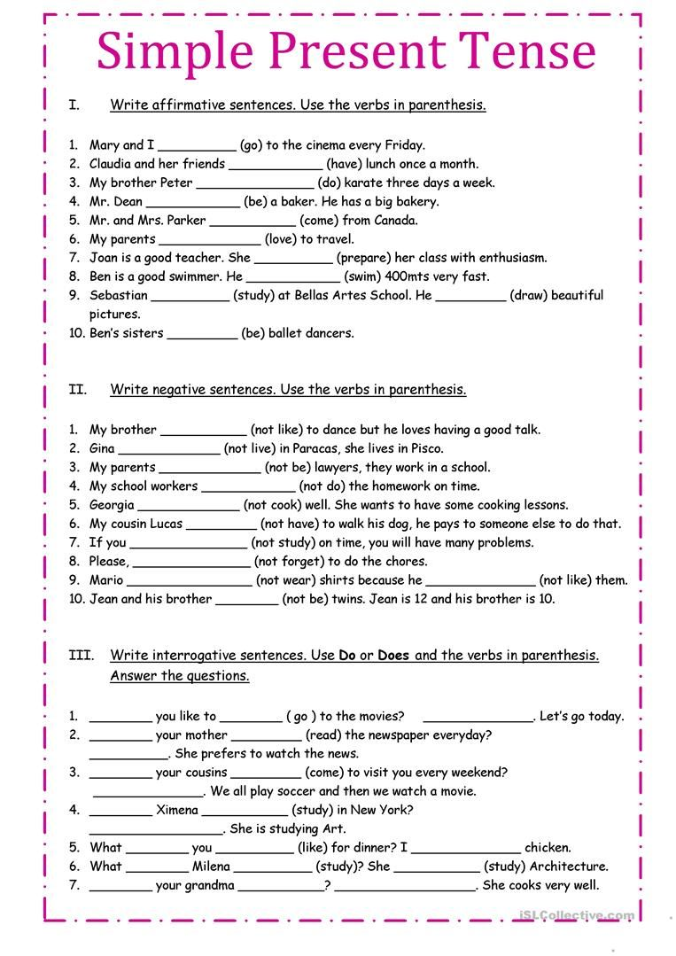

|  |  |  |  |  |
| --- | --- | --- | --- | --- |
| **Rubric:** | **Ex.** | **Go.** | **Sat.** | **NI** |
| **Content Accuracy** | **1** | **2** | **3** | **4** |
| **Creativity** | **1** | **2** | **3** | **4** |
| **Completeness** | **1** | **2** | **3** | **4** |
| **Neatness** | **1** | **2** | **3** | **4** |
| **1-Excellent 2- Good 3- Satisfactory**  **4- Needs improvement** | | | | |