

**PAKISTAN SCHOOL , KINGDOM OF BAHRAIN.**

**E-Support and Learning Material/Session 2020-2021**

**Subject: English Grade: 2**

**TOPIC: VERB ( DEFINITION )**

**Activity**

**Q: Look at the pictures and write a verb under each picture.**

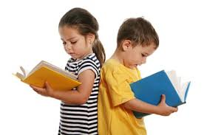 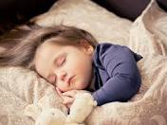 

read

write

sleep

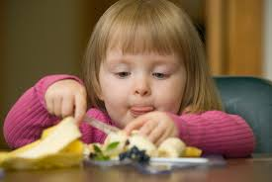 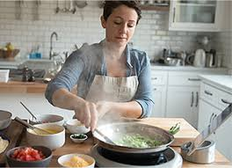 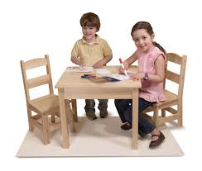

sit

cook

eat

**TEXT BOOK PAGE (26)**

**Q: Choose verbs from box which go with each noun.**

|  |  |  |  |  |  |  |  |
| --- | --- | --- | --- | --- | --- | --- | --- |
| **sings** | **jumps** | **speeds** | **falls** | **brakes** | **travels** | **runs** | **swerves** |



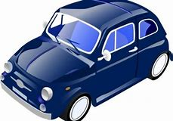

**s**

**Q: Read these sentences carefully and underline the verbs.**

1: They **run** very fast .

2: He **cooks** delicious food .

3: We **play** in the garden .

4: I **read**  my English book .

5: You **go** to hospital .

**PAKISTAN SCHOOL , KINGDOM OF BAHRAIN**

**E-Support and Learning Material/Session 2020-2021**

**Subject: English Grade: 2**

**Topic: Verb ACTIVITY**

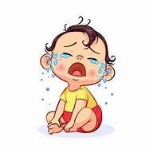**Q: Match the pictures with the correct verb.**

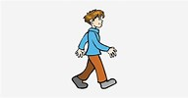

drink sit

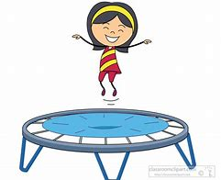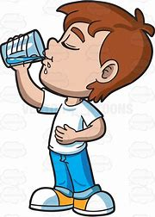

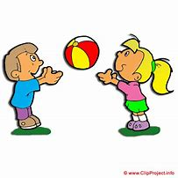 play walk

cry jump

**Q: Encircle the verbs from given sentences.**

1: They go to market.

2: He drinks water.

3: I like to eat an apple.

4: You write a letter.

|  |  |  |  |  |  |
| --- | --- | --- | --- | --- | --- |
| **eat** | **write** | **laugh** | **sing** | **fight** | **sleep** |

**Q: Find the given verbs.**

|  |  |  |  |  |  |  |
| --- | --- | --- | --- | --- | --- | --- |
| **p** | **r** | **o** | **s** | **i** | **n** | **g** |
| **m** | **f** | **p** | **g** | **h** | **d** | **k** |
| **n** | **i** | **l** | **c** | **s** | **b** | **j** |
| **d** | **g** | **w** | **r** | **i** | **t** | **e** |
| **e** | **h** | **c** | **v** | **b** | **n** | **m** |
| **a** | **t** | **l** | **a** | **u** | **g** | **h** |
| **t** | **u** | **d** | **b** | **h** | **j** | **x** |
| **s** | **l** | **e** | **e** | **p** | **o** | **h** |

|  |  |  |  |  |
| --- | --- | --- | --- | --- |
| **Rubric:** | **Ex.** | **Go.** | **Sat.** | **NI** |
| **Content Accuracy** | **1** | **2** | **3** | **4** |
| **Creativity** | **1** | **2** | **3** | **4** |
| **Completeness** | **1** | **2** | **3** | **4** |
| **Neatness** | **1** | **2** | **3** | **4** |
| **1-Excellent 2- Good 3- Satisfactory**  **4- Needs improvement** | | | | |



**PAKISTAN SCHOOL , KINGDOM OF BAHRAIN.**

**E-Support and Learning Material/Session 2020-2021**

**GRAMMAR CLUB Unit: 5 Next to,between,in front of and behind Grade: 2**

