**Pakistan School, Ministry of Education, Kingdom of Bahrain**

**E- Support and Learning / April 2020**

**1st term English notes – STUDENT BOOK - Grade 3**

**LESSON 4: THE MAD HATTER’S TEA PARTY**

**Vocabulary Words**

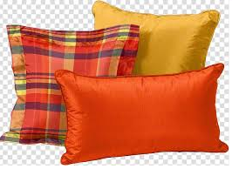 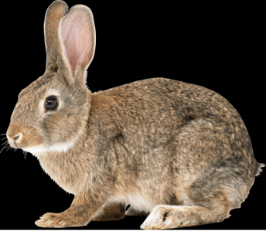

**c – u –s – h – I – o - n h-a-r-e**

**cushion hare**

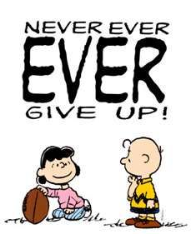 

**e – n – c – o – u – r –a – g - e c – r – o – w – d – e - d**

**encourage crowded**

 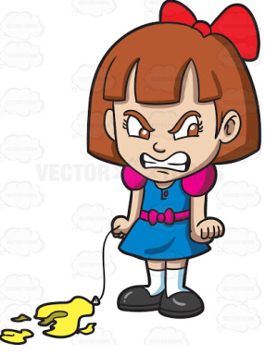

**a – r – m – c – h – a – I - r i – n – d – i – g – n – a – n – t – l - y**

**armchair indignantly**

**Practice dictation sentences**

1. The table was set out under a tree.
2. Alice spoke indignantly.
3. She sat down in a large armchair.

|  |  |  |
| --- | --- | --- |
|  | **WORD** | **MEANINGS** |
| 1 | Uncomfortable | not easy |
| 2 | plenty | many |
| 3 | indignantly | angrily |
| 4 | encourage | to give support |
| 5 | remark | to say something |

|  |  |  |
| --- | --- | --- |
|  | **WORD** | **SENTENCES** |
| 1 | uncomfortable | I was uncomfortable in the car. |
| 2 | plenty | I have plenty of toys. |
| 3 | indignantly | The rich man was talking indignantly. |
| 4 | encourage | We should encourage people to do good. |
| 5 | remark | The teacher gave good remarks about the class. |

**Comprehension Skills : Questions and answers, Pg - 17**

1. Where were the mad hatter and the March hare having tea?

Ans : They were having tea on a table set out under a tree in front of the house.

1. Where was the dormouse?

Ans : He was sleeping between the Mad Hatter and the March hare.

1. What did the March Hare offer to Alice?

Ans : He offered Alice some juice.

1. Why was this an odd thing to do?

Ans : It was odd because there was no juice on the table.

1. What do you think Alice thought about the March hare and his friends?

Ans : I think Alice thought of them as very odd.

**Antonyms (Pg 17)**

Which word in brackets is the antonym of these words?

1. rough (cold, **smooth**, heavy, hard)
2. large (dirty, full, big, **small)**
3. wide (**narrow**, fat, round, large)
4. fast (quick, speed, **slow**, follow)

**Dictionary Work**

Ex A:

1. little, leaf, lamb

lamb, leaf, little

1. Alice, ant, Africa

Africa, Alice, ant

1. mouse, meal, make, mice

make, meal, mice, mouse

1. elephant, escape, eat, enemy

eat, elephant, enemy, escape

Ex B:

1. grain, goat, house, hill

goat,grain,hill,house

1. sheep, ox, hare, horse, owl

hare,horse,owl, ox, sheep

1. barn, high, hay, dip, bucket

barn, bucket, dip, hay, high

**Subject: English WORKSHEET GRADE:3**

**Lsn 4: The Mad Hatter’s Tea Party (Pg 16)/ Activity 1**

**Color the picture and list down the characters of the story.**

**Characters of the story**

1. __________________ 2. ____________________

3. __________________ 4._____________________

1. __________________

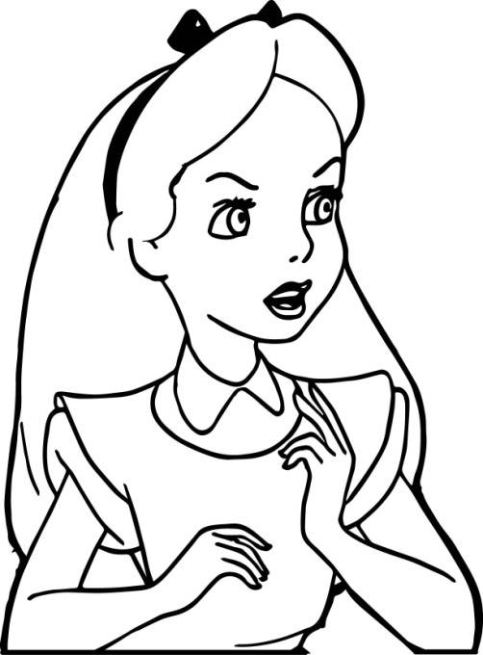 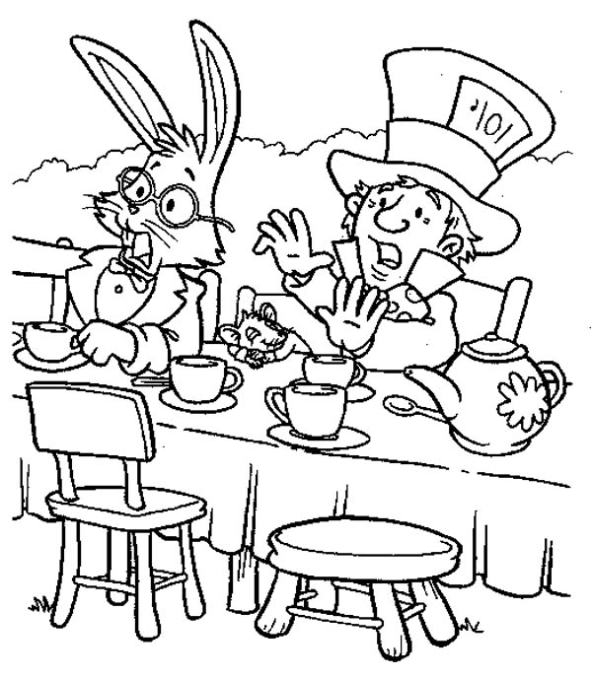

Q1: Match the words with their suitable meanings.

|  |  |  |  |
| --- | --- | --- | --- |
| SN | Words |  | Ans |
| 1 | uncomfortable | with anger |  |
| 2 | crowded | a lot of |  |
| 3 | Plenty | not easy |  |
| 4 | indignantly | filled with/ little or no space left |  |

Q2: Who was sitting between the Mad Hatter and March Hare? ________________________

Q3: Alice never talked indignantly. True or False? _____________________

Q4: Did they offer tea or juice to Alice? _______________

Q5: Were the Mad Hatter and March Hare happy to have Alice at their table? _________________

|  |  |  |  |  |
| --- | --- | --- | --- | --- |
| **Rubric:** | **Ex.** | **Go.** | **Sat.** | **NI** |
| **Content Accuracy** | **1** | **2** | **3** | **4** |
| **Creativity** | **1** | **2** | **3** | **4** |
| **Completeness** | **1** | **2** | **3** | **4** |
| **Neatness** | **1** | **2** | **3** | **4** |
| **1-Excellent 2- Good 3- Satisfactory**  **4- Needs improvement** | | | | |