

**Pakistan School, Kingdom of Bahrain**

**E- Support and Learning Material / Session 2020-2021**

**Subject: English Grammar (Worksheet: 1) Grade: 4th**

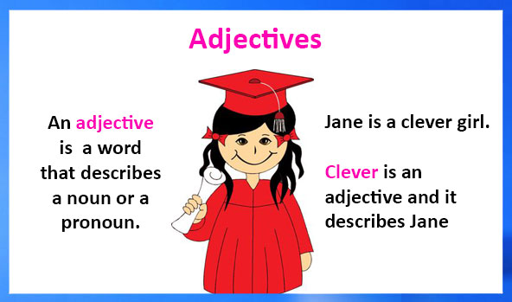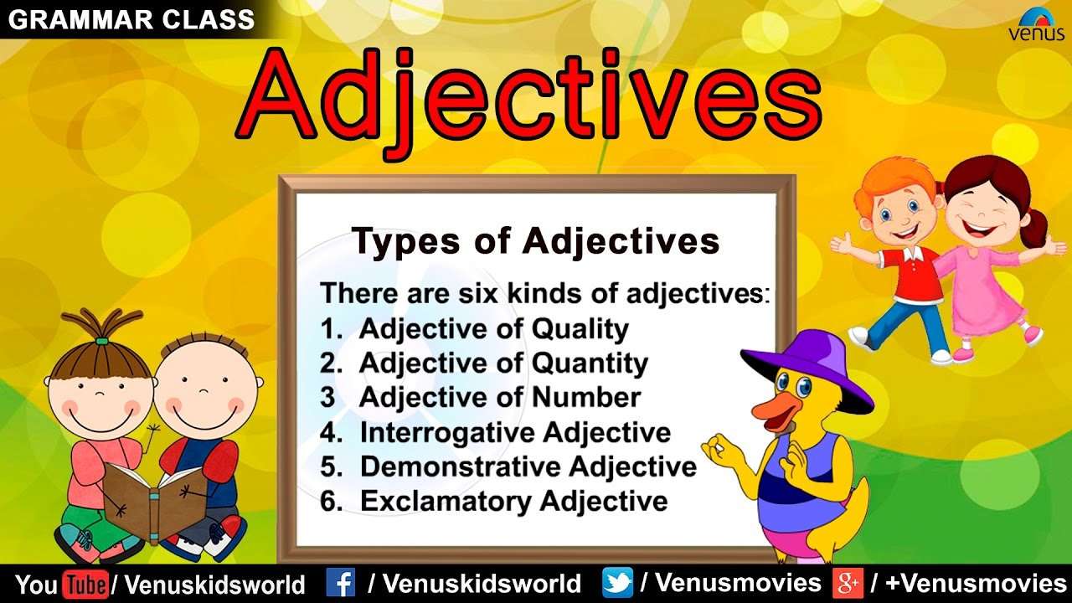**Topic: Adjectives FIRST TERM**

Q1. Fill in the blanks with the list of adjectives provided.

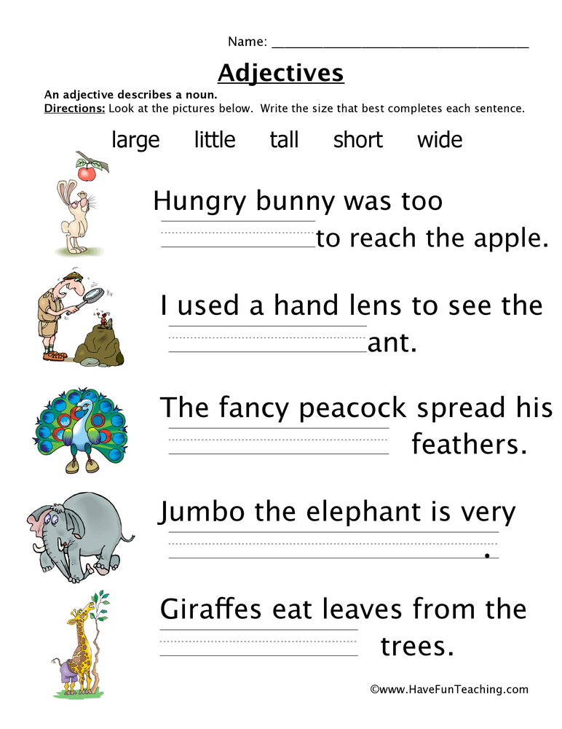

Q2. Fill in the blanks with adjectives of quantity

1. I have _________eyes.
2. _________children were in the park.
3. I read ______stories from the book.
4. She made only ________mistake.
5. Our school won the __________prize.

**Q3. Fill in the blanks with the adjectives of quality from the help box**

**Old pretty intelligent strong clever**

1. I have a _____________dress.
2. Ali is an _____________ boy.
3. He lives in an ___________house.
4. A ________ man lifted the old lady to help her.
5. My boss is a ___________person.



|  |  |  |  |  |
| --- | --- | --- | --- | --- |
| **Rubric:** | **Ex.** | **Go.** | **Sat.** | **NI** |
| **Content Accuracy** | **1** | **2** | **3** | **4** |
| **Creativity** | **1** | **2** | **3** | **4** |
| **Completeness** | **1** | **2** | **3** | **4** |
| **Neatness** | **1** | **2** | **3** | **4** |
| **1-Excellent 2- Good 3- Satisfactory**  **4- Needs improvement** | | | | |

**English Worksheet: 2 Topic: Adjectives Grade: 4th**

Q2.Write Demonstrative Adjectives for the following sentences.

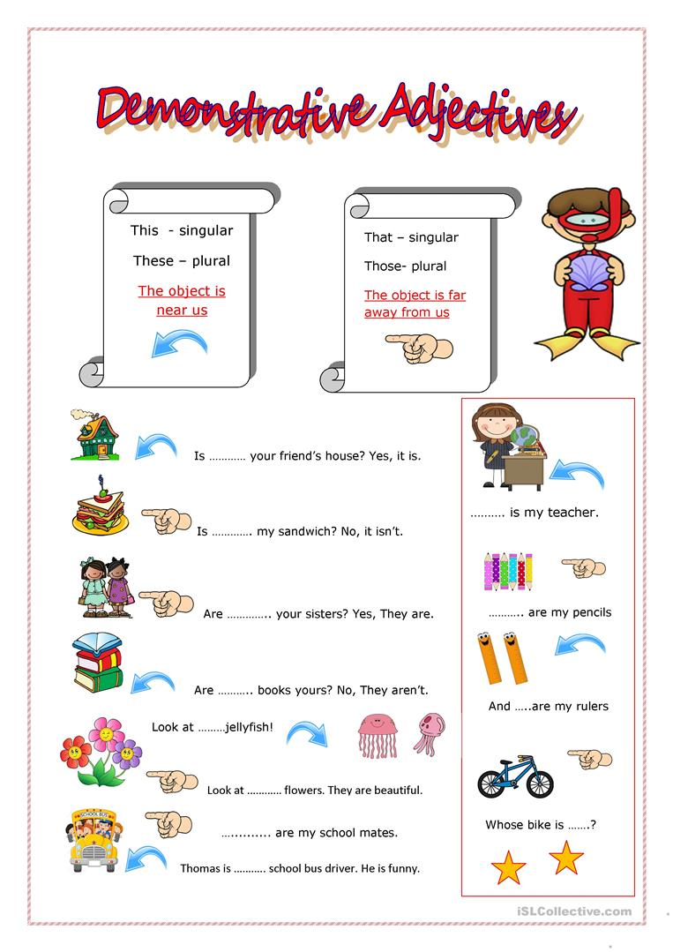



|  |  |  |  |  |
| --- | --- | --- | --- | --- |
| **Rubric:** | **Ex.** | **Go.** | **Sat.** | **NI** |
| **Content Accuracy** | **1** | **2** | **3** | **4** |
| **Creativity** | **1** | **2** | **3** | **4** |
| **Completeness** | **1** | **2** | **3** | **4** |
| **Neatness** | **1** | **2** | **3** | **4** |
| **1-Excellent 2- Good 3- Satisfactory**  **4- Needs improvement** | | | | |