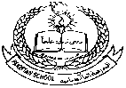**Pakistan School , Kingdom of Bahrain**

**E- Support and Learning Material / Session 2020-2021**

**Subject: English Grade : 4**

**Grammar FIRST TERM Paragraph writing (Worksheet)**

Write a paragraph on “Pyramids” using the given information. Your paragraph should include at least eight sentences.

* Main topic: Pyramids
* Triangular, made up of blocks
* One of the 7 wonders of the world
* Found in Egypt, built in deserts
* Over 4000 years old
* Built to be tomb

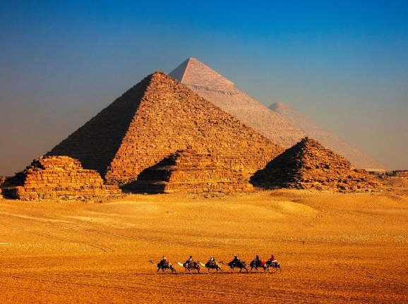

______________________________________________________________________________________________________________________________________________________________________________________________________________________________________________________________________________________________________________________________________________________________________________________________________________________________________________________________________________________________________________________________________________________________________________________________________________

|  |  |  |  |  |
| --- | --- | --- | --- | --- |
| **Rubric:** | **Ex.** | **Go.** | **Sat.** | **NI** |
| **Content** | **1** | **2** | **3** | **4** |
| **Vocabulary** | **1** | **2** | **3** | **4** |
| **Organization** | **1** | **2** | **3** | **4** |
| **Capitals and Punct.** | **1** | **2** | **3** | **4** |
| **Completeness** | **1** | **2** | **3** | **4** |
| **1-Excellent 2- Good 3- Satisfactory**  **4- Needs improvement** | | | | |

**Pakistan School , Kingdom of Bahrain**

**E- Support and Learning Material / Session 2020-2021**

**Subject: English Grade : 4**

**Grammar FIRST TERM**

**Comprehension**

**Worksheet**

**QI. Read the passage and answer the following questions.**

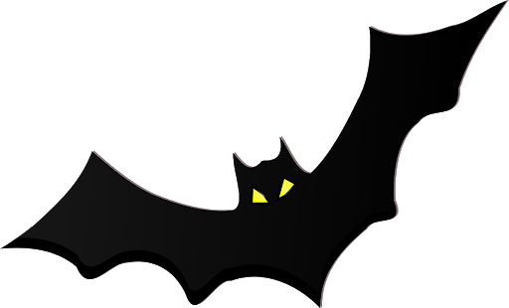 **Bats and Birds**

**Both bats and birds can fly. You might see them on a rooftop.**

**In other ways, bats and birds are very different.**

**Birds have feathers. Bats have fur.**

**Birds have beaks. Bats have teeth.**

**Bats hang upside-down when they rest.**

**Birds never do that!**

**Bats and birds are very easy to tell a part**

**When they are not flying.**

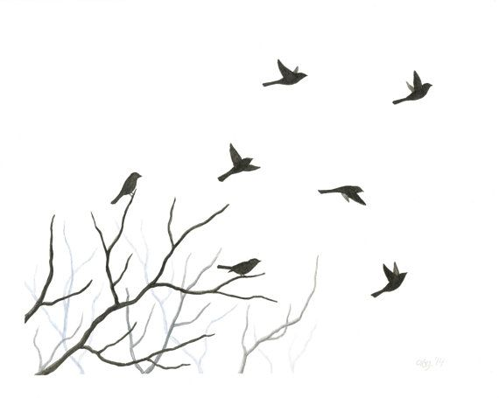

**Q1. Write true or false for the given statements.**

1. Both birds and bats cannot fly. ( )

2. Birds have beak. ( )

3. Bats hang upside down. ( )

**Q2. Read the passage and complete the sentences.**

1. Both bats and birds can ___________________.
2. Bats hang ________________________ when they rest.
3. Birds have beaks. Bats have _____________.

**Q3. How bats and birds are different from each other?**

Ans: ____________________________________________________________________________

_______________________________________________________________________________

|  |  |  |  |  |
| --- | --- | --- | --- | --- |
| **Rubric:** | **Ex.** | **Go.** | **Sat.** | **NI** |
| **Content Accuracy** | **1** | **2** | **3** | **4** |
| **Creativity** | **1** | **2** | **3** | **4** |
| **Completeness** | **1** | **2** | **3** | **4** |
| **Neatness** | **1** | **2** | **3** | **4** |
| **1-Excellent 2- Good 3- Satisfactory**  **4- Needs improvement** | | | | |