**Pakistan School , Kingdom of Bahrain**

**E- Support and Learning Material / Session 2020-2021**

**Subject: English Grade : 6th**

**Book: Grammar FIRST TERM**

**Simple Future Tense**

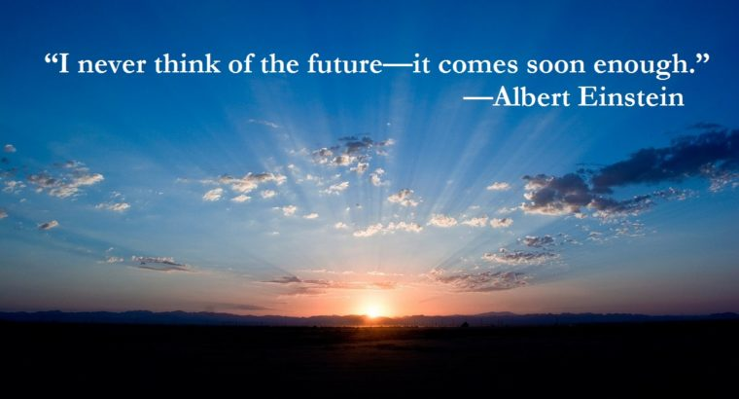

The simple future is a verb tense that’s used to talk about things that haven’t happened yet.

Example:- This year, Jen **will read** *War and Peace*. It **will be** hard, but she’s determined to do it.

Use the simple future to talk about an action or condition that will begin and end in the future.

## **How to Form the Simple Future**

The formula for the simple future is **will + [root form of verb]**.

Example:- I will learn a new language. Jen will read that book. My brothers will sleep till noon if no one wakes them up. You will see what I mean.

It doesn’t matter if the subject is singular or plural; the formula for the simple future doesn’t change.

**But…**

There is another way to show that something will happen in the future. It follows the formula **[am/is/are] + going to + [root form verb]**.

Example :- I am going to learn a new language. Jen is going to read that book. My brothers are going to sleep till noon if no one wakes them up. You are going to see what I mean.

The “going to” construction is common in speech and casual writing. Keep in mind though that it’s on the informal side, so it’s a good idea to stick to the **will + [root form]** construction in formal writing.

## **How to Make the Simple Future Negative**

To make the simple future negative, the formula is **will + not + [root form]**.

Example:- Jen will not quit before she reaches her goal. Make sure you arrive on time tomorrow because the bus will not wait for you. He will not say anything bad about his boss. I will not finish my homework in time for class.

Using the “going to” construction, the formula is **[am/is/are] + not + going to + [root form]**.

Example:- Jen is not going to quit before she reaches her goal. Make sure you arrive on time tomorrow because the bus is not going to wait for you. He is not going to say anything bad about his boss. I am not going to finish my homework in time for class.

## **How to Ask a Question:-**

To ask a question in the simple future, the formula is **will + [subject] + [root form]**.

Example:- Will Jen finish War and Peace over the summer? Will I have the discipline to study Spanish every day? What will you buy with the money you found?

The formula for the “going to” construction is **[am/is/are] + [subject] +going to + [root form]**.

Example:- Is Jen going to finish War and Peace over the summer? Am I going to have the discipline to study Spanish every day? What are you going to buy with the money you found?

## **Common Verbs in the Simple Past**

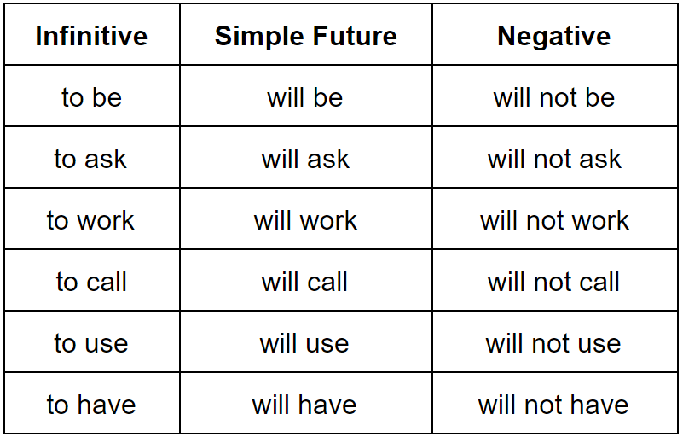

## **The “Going to” Construction**

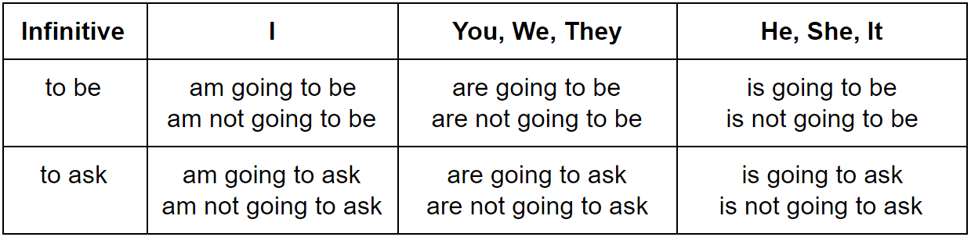

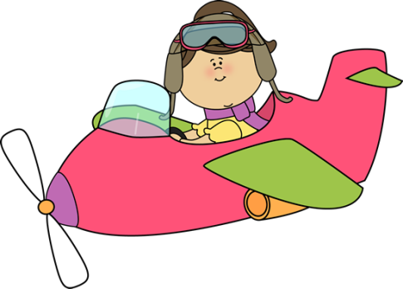

will or going to

Circle the correct answer

1. Oh look! It **is going to/ will** snow soon.

2. Next summer I **am going to/ will** backpack around Europe.

3. Ring! Ring! **I am going to/ I’ll** answer it.

4. I think our team **is going to/ will** win the match.

5. In 2055 robots **are going to/ will be** our teachers.

6. Tonight we **are going to have/ will have** a birthday party for my brother.

7. Sponge Bob **is going to/ will work** at the Crabby Patty tonight.

8. My friends **are going to/ will go** to the movies tonight.

9. I doubt that he **is going to/ will pass** the English test.

10. He **is going to/ will study** for the test tomorrow.

Fill in will or the correct form of be going to

1. Next Saturday we _________________ (attend) an NBA game.

2. I think the game ____________ (be) at the Olympic arena.

3. My father __________________(buy) tickets tonight.

4. _________ the Miami Heat _________ (win) the championship?

5. The weather ___________(be) dreadful tomorrow. But I doubt that it _____________(snow) in June.

6. We use the word(s) ________________ when we want to talk about predictions.

7. In 300 years people __________________ (travel) with flying cars instead of airplanes.

8. We use the word(s) _______________ when we offer to help someone.



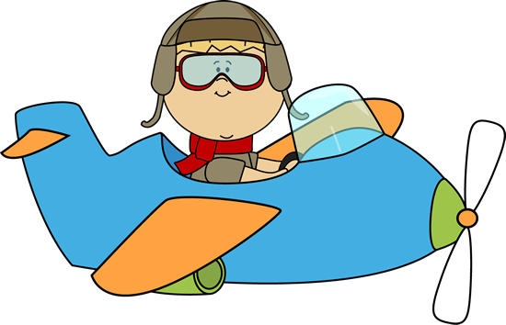

Yes or no

1. **will** is used for plans _______________

2. **will** is used for predictions ______________

3. **am going to** is used for plans ____________

4. **will** is used for offers of help ____________

**Simple Future**

**2. Negate the following sentences.**

1. We will travel to the Mars.

2. Bob will have lunch with me tomorrow.

________________________

3. I will play football with you.

________________________

4. Mr Green will work in a library.

________________________

5. They will have a party next week.

________________________

**1. Put the verbs in brackets into Simple Future Tense.**

1. Jack___________ to the cinema. (go)

2. Sandy___________ a novel. (write)

3. I___________ a famous singer. (become)

4. My friends___________ an exam next week. (have)

5. Jane___________ to school tomorrow. (go)

**3. Put the words into the correct order.**

1. go out / will / you / tonight ?

___________________

2. Ben / tomorrow /go dancing / will ?

___________________

3. in June / get married / they / will .

4. next week / won’t / it / be cold .

__________________

5. by car / she / travel / will ?

_______________________

**4. Answer the following questions.**

**(☺ = yes, ☹ = no)**

1. Will John be famous?

_________________2. Will you go to the zoo?

_________________

3. Will Jenny do the washing-up?

4. Will your friends come tonight?

5. Will it snow tomorrow? ☹

_________________

|  |  |  |  |  |
| --- | --- | --- | --- | --- |
| **Rubric:** | **Ex.** | **Go.** | **Sat.** | **NI** |
| **Content Accuracy** | **1** | **2** | **3** | **4** |
| **Creativity** | **1** | **2** | **3** | **4** |
| **Completeness** | **1** | **2** | **3** | **4** |
| **Neatness** | **1** | **2** | **3** | **4** |
| **1-Excellent 2- Good 3- Satisfactory**  **4- Needs improvement** | | | | |