**Pakistan School , Kingdom of Bahrain**

**E- Support and Learning Material / Session 2020-2021**

**Subject: English Grade : 7**

**Book: Student Book 3 FIRST TERM**

**Unit 3**

**Fire in the night…**

**Pg. No: 46 to 47.**

**Q.1 Vocabulary Words. Page 48.**

|  |  |  |
| --- | --- | --- |
| Grinned | Impressed | Mentioned |
| Especially | Chuffed | Wrapped |
| Paralysed | Terrifying | Withered |

**Q.2 Words Meanings. Page**

|  |  |  |
| --- | --- | --- |
| **No.** | **Words** | **Meanings** |
| **1** | grinned | smiled stupidly |
| **2** | impressed | strongly affected |
| **3** | especially | particularly |
| **4** | chuffed | displeased |
| **5** | terrified | frightened |

**Q.3. Words sentences. Page 48**

|  |  |  |
| --- | --- | --- |
| **No.** | **Words** | **Sentences** |
| 1 | grinned | The girl grinned at her friend for her own foolish mistake. |
| 2 | impressed | Teacher was impressed by the student who gave an inspirational speech. |
| 3 | especially | I love to eat chocolates especially when it comes to my favorite one. |
| 4 | chuffed | I really get chuffed on certain things. |
| 5 | paralyzed | Paralysed people are usually strong and determined |
| 6 | terrifying | This dream of mine was terrifying. |

**Q.4 Comprehension. Page.47**

**COMPREHENSION**

**Write 'True or' False for each of these statements.**

1. **The narrator and his mum looked at the bag of fireworks. *F.***
2. **Norbert, Barry and Tony came to look at the fireworks. T.**
3. **Norbert suggested they light a sparkler. T.**

**4.The bonfire was on Tuesday. F.**

**5.Barry stamped on the fireworks. T.**

**Q. 5 Answer the questions. Page . 48**

**B. Q1. How did the boys know the narrator was at home?**

**A. The boys knew the narrator was at home because they saw his mother going out alone. And she said to the boys that he was at home.**

**Q.2.Five types of fireworks are named in the extract. What are they?**

1. **Dive bombers**
2. **Rockets**
3. **Electric storms**
4. **Sparklers**
5. **Bangers**

**Q3. What did the boys :**

1. **see when the fireworks went off?**
2. **hear when the fireworks went off?**
3. **They saw lots of bright colors.**
4. **Sparks were shooting up to the ceiling.**

**Q4. How did each of the boys react when the friends went off?**

1. **The reaction of the boys was terrified.**

**Q5. Explain in your own words how you think the accident happened?**

1. **The accident happened because the boys took out all the fireworks.**

**They lit one that was kept near the others.**

**SPELLING**

**HOMOPHONES *Are words which sound the same but have different spelling and different meanings.***

***E. g🤔 Did your mum buy you all these?***

***Tony stood by the door.***

**Find the HOMOPHONES in the exact for each of these words.**

|  |  |  |
| --- | --- | --- |
| **Bean** | **past tense of to be** | **been** |
| **Sore** | **Past tense of to see** | **saw** |
| **Hymn** | **Opposite of her** | **him** |
| **grate** | **Wonderful** | **great** |
| **sea** | **your eyes do this** | **see** |

**Subject: English WORKSHEET Grade: 7**

**Writing Assignment:**

***1- Write a short story which has a crisis.***

* ***You are one of the characters but you do not cause the crisis.***
* ***Write in the first person.***

***Plan your story by deciding :***

***1.What other characters are involved with you in the crisis.***

***2. What the crisis is?***

***3.How the crisis ends.?***

* **Write three paragraphs :**

***Paragraph 1:the start of the crisis.***

***Paragraph 2:the middle of the crisis.***

***Paragraph 3.the end of the crisis.***

**Hint:DON'T BEGIN EVERY SENTENCE WITH 'I'**

**Rubric:**

|  |  |  |  |  |  |
| --- | --- | --- | --- | --- | --- |
| **1- Main Idea:**  **Clear focus.**  **Writer understands**  **Task.** | | **2- Content:**  **Detail/evidence relevant to main idea.**  **Accurate Conclusion.** | **3- Organization:**  **Introduction**  **Body**  **Conclusion** | **4- Language Use:**  **Accurate**  **vocabulary.**  **Sentence form and**  **structure.**  **Coherence.** | **5- Mechanics:**  **Spelling.**  **Capitalization & Punctuation.**  **Grammar** |
| **1 /2/3/4** | | **1/2/3/4** | **1//2/3/4** | **1/2/3/4** | **1/2/3/4** |
| **1. Excellent 2. Good 3. Satisfactory 4. Needs Improvement** | | | | |

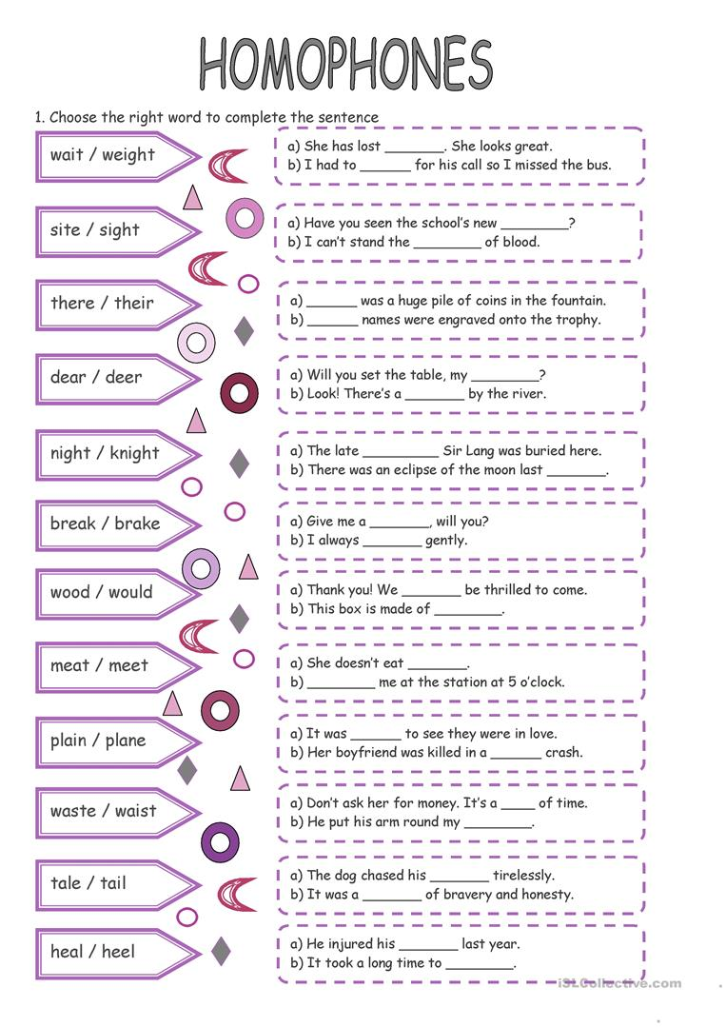

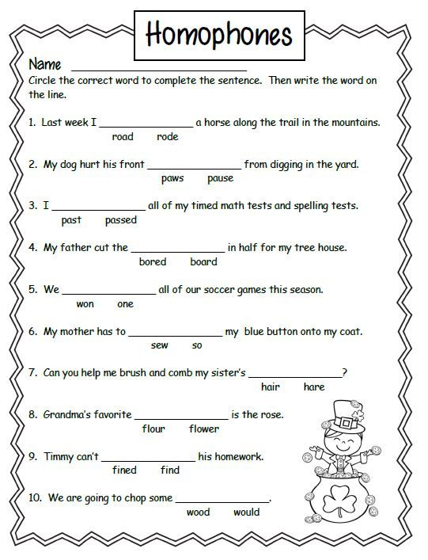

|  |  |  |  |  |
| --- | --- | --- | --- | --- |
| **Rubric:** | **Ex.** | **Go.** | **Sat.** | **NI** |
| **ContentAccuracy** | **1** | **2** | **3** | **4** |
| **Creativity** | **1** | **2** | **3** | **4** |
| **Completeness** | **1** | **2** | **3** | **4** |
| **Neatness** | **1** | **2** | **3** | **4** |
| **1-Excellent 2- Good 3- Satisfactory**  **4- Needs improvement** | | | | |