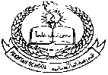

**Pakistan School , Kingdom of Bahrain**

**E- Support and Learning Material / Session 2020-2021**

**Subject: English**

**Grade : 8**

**TOPIC: Transitive & Intransitive Verbs**

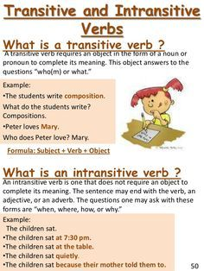

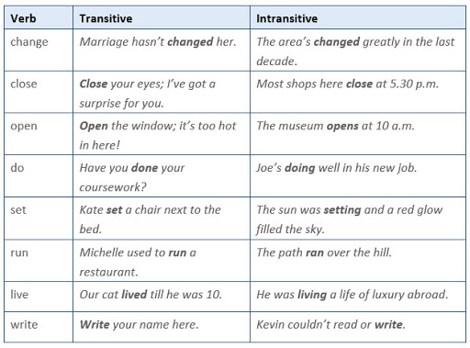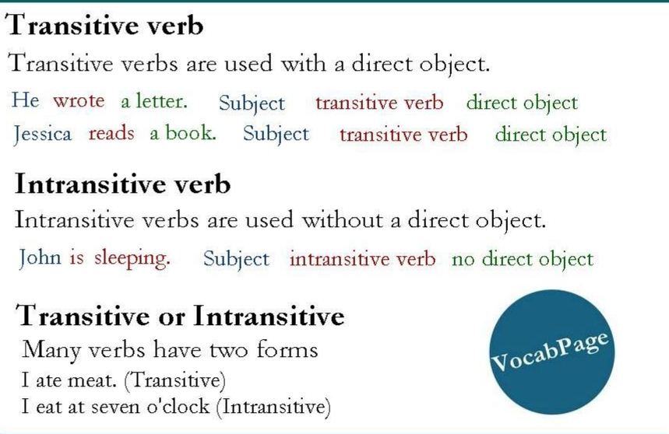

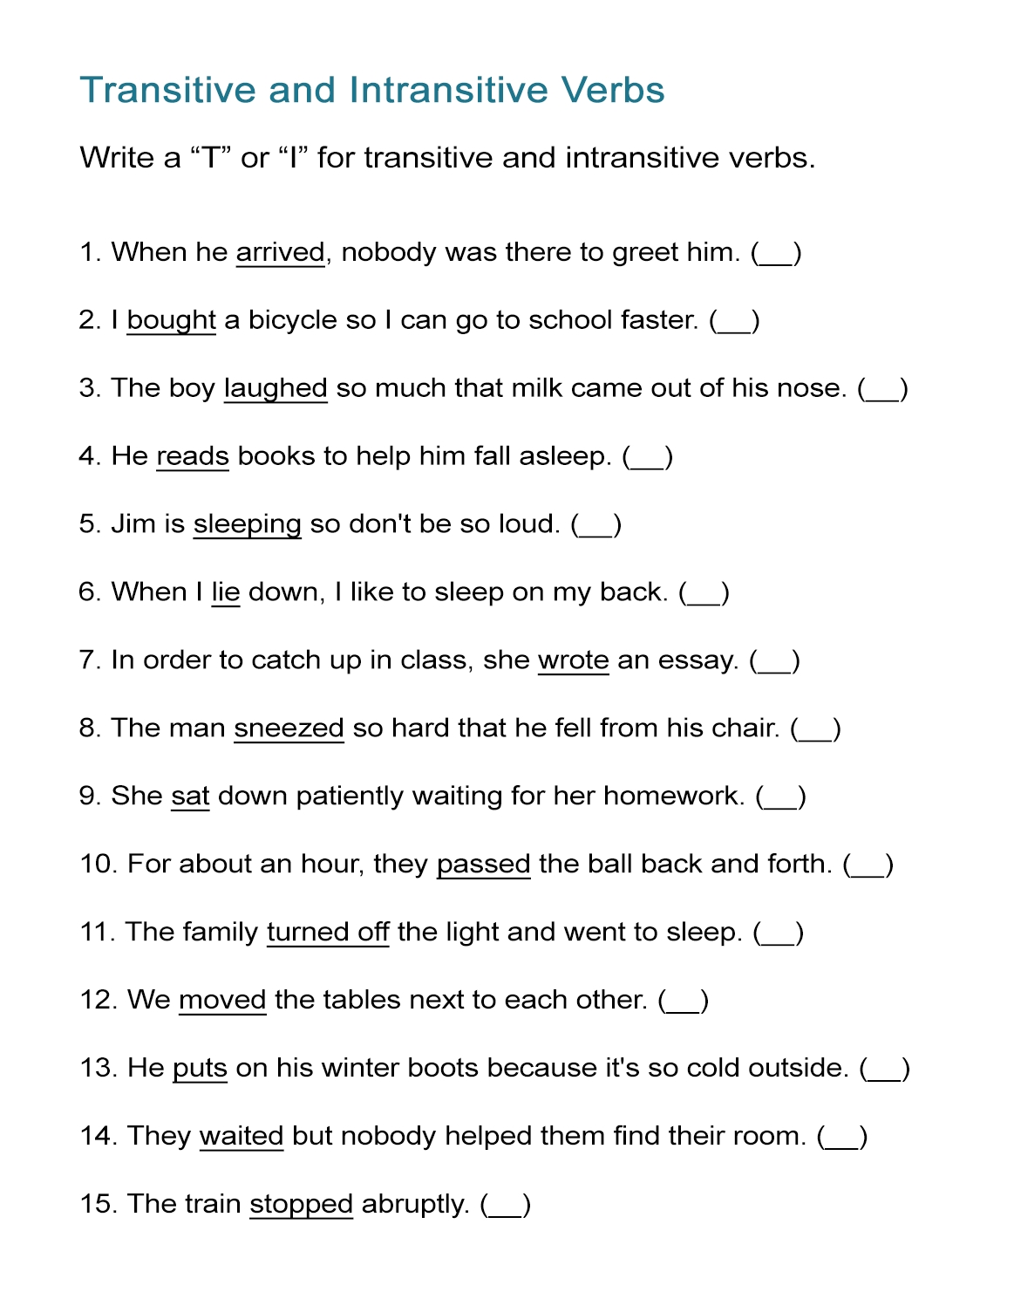

|  |  |  |  |  |
| --- | --- | --- | --- | --- |
| **Rubric:** | **Ex.** | **Go.** | **Sat.** | **NI** |
| **Content Accuracy** | **1** | **2** | **3** | **4** |
| **Creativity** | **1** | **2** | **3** | **4** |
| **Completeness** | **1** | **2** | **3** | **4** |
| **Neatness** | **1** | **2** | **3** | **4** |
| **1-Excellent 2- Good 3- Satisfactory**  **4- Needs improvement** | | | | |