**Pakistan School , Kingdom of Bahrain**

**E- Support and Learning Material / Session 2020-2021**

**Subject: English Grade : 8**

**Book: English Student BOOK 8 FIRST TERM**

# Formal and Informal Letters

[](https://keydifferences.com/wp-content/uploads/2016/08/formal-vs-informal-letter1.jpg)Letters are a form of verbal and written communication, which contains information or message, send by one party to another, to convey the message. It is sent by one party to another, to provide certain important information. There are two types of letters, i.e. formal letters and informal letters. The **formal letter** is written for business or professional purposes with a specific objective in mind. It uses simple language, that can be easy to read and interpret. On the contrary, informal letters are written to friends and relative for personal communication and uses a casual or an emotional tone. The article excerpt presents you all the important differences between formal and informal letters in a detailed manner.

**Formal Letters**

While writing a formal letter one should keep in mind the following things:

1. It should be in specified format.
2. It should avoid the use of unnecessary words.
3. It should be straight to the point.
4. It should be relevant and objective.
5. It should be complex and thorough.
6. It should be polite, even if it is a complaint letter.
7. It should be free from any mistakes, i.e. grammatical or spelling.

**Informal Letters**

1. A letter is said to be informal when it is written in a friendly manner, to someone you are familiar with.

**2** .Informal letters are used for casual or personal communication.

**3.** Informal letters are written in first, second and third person.

**4.** we use informal letters for writing letters to friends, relatives, acquaintance, etc.

**5.** informal letter, where we use short and simple sentences which are easy to interpret.

**6.** The informal letter can be concise or large.

1. Informal letters, which makes use of contraction, abbreviation, idioms, phrasal verbs and even slang and colloquial terms.

### Formal letter

1. [Letter to the editor](https://www.successcds.net/learn-english/writing-skills/letter-to-the-editor-format-cbse-class-9-10-12.html)   
   2. Letter to the Government  
   3. Letter to the police  
   4. [Letter to the principal](https://www.successcds.net/learn-english/writing-skills/application-for-school-leaving-certificate.html)   
   5.[Order letter](https://www.successcds.net/learn-english/writing-skills/order-letter-format-english-letter-writing-skills-class-x-xii.html)   
   6. [Complaint letter](https://www.successcds.net/learn-english/writing-skills/complaint-letter.html)   
   7. [Inquiry letter](https://www.successcds.net/learn-english/writing-skills/enquiry-letter-format-english-letter-writing-skills-class-x-xii.html)   
   8. Business letter  
   9. [Application letter for job](https://www.successcds.net/learn-english/writing-skills/job-application-bio-data.html)   
   10. [Letter to the Bank manager](https://www.successcds.net/learn-english/writing-skills/application-letter-bank-manager.html)   
   11.[Invitation letter](https://www.successcds.net/learn-english/writing-skills/invitation-letter-format-examples.html)   
   12. [Resignation letter](https://www.successcds.net/learn-english/writing-skills/resignation-letter.html)   
   13. [Leave Application](https://www.successcds.net/learn-english/writing-skills/leave-application.html)  
   14. [Leave Application for marriage](https://www.successcds.net/learn-english/writing-skills/leave-application-for-marriage.html)

Informal Letters

1.Letter to parents

2. Letter to siblings

3. Letter to friends

4. Letter to classmates

5. Letter to neighbours

Informal Letter

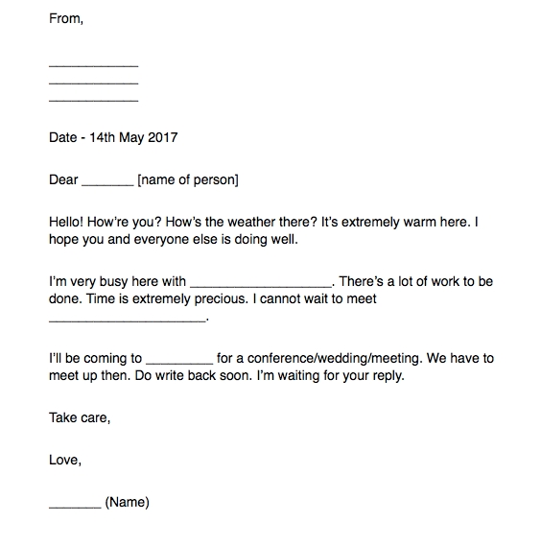

Examination Hall,

City A. B. C.

June 10,2020

When you finish writing your letter fill this checklist:

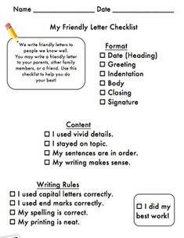

INDEFINITE TENSES – PRESENT/PAST/FUTURE

1- Present Indefinite Tense

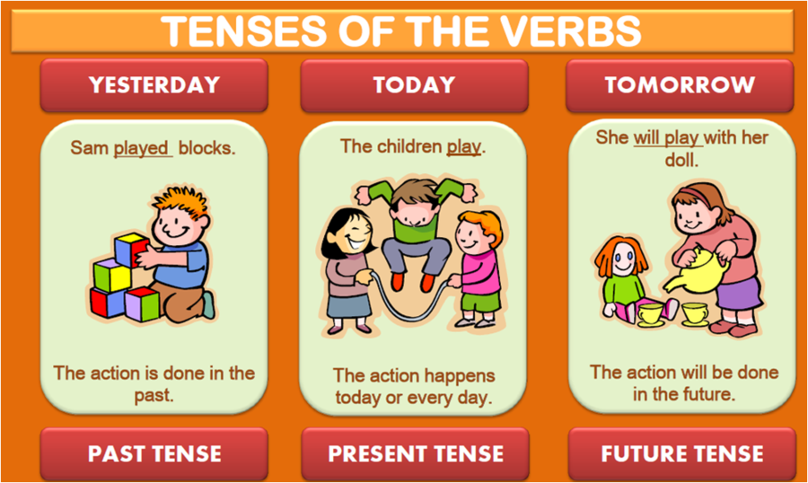

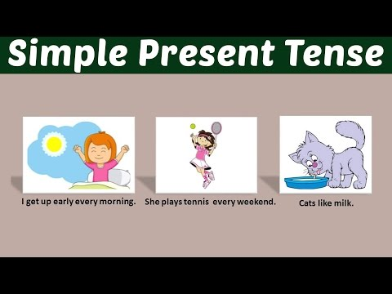

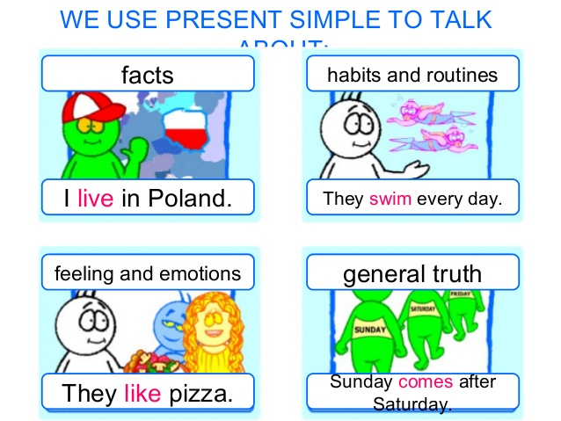

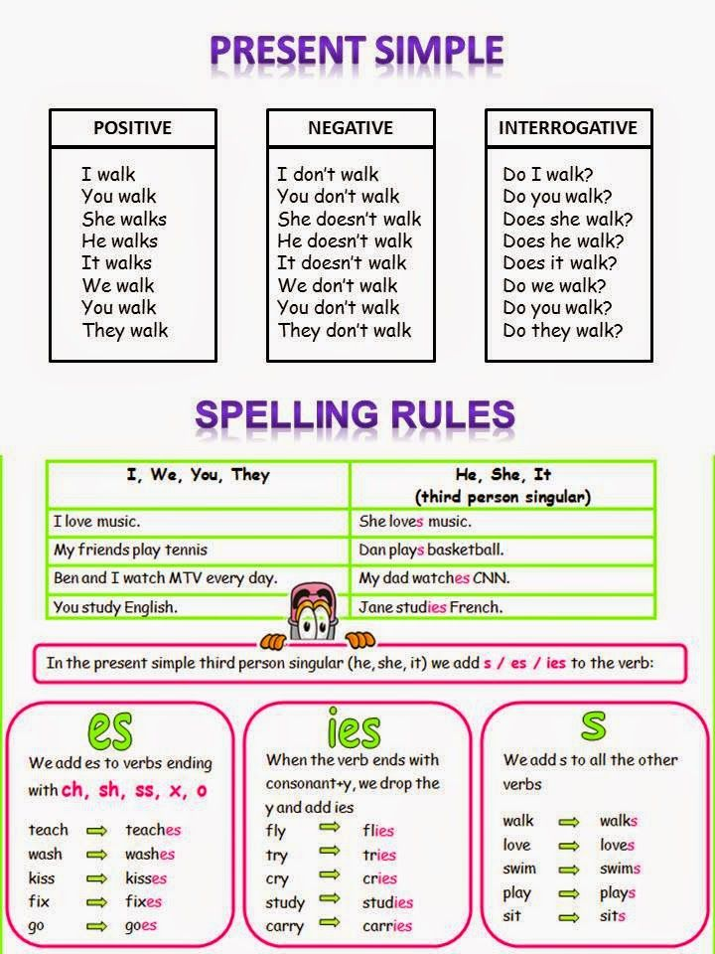

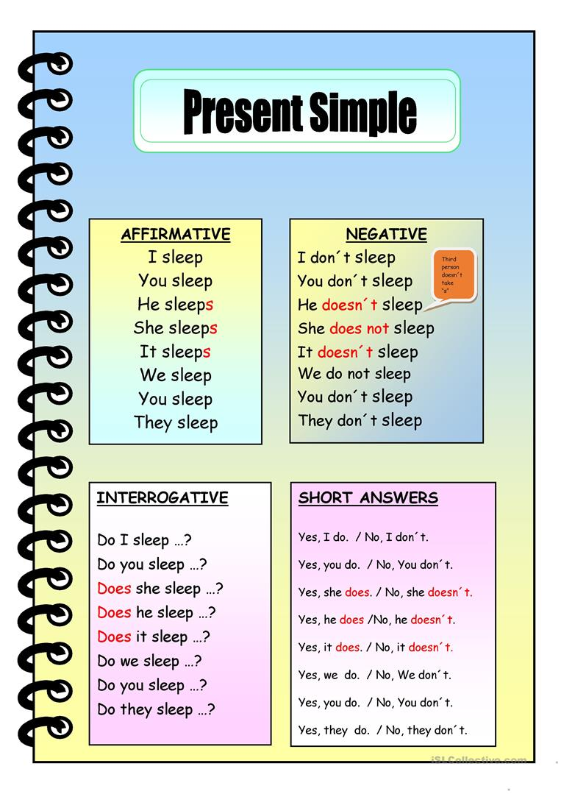

2- Past Indefinite Tense

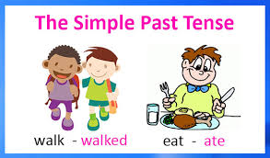

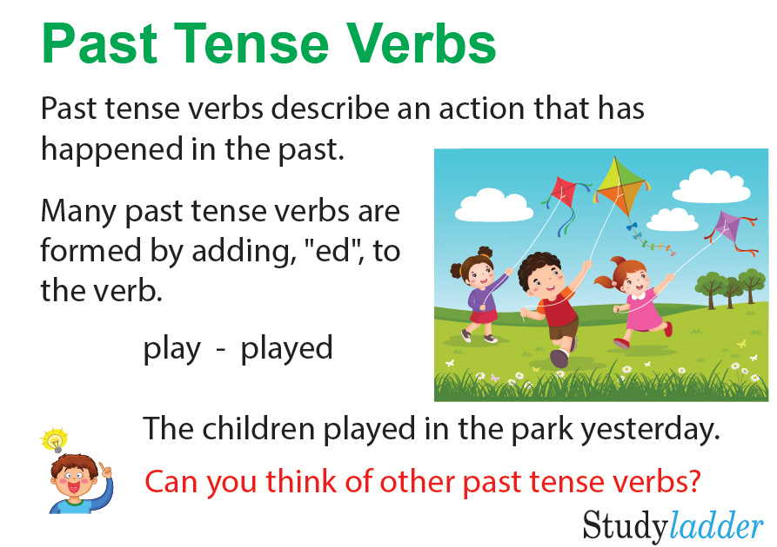

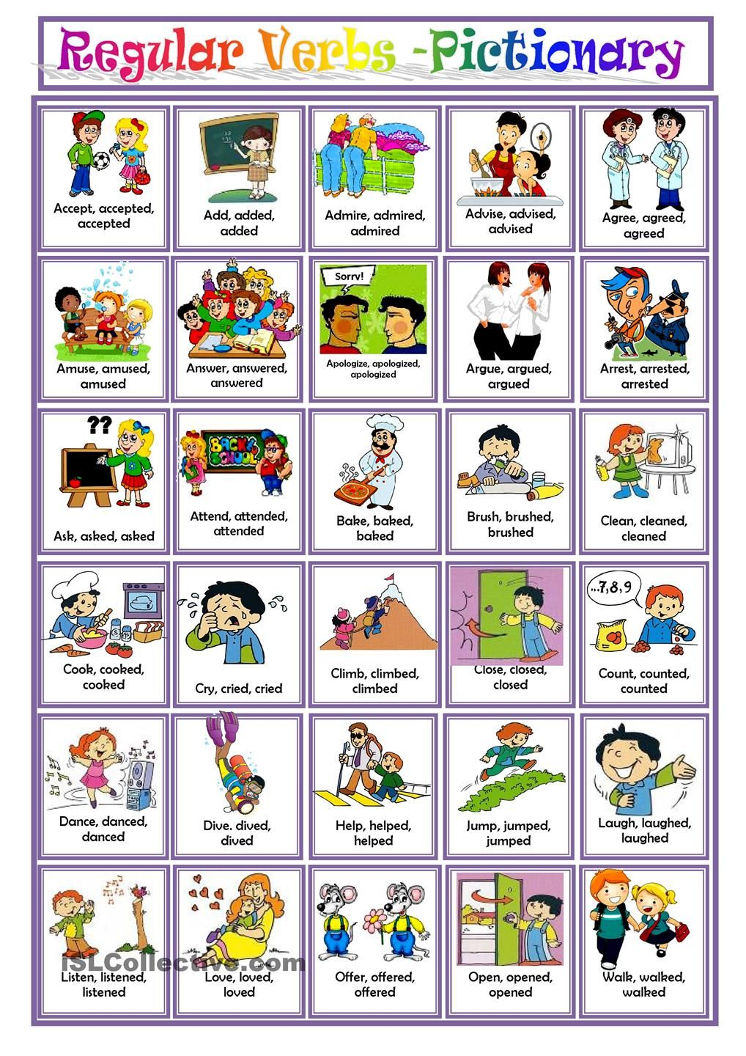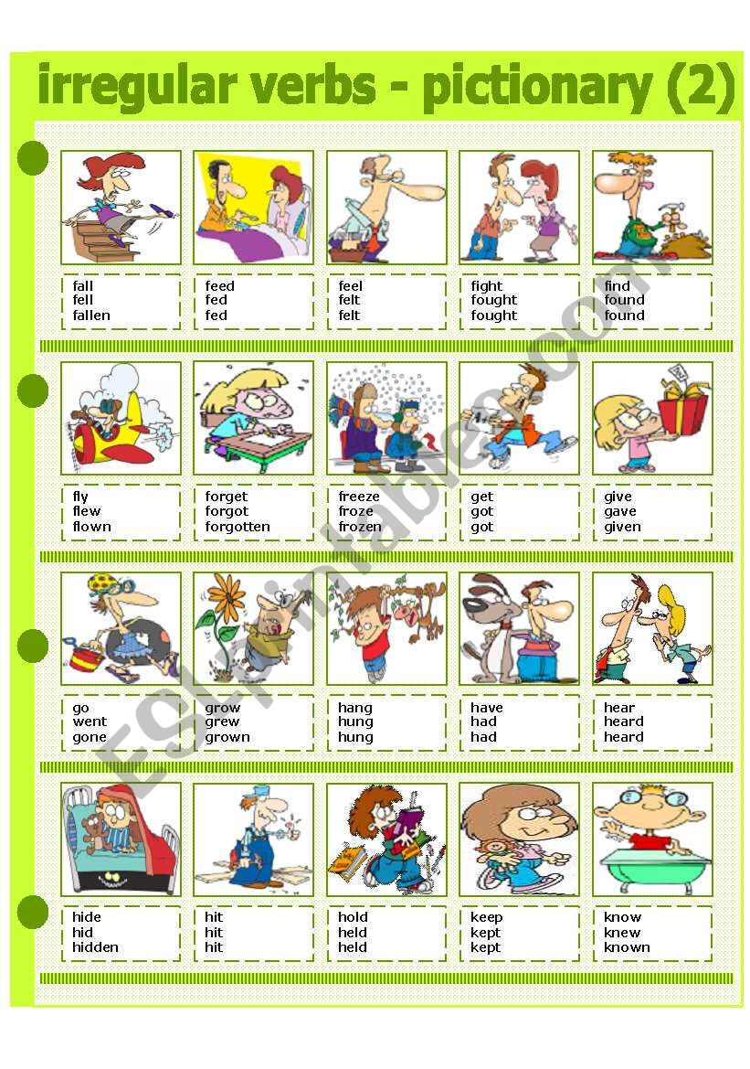

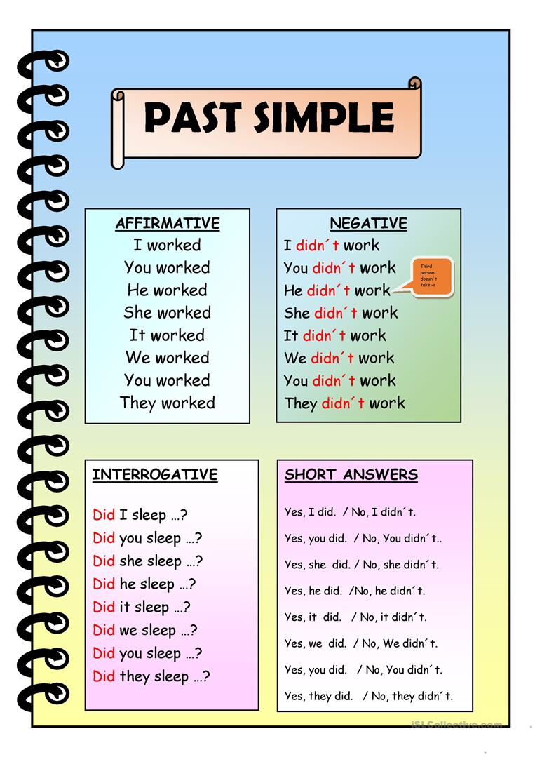

3- Future Indefinite Tense

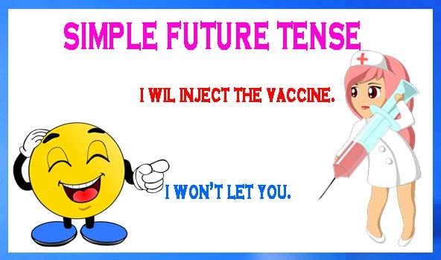

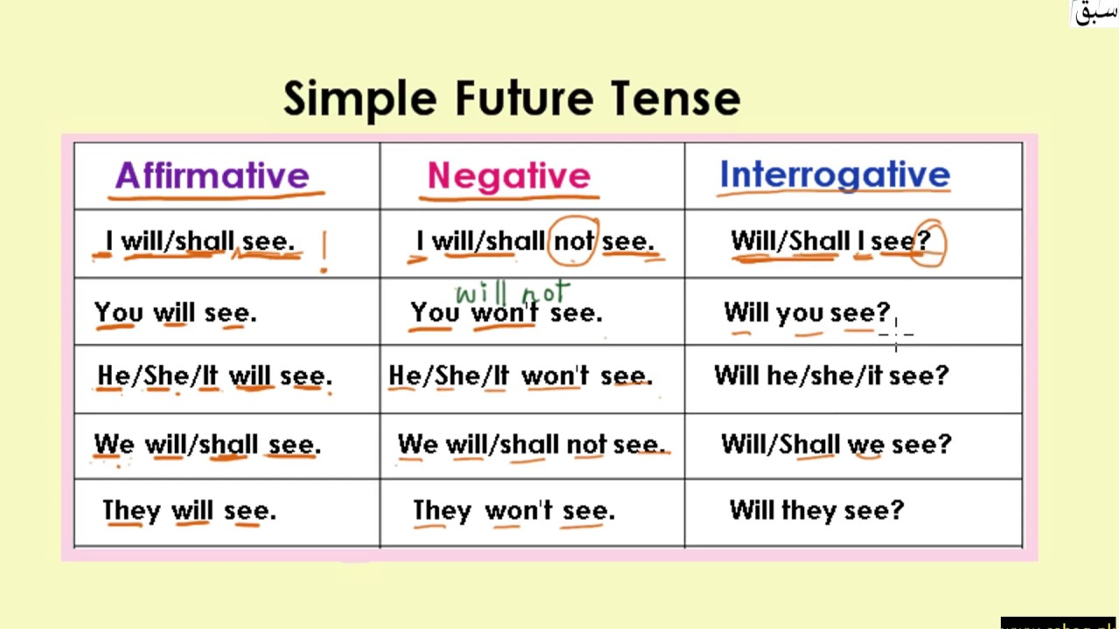

Subject: English WORKSHEETS GRADE:8

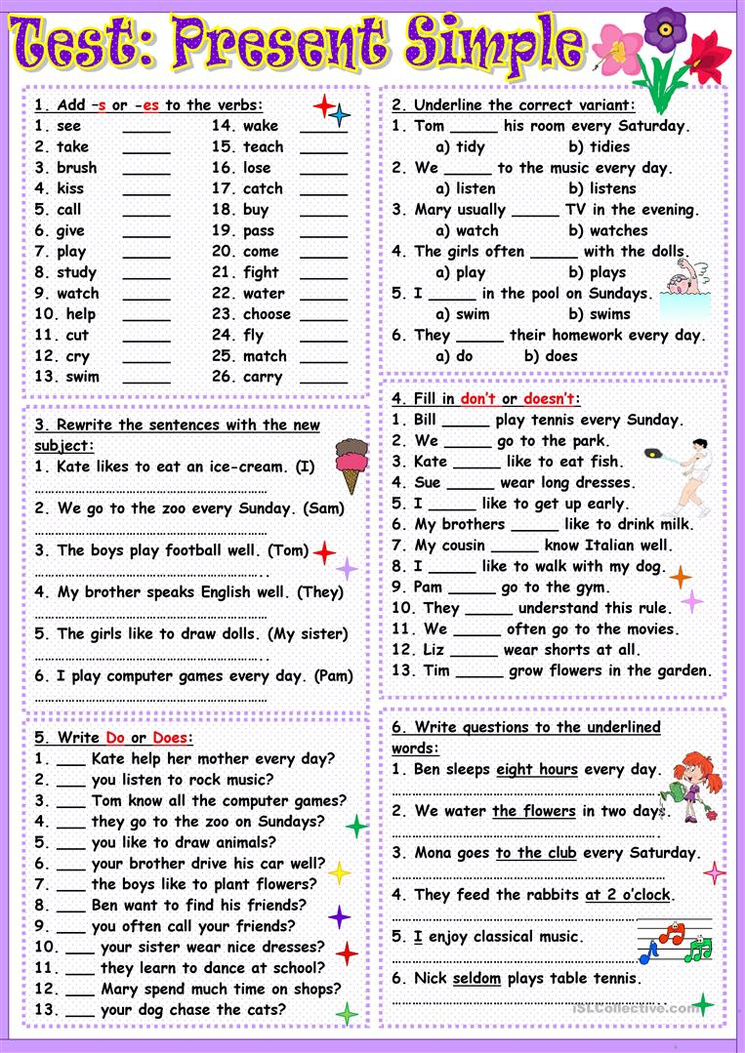

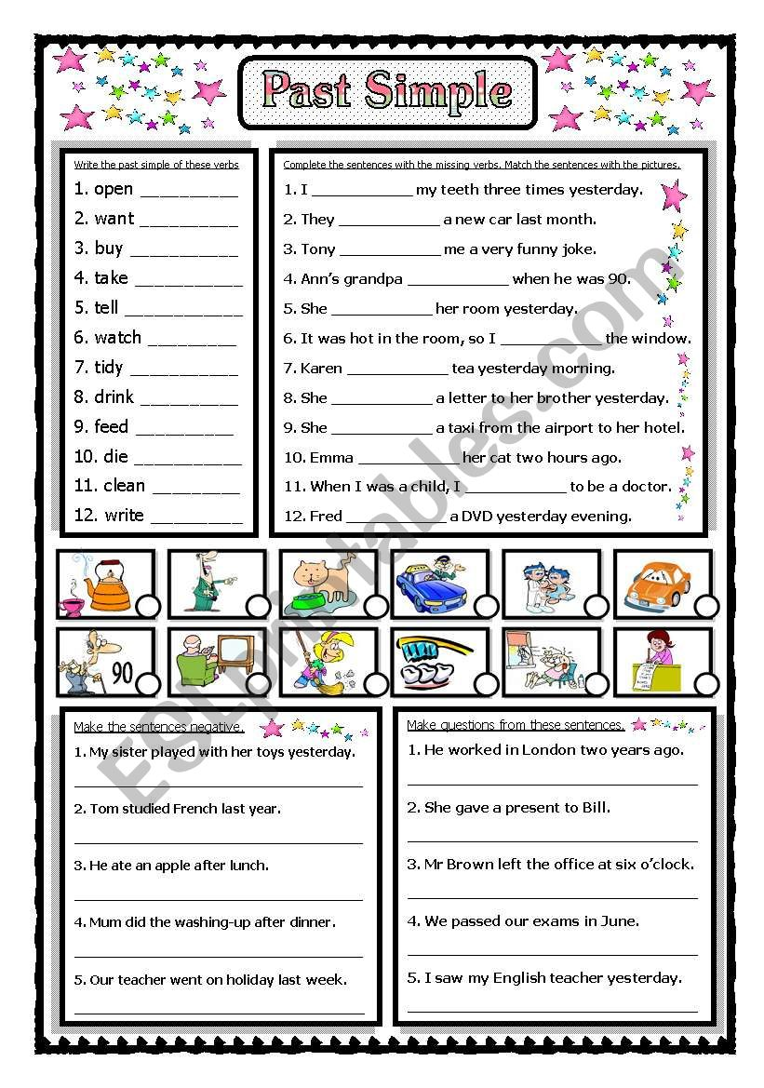

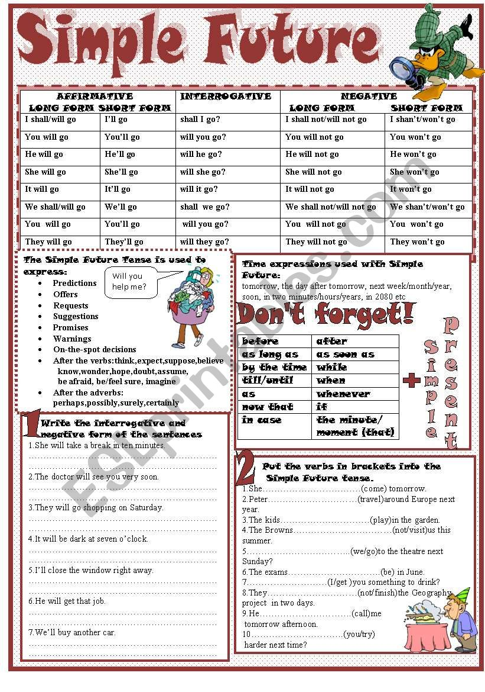

|  |  |  |  |  |
| --- | --- | --- | --- | --- |
| **Rubric:** | **Ex.** | **Go.** | **Sat.** | **NI** |
| **Content Accuracy** | **1** | **2** | **3** | **4** |
| **Creativity** | **1** | **2** | **3** | **4** |
| **Completeness** | **1** | **2** | **3** | **4** |
| **Neatness** | **1** | **2** | **3** | **4** |
| **1-Excellent 2- Good 3- Satisfactory**  **4- Needs improvement** | | | | |

Q2. Letter Writing-Informal (Any 1)

**1- Write a letter to your younger brother who has grown very weak. Suggest ways how he can improve his health.**

**2- Write a letter to your elder sister on her birthday. She is away from home preparing for medical entrance exam.**

**3- Write a letter to your father requesting him to buy you a new i-pad/tablet to take online classes.**

Letter Writing Rubric:

|  |  |  |  |  |
| --- | --- | --- | --- | --- |
| **Rubric:** | **Ex.** | **Go.** | **Sat.** | **NI** |
| **Letter Format** | **1** | **2** | **3** | **4** |
| **Body of the letter** | **1** | **2** | **3** | **4** |
| **Creativity** | **1** | **2** | **3** | **4** |
| **Completeness** | **1** | **2** | **3** | **4** |
| **1-Excellent 2- Good 3- Satisfactory**  **4- Needs improvement** | | | | |