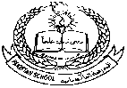**Pakistan School, Kingdom of Bahrain**

**E- Support and Learning Material**

**Subject: English Grade : HKG**

**Topic #3: "a" Sound Words (hat, cat, bat, rat)**

|  |  |
| --- | --- |
|  |  |
| **Student Name: _________________________________________________** | |
|  | |

**Q. 1: Write the missing letter and then write the full word:**

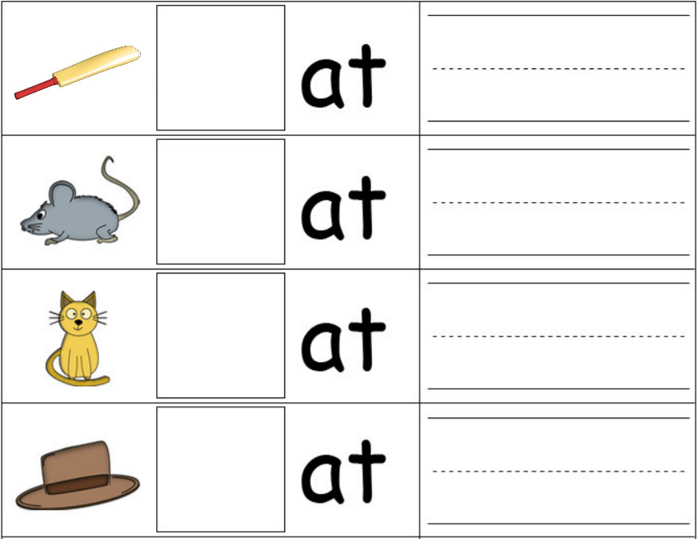

**Q. 2: Match the pictures with the correct words:**

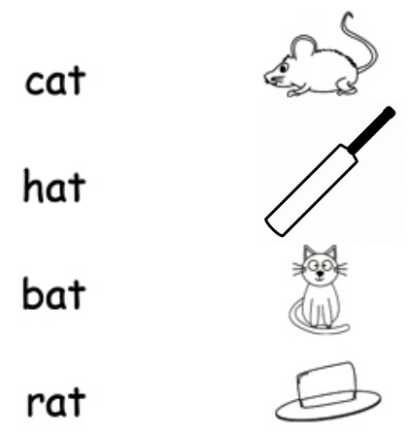

**Q3. Write and learn the spellings:**

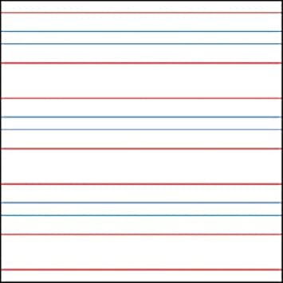

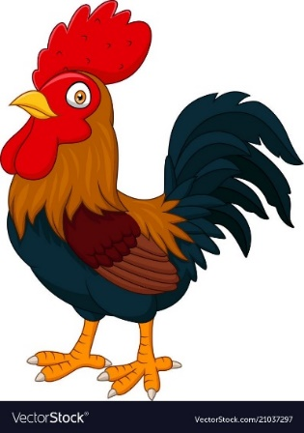

**Q.4: Read and practice book page numbers 25 , 26 , 27 , 28, 29, 30, 31 and 32.**

**Pakistan School, Kingdom of Bahrain**

**E- Support and Learning Material**

**Subject: English Grade : HKG**

**Topic #3: "a" Sound Words (fan, man, pan, can)**

|  |  |
| --- | --- |
|  |  |
| **Student’s Name: _________________________________________________** | |
|  | |

**Q. 1: Write the missing letter and then write the full word:**

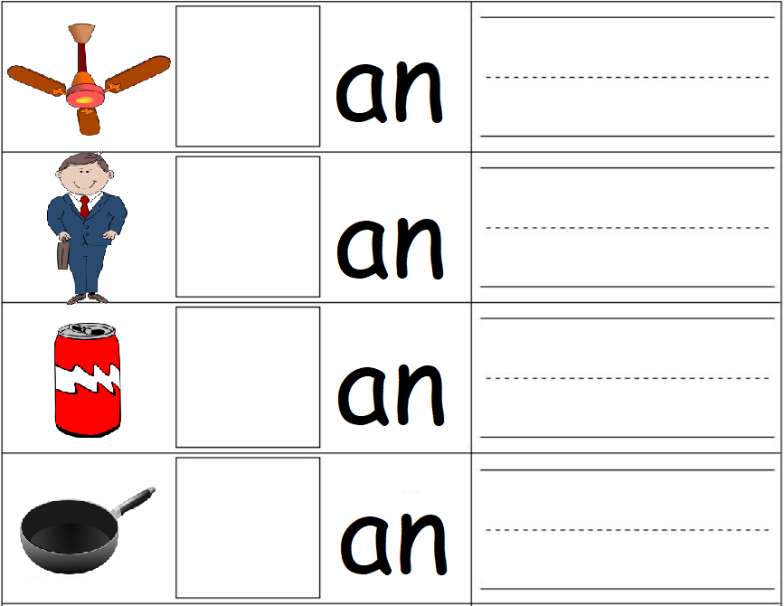

**Q. 2: Match the pictures with the correct words:**

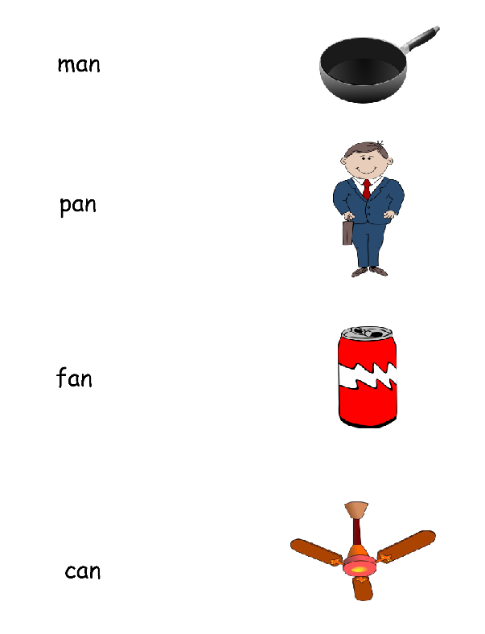

**Q3. Write and learn the spellings:**



**Q.4: Read and practice book page numbers 33, 34, 35 and 36.**

**Pakistan School, Kingdom of Bahrain**

**E- Support and Learning Material**

**Subject: English Grade : HKG**

**Topic #3: "a" Sound Words (bar, car, far, jar)**

|  |  |
| --- | --- |
|  |  |
| **Student’s Name: _________________________________________________** | |
|  | |

**Q. 1: Write the missing letter and then write the full word:**

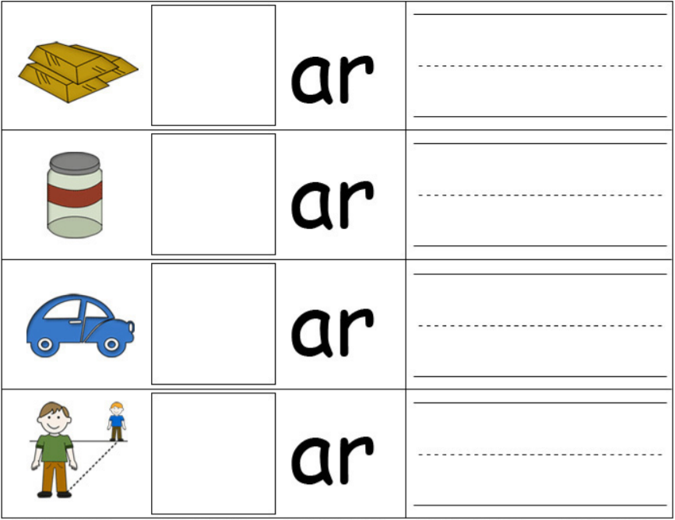

**Q. 2: Match the pictures with the correct words:**

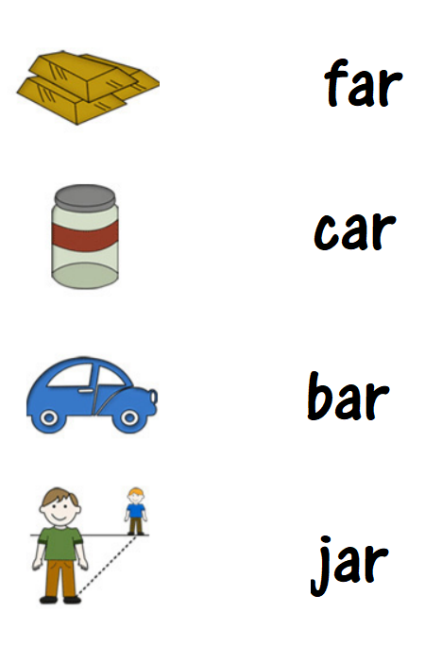

**Q3. Write and learn the spellings:**





**Q.4: Read and practice book page numbers 37, 38, 39 and 40.**