**Pakistan School,**

**Kingdom of Bahrain**

**E**

**-**

**Support and Learning Material**

**Subject: English**

**Grade : HKG**

**Topic**

**:**

**"e" Sound words (bed, f**

**ed, red,**

**w**

**ed)**

**Student’s Name: _________________________________________________**

**Q. 1:**

**Circle the correct word**

**:**

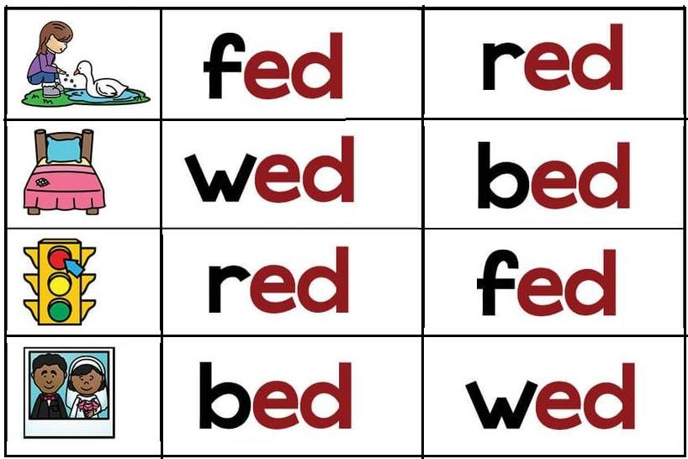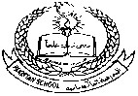

**Q.**

**2**

**:**

**Write the missing letter and read the sentences**

**:**

**Q.**

**3**

**Read and**

**:**

**practice b**

**ook**

**p**

**age**

**n**

**umber**

**s**

**41**

**,**

**42**

**,**

**,**

**44**

**43**

**and**

**4**

**5**

**.**

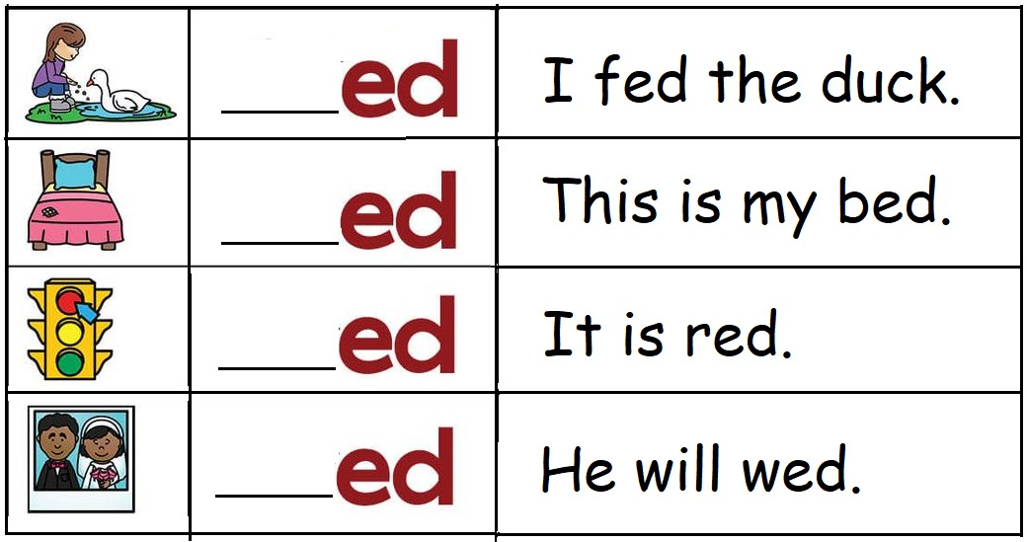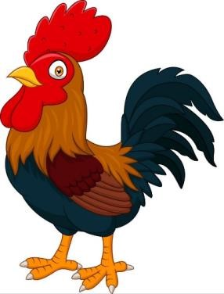

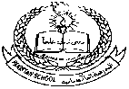**Pakistan School, Kingdom of Bahrain**

**E- Support and Learning Material**

**Subject: English Grade : HKG**

**Topic : "e" Sound Words (ten, hen, men, pen)**

|  |  |
| --- | --- |
|  |  |
| **Student’s Name: _________________________________________________** | |
|  | |

**Q. 1: Write the missing letter and then write the full words:**

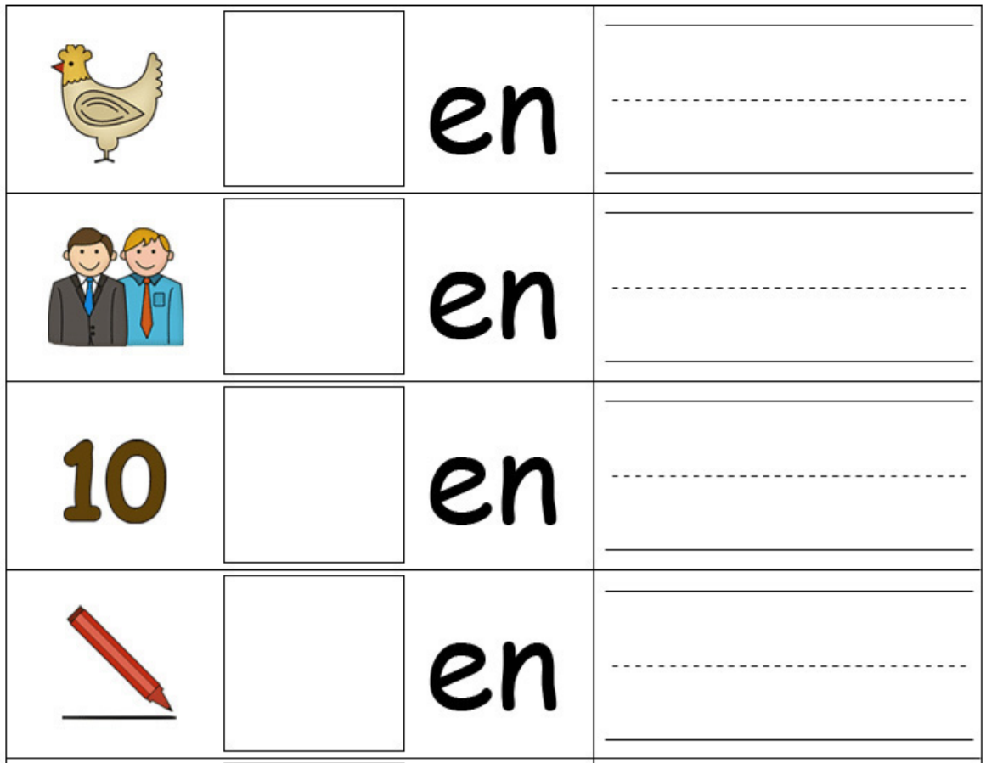

**Q. 2: Match the pictures with the correct words:**

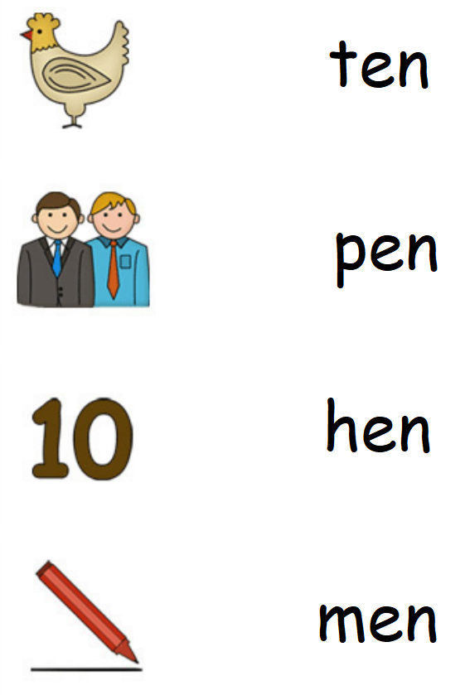

**Q.4: Read and practice book page numbers 46, 47 and 48.**

**Pakistan School, Kingdom of Bahrain**

**E- Support and Learning Material**

**Subject: English Grade : HKG**

**Topic: Dictation Words (cat, car, bed, pen, fan)**

|  |  |
| --- | --- |
|  |  |
| **Student’s Name: _________________________________________________** | |
|  | |

**Q. 1: Write and learn following words:**

|  |  |  |  |  |
| --- | --- | --- | --- | --- |
| **cat** | **car** | **bed** | **pen** | **fan** |
|  |  |  |  |  |
|  |  |  |  |  |
|  |  |  |  |  |
|  |  |  |  |  |
|  |  |  |  |  |
|  |  |  |  |  |

**Pakistan School, Kingdom of Bahrain**

**E- Support and Learning Material**

**Subject: English Grade : HKG**

**Topic: Dictation Words (hen, jar, red, hat, man)**

|  |  |
| --- | --- |
|  |  |
| **Student Name: _________________________________________________** | |
|  | |

**Q. 1: Learn and write following words:**

|  |  |  |  |  |
| --- | --- | --- | --- | --- |
| **hen** | **jar** | **red** | **hat** | **man** |
|  |  |  |  |  |
|  |  |  |  |  |
|  |  |  |  |  |
|  |  |  |  |  |
|  |  |  |  |  |
|  |  |  |  |  |

