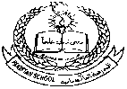**Pakistan School, Kingdom of Bahrain ( Junior Section)**

**E- Support and Learning Material / Session 2020-2021**

**Subject: English Grade: LKG Sec: _____**

**Name: ______________________________ Isa Town / Manama**

* 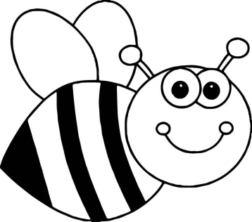Color the friends of letter B :
* Trace the letter B:

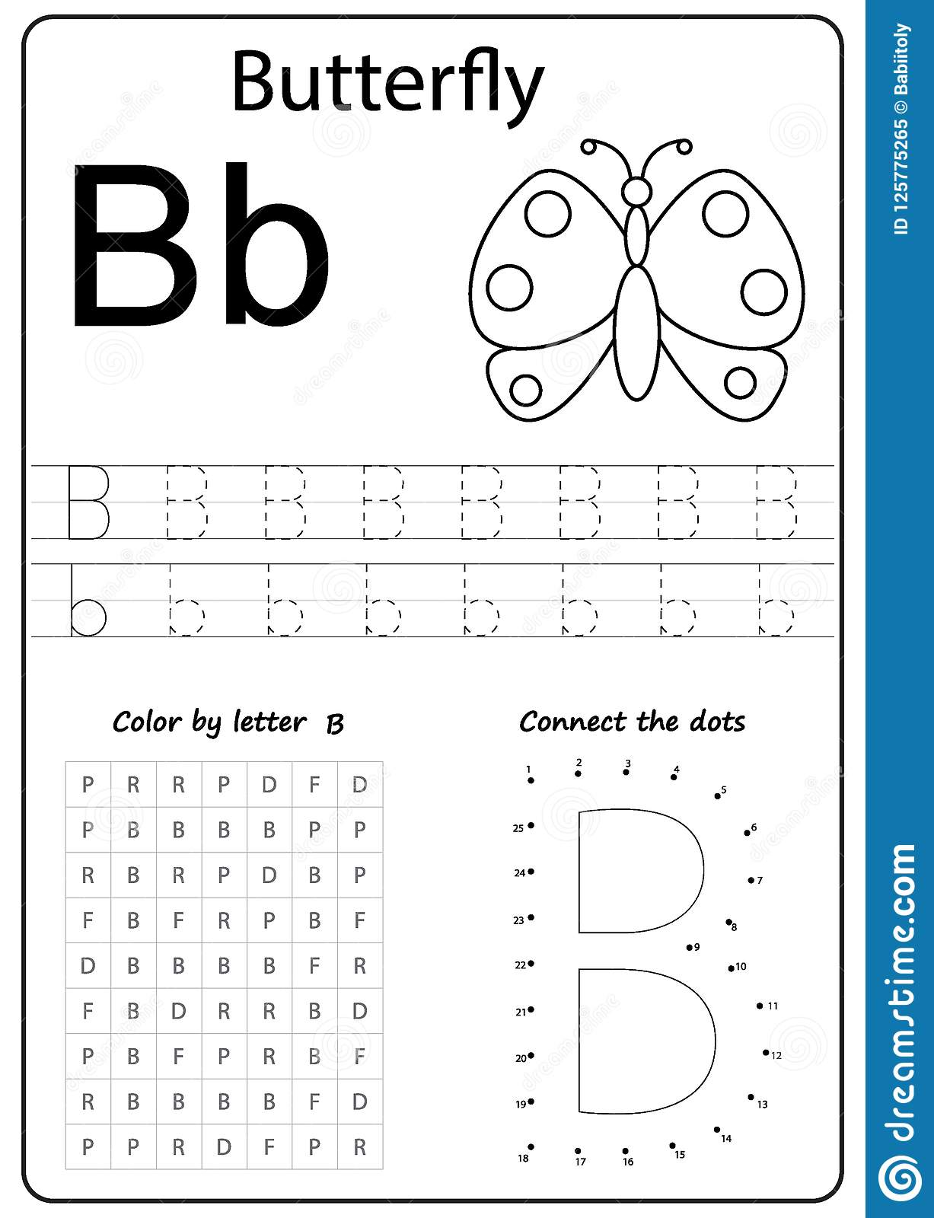



* Circle letter B:

A C B N B M B T B H B

V B N G B J B L I B V



**Pakistan School, Kingdom of Bahrain ( Junior Section)**

**E- Support and Learning Material / Session 2020-2021**

**Subject: English Grade: LKG Sec: _____**

**Name: ______________________________ Isa Town / Manama**

* 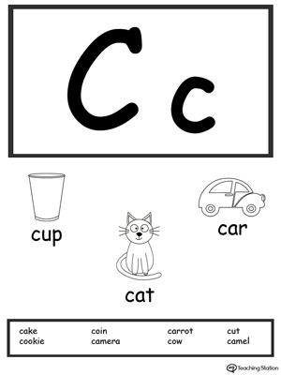Color the friends of letter C :
* 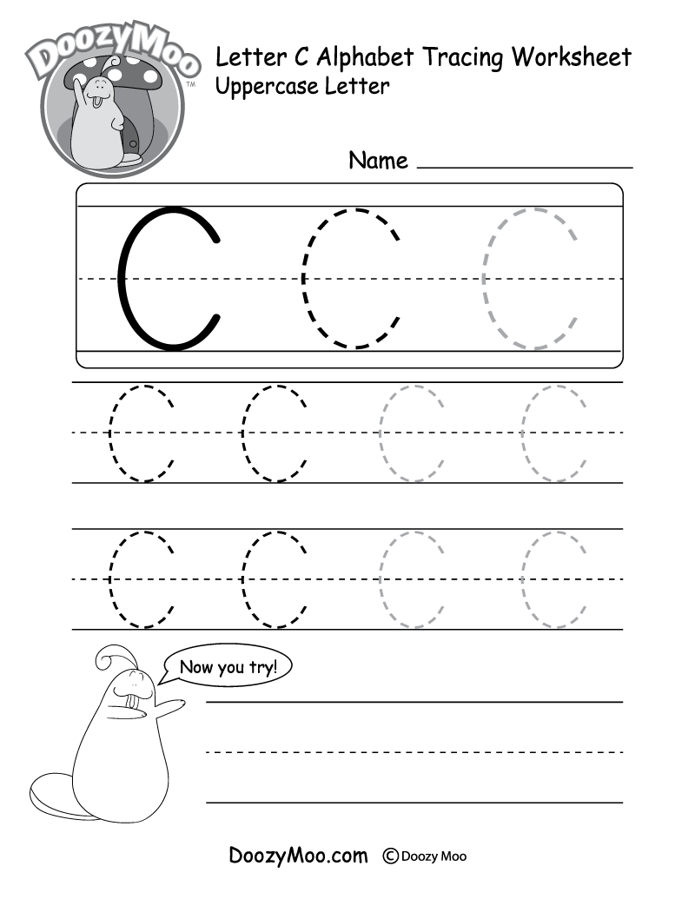Trace the letter C:



* Circle letter C:

A C B N C M C T C H B

V B N G C J B L I C V

**Pakistan School, Kingdom of Bahrain ( Junior Section)**

**E- Support and Learning Material / Session 2020-2021**

**Subject: English Grade: LKG Sec: _____**

**Name: ______________________________ Isa Town / Manama**

**Color the friends of letter D:**

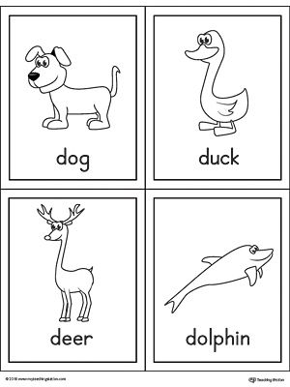

**Trace the letter D:**

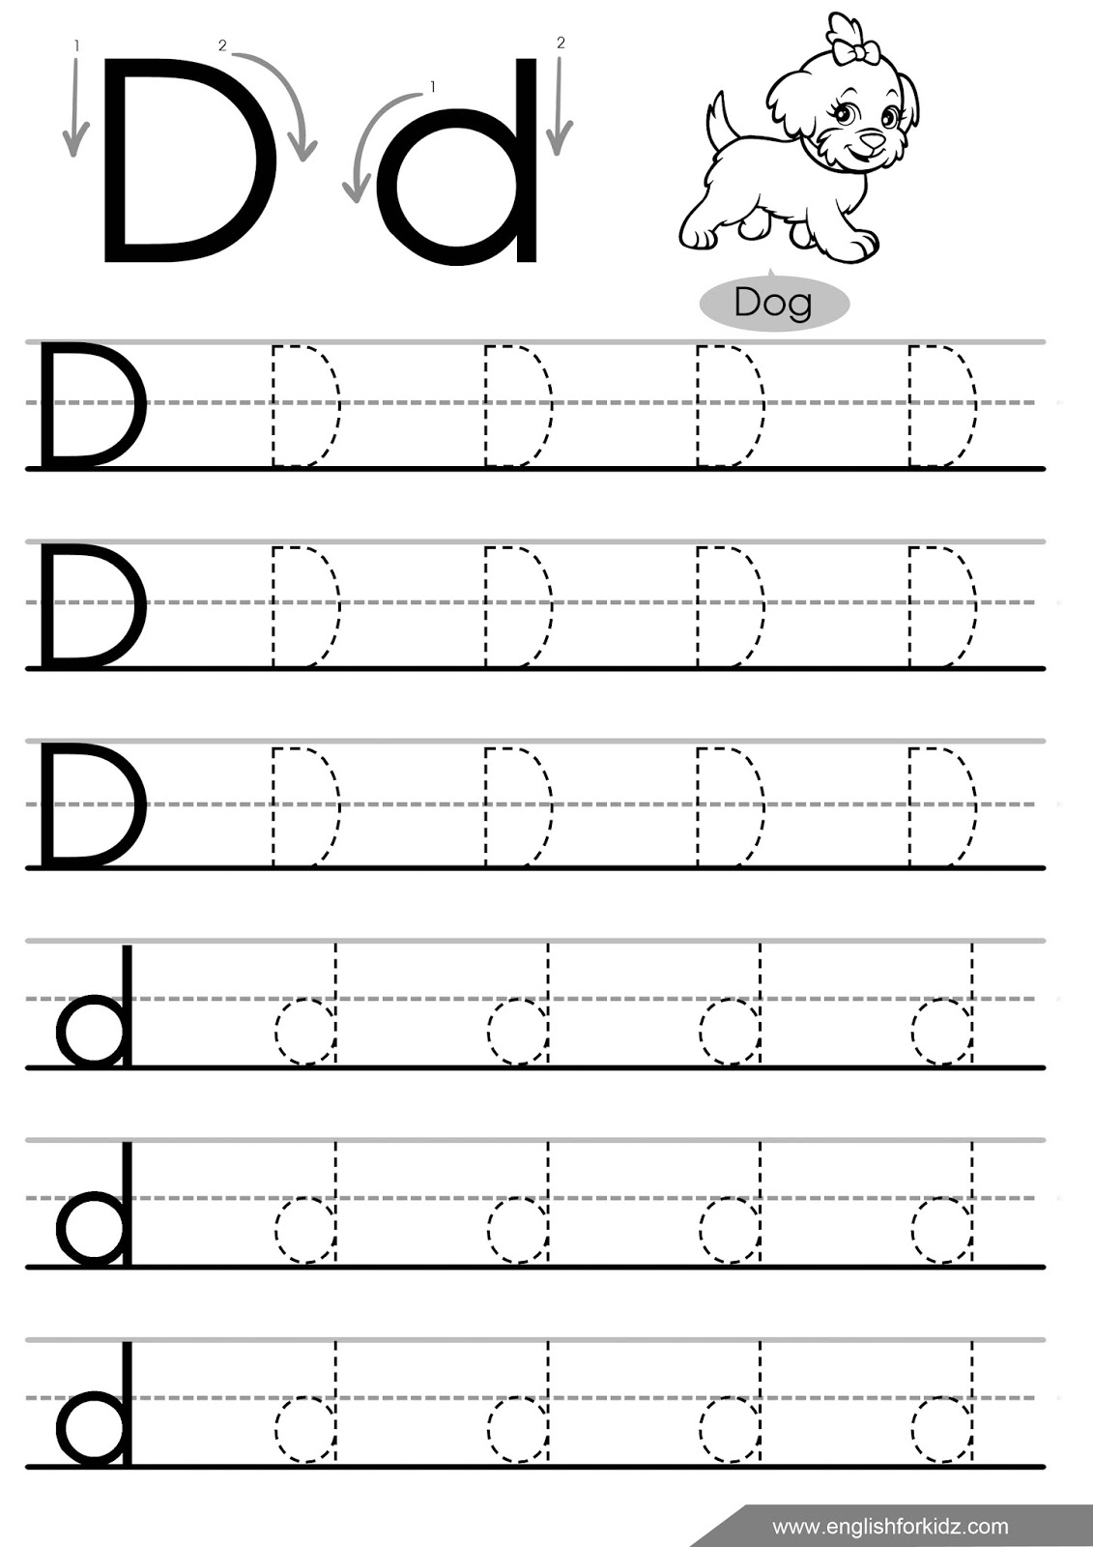





**Pakistan School, Kingdom of Bahrain ( Junior Section)**

**E- Support and Learning Material / Session 2020-2021**

**Subject: English Grade: LKG**

G

**NAME**_____________________

COLOR L

|  |
| --- |
|  |

TRACE

|  |
| --- |
|  |

**Pakistan School, Kingdom of Bahrain ( Junior Section)**

**E- Support and Learning Material / Session 2020-2021**

**Subject: English Grade: LKG**

**FIRST TERM**

**NAME**_____________________ **DATE**_______________

COLOR L

**Letter :O**

O

|  |
| --- |
|  |

TRACE

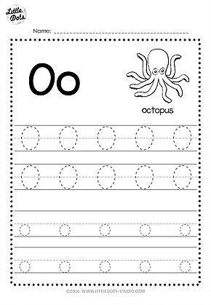

FIND O

|  |
| --- |
| K KK O N O Y O L D O O N O Y O L D O  K O N O L D O |