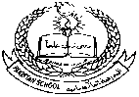**Pakistan School, Kingdom of Bahrain ( Junior Section)**

**E- Support and Learning Material / Session 2020-2021**

**Subject: English Grade: LKG**

COLOR L

J

**Letter J**

TRACE

|  |
| --- |
|  |

|  |
| --- |
|  |



**Pakistan School, Kingdom of Bahrain ( Junior Section)**

**E- Support and Learning Material / Session 2020-2021**

**Subject: English Grade: LKG**

**FIRST TERM**

**NAME**____________________________  **DATE**_______________

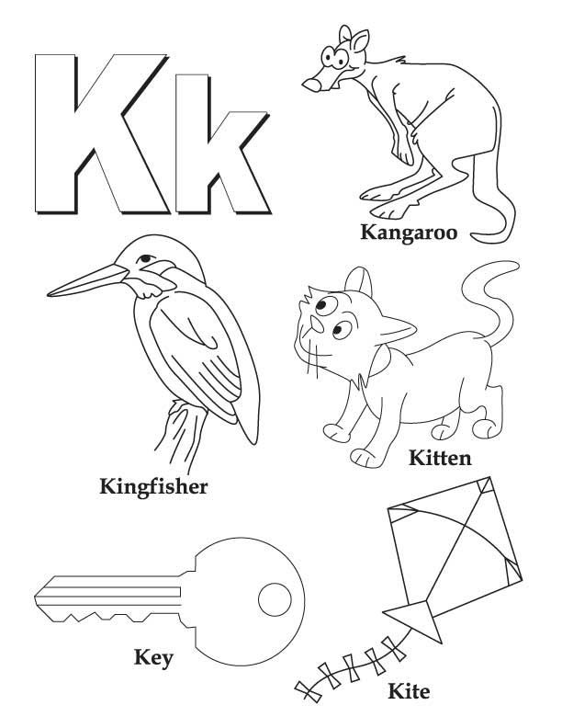Color the friends of letter K:



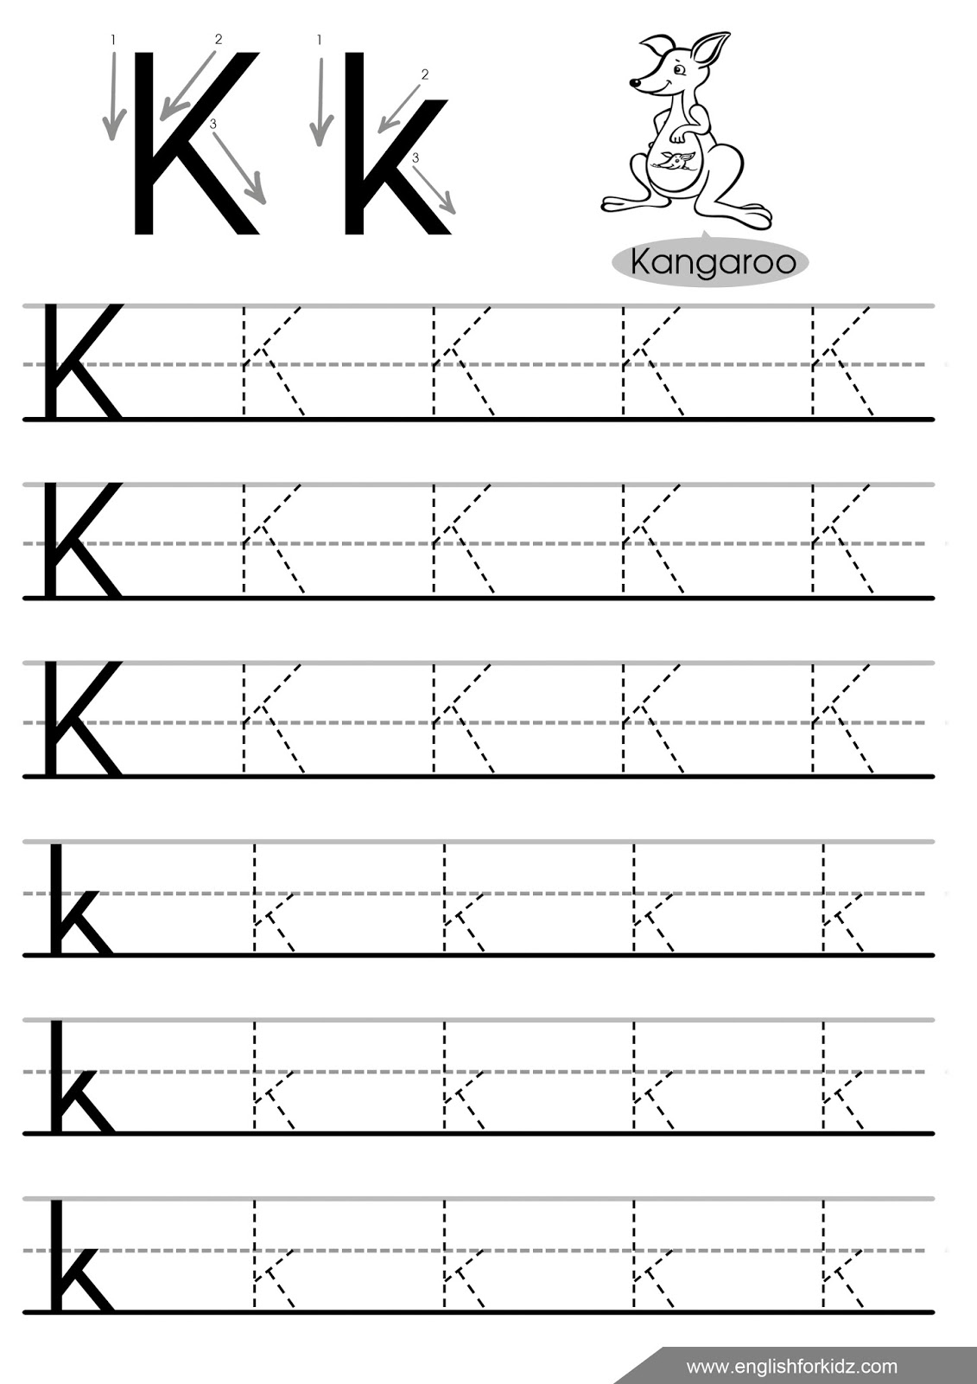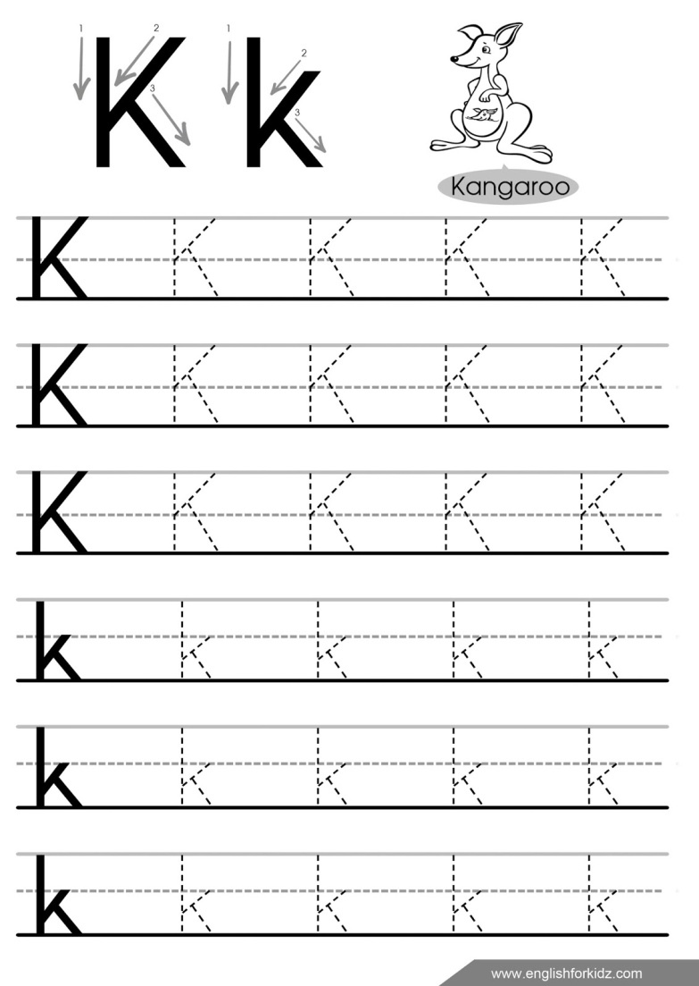

**Trace the letter K:**

Circle letter K:

K K B N K M K T K

V B N G K B L K L

**Pakistan School, Kingdom of Bahrain ( Junior Section)**

**E- Support and Learning Material / Session 2020-2021**

**Subject: English Grade: LKG**

**Letter : P**

P

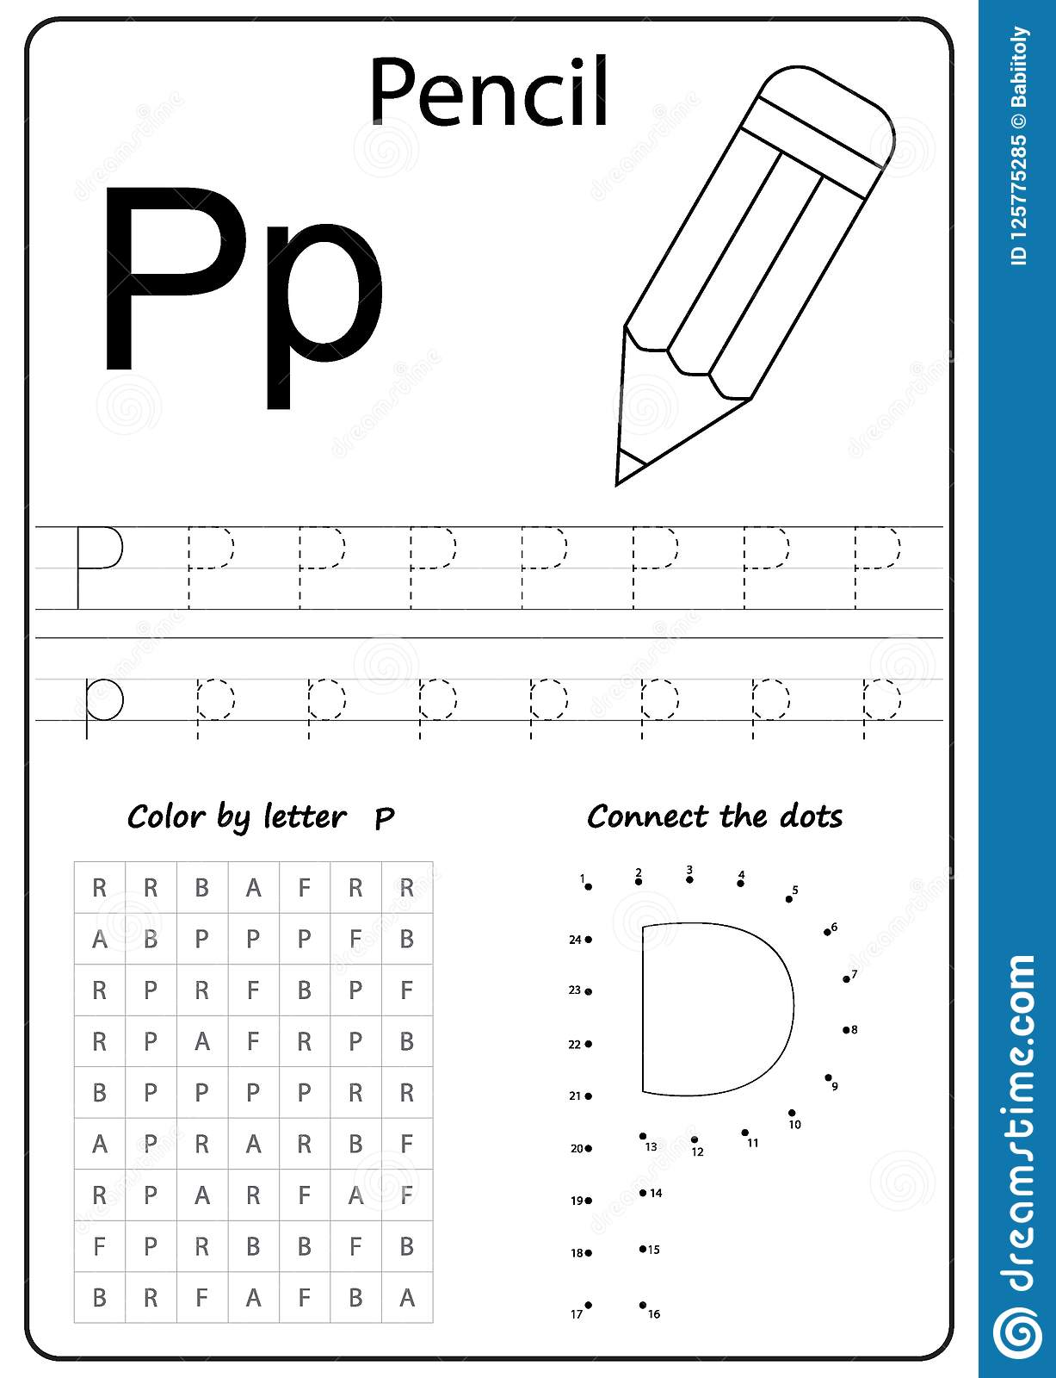



**Pakistan School, Kingdom of Bahrain ( Junior Section)**

**E- Support and Learning Material / Session 2020-2021**

**Subject: English Grade: LKG**

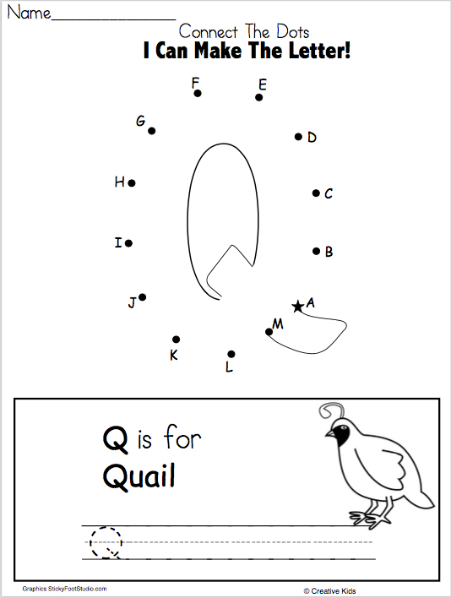

* NOW YOU CAN MAKE IT:

----------------------------------------------------------------------------------------------------------------------------------------------------------------------------------------------------------------------------------------------------------------______________________________________________________________________________

----------------------------------------------------------------------------------------------------------------------------------------------------------------------------------------------------------------------------------------------------------------______________________________________________________________________________



**Pakistan School, Kingdom of Bahrain ( Junior Section)**

**E- Support and Learning Material / Session 2020-2021**

**Subject: English Grade: LKG**

**FIRST TERM**

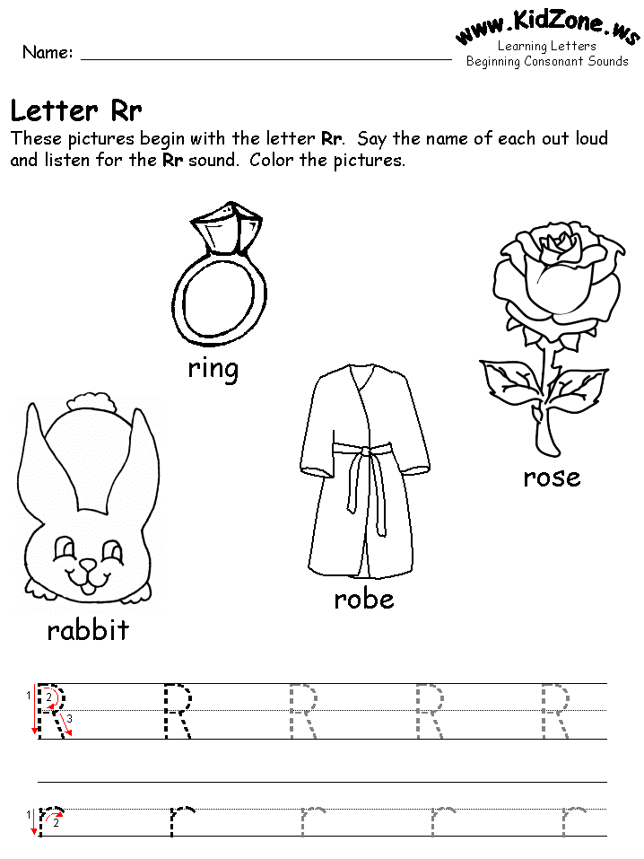Color the friends of letter R:

**Trace the letter R:**



Circle letter R:

N R B N R N H R N

R B N R H R N I R

**Pakistan School, Kingdom of Bahrain ( Junior Section)**

**E- Support and Learning Material / Session 2020-2021**

**Subject: English Grade: LKG**

Color the friends of letter S:

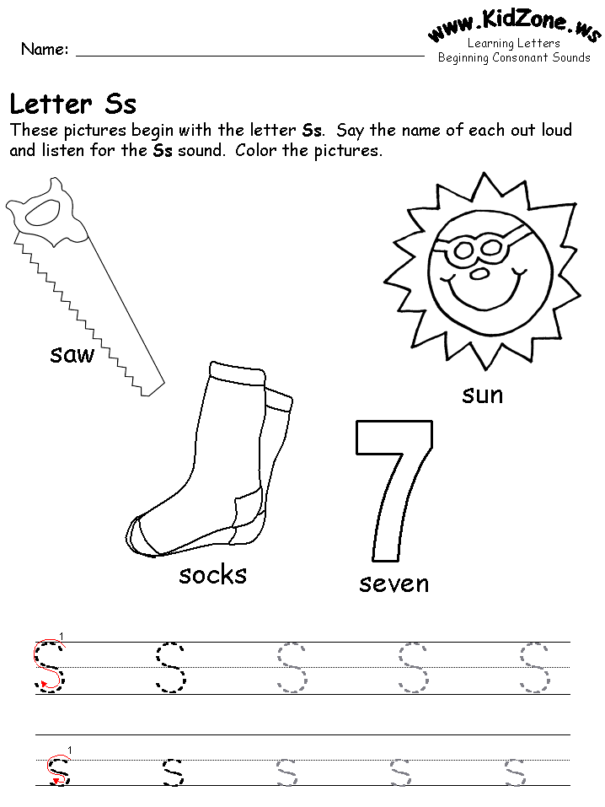

**Trace the letter S:**



Circle letter S:

S R B S R N H S N

R S N R H S N I S



**Pakistan School, Kingdom of Bahrain ( Junior Section)**

**E- Support and Learning Material / Session 2020-2021**

**Subject: English Grade: LKG**

Color the friends of letter U:

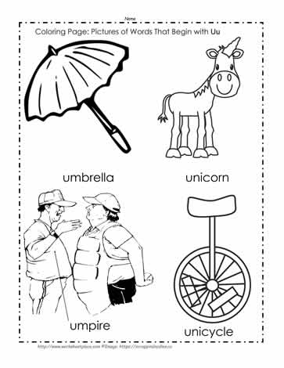

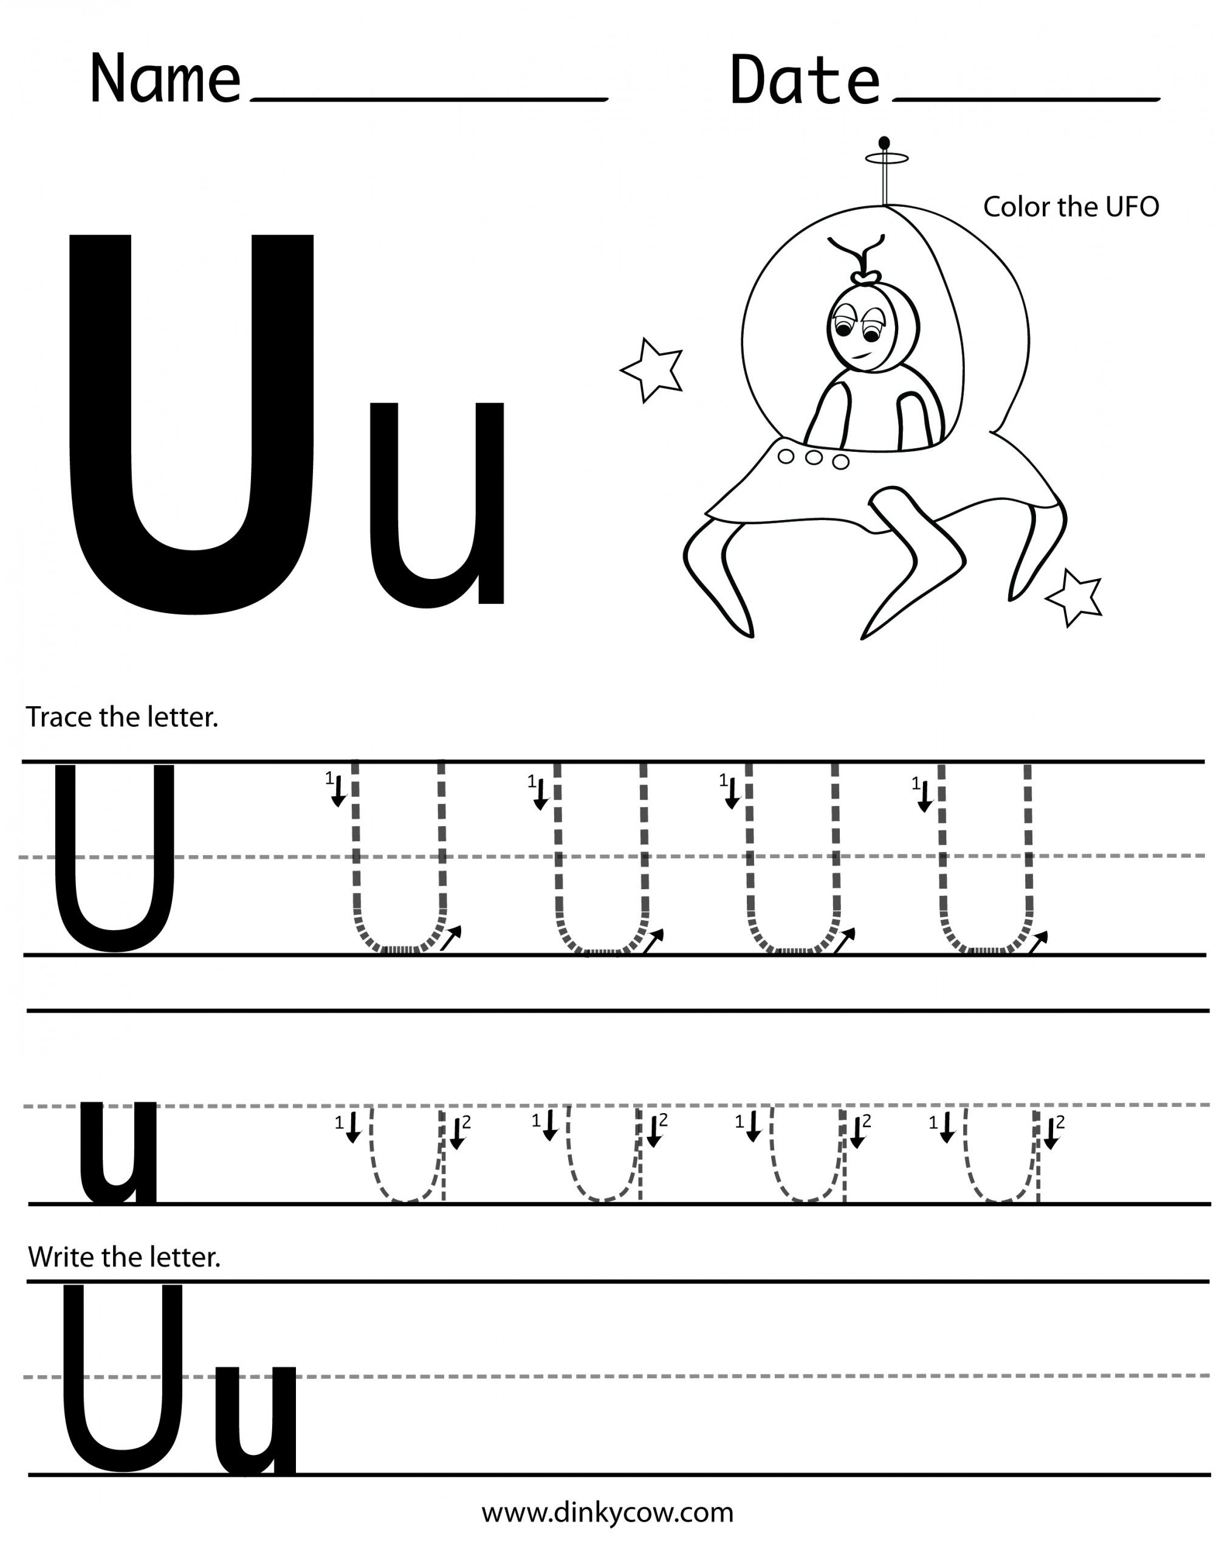**Trace the letter U:**





Circle letter U:

T U B U R N U S U

U T U R H U N U S

