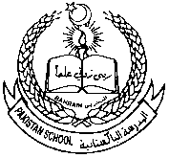 Pakistan school ,Isa town kingdom of Bahrain

E-support and learning Material / session 2020-2021

Subject :Science Grade :3 Book : simply science 3

Unit No:2:solids ,liquids and how they can be separate

Assignment -5

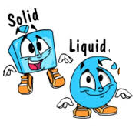 Topic:1: solids and liquids. Pg.16 & 17.

Notes

Q1.Answer the following questions.

a.Name any three solids and liquid that you use in your daily life.

Solids: wood , salt and book etc

Liquids: water , milk and juice etc

b.Explain how solids and liquids behave differently.

|  |  |  |
| --- | --- | --- |
|  | solids | liquids |
| 1 | Solids are hard. | Liquid are runny. |
| 2 | Solids have fixed shape. | Liquid do not have fixed shape. |

 Pakistan school ,Isa town kingdom of Bahrain

E-support and learning Material / session 2020-2021

Subject :Science Grade :3 Book : simply science 3

Unit No:2:solids ,liquids and how they can be separate

Topic:1: solids and liquids. Pg.16 & 17.

Worksheet no: 1

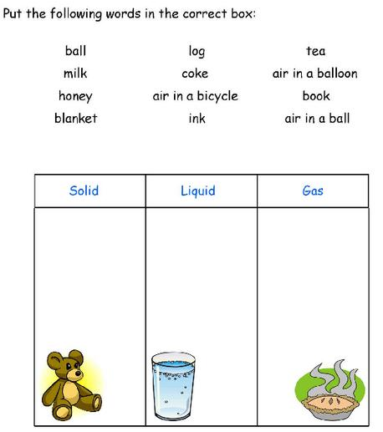

Q.fill in the blanks with suitable words.

( State , solid , container , shape)

1.Most of the materials around us are found in only one ____________________.

2.All solids try to keep their _________________.

3.Liquid take up the shape of the ___________________ in which they are kept.

4.Ice is a _________________ form of water.

**Home work:**

Paste and name any five liquids. or

Paste and name any five solids.