**Pakistan School , Kingdom of Bahrain**

**E- Support and Learning Material / Session 2020-2021**

**Subject: G.Science Grade : 4**

**Book: Simply Science FIRST TERM**

**Unit 3: Changing sounds. Pg. No: ____36__**

**Topic: Difference in sounds.**

**Assignment-5**

**Activity 1**

**Write true or false:**

1. **Bats and dolphins have high pitch sound. T/F**
2. **If the vibrations are small then the sound you make is loud. T/F**
3. **A sound that is hear again as it is bounced off form a hard surface. T/F**

**Activity 2**

**Q.2 Which of the following make high and low sound?**

**Violin, flute, bell, cello, recorder, kettledrum ,side drum.**

|  |  |
| --- | --- |
| **High sound** | **Low sound** |
|  |  |
|  |  |
|  |  |
|  |  |
|  |  |

**Activity 3**

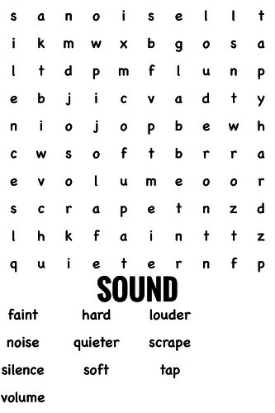

**Activity :**

**Q.3 Hold a ruler on the edge of table with different length of it sticking out. Twang the end of the ruler when it is different lengths and record the pitch of sound it makes (high ,low ,very high, very low).And record your results.**

|  |  |
| --- | --- |
| **Length of ruler** | **Pitch of sound** |
| **8cm** |  |
| **14cm** |  |
| **24 cm** |  |
| **30cm** |  |

**Pakistan School , Kingdom of Bahrain**

**E- Support and Learning Material / Session 2020-2021**

**Subject: G.Science Grade : 4**

**Book: Simply Science FIRST TERM**

**Unit 3: Changing sounds. Pg. No: ___36__**

**Topic:( Musical sounds) and ( wind and percussion instruments)**

**Activity 1**

**Write true or false:**

1. **A violins is similar to a guitar T/F**
2. **A loose string makes a high- pitched sound. T/F**
3. **Drum is example of wind instruments T/F**

**Activity 2:**

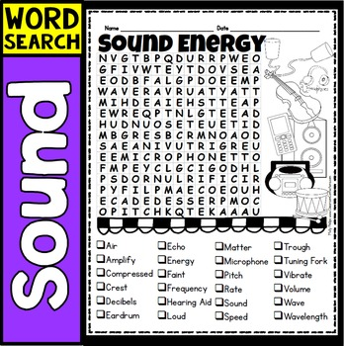

**Activity 3;**

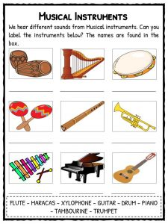

**Activity 4;**

**Q. IN your own words, describe how you would change the pitch of the**

**Notes made by guitar?**

**Pakistan School , Kingdom of Bahrain**

**E- Support and Learning Material / Session 2020-2021**

**Subject: G.Science Grade : 4**

**Book: Simply Science FIRST TERM**

**Unit 3: Changing sounds. Pg. No: ____36__**

**Topic: Difference in sounds.**

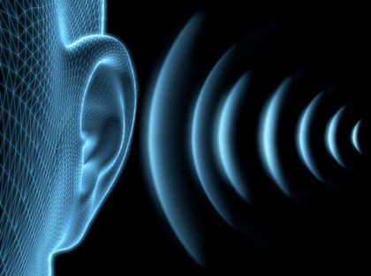

**(A) Short questions answers**

**Q.1 How loud and soft sound are made?**

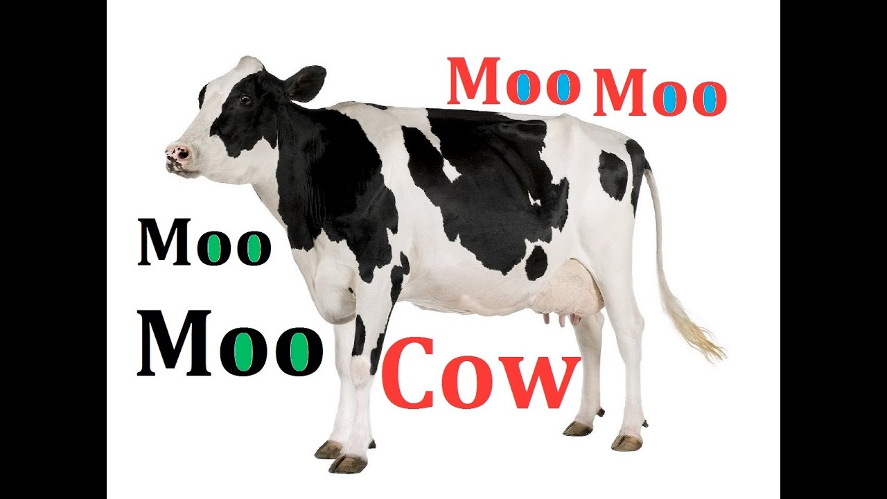**ANS: Large vibrations make loud sound and small vibration make soft sound. E.g:**

**A cow makes a low sound**

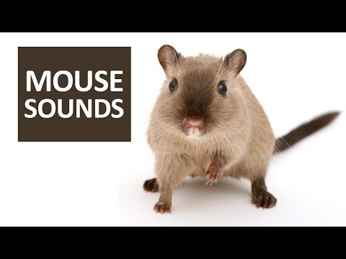**A mouse makes a loud sound.**

**Q.2 Can we change the volume of sound? Give an example.**

**Ans: Yes we can change the volume of sound.**

**E.g: we can change the sound of T.V and mobile.**

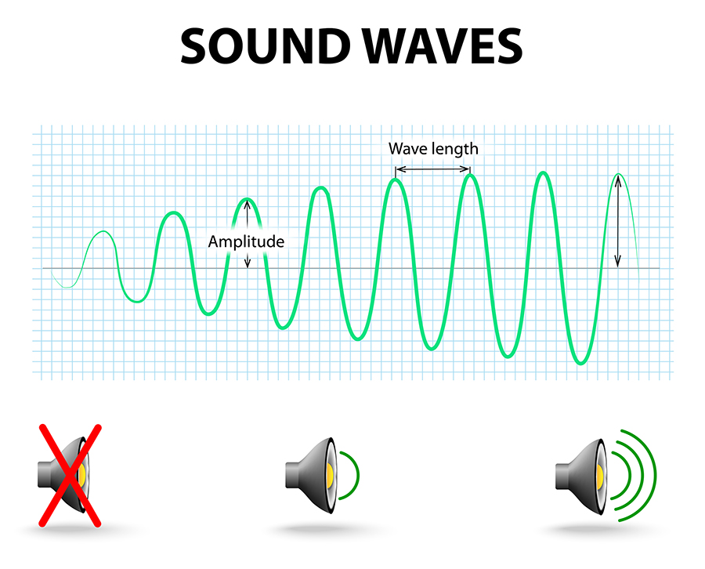**Q.3 Which animals have loud sound? Write any three.**

**Ans: 1) Lion**

**2) Elephant**

**3) Dog**

**Q.4 How can we distinguish between high and low sounds?**

**Ans: Pitch of the sound tell us how high and low sound is.**

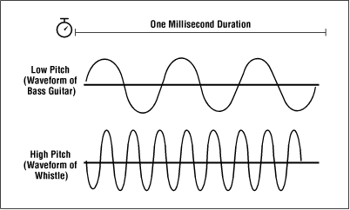

**Q.5 Which sound make noise? Loud and soft.**

**Ans: Loud sound make noise.**

**(A) MCQS**

**Choose the correct answer from the given option.**

**1……….. of the sound tells us how high and low sound is.**

**(a) Pitch (b) Echo (c) Tv mobile (d) None**

**2.Sound are high when something vibrate………………**

**(a) Very low (b) Very fast (c) Medium (d) None**

**3..Example of low sound is ………………………….**

**(a) Bell (b) Mouse (c) Violin (d) Cow**

**4. Sound are low when something vibrate.…………**

**(a) Very low (b) Very fast (c) Medium (d) None**

**5.People make high and low sounds when they…..**

**(a) Sing (b) Sleep (c) (d) None**

**ANS;**

**Mcq 1…….Pitch**

**Mcq 2………very fast**

**Mcq 3………..Cow**

**Mcq 4………….very low**

**Mcq 5……………Sing**

**Pakistan School , Kingdom of Bahrain**

**E- Support and Learning Material / Session 2020-2021**

**Subject: G.Science Grade : 4**

**Book: Simply Science FIRST TERM**

**Unit 3: Changing sounds. Pg. No: ___36__**

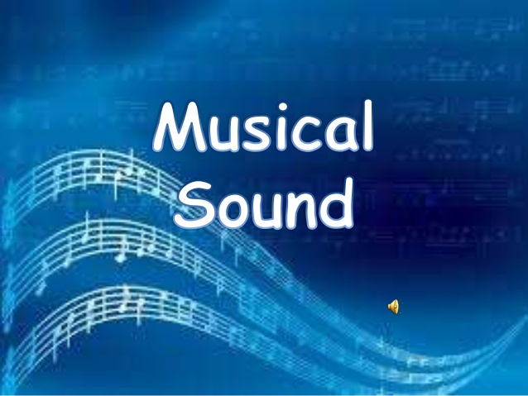 **Topic:( Musical sounds) and ( wind and percussion instruments)**

**(A) Short questions answers**

**Q.1.How musical instrument produced sound?**

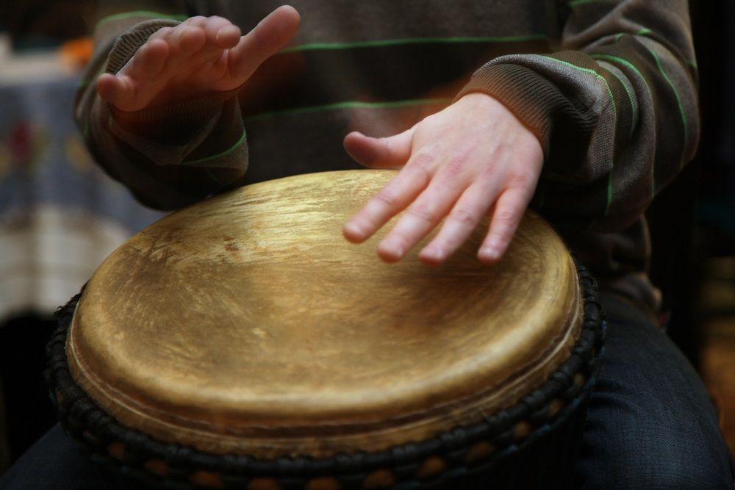**Ans: Musical instruments produced sound when part of it vibrates rapidly .For example skin of a drum vibrate when played.**

**Q.2 How many types of musicsl instrument are there?**

**Ans: There are FIVE major types of musical instrument. These are:**

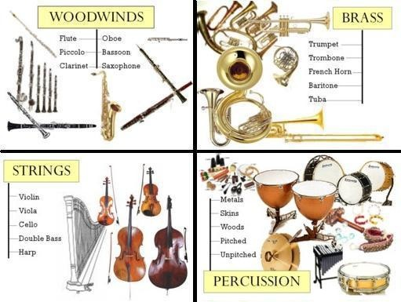 **1) Woodwind**

**2) String**

**3) Brass**

**4) Keyboard**

**5) Percussion**

**Q.3.Which would make the lower pitched note ,a small violin or a much larger cello?**

**Ans: A cello has long strings and so it will produce low notes.**

**A small violin has shorter strings and will produce higher notes.**

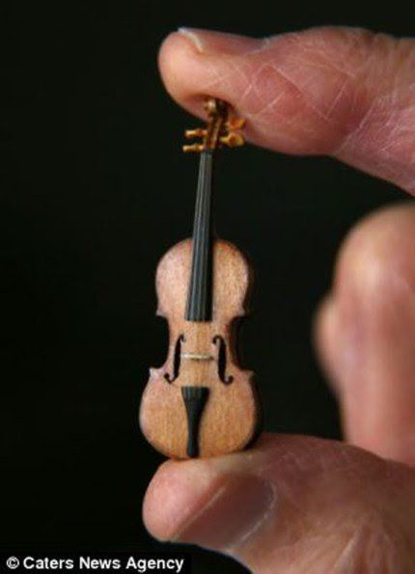**Cello Violin**

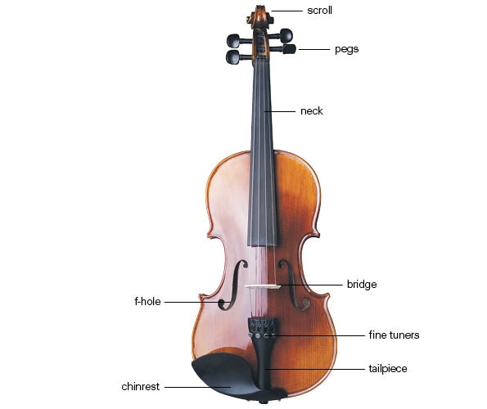

**Q.4 Write the names of two percussion instruments?**

**1) Drum 2) Cymbals**

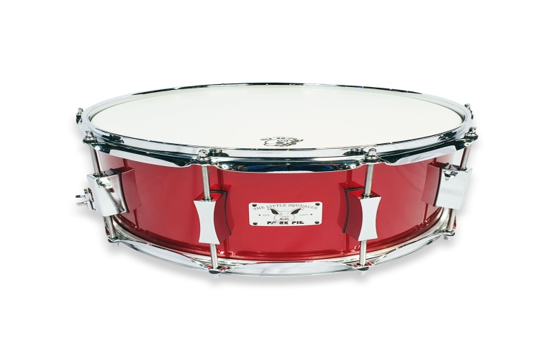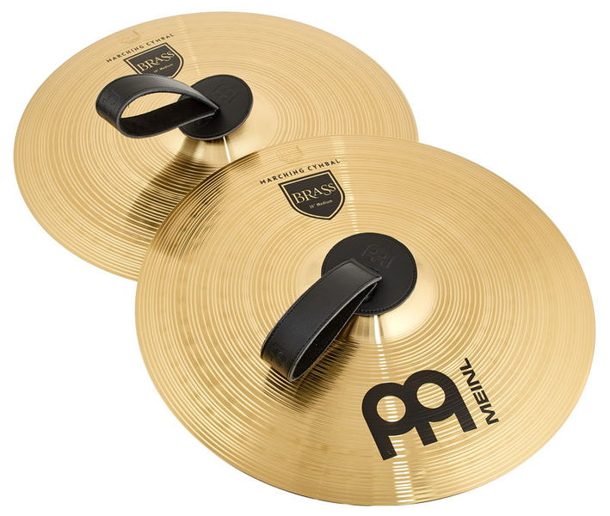

**(A) MCQS**

**Choose the correct answer from the given option.**

**1.The hollow body of a…………….is like a box with strings fixed on it.**

**(a) Guitar (b) Cello (c) Tv (d) None**

**2.A……………… is a row of keys that you press to make sounds.**

**(a) Harps (b) Key board (c) Guitar (d) None**

**3.The example of string instrument is ………………………….**

**(a) Harps (b) Guitar (c) Drum (d) None**

**4. The long strings of piano have a ………… pitch.**

**(a) low (b) fast (c) Medium (d) None**

**5.The shorter the vibrating part of musical instrument the………..the pitch.**

**(a) Lower (b) Higher (c) Medium (d) None**

**ANS;**

**Mcq 1…….Guitar**

**Mcq 2………Keyboard**

**Mcq 3………..Guitar**

**Mcq 4………….low**

**Mcq 5……………higher**