**Pakistan School, Ministry of Education, Kingdom of Bahrain**

**ONLINE GUDIANCE AND SUPPORT FOR HSSC-II**

**Ch 1: Operating System**

**OPERATING SYSTEM FUNCTIONS**

**Q: List functions of Operating System.**

**Ans:** The following are the functions performed by operating system.

1. Process Management
2. Memory Management
3. File Management
4. I/O Management
5. Secondary Storage Management
6. Network Management
7. Protection System
8. Command-interpreter

**Q: Describe functions of Operating System in Detail.**

**Ans:**

1. **Process Management:**  A process is a program in execution. Process management is the part of operating system that manages allocation of computer resources (like CPU time) to various processes in main memory. Process management actually describes the state and resource ownership of each process.

Example: In this example there are 3 processes X, Y and Z ready for execution. The OS will manage the CPU time as follows.

Process A has CPU cycle (ta = 5 milli sec)

Process B has CPU cycle (tb = 2 milli sec)

Process C has CPU cycle (tc = 1 milli sec)

Case 1: When the 3 processes become ready in the order of XYZ, the total execution time will be: τ = (5 + 7 + 8)/3 = 6.67 milli sec

Case 2: When the 3 processes become ready in the order of YZX, the total execution time will be: τ = (2 + 3 + 8)/3 = 4.33 milli sec

In Case2, the OS is managing the processes more efficiently. The execution time in Case 2 is less as compare to Case 1.

1. **Memory Management** : It controls and manages the operation of main memory during the operation of computer. It allocates space to programs which are loaded in main memory for execution. It keeps track of free memory when a program is closed and updates the memory status.
2. **File Management** : OS manages files and folders on storage devices eg hard disk, USB flash drive and DVD. It allows computer user to perform operations such as creating, copying, moving, renaming, deleting, and searching files and folders. It also allows the user to perform read, write, open and close operations upon files and folders.
3. **I/O Management**: I/O management is the part of operating system that controls all the input & output operations during program execution. It manages all the input/output operations of input/output and storage devices. Efficient I/O management improves the performance of computer.
4. **Secondary Storage Management:** OS manages free space and storage allocation of user programs and data on secondary storage devices.

Eg: Program ‘A’ is ready to be stored in Harddisk. Now OS will look for any free space in the Hard disk and assign proper address to it. If space is not available, OS will prompt the user to empty some space.

1. **Network Management:**  Network management is the part of network operating system that monitors and manages the resources of a network. It creates user groups and assigns privileges to them. It shares the network resources among users and detects and fixes network problems.
2. **Protection System: I**t ensures that each resource of computer is used according to the privileges given to users by the system administrator. It creates account for each user and gives privileges to prevent misuse of the system eg provides user name & password to maintain network security.
3. **Command-Interpreter** : It provides interface between user and the computer system. It is a file in operating system that reads and executes user commands entered as text through keyboard.

For example, Windows operating system uses the cmd.exe file as command-interpreter.

**PROCESS MANAGEMENT**

**Q23: Define process management.**

**Ans:** Process management is an important task of operating system. It allocates systems resources to various processes so that they can run efficiently.

**Q24: Define process. Also give example.**

**Ans:** A process is a program in execution.

Process is a part of program under execution that is scheduled and controlled by operating system. When a program is loaded in memory for execution, it becomes a process.

A program is an executable code that is stored in disk as a text file whereas a process is a dynamic instance of a program during its execution in RAM.

It represents basic unit of work. It uses various resources of computer such as CPU time, files, I/O devices, memory, etc.

For example, when we write a program in C or C++ and compile it, the compiler creates a binary code. The original code and Binary code, both are programs. When we actually run the binary code, it becomes a process.

**Q: Describe briefly five states of a process.**

Five states of a process are: new, ready, running, waiting and terminated.

1. **New State:** This is the first state of a process when it is created. Any new operation or service that is requested by a program for execution by the processor is known as new state of process.
2. **Ready State**: A process is said to be in ready state when it is ready for execution but it is waiting to be assigned to the processor by the operating system.
3. **Running State:** A process is said to be in running state when it is being executed by the processor. A process is assigned to a processor for execution by operating system.
4. **Blocked State/Waiting State**: A process is in blocked or waiting state when it is not under execution. It is waiting for a resource to become available.
5. **Terminated State**: A process is in terminated state when it completes its execution.

**Q: Define process & thread**

**Ans:** In programming, there are two basic units of execution: processes and threads. They both execute a series of instructions. A Process is an instance of a program that is being executed. A process may be made up of multiple threads. A Thread is a basic ordered sequence of instructions within a process that can be executed independently. The threads are made of a Process & exist within a process; every process has at least one thread. Multiple threads can also exist in a process and share resources.

* The process of executing multiple threads simultaneously is known as multithreading.
* Multithreading is an execution method of a program that allows a single process to run multiple threads at the same time.
  + - Multithreading allows multiple threads to exist within a single process and these threads can execute independently.
    - The main purpose of multithreading is to provide simultaneous execution of two or more parts of a program to maximum utilize the CPU time.

EXAMPLES: A user is typing a paragraph on MS word. But in background one more thread is running

and checking the spelling mistakes. As soon as user is doing a typing work the other thread notifies the user about the spelling mistakes.

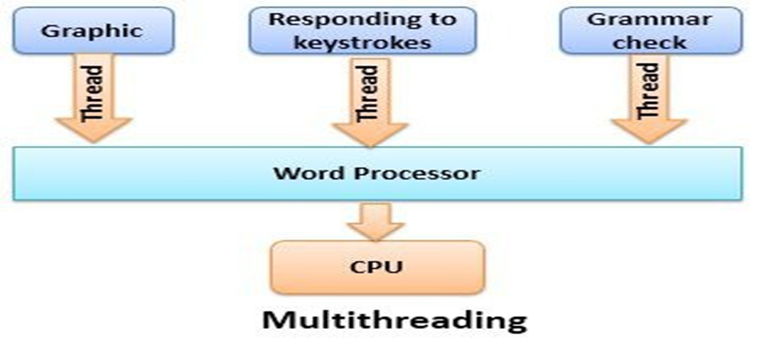

**Q: Choose the Correct answer**

1. _______ allocates systems resources to various processes so that they can run efficiently.

a) Process b) Process Management

c) System d) None of these

1. Process is a part of program under execution that is scheduled and controlled by operating system.

a) Process b) Process Management

c) System d) None of these

1. Any new operation or service that is requested by a program for execution by the processor is known as ______ state of process.

a) Block b) Running

c) New d) Ready

1. When process is ready for execution but it is waiting to be assigned to the processor by the operating system is said to be in ______ state

a) Block b) Running

c) New d) Ready

1. When a process is assigned to a processor for execution by operating system, it is said to be in _______ state.

a) Block b) Running

c) New d) Ready

1. When process is not under execution, It is waiting for a resource to become available called _______ state of process

a) Block b) Running

c) New d) Ready

1. **________** is a subset of the process

a) Process b) Process Management

c) Sub-System d) Thread

1. The process of executing multiple threads simultaneously is known as

a) Process b) Multiprocessing

c) Multithreading d) Thread

1. Loading multiple (programs, processes, tasks, threads) in main memory and executes them at the same time by rapidly switching the CPU among them.

a) Multitasking b) Multiprocessing

c) Multithreading d) Multiprogramming

1. In ______________many programs are loaded in memory but the CPU only executes one program at a time

a) Multitasking b) Multiprocessing

c) Multithreading d) Multiprogramming

1. ____________the ability of an operating system to execute more than one process simultaneously on a multi-processor machine (having more than one CPUs).

a) Multitasking b) Multiprocessing

c) Multithreading d) Multiprogramming

**Pakistan School, Ministry of Education, Kingdom of Bahrain**

**ONLINE GUDIANCE AND SUPPORT FOR HSSC-II**

**Ch 2: System Development Life Cycle (SDLC)**

**Q: What is meant by system development life cycle?.**

**Ans:** The **Systems Development Life Cycle (SDLC)**, in Software Engineering, is the process of creating or altering information systems. In other words these are the models and methodologies that experts use to develop these systems. Software engineering is an engineering approach for software development. In software engineering the SDLC concept reinforces many kinds of software development techniques. These techniques form the framework for planning and controlling the creation of an information system.

**Q: Define system**

**Ans:** A ***system*** is a set of components (hardware and software) for collecting, creating, storing, processing, and distributing information.

**Q: What is importance of system development life cycle?.**

**Ans: System developing life cycle (SDLC)** is a problem-solving process through which a series of steps or phases helps to produce a new computer system.

**Importance of System Development Life Cycle**

* The basic purpose is to develop a system in a systematic way in the perfect manner.
* It delivers quality software which meet the system requirements.
* It ensures that the requirements for the development of the software system
  + are well defined and subsequently satisfied.
* It delivers cost-effective system.
* It maximizes the productivity.

**Q : List three primary Objectives of SDLC**

Ans: A systems development lifecycle (SDLC) has three primary objectives:

1. Ensure that high quality systems are delivered
2. Provide strong management controls over the projects
3. Maximize the productivity

**Q: What is meant by Stakeholders of SDLC**

**Ans : Stakeholders** of SDLC are those entities or groups which are either within theorganization or outside of the organization that sponsor, plan, develop or use a project. Stakeholders may be:

* 1. users
  2. managers
  3. developers

**Q: List phases of SDLC**

**Ans:**

1. Defining Problem
2. Planning
3. Feasibility Study
4. Analysis
5. Requirement Engineering
6. Design
7. Coding
8. Testing / Verification
9. Deployment / Implementation
10. Maintenance / Support

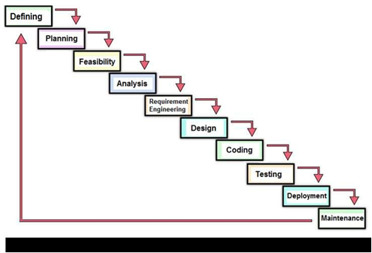

**Q: Describe Defining stage of SDLC**

**Ans:** In this phase the problem to be solved or system to be developed is clearly defined.

* + All the requirements are documented and approved from the customer or the company which consists of all the product requirements to be designed and developed during the development life cycle.

Example: Students’ Examination Development System

Defining the problem: A Students’ Examination developed System that covers all the aspects from Examination taking to the Students’ results generation

**Q: Describe planning phase of SDLC**

**Ans:** During the planning phase,

* + the objective of the project is determined
  + the requirements to produce the product are considered.
  + An estimate of resources, such as personnel and costs, is prepared, along with a concept for the new product.
  + All of the information is analyzed to see if there is an alternative solution to creating a new product. If there is no other viable alternative, the information is assembled into a project plan and presented to management for approval.

Example: In the Students’ Examination System Development project planning will be made to set the ultimate goals and an estimate of resources, such as personnel and costs, is prepared.

**Q: Describe Feasibility phase of SDLC. Also list types of feasibility.**

**Ans:** Feasibility study is used to assess the strengths and weaknesses of a proposd software/system and present directions of activities which will improve a project and achieve desired results. The nature and components of feasibility studies depend primarily on the areas in which analyzed projects are implemented.

* Feasibility study is the analysis and evaluation of a proposed project/system, to determine, whether it is technically, financially/economically, legally and operationally feasible within the estimated cost and time. Feasibility study is one of the important steps in SDLC. It is divided into the following types/forms.
  1. Technical feasibility
  2. Economic feasibility
  3. Operational feasibility
  4. Legal feasibility
  5. Schedule feasibility

 Example: The Students’ Examination project access Development for all types of feasibilities and presented to management for final approval.

**Q: Describe Analysis phase of SDLC.**

**Ans:** During the analysis phase the project team determines the end-user requirements.

Often this is done with the assistance of client focus groups, which provide an explanation of their needs and what their expectations are for the new system and how it will perform.

* In this phase, the in-charge of the project team must decide whether the project should go ahead with the available resources or not.

The project team asks the following questions during the analysis.

* 1. Can the proposed software system be developed with the available resources and budget?
  2. Will this system significantly improve the organization?
  3. Does the existing system even need to be replaced etc.?

Example: The Students’ Examination System project is analyzed for development. The project team will visit the School to study the existing system and will suggest the possible improvements.

**Q: QUIZ - Choose the correct choice**

1. The first step in the system development life cycle is:

a) Analysis b) Design c) Problem Identification d) Development and Documentation

1. The organized process or set of steps that needs to be followed to develop an information system is known as:

a) Analytical cycle b) Design cycle

c) Program specifications d) System development life cycle

1. Enhancements, upgradation and bugs fixation are done during the ______________ step in the SDLC.

a) Maintenance and Evaluation b) Problem Identification

c) Design d) Development and Documentation