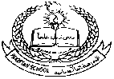**Pakistan School , Kingdom of Bahrain**

**E- Support and Learning Material / Session 2020-2021**

**Subject: General Knowledge Grade :HKG Sec: ______**

**Name: ________________________________ Isa Town / Manama**

**Days of the Week**

**Watch this video :**  [**https://youtu.be/mXMofxtDPUQ**](%20https://youtu.be/mXMofxtDPUQ)

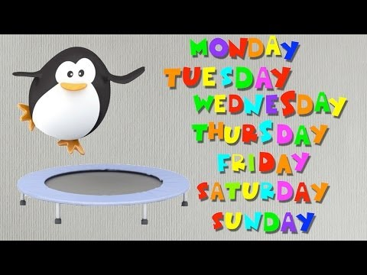

**Learn the names of the days of the week with spellings:**

**Learn the names of the days of the week and also colour it.**

**Activity no 1**

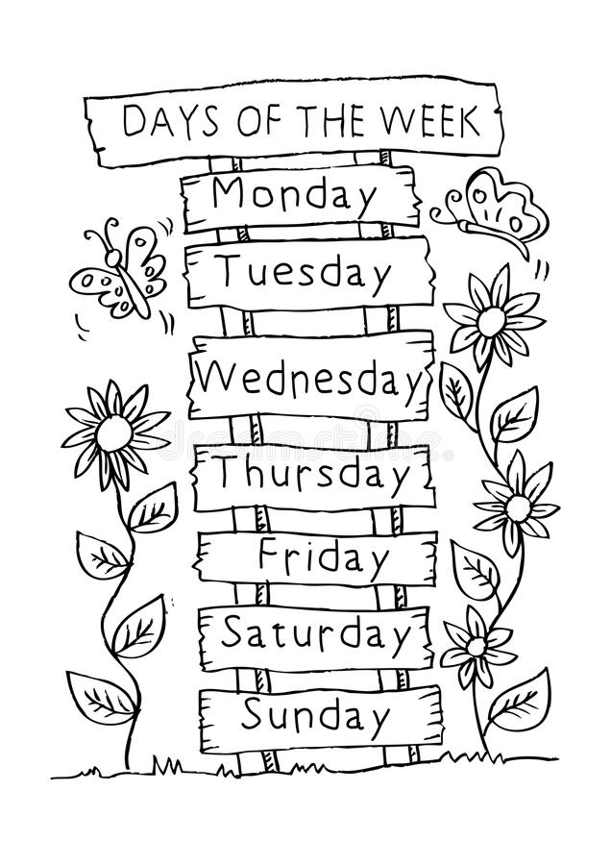

**Activity no 2: Trace the names of the days of the week and learn the spellings:**

