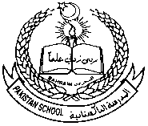 **Pakistan School, Kingdom of Bahrain**

**Subject: GK E- Support and Learning Material**

**Class : LKG( ) Name:___________________**

**Isa Town /Manama**

**Common Vegetables**

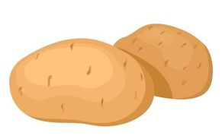

**POTATO TOMATO**

 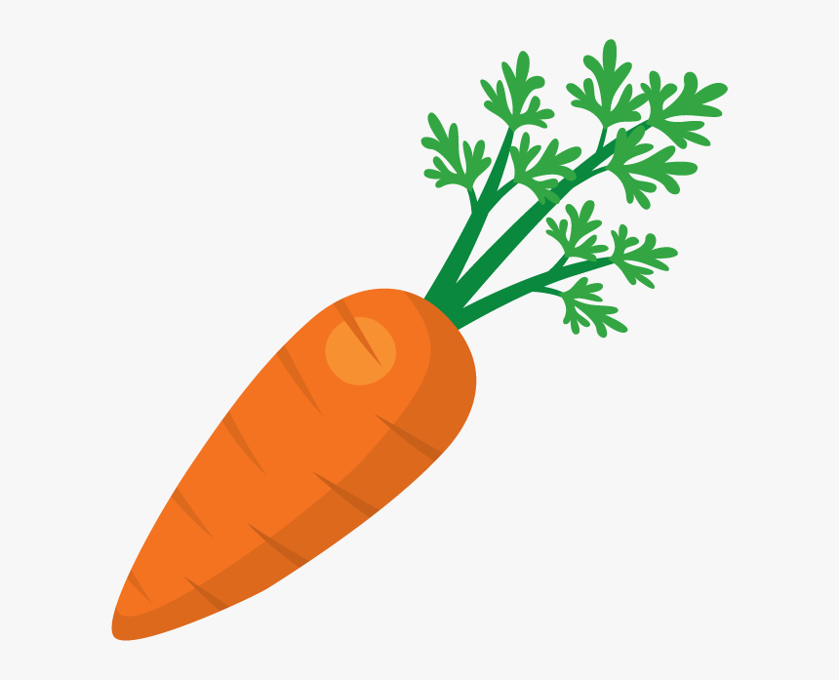

**BRINJAL CARROT**

 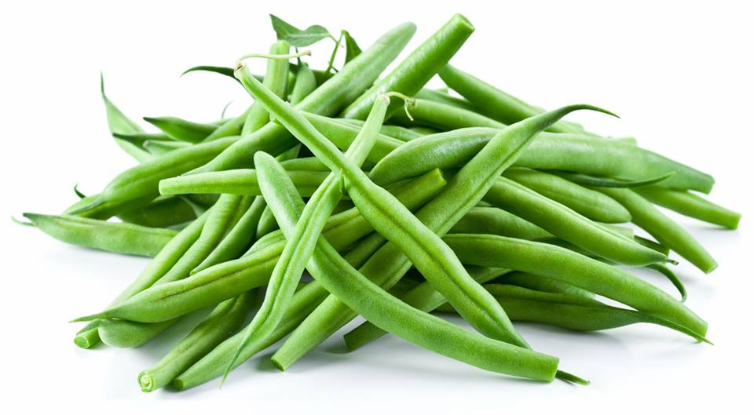

**PEAS BEANS**

**Q1. Color the vegetables.**



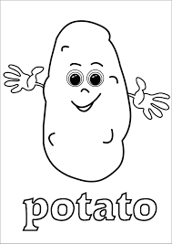

**Potato tomato brinjal/egg plant**

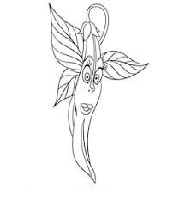

 

**carrot peas beans**