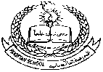**Pakistan School , Kingdom of Bahrain**

**E- Support and Learning Material**

**Subject: Math Name:________________________ Grade : 1 ( )**

* **Topic # 6. Subtraction within Tens.**

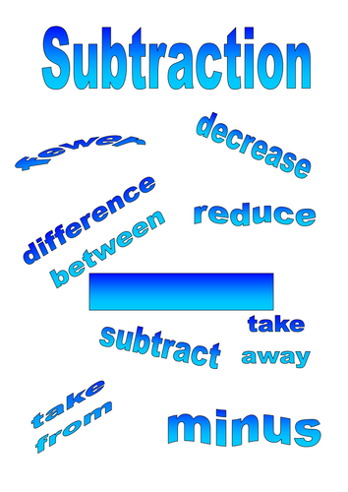

**For Example:**

|  |  |  |
| --- | --- | --- |
| a. | **5**  **- 3**  **2** | **2**  **5 - 3 =** |
| b. | **3**  **- 3**  **0** | **0**  **3 - 3 =** |
| c. | **7**  **- 0**  **7** | **7**  **7 - 0 =** |

**Worksheets Subtraction**

**(Activity- 1)**

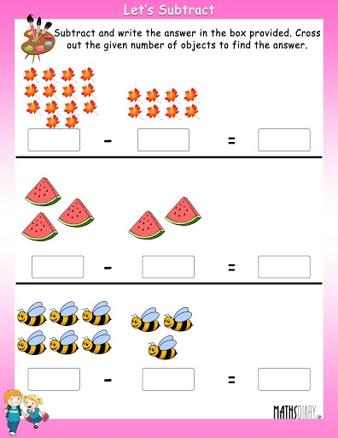

**(Activity -2)**

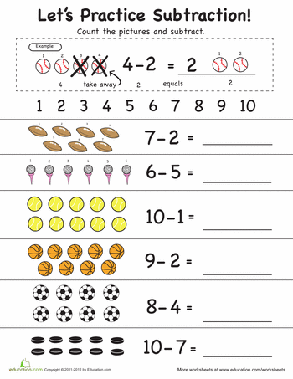

**(Activity – 3)**

**Solve the following sums.**

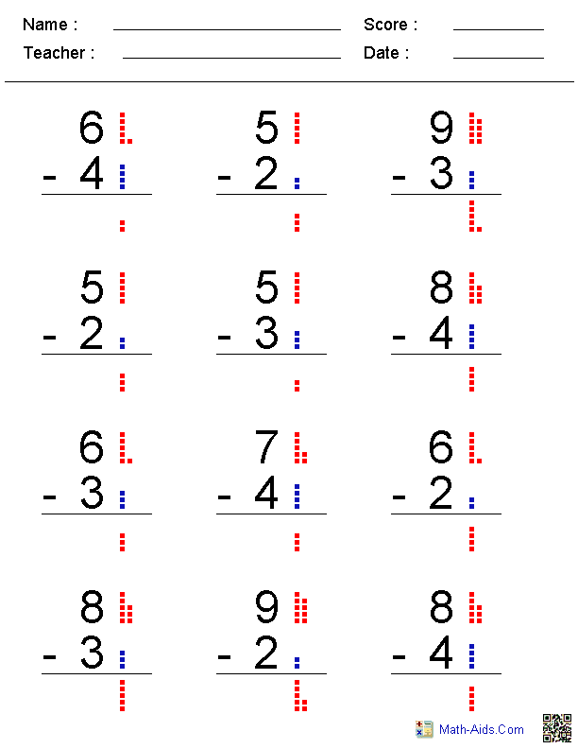

* **Subtraction Word Problem. (Example)**

1. 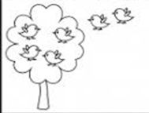**There are 6 birds sitting on a tree. 2 birds flew away. How many birds were left on the Tree?**

Working

6

- 2

4

2

6

**Solution: sitting on the tree, flew away**

4

**birds were left on the tree.**

***\*Note: HW: Solve book pages: 31, 35, 36, 37, 39, 41, 43.***