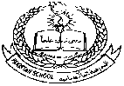**Pakistan School , Kingdom of Bahrain**

**E- Support and Learning Material**

**Subject: Math’s (science) Grade : 10**

**Definitions**

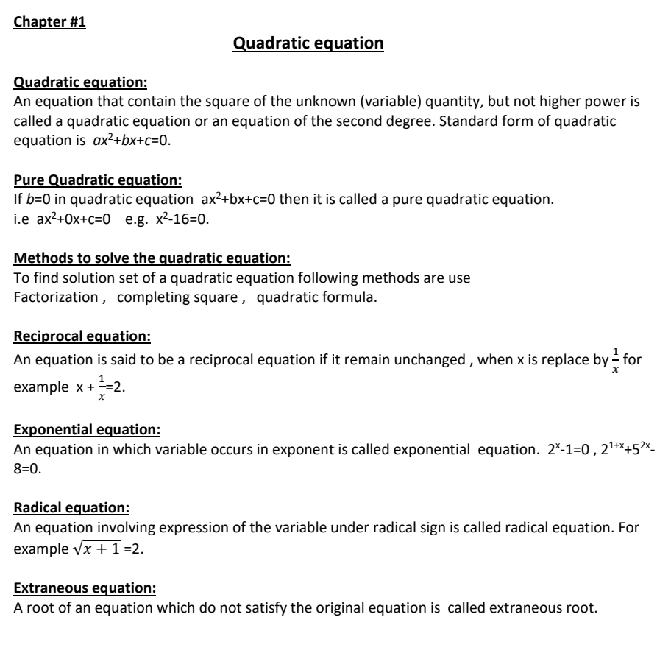

**Pakistan School , Kingdom of Bahrain**

**E- Support and Learning Material**

**Subject: Math’s (science) Grade : 10**

**Unit 1: Quadratic Equations**

***Exercise 1.1***

**Q1. Write the following quadratic equations in the standard form and point out pure quadratic equations**

**(i) $\left(x+7\right)\left(x-3\right)=-7$**

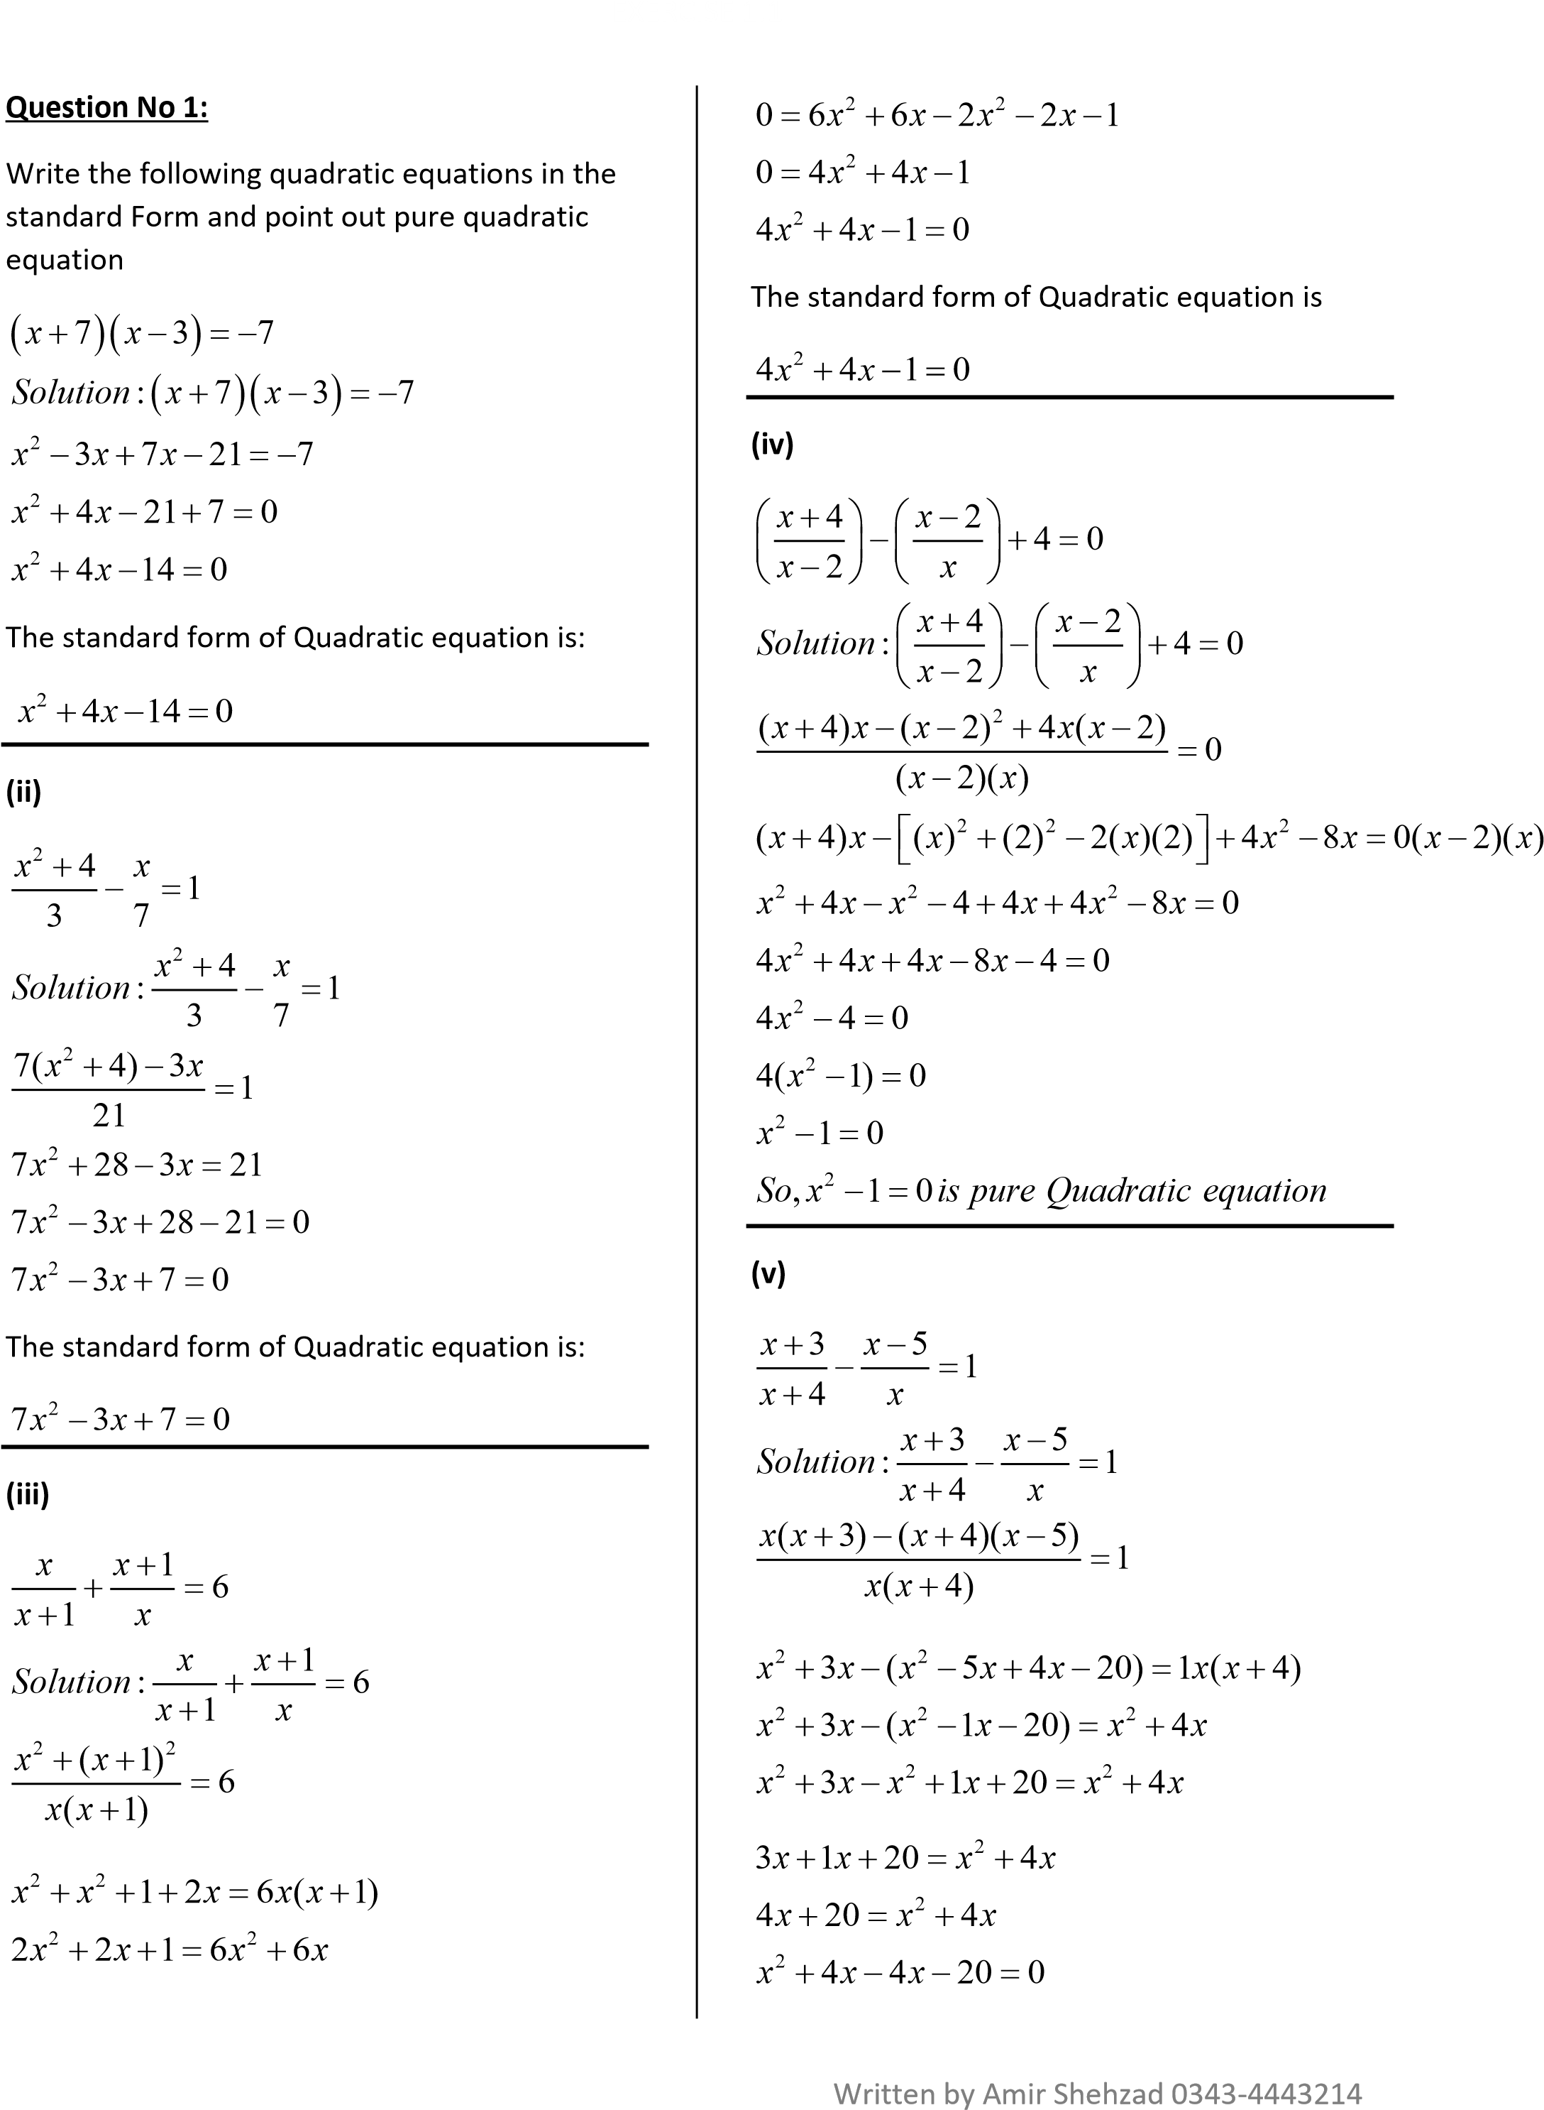

**(iv) $\left(\frac{x+4}{x-2}\right)-\left(\frac{x-2}{x}\right)+4=0$**



**Q2. Solve by factorization**

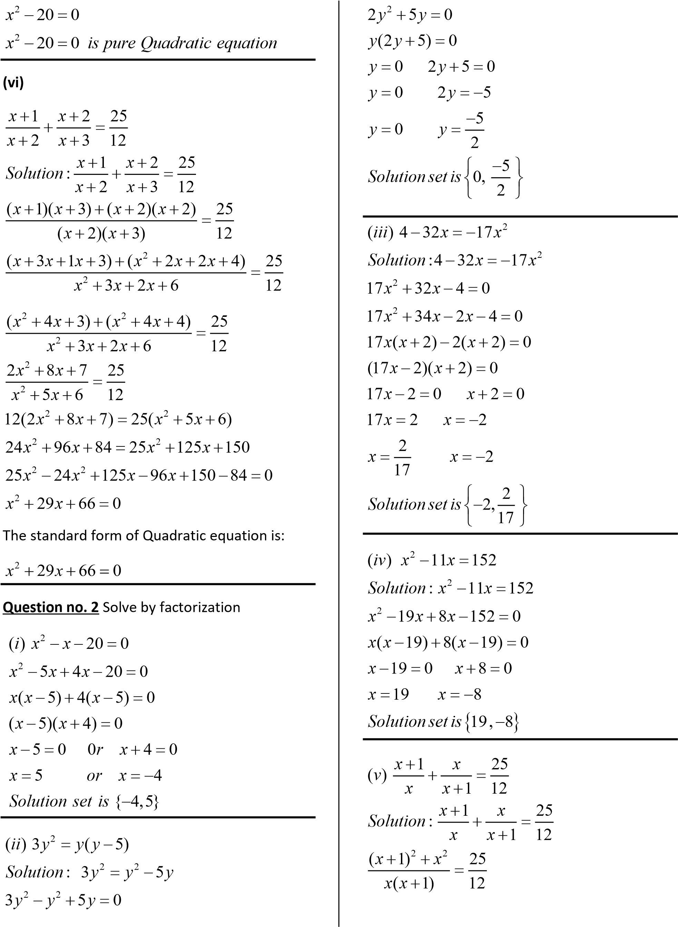

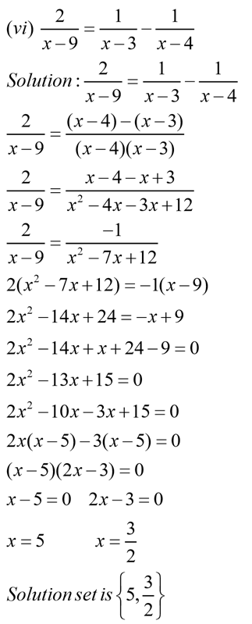

**Activity**

1. Write the given equation in standard form

2) Solve using factorization

$4-32x=17x^{2}$

**Q3. Solve the following equations by completing square**

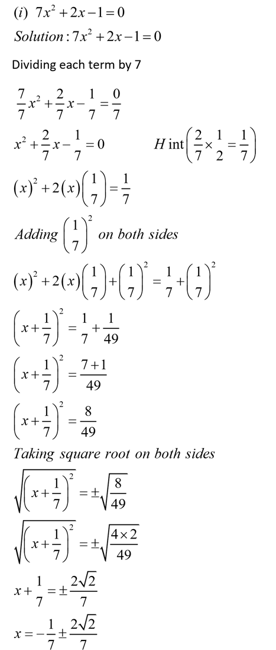

**Activity**

1) Solve using completing square method

$lx^{2}+mx+n=0$

$x^{2}-2x-195=0$

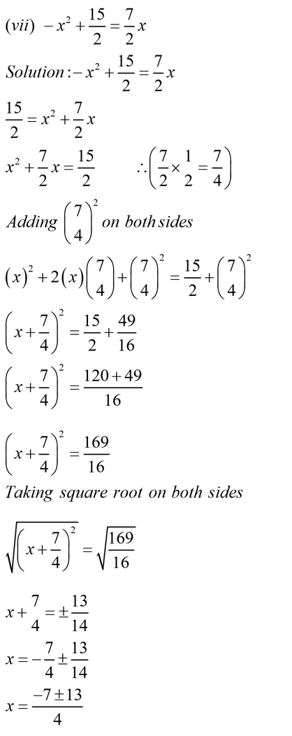

**Homework**

1) Write the given equation in standard form

2) Solve using factorization

3) Solve using completing square method

$3x^{2}+7x=0$

***Exercise 1.2***

**Q1. Solve the following equations using quadratic formula**

(i) $2-x^{2}=7x$

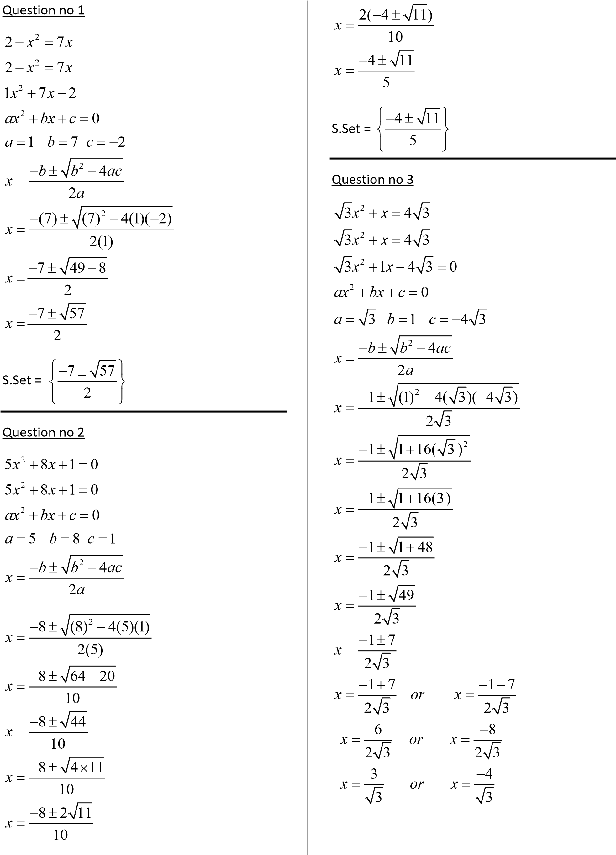

(iv) $4x^{2}-14=3x$

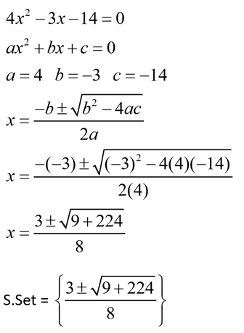

(vii) $\frac{3}{x-6}-\frac{4}{x-5}=1$

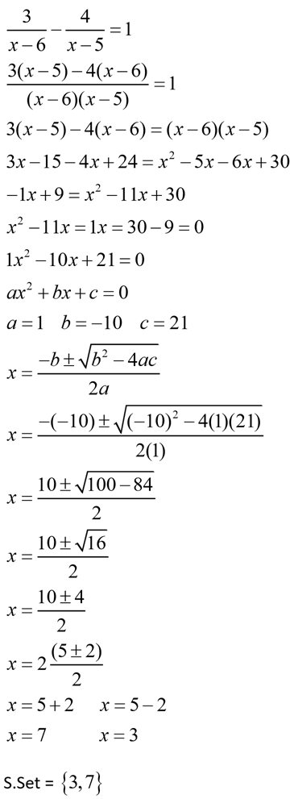

**Activity**

Q. Solve using quadratic formula

$5x^{2}+8x+1=0$

$\frac{x+2}{x-1}-\frac{4-x}{2x}=2\frac{1}{3}$

(ix) $\frac{a}{x-b}+\frac{b}{x-a}=2$

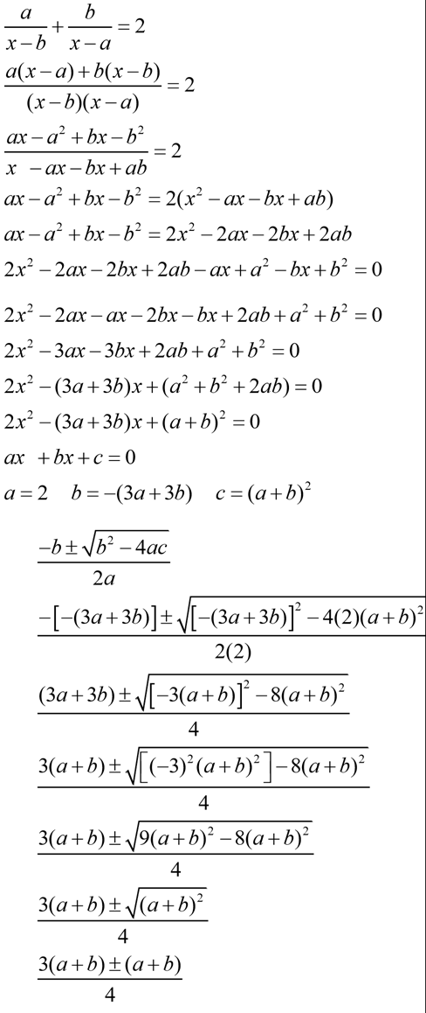

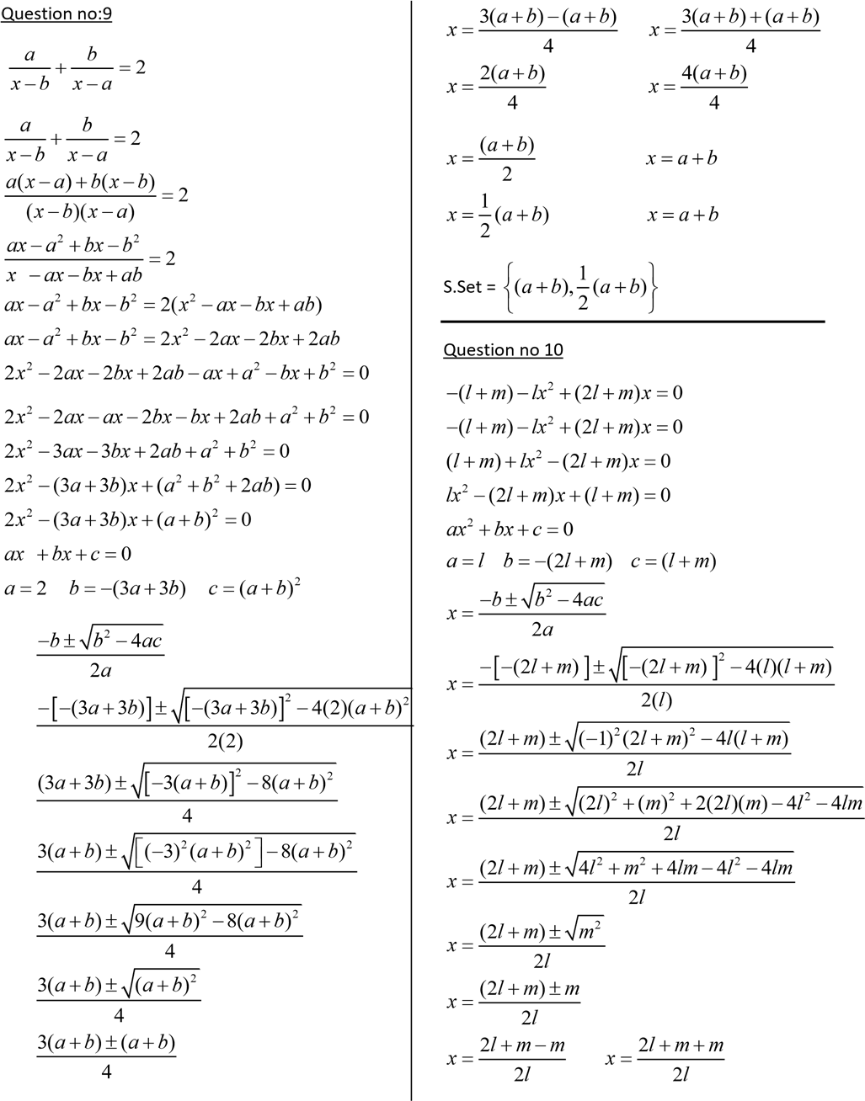  
**Homework**

Q. Solve using quadratic formula

$3x^{2}+8x+2$

$-\left(l+m\right)-lx^{2}+\left(2l+m\right)x=0$

***Exercise 1.3***

**Q. Solve the following equations**

(1) $2x^{4}-11x^{2}+5=0$

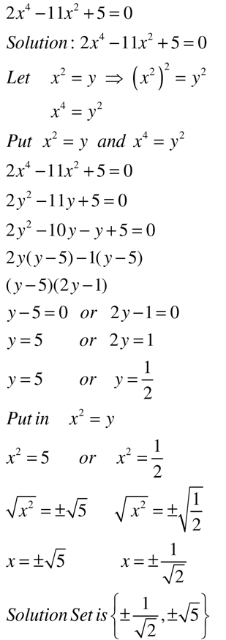

(5) $3x^{-2}+5=8x^{-1}$

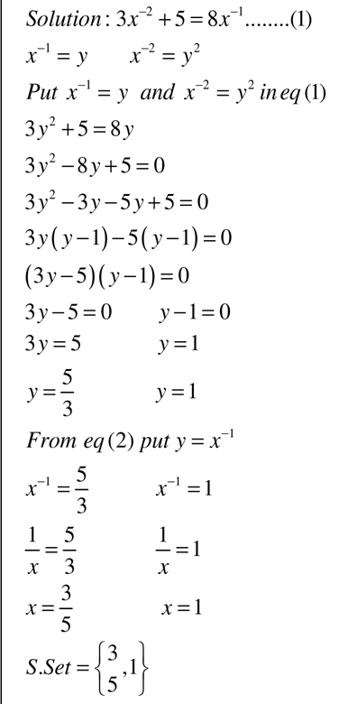

**Activity**

Q. Solve the following equations

$5x^{\frac{1}{2}}=7x^{\frac{1}{4}}-2$

$x^{\frac{2}{3}}+54=15x^{\frac{1}{3}}$

(7) $\frac{x}{x-3}+4\left(\frac{x-3}{x}\right)=4$

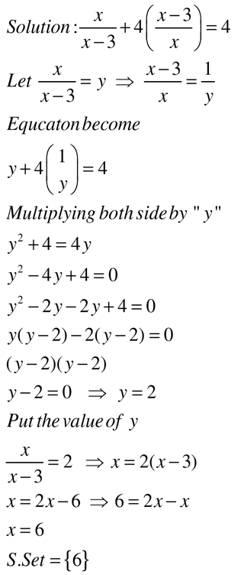

(10) $x^{4}-2x^{3}-2x^{2}+2x+1=0$

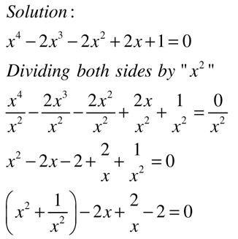

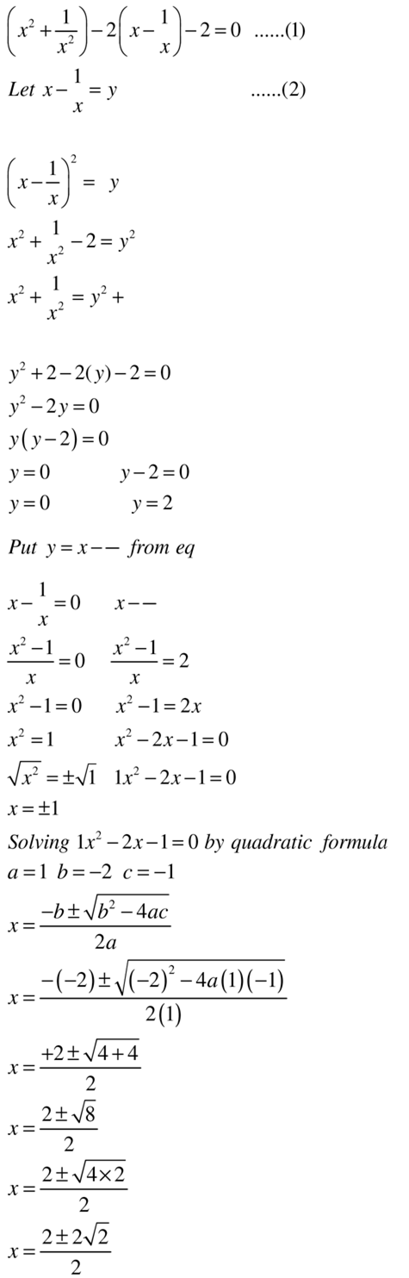

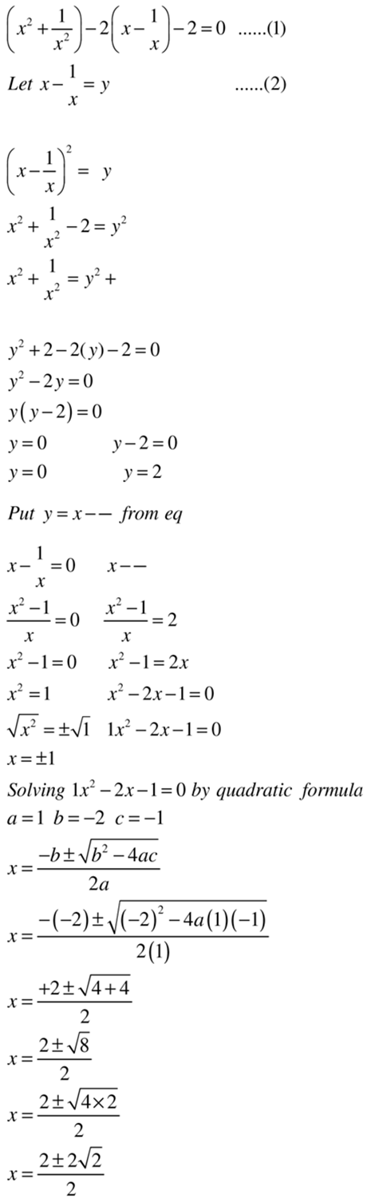

**Homework**

Q. Solve the following equations

${2x}^{4}+x^{3}-6x^{2}+x+2=0$

$\left(x+1\right)\left(x+3\right)\left(x-5\right)\left(x-7\right)=192$

***Exercise 1.4***

**Q. Solve the following equations**

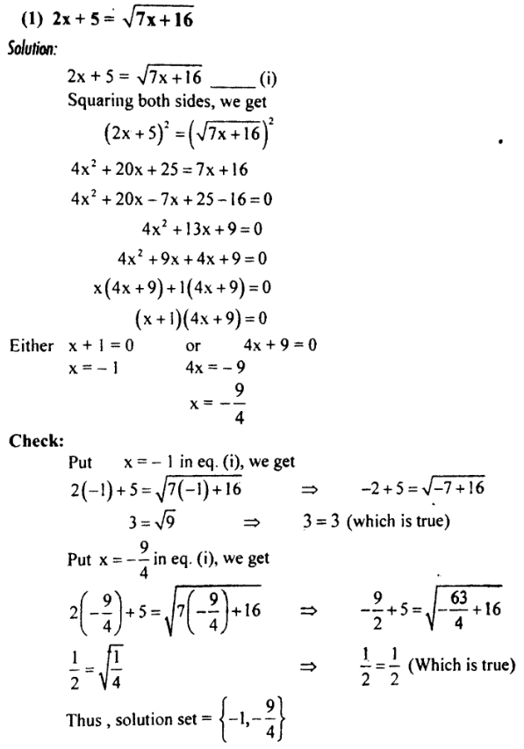

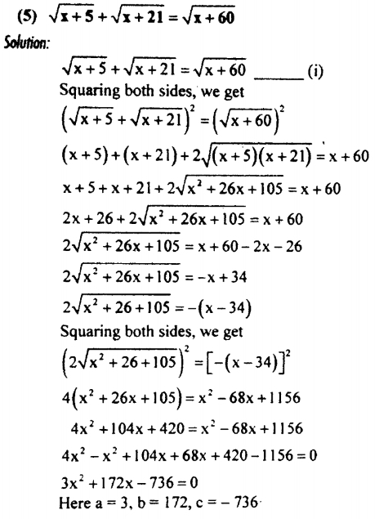

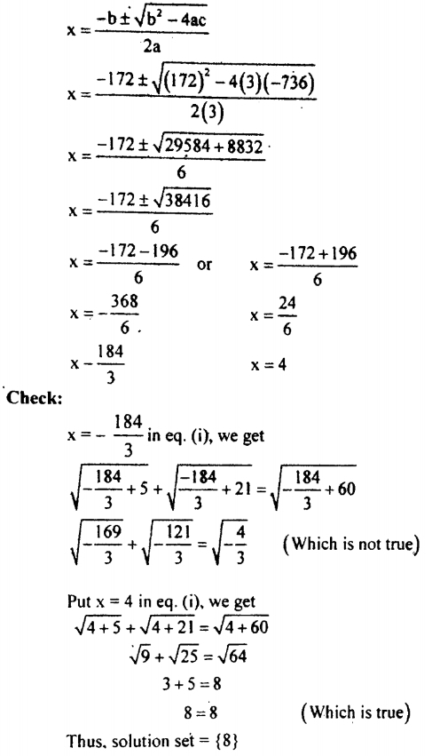



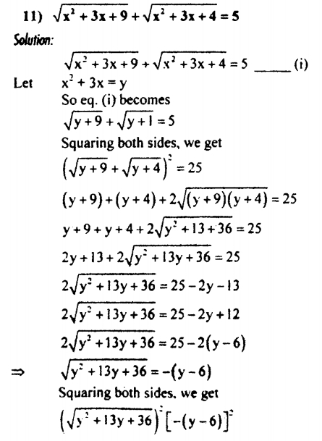

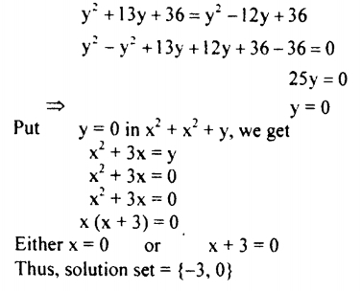

**Activity**

Q. Solve the following equation

$\sqrt{x+3}=3x-1$

$\sqrt{x+1}+\sqrt{x-2}=\sqrt{x+6}$

**Homework**

Q. Solve the following equation

$4x=\sqrt{13x+14}-3$

$\sqrt{11-x}-\sqrt{6-x}=\sqrt{27-x}$

