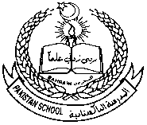  
 Pakistan School, Kingdom of Bahrain.  
 E-Support and learning Material  
 Subject: Math

Unit 11: Two – Dimensional Shapes

Topic: **Straight Lines and Curves** Activity No: 1 Grade: 2 ____

Name: _____________________________ Date: ___________

Q1: Circle the straight lines:-

Q2: How many straight and curved lines are there?  
  
   
  
  
  
  
Straight lines _____ Straight lines ____ Straight Lines _____ Straight lines___  
Curved Lines _____ Curved lines _____ Curved lines ______ Curved lines ____

Q3: Choose the correct answer: -

1- Half Circle has _______ curved lines ( 1 , 2 )

2- A Square has ______ straight lines ( 4 , 0 )

3- A triangle has ______ straight lines ( 4 , 3 )

4- A star has ______ straight lines ( 10 , 6 )

5- Letter **V** has _____ straight lines ( 2 , 4 )

  
 Pakistan School, Kingdom of Bahrain.  
 E-Support and learning Material  
 Subject: Math

Unit 11: Two – Dimensional Shapes

Topic: **Straight Lines and Curves** Activity No: 2 Grade: 2 ____

Name: _____________________________ Date: ___________

Q1: Count the lines in the flag: -   
  
  
How many straight lines are there in the flag? Ans: ___________

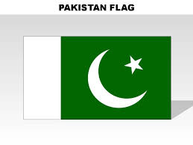

How many straight lines and curved lines are there in in the flag?

Ans: straight lines _________, curved lines _________.

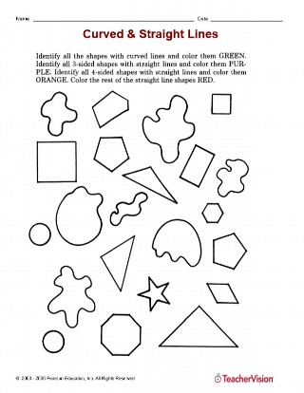

Color the curved lines objects in red.

Color the straight lines object in yellow.

  
 Pakistan School, Kingdom of Bahrain.  
 E-Support and learning Material  
 Subject: Math

Unit 11: Two – Dimensional Shapes

Topic: **Straight Lines and Curves**  Activity No: 3 Grade: 2 ____

Name: _____________________________ Date: __________

Q1: Choose correct answer:-

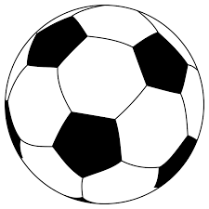  
1- Ball Circle - Oval

2- Cylinder Cylinder - Circle



3- Balloon Oval - Circle

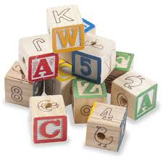

4- Blocks Rectangle - Square

Mountains Oval - Triangle

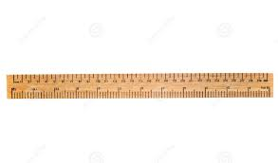

6- Ruler Rectangle - Square

Q2: a) Draw an ice cream using straight and curved lines.

b) Draw a house using straight lines

****Pakistan School, Kingdom of Bahrain.  
E-Support and learning Material  
Subject: Math  
 Unit 11: Two – Dimensional Shapes

Topic: **Straight Lines and Curves** Activity No: 4 Grade: 2 _____

Name: _____________________________ Date: ___________  
  
Q1: Count and complete the table using the shaded boxes only.

|  |
| --- |
| **Figure** |
| **Number of** | **Number of** |
| **Straight Lines** | **Curved lines** |
|  |  |  |
|  |  |  |
|  |  |  |
|  |  |  |

Q2: Match the Following: - ________  
1- Circle   
2- Square ________

3- Triangle _________

4- Cylinder ________

5- Rectangle ________

****Pakistan School, Kingdom of Bahrain.  
E-Support and learning Material  
Subject: Math  
 Unit 11: Two – Dimensional Shapes

Topic: **Symmetrical figures** Activity No: 4 Grade: 2 _____

Name: _____________________________ Date: ___________

Q1: Draw a line to cut the shapes equally in the given worksheet

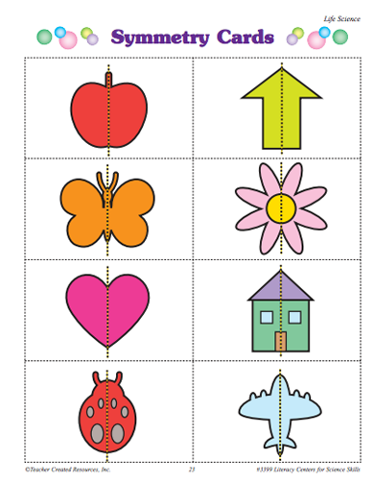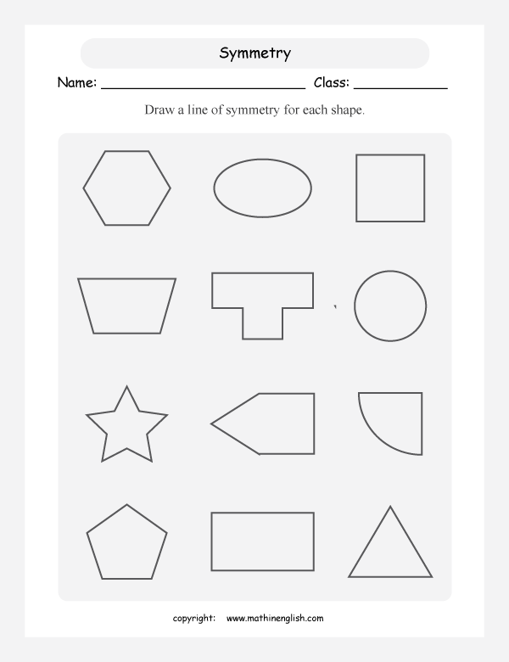

Q2: Which objects are symmetrical (Circle them)

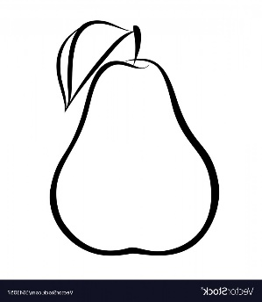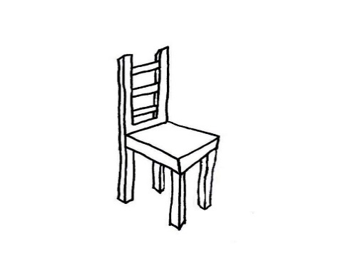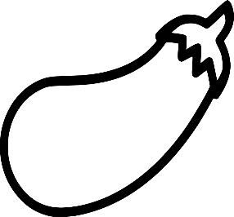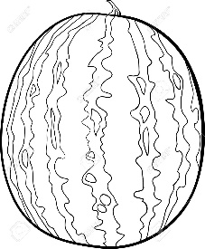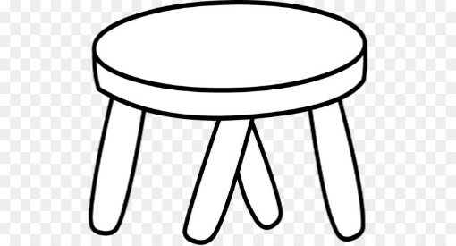

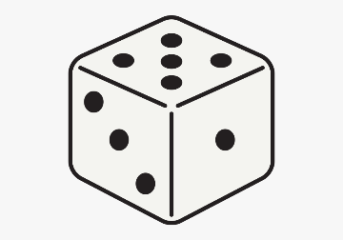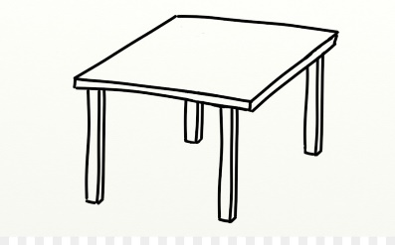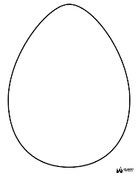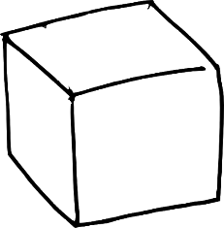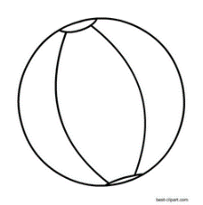

**Book Task**

**Do the following pages in the book**

**Page 188: Q3**

**Page: 189**

**Page: 192**

**Page 196: Q1**

**Page: 202**

**Page: 205**

**Chapter 11 is done**

**Keep doing practice of the given work sheets and book pages**

**Thank you**