** E- Support and Learning Material / Session 2020-2021**

**PAKISTAN SCHOOL, M/O EDUCATION, KINGDOM OF BAHRAIN**

**Subject: Computer Grade: 2**

**Book: OXFORD KEYBOARD Book-2 (Third Edition)**

**FIRST TERM NOTES**

**Chapter 2**

**(Topic: - Printer, Microphone, Speakers, and Headphones) Week 6**

**OBJECTIVE**

The student should be able to:

* **Recognize t**he Printer, microphone, speakers, and headphones.
* **Describe** the uses of Printer, microphone, speakers, and headphones.

**Q1. Who am I?**

1. I am used to store data and can easily be carried in a pocket. **____USB____**
2. I am used to take a printout. **____Printer__**
3. I am used to record sound. **_Microphone_**

**Q2. Write the name of the following devices of a computer:-**

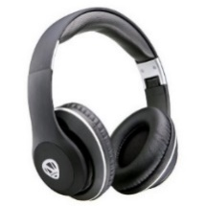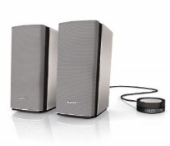

**__Speaker____** ___**Headphone__**

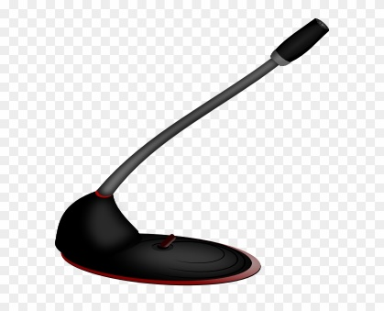

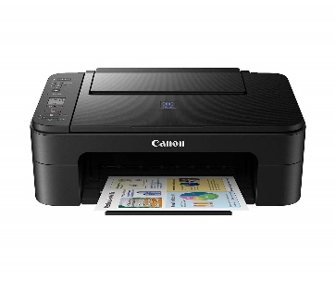

__**Microphone__**

**Printer**

**Q3.Answer the following:-**

**1. Mention two devices used to listen to recorded sound or music?**

Ans: Speakers and headphones

2. **Define the Microphone?**

Ans: Microphone is used to record the sounds.

3. **What is Speaker used for?**

Ans: They are used to listen to recorded sound or music.

4. **Why we used Headphones?**

Ans: Only one person who is wearing the headphone can hear the recorded sound or music.

-------------------------------------------------------------------------------------------------------------------------------