** E- Support and Learning Material / Session 2020-2021**

**PAKISTAN SCHOOL, M/O EDUCATION, KINGDOM OF BAHRAIN**

**Subject: Computer Grade: 2**

**Book: OXFORD KEYBOARD Book-2 (Third Edition)**

**FIRST TERM NOTES**

**Chapter 2 (Topic: - Input and Output Devices) WEEK 7**

**OBJECTIVE**

The student should be able to:

* **Identify** what the input and the output devices are.
* **Describe** Different types of input and output devices.

**Q1.Write the different types of input and output devices?**

|  |  |
| --- | --- |
| **Input Devices** | **Output Devices** |
| Keyboard  Mouse  Microphone | Monitor  Printer  Speaker  Headphone |

**Q2. Answer the following: - (Pg 20)**

1. **Compare output and input devices?**

Ans: **Input devices**: are the ones that are used to enter data into the computer.

**Output devices**: are the ones that are used to give output such as text, images, etc.

**----------------------------------------------------------------------------------------**

**Topic: UPS**

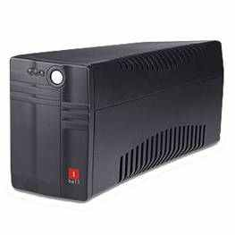**Q3.Short questions and answers:-**

1. **What the UPS stands for?**

**Ans:** It stands for Uninterrupted Power supply. ___**UPS___**

1. **Write any one use of a UPS?**

Ans: A UPS keeps the computer working sometime even after the electricity goes off.

**----------------------------------------------------------------------------------**

**Activity**

**Search for two input and two output device in the gird given below:-**

|  |  |  |  |  |  |  |  |  |  |
| --- | --- | --- | --- | --- | --- | --- | --- | --- | --- |
| S | C | W | F | H | Y | J | N | B | F |
| X | D | P | R | I | N | T | E | R | D |
| E | E | J | S | Y | J | P | S | D | S |
| W | R | T | G | T | U | T | A | E | M |
| F | H | R | F | R | Y | E | W | V | O |
| K | E | Y | B | O | A | R | D | C | U |
| G | S | E | A | G | D | S | C | X | S |
| T | A | W | S | D | E | A | G | G | E |
| Y | W | A | W | S | R | W | H | H | D |
| H | E | A | D | P | H | O | N | E | S |

**Keyboard, Mouse, Printer, Headphone**