** E- Support and Learning Material / Session 2020-2021**

**PAKISTAN SCHOOL, M/O EDUCATION, KINGDOM OF BAHRAIN**

**Subject: Computer Grade: 2**

**Book: OXFORD KEYBOARD Book-2 (Third Edition)**

**FIRST TERM NOTES**

**Chapter 2 (Topic: - Floppy Disk, Hard Disk, CD, DVD, and USB) Week 8**

**OBJECTIVE**

The student should be able to:

* **Identify** floppy disks, hard disks, CDs and DVDs, and USBs

1. what a hard disk is and what it is used for

* **Describe** the use of a USB and its advantage over a CD and DVD

1. differentiate between a CD and a DVD

**Q1. Label the following that you can see in the given picture:**-

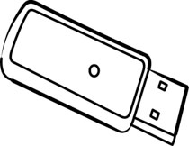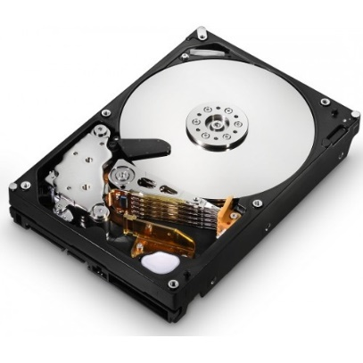

USB_____ __Hard-disk____



**_**Floppy Disk**_**  __DVD___

**Q2.Write the correct words from the given jumbled words:-**

1. **O P Y P L F**

Hint: It is a square-shaped storage device hardly used nowadays.

Ans: **___Floppy_____**

1. **E K R P E A S**

Hint: It is used to listen to recorded sound or music.

Ans: **___Speaker______**

1. **I C D E E V**

Hint: It is an object used to perform a particular task.

Ans: **_____Device______**

**Q3.Answer the following:-**

1. **Name any three devices used to store information permanently?**

Ans: CD, DVD, and ‘USB’

1. **What is hard-disk and why we use it?**

Ans: It look like a box, it is fixed inside the CPU and we used to save data from the computer.

1. **What the UPS stands for?**

**Ans:** It stands for Uninterrupted Power supply.

1. **Write any one use of a UPS?**

Ans: A UPS keeps the computer working sometime even after the electricity goes off.

**Q4. Advantage and disadvantages of hard drive and Floppy disk?**

|  |  |  |
| --- | --- | --- |
| **Storage Device** | **Advantages** | **Disadvantages** |
| **HARD DRIVE** | * Cheapest * Save large amount of data * hard drive is portable | * damaged by   sunlight, dust or liquids |
| **USB** | * It is Small * Easy to Carry * To save data | * It cannot store as much as a hard drive * slower |

**Q5. Differentiate between a CD and a DVD, its advantage and disadvantages**

|  |  |  |
| --- | --- | --- |
| **Storage Device** | **Advantages** | **Disadvantages** |
| **CDs/CDRoms** | * It is small and portable * It can store audio and video data | * It can be easily scratched |
| **DVDs** | * It store good quality audio   and video | * DVDs do not work in   CD drives. |

**GOOD LUCK**

**UNIT: 2 Part of a Computer (Activity)**

**PAKISTAN SCHOOL, M/O EDUCATION, KINGDOM OF BAHRAIN**

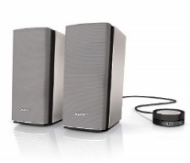**Q1.Name the following devices of a computer:-**



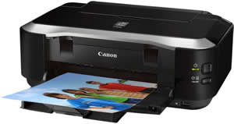

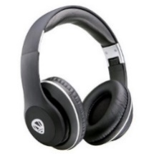



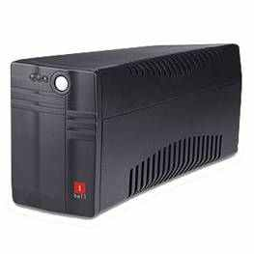



**Q2. Who am I?**

1. I am used to store data and can easily be carried in a pocket. **_______ ____**
2. I am used to take a printout. **____________**
3. I am used to record sound. **____________**
4. I control all the other parts of a computer. **____________**
5. I am an input device. I am also known as a pointing device. **___________**

**Q3.Answer the following:-**

1. **What the CPU stands for?**

**____________________________________________________**

1. **Name any three devices used to store information permanently?**
2. **What is Monitor?**
3. **Define the Microphone?**
4. **Write the name of two devices used to listen to recorded sound or music?**

**___________________________________________________________________________**