** Pakistan School, Kingdom of Bahrain**

**Subject: Maths E- Support and Learning Material**

**Class : 3 Name:___________________**

**Activity No :1 Date: / /**

**Topic: Subtraction**

**Q:Choose the correct answer by subtracting the ones and tens . First one is done for you.**

|  |  |
| --- | --- |
| **1** | 32  **56 -24 = ( 32 , 45 )** |
| **2** | **54 - 34= ( 46 , 20)** |
| **3** | **65 – 21= ( 42 , 44 )** |
| **4** | 76 - 14 (40 , 62) |

**Q: Subtract the 4 digit numbers together by adding ones , tens ,hundreds and**

**thousands.**

|  |  |  |  |
| --- | --- | --- | --- |
| **Th** | **H** | **T** | **O** |
| **4**  **-3** | **6**  **5** | **8**  **6** | **9**  **3** |
|  |  |  |  |

|  |  |  |  |
| --- | --- | --- | --- |
| **Th** | **H** | **T** | **O** |
| **5**  **-3** | **3**  **1** | **7**  **6** | **1**  **0** |
|  |  |  |  |

|  |  |  |  |
| --- | --- | --- | --- |
| **Th** | **H** | **T** | **O** |
| **6**  **-2** | **5**  **5** | **2**  **1** | **7**  **2** |
|  |  |  |  |

**Q: Solve the following sums.**

**1: 4 4 5 5 - 3 4 2 3 =**

**2: 6 3 9 3 - 6 0 4 1=**

**Math Book pg: 35 Solve on book**

**Math Book pg: 36 , 38 , 40 Solve on book**

** Pakistan School, Kingdom of Bahrain**

**Subject: Maths E- Support and Learning Material**

**Class : 3 Activity No : 2**

**Topic: Subtraction Date: / /**

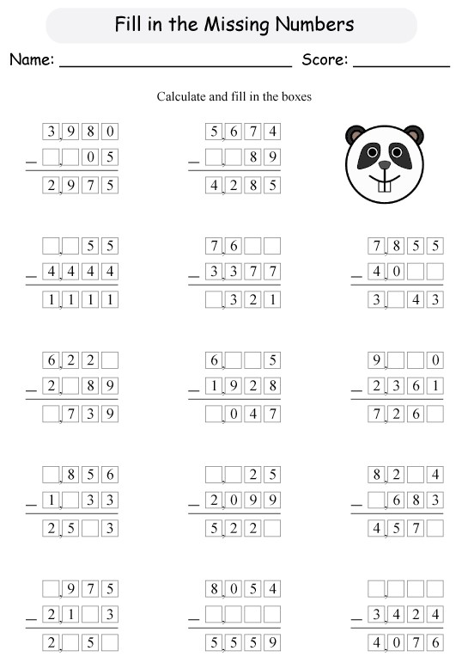

**Mental Math Subtraction book pg : 42 , 43 solve on book.**

**Do more practice of subtraction Sums.**

** Pakistan School, Kingdom of Bahrain**

**Subject: Maths E- Support and Learning Material**

**Class : 3 Name:___________________**

**Activity No : 3 Date: / /**

**Topic: Subtraction**

**Q1:Subtract the following numbers without borrow .**

**6 7 8 6**

**-4 3 4 3**

1. **4 1 7**

**-3 4 0 3**

**5 4 7 6**

**- 2 3 5 3**

**Q2: Solve word problems.**

**( a ): Joe had 2856 T- shirts . If 635 of his T- shirts were red , how many T-shirts were**

**blue?**

**Total no of T-shirts =**

**No of red shirts =**

**=**

**T-shirts were blue.**

**( b): There are 2345 students in a school .If 1202 of them are girls . How many**

**of them are boy?**

**Total no of students in a school:**

**No of girls in a school :**

**=**

**of them are boys.**

**Book pg: 48 Subtraction solve on book.**

**Book pg : 52 , 53 Subtraction solve on Note book .**