** Pakistan School,Kingdom of Bahrain**

**Subject: Maths E- Support and Learning Material**

**Class : 3 Activity No : 1 Date: / /**

**Topic: Currency Name: _________________**

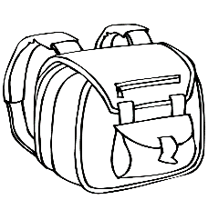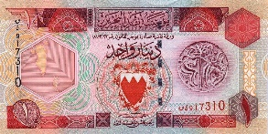 **Q1: Who can buy it? (Directions: Draw a line from each child to the item they can buy):**

5 BD

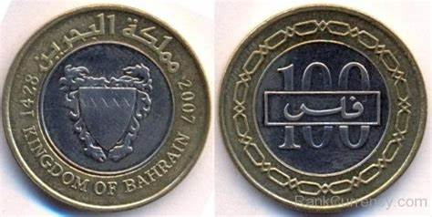

2 BD

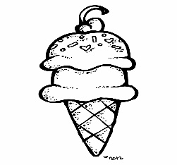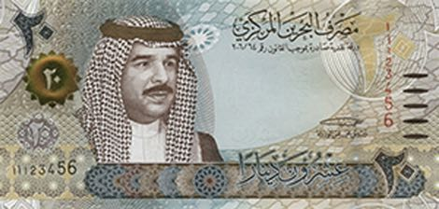

200 fils

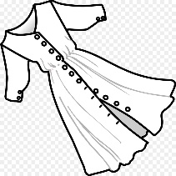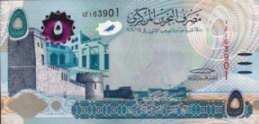

20 BD

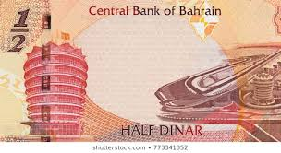 **Q1: Identify the currency and circle the correct answer.**

**( ½ BD , 1BD , 200 fills)**

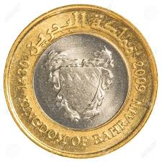

**( 100 fills , 25fills , 1BD)**

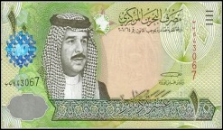

**(10BD , 1BD , 100fills)**

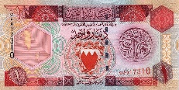 **Q2: The following currency and write the correct answer.**

**+ = _____ BD**

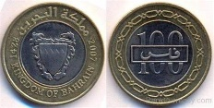

**+ = _____ BD**

**[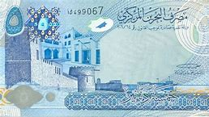](https://www.bing.com/images/search?view=detailV2&ccid=nytQ0orZ&id=3CEC853E26463427BCACC46F96A8C2C8287ABBD0&thid=OIP.nytQ0orZJFhBnD0zRK8wfgHaDm&mediaurl=https://banknoteindex.com/images/notes/submitted/54092_A.jpg&exph=497&expw=1024&q=picture+of+5+bahrain+dinar&simid=608035195068484313&selectedIndex=2)**

**+ = _____ BD**

** Pakistan School, Kingdom of Bahrain**

**Subject: Maths E- Support and Learning Material**

**Class : 3 Name:______________**

**Topic : Currency Date: / /**

**Activity :2**

**Convert fills into BD.**

**1: 1500 fills = _______ BD**

**2: 500 fills = _______BD**

**3: 3000 fills= _______ BD**

**4: 4500 fills= _______ BD**

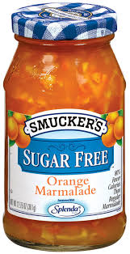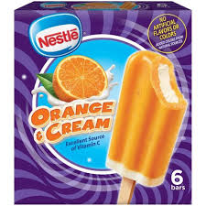**Q: How much do the ice cream and orange jam cost altogether?**

Working

**+**

**+**

1.2 BD

750 FILLS

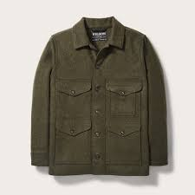**Q: Tom buys a jacket and a pair of jeans . How much does he pay ?**

Working

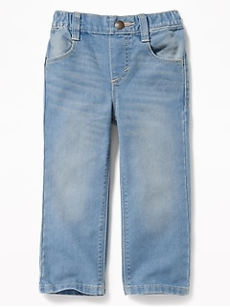

+

3.7 BD

3.5BD

|  |
| --- |
| **See the source imageSara has Her Ice cream cost What will her change be?**  **[Image result for picture of ice cream box](https://www.bing.com/images/search?view=detailV2&ccid=aqAEifg8&id=649F0ACB5055310B8CE9FEFDA4A7D5EA5AF92E2D&thid=OIP.aqAEifg877HpZo9zf46utgHaHa&mediaurl=https://d2lnr5mha7bycj.cloudfront.net/product-image/file/large_4498dcf0-902a-4bc6-a755-46a63d563d8f.JPG&exph=600&expw=600&q=picture+of+ice+cream+box&simid=608014849819935077&selectedIndex=3)**  **Image result for bahrain currency pictures**      **1.5 bd ______________** |
| **See the source image Sania has Her snacks cost What will her change be?**  **[Image result for picture of snack chips](https://www.bing.com/images/search?view=detailV2&ccid=8eqBAmic&id=5963F81D7A250DCAEC30965C58D9207925ED59E6&thid=OIP.8eqBAmicP9XQiygi854GgAHaHa&mediaurl=https://d1vlhxry9oul9s.cloudfront.net/wp-content/uploads/2016/08/12521_kims_snack_chips-1.jpg&exph=500&expw=500&q=picture+of+snack+chips&simid=608006719399199847&selectedIndex=31)Image result for bahrain currency pictures**  **Image result for bahrain currency pictures**  **600 fils ______________** |