** E- Support and Learning Material / Session 2020-2021**

**PAKISTAN SCHOOL, M/O EDUCATION, KINGDOM OF BAHRAIN**

**Subject: Computer Grade: 3**

**Book: OXFORD KEYBOARD Book-3 (Third Edition)**

**FIRST TERM NOTES**

**Chapter 2 (Topic:** - **Set Drawing as a Desktop Background)**

**Week 7**

**OBJECTIVE**

The student should be able to:

* **Identify** how to set a drawing as a desktop background.
* **Describe** the Steps to set drawing as a background.

**Q1. Fill in the blanks:-**

1. You can select a part of a drawing using the **_select**__ tool.
2. You can change the size of a **__drawing___.**
3. The __**Full Screen**__ Option is available by clicking on the view tab.

**Q2.Write T for the true statement and F for the false one.**

1. You can set a drawing as a desktop background. **_True_**
2. You cannot change the size of a drawing. **_False_**
3. The Full Screen Option is available by clicking on the HOME tab. **_False_**
4. You cannot set a picture as a desktop background.  **False_**

**Q3 (a) How will you view a drawing in full screen?**

Ans: To view a drawing in full screen we will click the Full screen option in the Display group on the View tab.

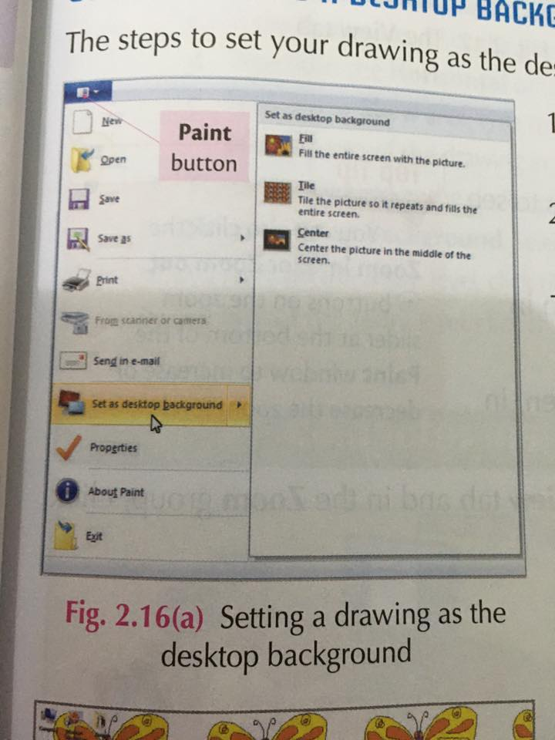**Q3 (b) Write the steps to set a drawing as a desktop background?**

**Ans: - The steps to set a drawing as the desktop background are**

1. Click the **Paint** button and then point to set as desktop background.
2. Select any one of three option:
3. Fill
4. Tile
5. Center
6. Then drawing will display as a background.

**(Topic:** - **Skew a drawing)**

1. The Skew option twists a drawing in the horizontal or vertical direction. **_True_**
2. The **___skew__** Command twists the drawing in the horizontal or vertical direction.

**Q2. What does the Skew command do?**

**Ans:** The **Skew** command twists the drawing in the horizontal or the vertical direction.

**Q3. Assume that the tree you have drawn in Paint fills the entire screen. Your teacher has instructed that the tree should only fill half of the screen. Which tool will you use to make the tree smaller?**

Ans: The Skew tool allows you to resize a picture. It can be used to resize the size of the tree which covers the entire screen so it only fills half the screen.

**----------------------------------------------------------------------------------------**



**PAKISTAN SCHOOL, M/O EDUCATION, KINGDOM OF BAHRAIN**

**Activity**

**Identify and name any four tools from the following figure that can be used to draw the figure of a joker?**

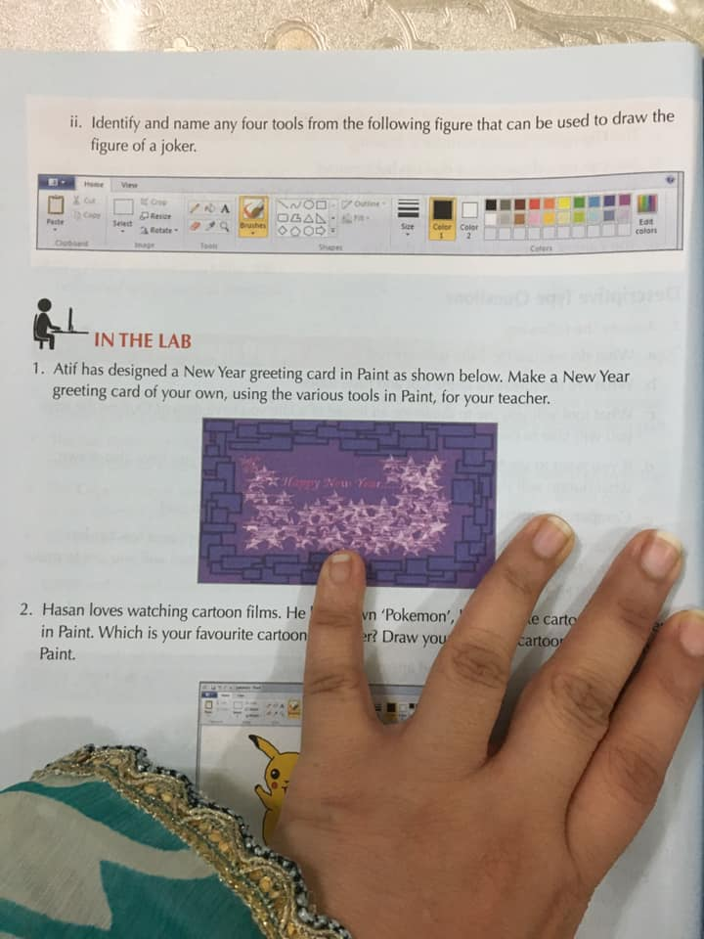

**Ans: - 1. _______________ 2. ____________________**

**3. ___________________ 4. _____________________**

**Answer Key (**Pencil tool, Brush tool, Paint Bucket tool, Shapes tool)