**Pakistan School, Kingdom of Bahrain**

**E- Support and Learning Material**

**Subject: Math Grade: 4**

**Unit 3 : Fraction**

**Lesson 2: Improper fractions**

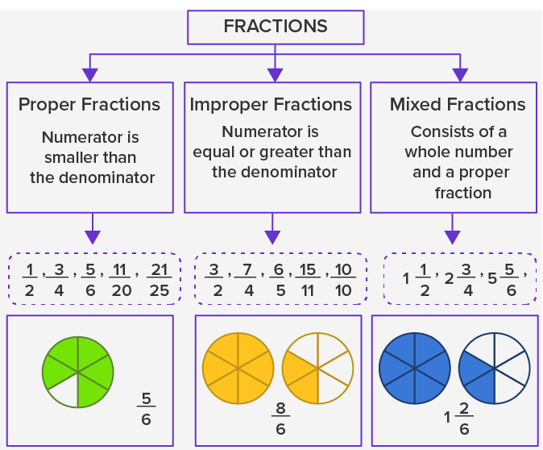

* **Improper fraction:**

The fraction in which numerator is greater than denominator is called improper fraction. For example

$\frac{9}{6}$, $\frac{7}{2}$

Improper Fraction are more than **or** equal to **1**.

**Q1: Write the improper fraction for each of the following?**

**a)**

**1 whole 1 whole $\frac{2}{4}$**   **= $\frac{10}{4}$** Ans

**b)**

**1 whole 1 whole 1 whole**

**1 whole $\frac{3}{4}$ = $\frac{19}{4}$** Ans

***Practice (B. Pg# 68+ 69) +( B. Pg# 71, Q:1)***

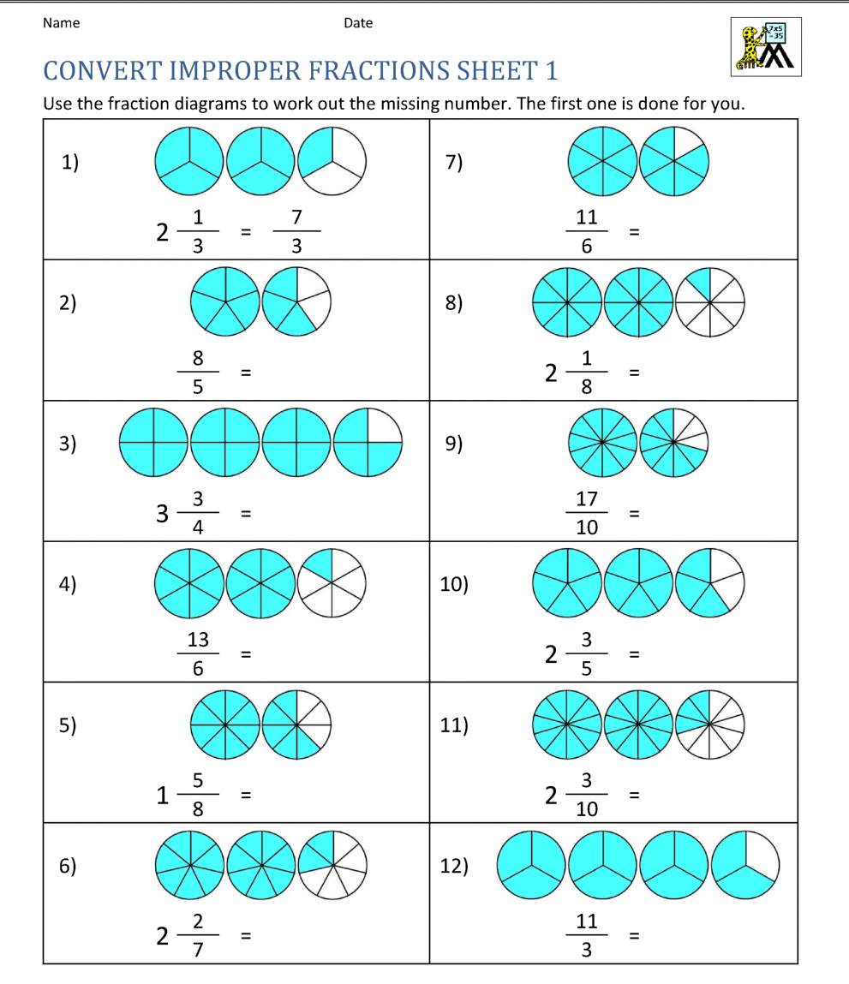***Activity***

**Q2 : What are the missing improper fractions on the number line?**

**1 2**

0 $\frac{1}{4}$ $\frac{2}{4}$ $\frac{3}{4}$ $\frac{4}{4} \frac{5 }{4} \frac{6}{4} \frac{7}{ 4} \frac{8}{ 4}$

**Improper Fraction**

***Practice (B. Pg# 69, Q:4)+( B. Pg# 70, Q:5) )+( B. Pg# 72, Q:2)***

**Q3: Express each of the following in its simplest form**.



$\frac{16}{12}$

4 is the common factor of 12 and 16.

= $\frac{16÷4}{12÷4}$

= $\frac{4}{3}$ Ans

***Practice ( B. Pg# 70, Q:7) )+( B. Pg# 72, Q:3)***

***Activity***

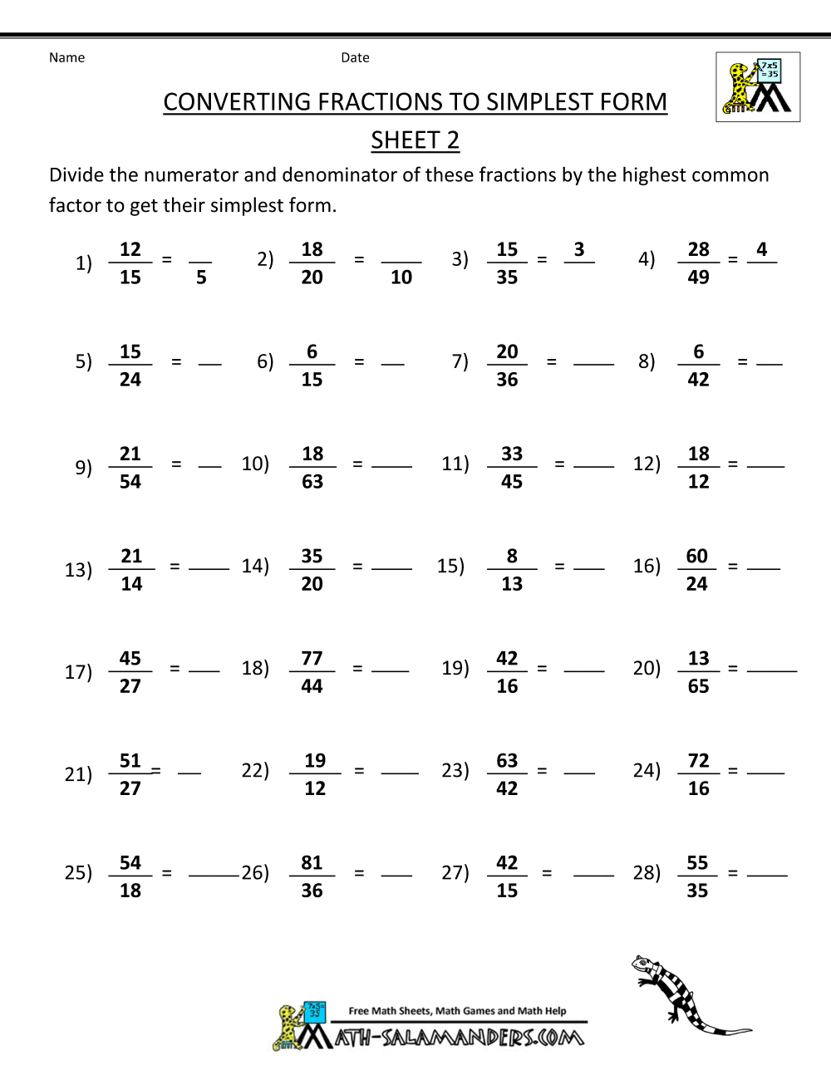

**Lesson 3: Converting Fraction**

**Q 1: Change each improper fraction to a mixed fraction.**

3

1. $\frac{7}{2}$ 2 7

=3 $\frac{1}{2}$ Ans - 6 1

***Practice ( B. Pg# 74+75) )+( B. Pg# 77, Q:1)***

***Practice ( B. Pg# 76, Q:6) )+( B. Pg# 77, Q:2)***

**Q 1: Change each mixed fraction to an improper fraction.**

5 $\frac{2}{9}$

Method: 1) Multiply whole number and denominator.

2) Then add numerator.

3) Write the number on the top of denominator.

= $\frac{9 x 5 + 2}{9}$

= $\frac{47}{9}$ Ans

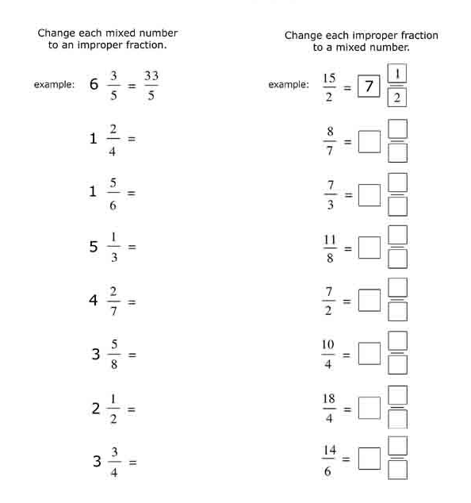 ***Activity***

