**Pakistan School, Kingdom of Bahrain**

**E- Support and Learning Material / Session 2020-2021**

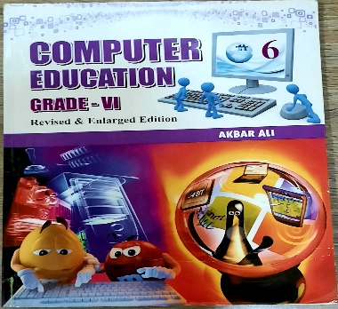 **Subject: Computer Grade: 6**

**Book: Computer Education FIRST TERM**

**Unit 2: Interacting with the computer Week 5**

**Topic: The Mouse: An Input Device**

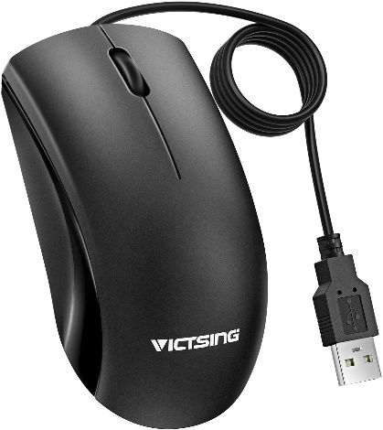**Objectives:**

The student should be able to:

* Identify the computer mouse.
* Types of mouse
* Techniques of using mouse

**Q.1: What do you know about Mouse? Describe briefly?**

**Ans.** The mouse is an input device, a pointing device that rolls around on a flat surface and controls the pointer. The pointer is an on screen object, usually an arrow that is used to select text, access menus, move files and to interact with other objects on the screen.

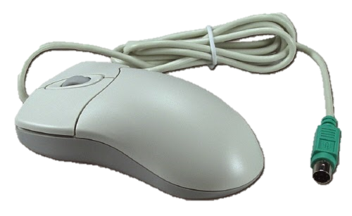 **Q.2: Write a note on mechanical mouse?**

**Ans.** A mechanical mouse is a computer mouse that contains a metal or rubber ball on its underside. When the ball is rolled in any direction, sensors inside the mouse detect this motion and move the on-screen mouse pointer in the same direction. You should place a mechanical mouse on a mouse pad that protects the ball in the mouse from dust.

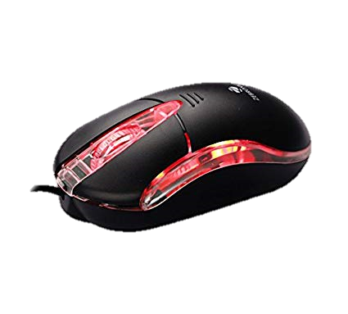**Q.3: What do you know about an optical mouse?**

**Ans.** An optical mouse have no moving mechanical parts inside. It uses devices that emit and sense light to detect the movement of mouse. Some use optical sensors, others use laser. You can place an optical mouse on nearly all types of surfaces. An optical mouse is more precise than a mechanical mouse and does not require cleaning like a mechanical mouse.

**Q.4: Explain the directions to use a mouse?**

**Ans.** You use a mouse to point to a location on the screen. When you will push the mouse in any direction the pointer will move in the same direction on the screen.

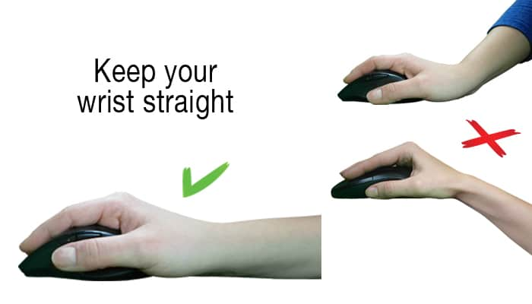

**Q.5: Write some techniques of using Mouse?**

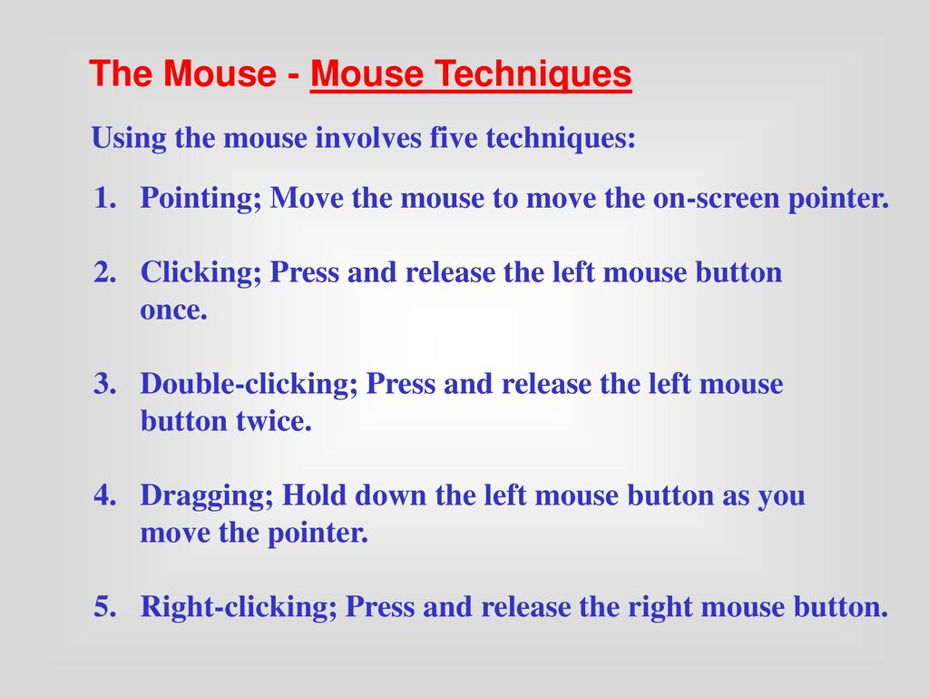**Ans.**

* **Fill in the blanks.**

1. An optical mouse is more precise than a mechanical mouse.
2. Pressing and releasing the mouse button is called clicking.
3. There are five types of using a mouse i.e. clicking, pointing, double-clicking, dragging, and right clicking.
4. Mouse is an input device.
5. The on screen arrow is called mouse pointer.
6. You use a mouse to point to a location on the screen.
7. A mechanical mouse uses devices that emit and sense light.
8. You can place an optical mouse on nearly all types of surfaces.
9. A mechanical mouse is a computer mouse that contains a metal or rubber ball on its underside.

**10.** You should place a mechanical mouse on a mouse pad.

* **Write T for the true statements and F for the false ones.**

1. The mechanical mouse is more precise than an optical mouse. (F)
2. Mouse is an output device. (T)
3. A mouse has only two buttons i.e. left click and right click. (F)
4. The pointer is an on screen object, usually an arrow. (T)
5. You cannot place an optical mouse on nearly all types of surfaces. (F)
6. A mouse pad protects the ball in the mouse from dust. (T)

