**Pakistan School, Kingdom Of Bahrain**

**NEW BOOK**

**Subject: Mathematics** **Grade: 6**

**Chapter: 6 CIRCLES**

**LESSON: 1 Pg.125**

**TOPIC : PERIMETER 0F SEMICIRCLE**

**EXAMPLE # 1**  
 **Pg.# 125**

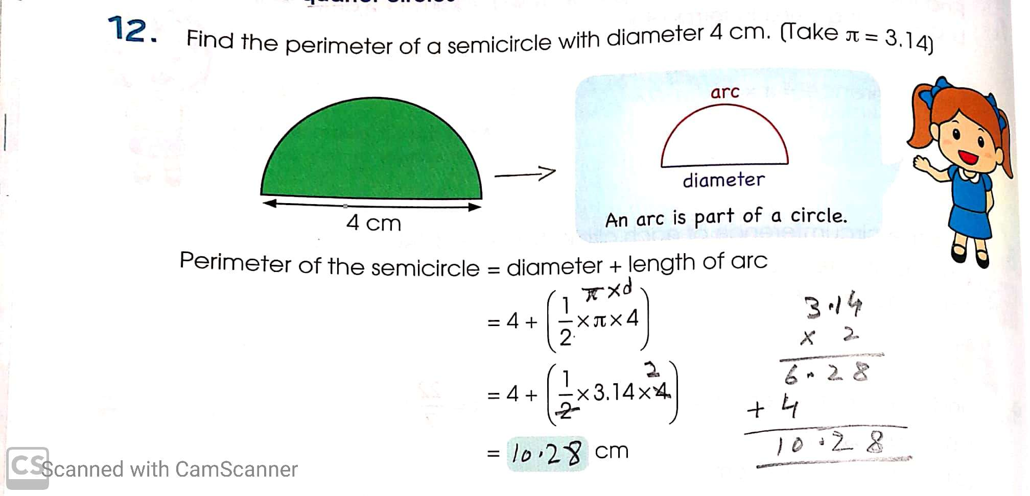

**Example # 2  
 Pg. # 125**

Q.14. Find the perimeter of the following. Give your answer correct to 2 decimal places.

(b) A semicircle of radius 3.8 cm.

Solution: d = 2 r

Formula =2x3.8cm

Perimeter of semicircle d =7.6 cm

=diameter + length of arc

=7.6 + (1/2 x π x d)

= 7.6 + (1/2 x 22/7 x 7.6)

= 7.6 + 83.6 / 7

= 7.6 + 11.94

= 19.54 cm Ans.

**Example # 3**

Q.14. Find the perimeter of the following. Give your answer correct to 2 decimal places.

(b) A semicircle of radius 1.2 cm.

Solution: d = 2 r

Formula =2x1.2cm

Perimeter of semicircle d =2.4 cm

=diameter + length of arc

= 2.4+ (1/2 x π x d)

= 2.4 + (1/2 x 3.14 x 2.4)

= 2.4 + 7.536 / 2

= 2.4 + 3.76

= 6.16 cm Ans.

**Homework**

1. Find the perimeter of the following semi-circles. (Solve any three)
2. Diameter = 5cm
3. Radius = 3.2cm
4. Radius = 2.5cm
5. Diameter = 7cm

**TOPIC : PERIMETER 0F QUARTER CIRCLE**

**EXAMPLE # 1 Pg. # 125**

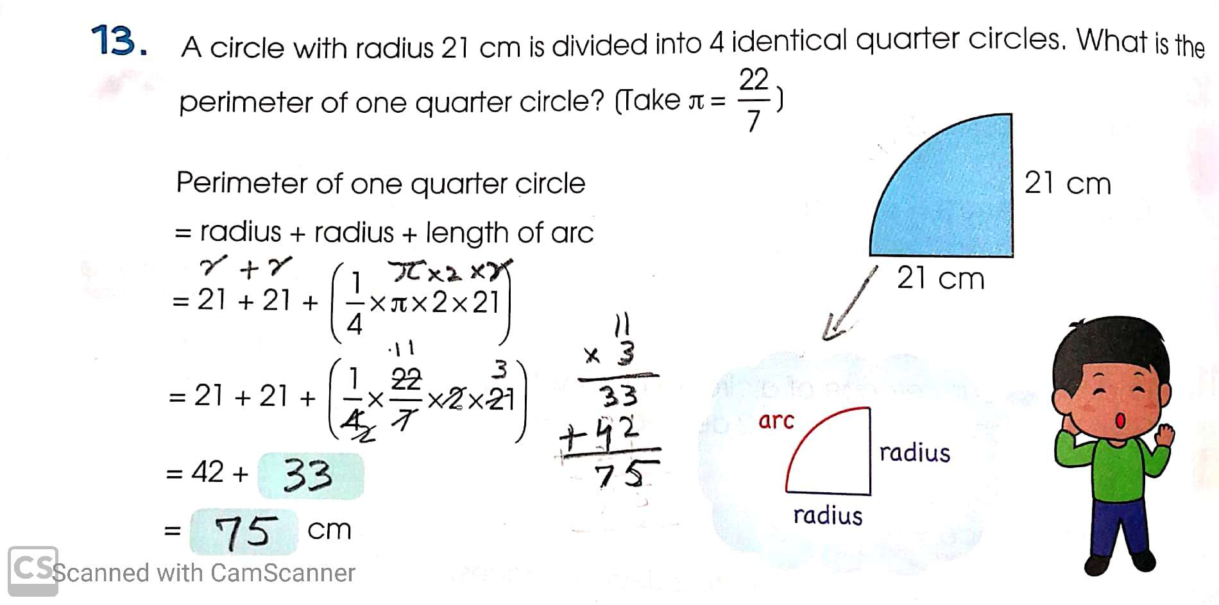

**Example # 2**

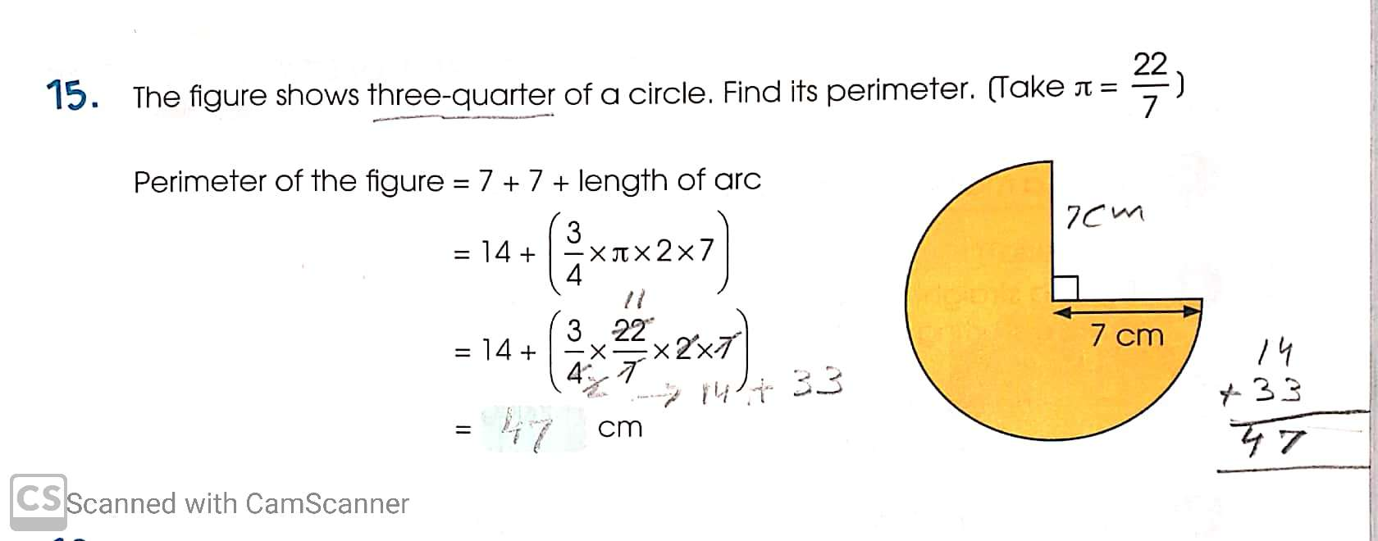

**Pg: 126**

**Example # 3**

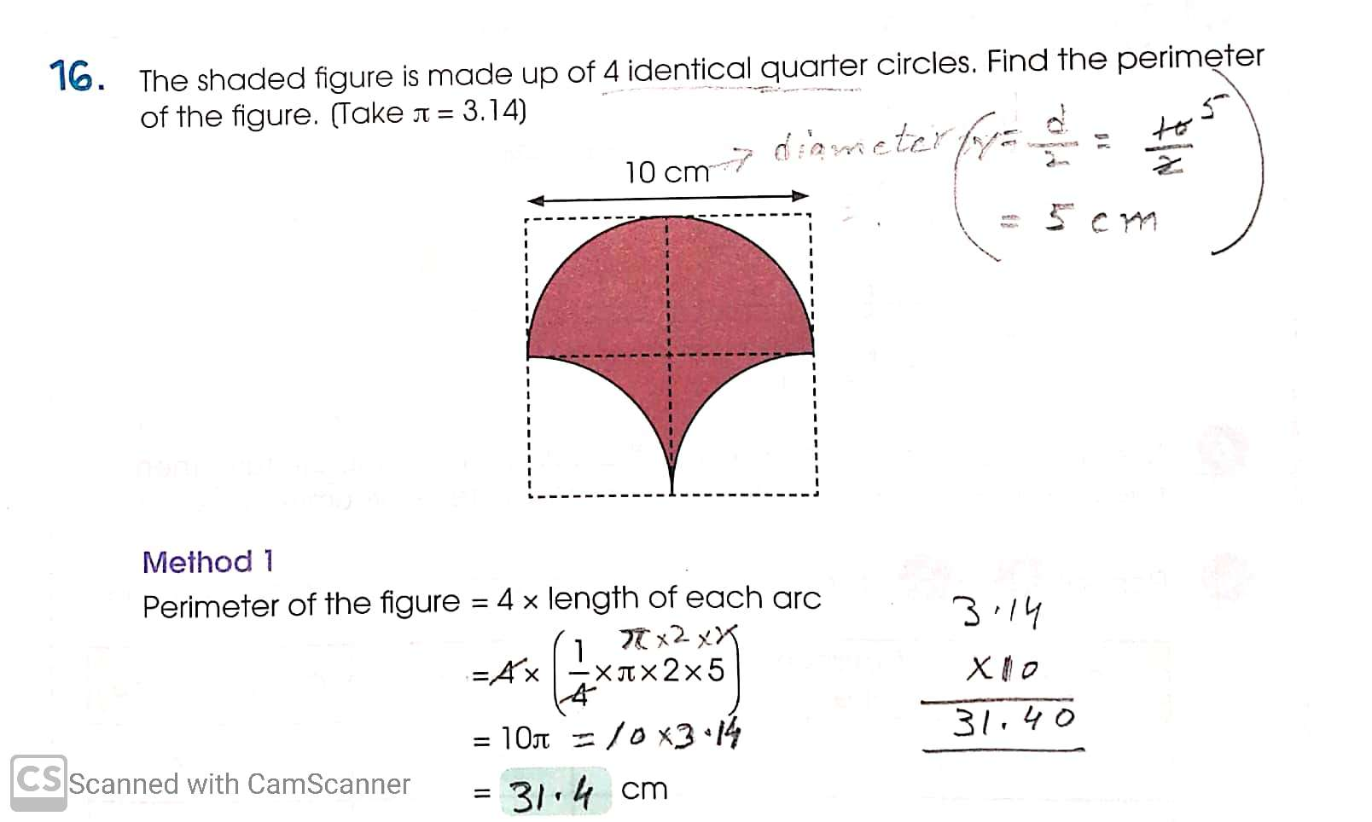

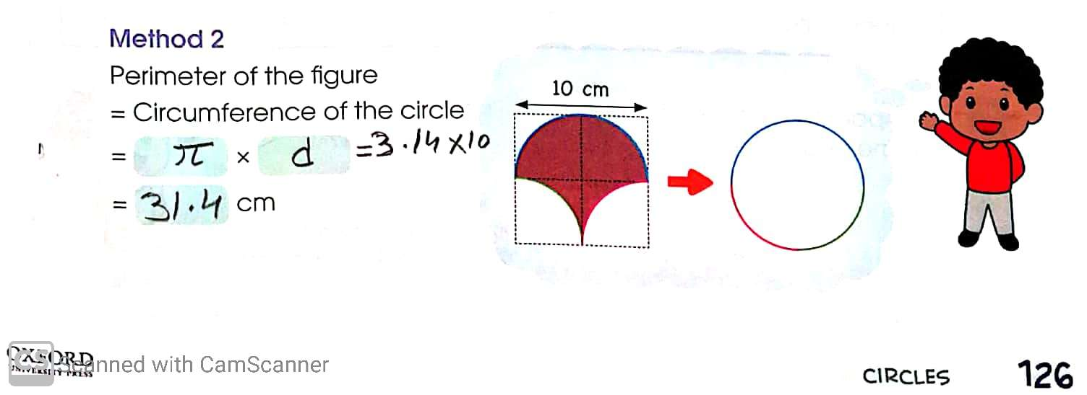 **Example # 4**

Q. Find the perimeter of the following. Give your answer correct to 2 decimal places.

A quarter circle of radius is 4.5 m.

Perimeter of one quarter circle

= radius + radius + length of arc

= 4.5 + 4.5 + ( 1/4 x π x 2 x r)

= 4.5 + 4.5 + (1/4 x 3.14 x 2 x 4.5)

= 9.0 + 28.26 / 4

= 9.0 + 7.065

= 16.065 or 16.07 m Ans.

**Homework**

1. Find the perimeter of the following quarter circles. (Solve any three)
2. Radius = 4cm
3. Radius = 1.2cm
4. Radius = 2.5cm
5. Radius = 6cm