**Pakistan School, Kingdom Of Bahrain**  
   
**Subject: Mathematics**  **Grade: 7**

**Chapter: 2 Ex. 2C**

**TOPIC: COMBINED OPERATIONS ON NUMBERS**

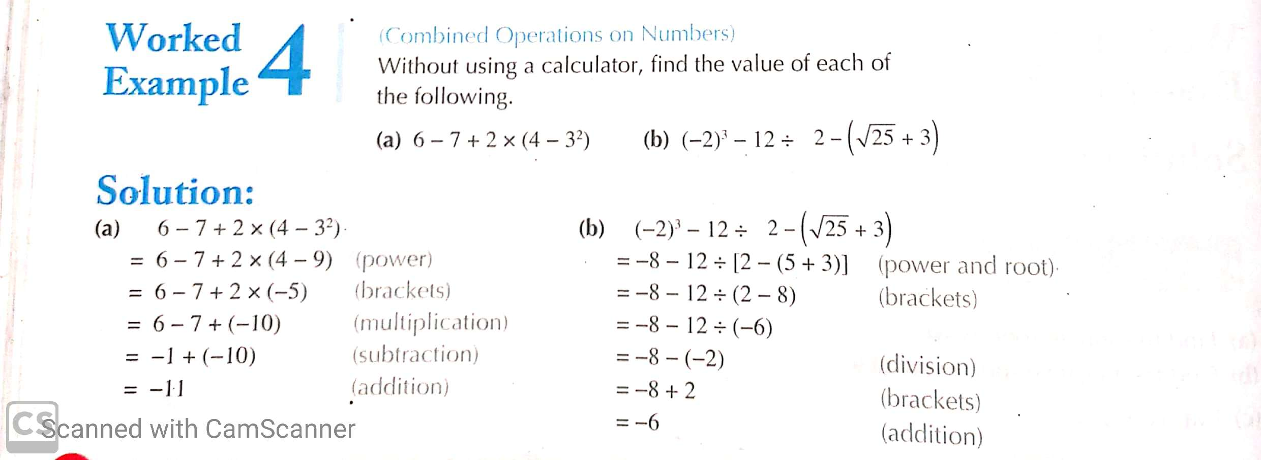

**EXAMPLES   
EXERCISE: 2C Page #043**

Q.7. Find the value of each of the following.

(f) – 25 x (- 4) ÷ (- 12 + 32)

= 100 ÷ 20

= 5 Ans.

Q.7. (g) working

3 x (-3)² – (7 – 2)² (-3)² = (-3) x (-3) = 9

= 3 x 9 – (5)²

= 27 – 25

= 2 Ans.

(h) 5 x [3 x (- 2) – 10]

= 5 x [- 6 – 10]

= 5 x (- 16)

= - 80 Ans.

**EXAMPLE**

1. Find the value of the following.

- 12 ÷ [2² - (- 2)]

= - 12 ÷ (4 + 2)

= - 12 ÷ 6

= - 2 Ans.

**HOME WORK**

Question # 9 parts (a, b, c, d and e)

Solve any 3.

For more practice solve all parts.

**EXERCISE # 2C Page # 043**

Q.9. Find the value of each of the following

(f) {[(- 15 + 5) X 2 +8] – 32 ÷ 8} – (-7)

= {[(-10) x 2 + 8] – 32 ÷ 8} – (- 7)

= {[- 20 + 8] – 32 ÷ 8} + 7

= {- 12 – 32 ÷ 8} + 7

= {- 12 – 4} + 7

= - 16 + 7

= - 9 Ans.

Q.9. (g)

(5 – 2)3 x 2 + [- 4 + (-7)] ÷ (- 2 +4)2

= (3)3 x 2 + [- 4 – 7] ÷ (2)2

= 27 X 2 + [- 11] ÷ 4

= 54 – 11 ÷ 4

= 54 – $\frac{11}{4}$ (LCM=4)

= $\frac{216-11}{4}$

= $\frac{205}{4}$

=51 $\frac{1}{4}$ Ans.

**EXAMPLE**

(h) Find the value of the following.

{- 10 – [12 + (- 3)2] +33 } ÷ (- 3)

= {-10 - [12 + 9] + 27} ÷ (- 3)

= {-10 – 21 + 27} ÷ (- 3)

= {- 31 + 27} ÷ (- 3)

= - 4 ÷ (- 3)

= 4 ÷ 3

= 1 $\frac{1}{3}$ Ans.

**HOME WORK** EX.2C Pg. 043

Solve question # 7 part (i)

And solve question # 11