**Pakistan School , Kingdom of Bahrain**

**E- Support and Learning Material / Session 2020-2021**

**Subject: General Science Grade : 8th**

**Book: Oxford Secondary Science 3 FIRST TERM**

**Unit 4: Pg. No: 93, 95 assignment 5**

**Scientists Must Measure Day 1.**

**Topics: Basic facts, Measuring, The Metric System, The Modernized metric system**

**Questions & Answers**

**Q1)** How did people measure 10,000 years ago?

**A:** Early farmers measured land to mark it off from their neighbours. Balances were used to measure food. The standard unit of mass was grain of wheat. The parts of the body of kings or emperors were units for measuring length. For example, span, cubit, fathom, palm, digit.

**Q2)** Describe the imperial system.

**A:** Over the centuries, many different systems of measurement were used. A system called the Imperial System was used in England, Canada, and many other countries. This was based on units such as the pound, the pint, the foot, the inch, and the yard. It is still used in the US. In that system, changing one unit into another is awkward and the arithmetic necessary to do it is time-consuming and sometimes difficult.

**Q3)** Describe the modernized metric system.

**A:** France devised the metric system, but there have been many different versions of it. In an attempt to create one standard system, several nations held a conference in Paris in 1960. At that meeting, the International System of Units (Système international d'unités, known as **SI** for short) was established. Since then, most nations have switched to SI units. Under the new system, the metre is defined as the distance light travels in a vacuum in 1/299,792,458 of a second. Now scientists in any one nation can be sure their metre is the same length as everyone else’s.

**Q4)** What are the seven base units in the SI system?

**A:** In the SI system, there are seven base units for seven kinds of measurement.

|  |  |  |
| --- | --- | --- |
| **BASE UNIT** | **SYMBOL** | **KIND OF MEASUREMENT** |
| metre | m | length |
| kilogram | kg | mass |
| second | s | time |
| ampere | A | electric current |
| kelvin* | K | temperature |
| candela | Cd | Intensity of light |
| mole | mol | Amount of substance |

* This is the scientific unit of temperature. The unit in everyday use is the degree Celsius (°C).

**Pakistan School , Kingdom of Bahrain**

**E- Support and Learning Material / Session 2020-2021**

**Subject: General Science Grade : 8th**

**Book: Oxford Secondary Science 3 FIRST TERM**

**Unit 4: Pg. No: 95, 96 Assignment5: DAY2 2**

**Scientists Must Measure**

**Topics: Measuring length, Parallax error**

**Questions & Answers**

**Q1)** Describe the four common units for measuring length.

**A:** There are four common units for measuring length. They are, in order of increasing size, the millimeter, the centimetre, the metre, and the kilometre. These units are related to each other like this:

1 millimeter (mm) = 1/1000 m

1 centimetre (cm) = 1/100 m

1 kilometre (km) = 1000 m

1000 mm = 1 m

100 cm = 1 m

**Q2)** Define a metre rule. Draw it.

**A:** A meter rule is a wooden ruler which is used to measure length of different objects. A meter rule of length 1m is equal to 100 centimeters (cm). 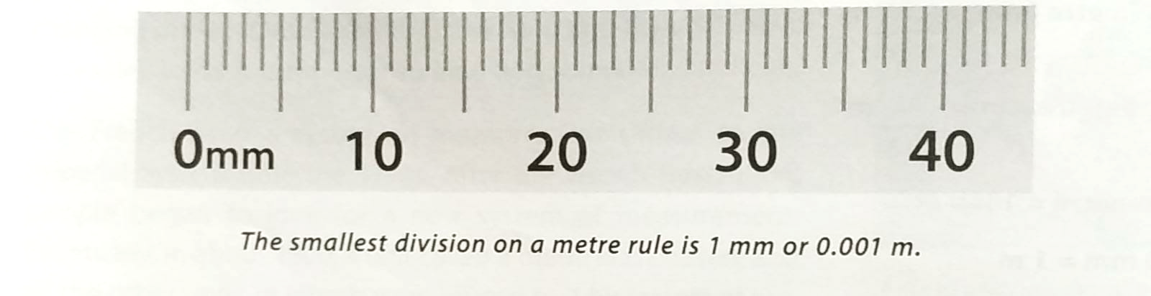

On meter rule each cm is divided further into 10 divisions which are called millimeters (mm).

So, a meter rule can measure up to 1mm as smallest reading

**Q3)** Define the parallax error.

**A:** Parallax error is the apparent change in the position of an object when it is looked at from different viewpoints.

**Q4)** Give a brief description of callipers and draw it.

**A:** It is not possible to measure things which do not have straight edges with a ruler on its own. That is where callipers are often useful. Callipers consist of two pieces of metal, rather like bowed legs, with a hinge at the top. Used with a ruler, callipers can measure such things as the internal diameter of a container or the external diameter of a ball. 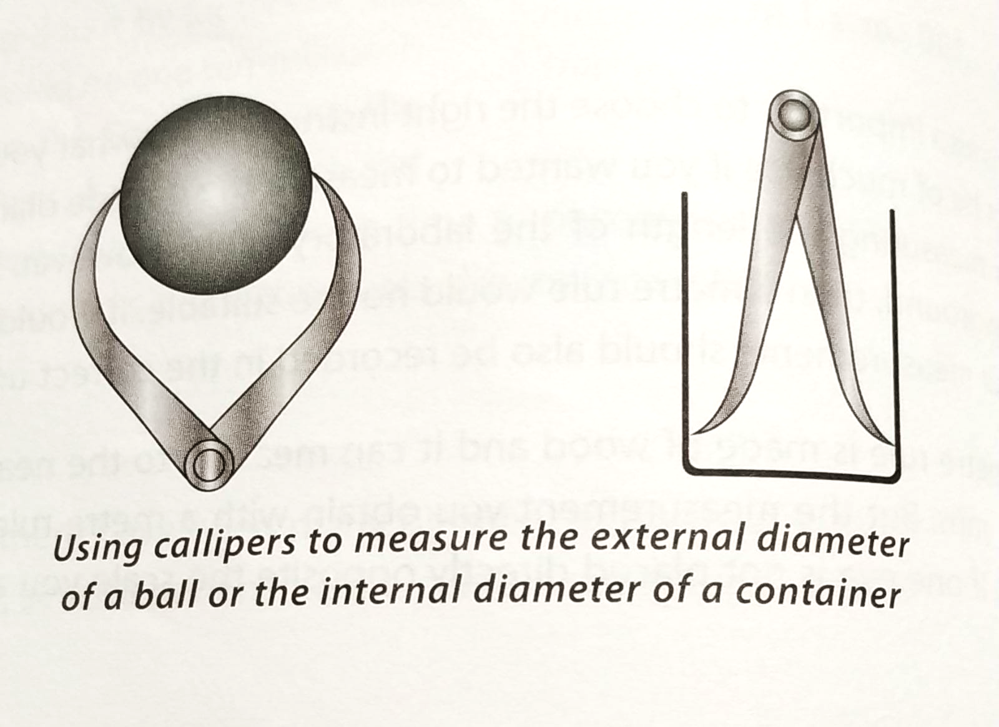

**WORKSHEET**

Fill in the blanks.

1. In the international system of units, the units of length and mass are _______ and ________.
2. Parallax error is caused by a __________ to put the eye in the correct position during measurement.
3. The SI unit for mass is ____________.
4. _____________ is the mass per unit volume.
5. _____________ is a measure of the extent of the surface of an object.

**Answers to FIB**

1) metre, kg 2) failure 3) kilogram (kg) 4) density 5) area

**Questions & Answers**

**Q1)** Describe the vernier calliper.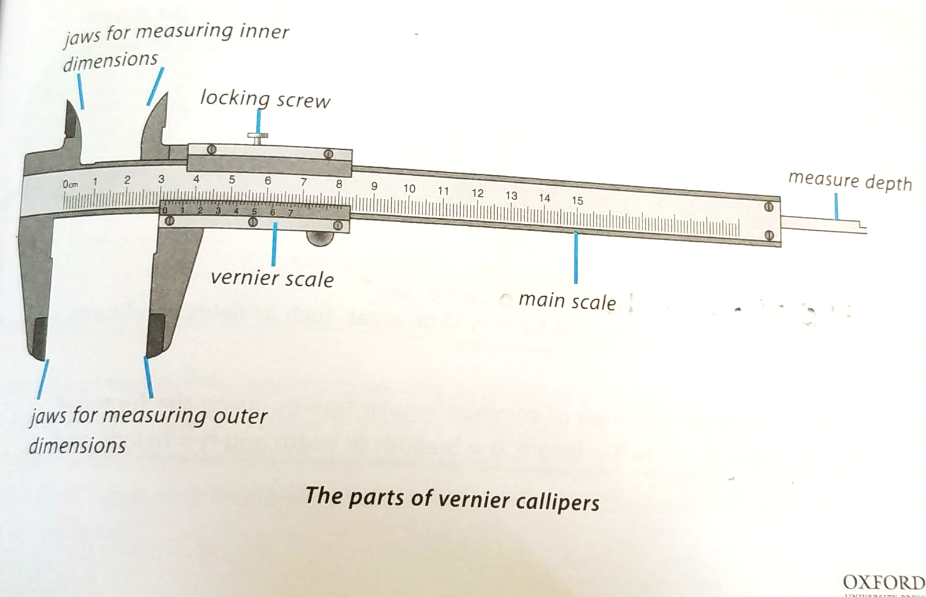

**A:** Vernier Callipers can be used to make internal or external measurements with an accuracy of 0.01 cm or 0.1 mm. Vernier scale is a small movable scale which is graduated in intervals that are 9/10 of marks on the main scale. When the jaws are closed, the zero marking on the main scale should be in line with the zero marking on the vernier scale.

**Q2)** What is the micrometer screw gauge?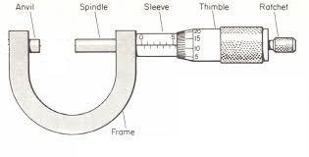

**A:** It is an instrument which uses a movable circular vernier scale. It can measure thickness up to 30 mm to 0.01 mm. The object to be measured is placed in the micrometer. The movement of the spindle of the screw gauge is read on a scale.

**Q3)** What is a caliper and how many types of callipers are there?

**A:** A caliper is a device used to measure the distance between two opposite sides of an object. There are many different types of calipers that can give measurement of distance on a ruled scale, a dial, or a digital display. But a caliper can be as simple as a compass with inward or outward-facing points.

There are 8 different types of caliper available.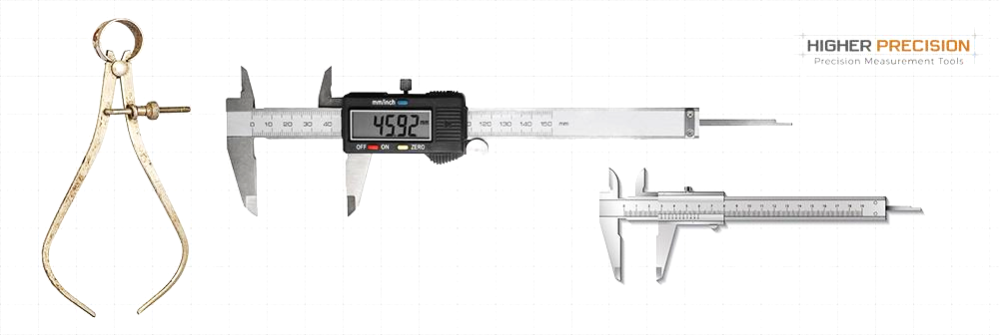

These include: inside caliper, outside caliper, divider caliper, oddleg caliper, micrometer caliper, Vernier caliper, dial caliper, and digital caliper.

**Pakistan School , Kingdom of Bahrain**

**E- Support and Learning Material / Session 2020-2021**

**Subject: General Science Grade : 8th**

**Book: Oxford Secondary Science 3 FIRST TERM**

**Unit 4: Pg. No: 98 - 101 Assignment 5 DAY 3**

**Scientists Must Measure**

**Topics: Accurate measuring, Measuring area, Measuring volume**

**Questions & Answers**

**Q1)** Write down the formulas to measure area.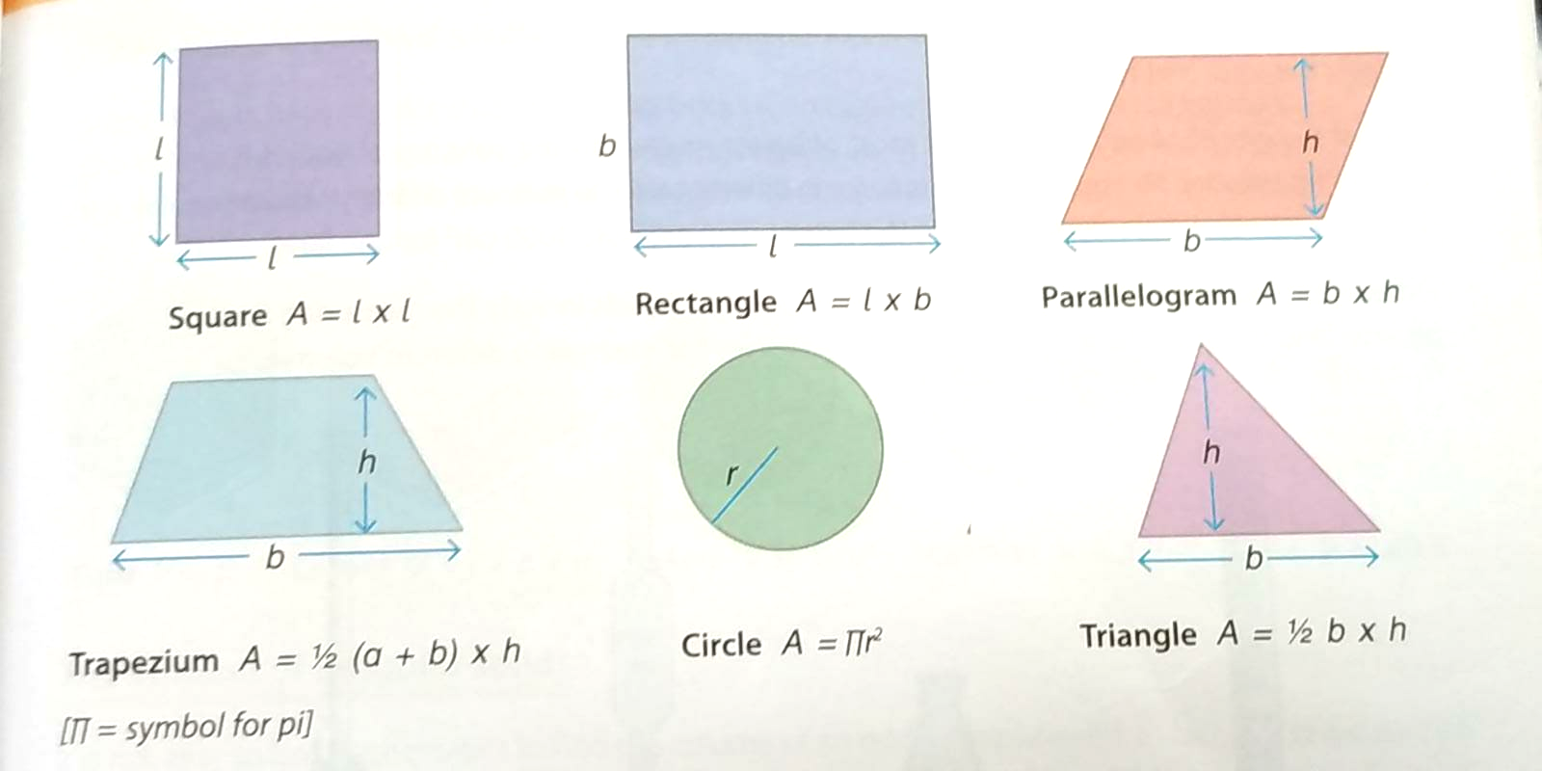

**A:** 1) Square: A= L x L

2) Rectangle: A= L x b

3) Parallelogram: A= b x h

Trapezium: A= ½ (a+b) x h

5) Circle: A= πr2

6) Triangle: A= ½ b x h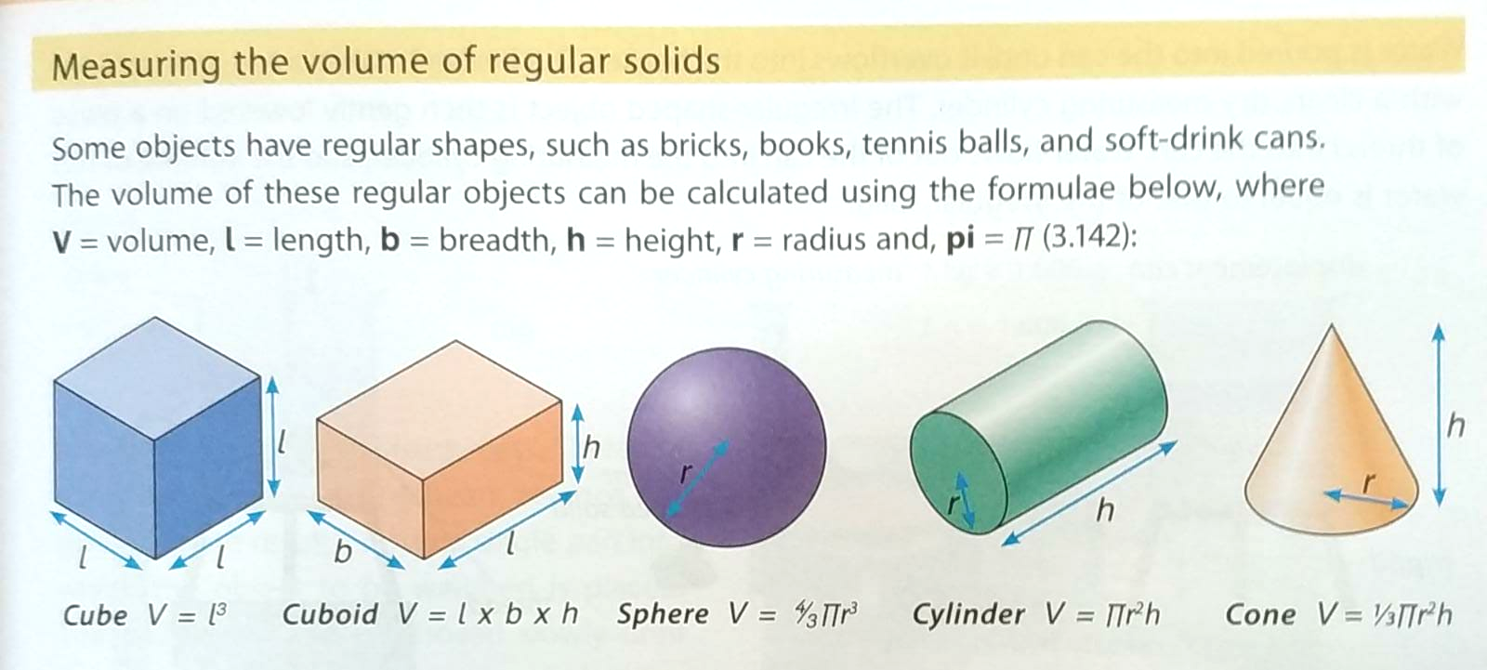

**Q2)** Write down the formulas to measure the volume.

**A:** 1) Cube: V= L3

2) Cuboid: V= L x b x h

3) Sphere: V= 4/3 πr3

4) Cylinder: V= πr2h

5) Cone: V= ⅓ πr2h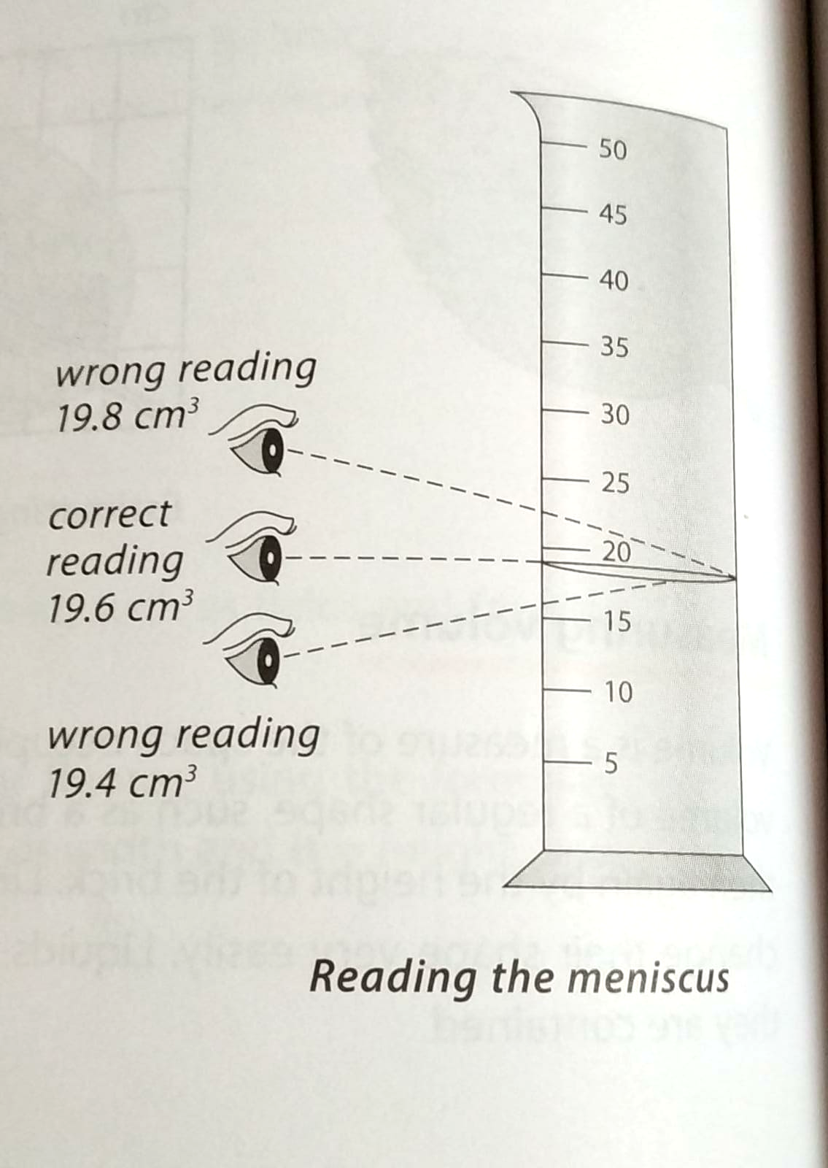

**Q3)** Define meniscus.

**A:** Meniscus is the curved surface of a liquid in a narrow tube.

Calculations: Do anyone.

**Q1)** A box measures 10 cm long, 10 cm wide and 10 cm high. What is its volume?

**A:**

**Q2)** A chapati has a radius of 14 cm. What is its area?

**A:**

**Pakistan School , Kingdom of Bahrain**

**E- Support and Learning Material / Session 2020-2021**

**Subject: General Science Grade : 8th**

**Book: Oxford Secondary Science 3 FIRST TERM**

**Unit 4: Pg. No: 102 - 104 Assignment 5:**

**Scientists Must Measure**

**Topics: Measuring Mass, Units of Mass, Density**

Mark True / False.

1. Volume is a measure of the space occupied by an object. _______
2. Meniscus is not a curved surface of the liquid in a narrow tube. _______
3. Earth’s gravity is not pulling down all the objects with the force of weight. _______
4. Mass is the amount of matter in an object. _______
5. Different materials have the same amounts of matter packed into the same volume. _______