**Pakistan School, Kingdom of Bahrain**

**Mathematics for grade 9 ( Science Group )**

**CHAPTER # 2**

***REAL AND COMPLEX NUMBERS***

**Set of real number:**

Union of two disjoint sets, the set of rational number Q and the set of irrational number Q`.

R= QUQ`

**Complex Number:**

A number of the form Z=a+bί where a and b are the real numbers and ί= is called complex number.

e.g. Z=6+2ί

**Complex conjugate:**

The number a+bί and a-bί are conjugate of each other.

**Rational Number:**

The number of the form where p,q integers and q≠0 are called ra_onal numbers.

e.g. ,

**Irrational Number:**

The number which cannot be express in the form of where p,q integers and q≠0 are called irra_onal numbers.

e.g. √2, 3.14

**Natural Numbers:**

The numbers 1,2,3,….. which we use for counting object are called natural numbers.

e.g. N= {1,2,3,…..}

**Whole Numbers:**

If we include 0 in the set of natural numbers then it is called whole number and it is denoted by W.

e.g. W= {0,1,2,3,…..}

Subject: Mathematics 9th

**Integers:**

Set of integers consist of positive integers,0 and negative and is denoted by Z.

e.g. Z= {……,-3,-2,-1,0,1,2,3,…..}

**Radicals and Radicands:**

If a real number then any real number x such that X=n√î is called the nth root of a, in the radical n√î , n is radical

and a is called radicand.

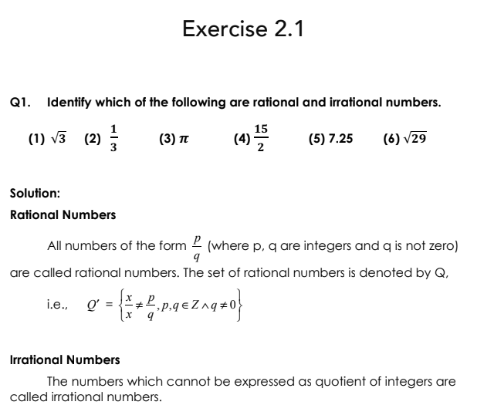

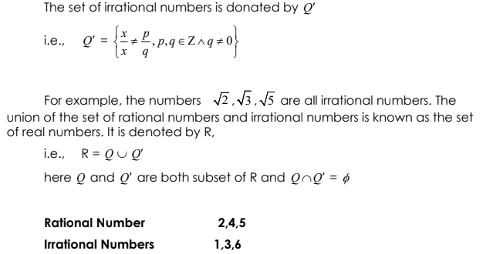



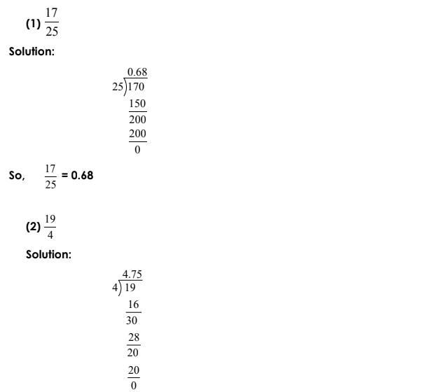

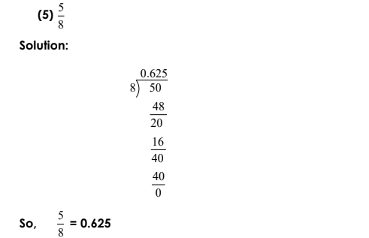

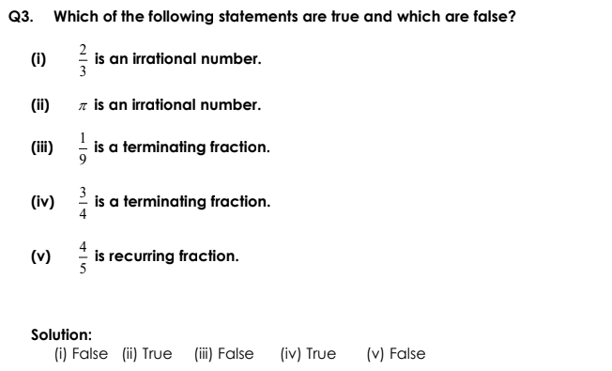

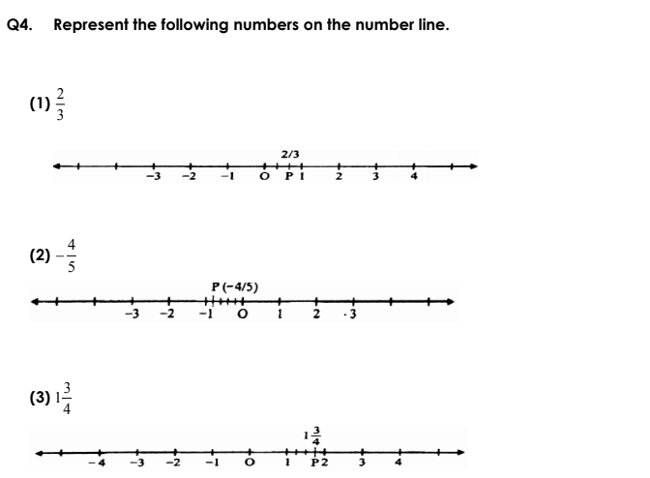

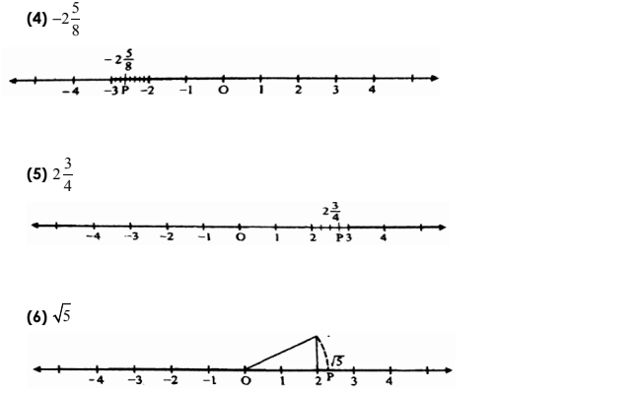

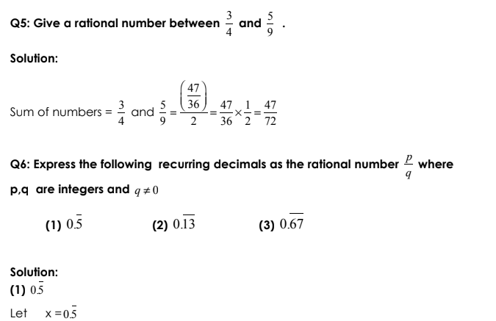

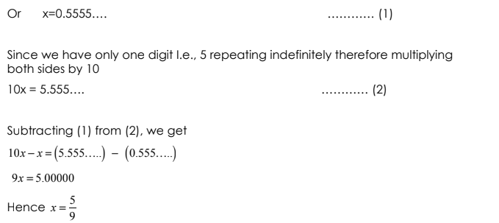

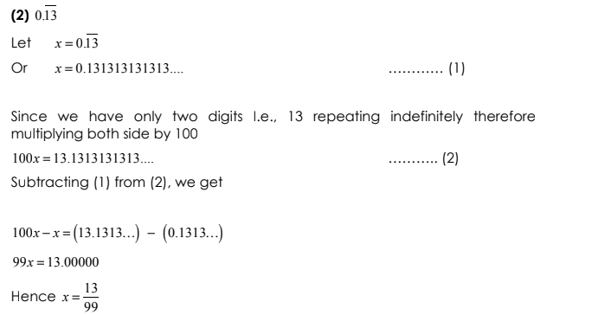

**Homework**

**Remaining questions**

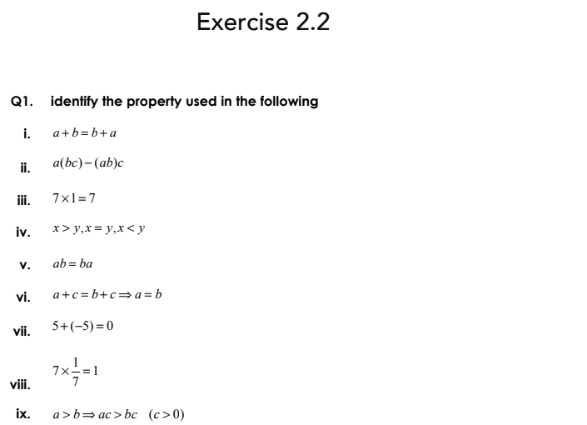

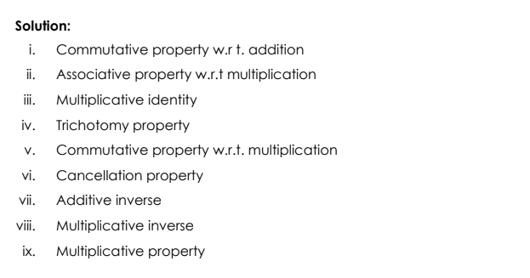

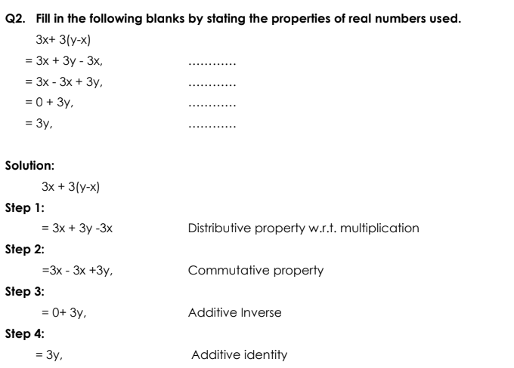

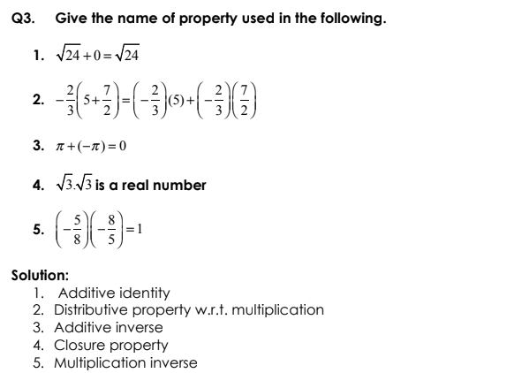

**Homework Remaining questions**

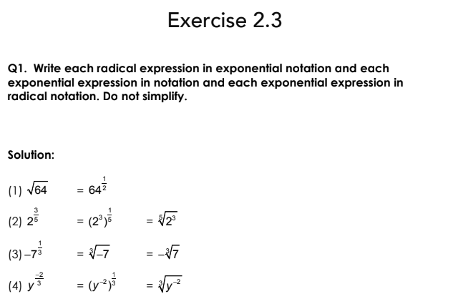

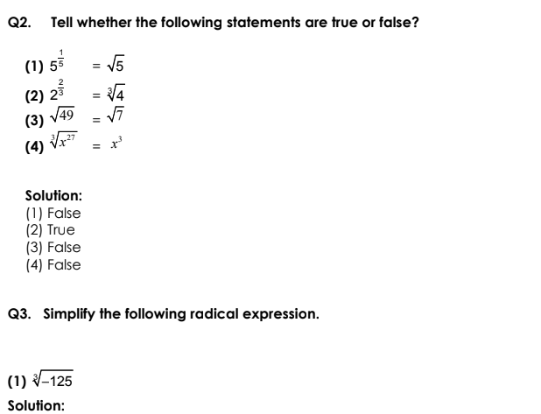

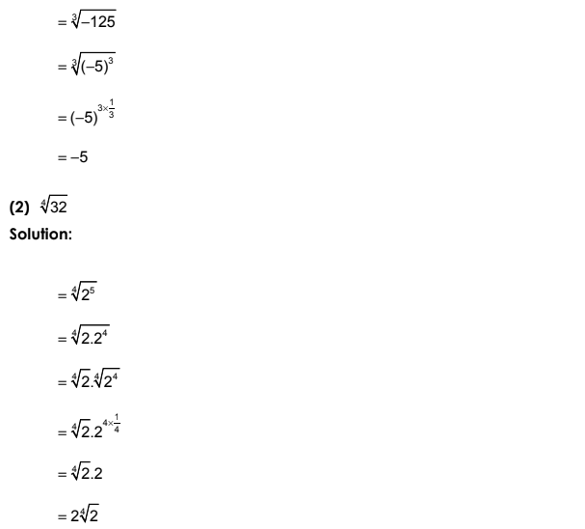

**Homework**

**Remaining questions**

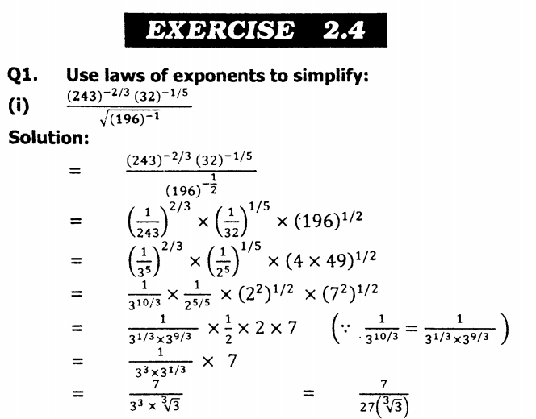

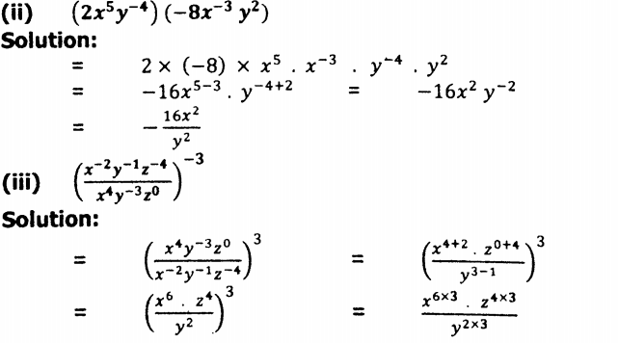

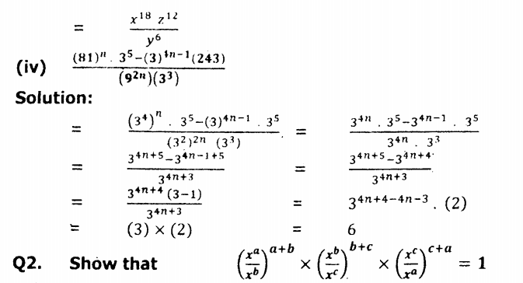

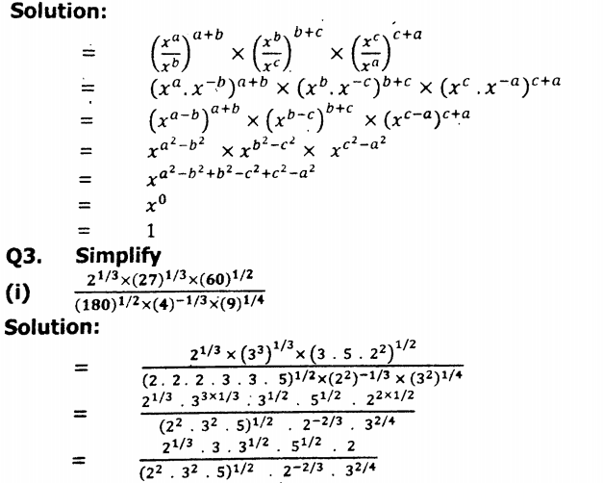

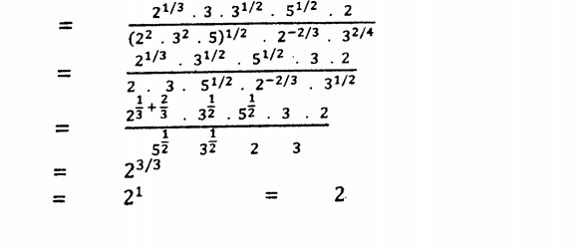

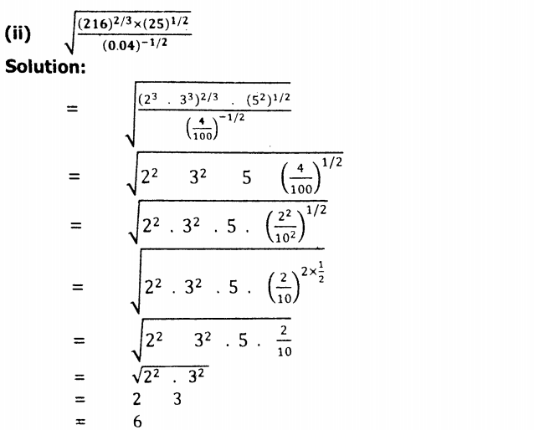

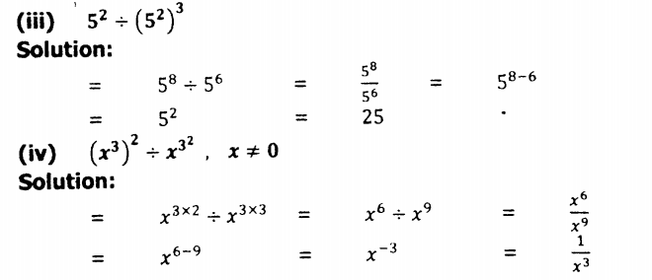

**Homework**

**Remaining questions**