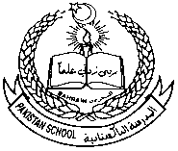 **Pakistan School, Kingdom of Bahrain**

**E- Support and Learning Material**

**Class H.KG (Topic: write in words)**

**Subject: Math (Isa Town / Manama)**

**Student Name: ________________________________________________**

Write in words

|  |  |
| --- | --- |
| 1 |  |
| 2 |  |
| 3 |  |
| 4 |  |
| 5 |  |
| 6 |  |
| 7 |  |
| 8 |  |
| 9 |  |
| 10 |  |

Q2: book page no 48, read and write:

** Pakistan School, Kingdom of Bahrain**

**E- Support and Learning Material**

**Class H.KG (Topic: write in words)**

**Subject: Math (Isa Town / Manama)**

**Student Name: ________________________________________________**

Write in words (one to ten)

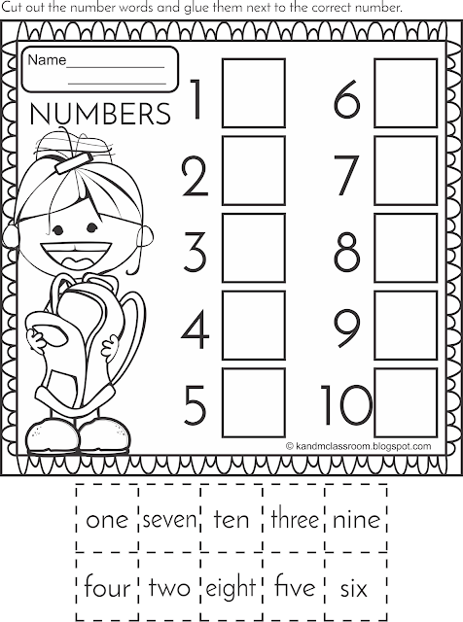

** Pakistan School, Kingdom of Bahrain**

**E- Support and Learning Material**

**Class H.KG (Topic: what come after)**

**Subject: Math (Isa Town / Manama)**

**Student Name: ________________________________________________**

What comes before

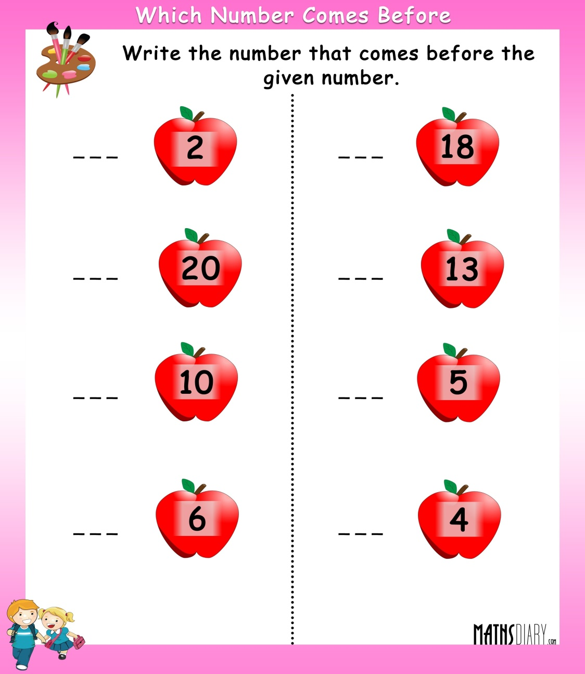

** Pakistan School, Kingdom of Bahrain**

**E- Support and Learning Material**

**Class H.KG (Topic: what comes between)**

**Subject: Math (Isa Town / Manama)**

**Student Name: ________________________________________________**

What comes between

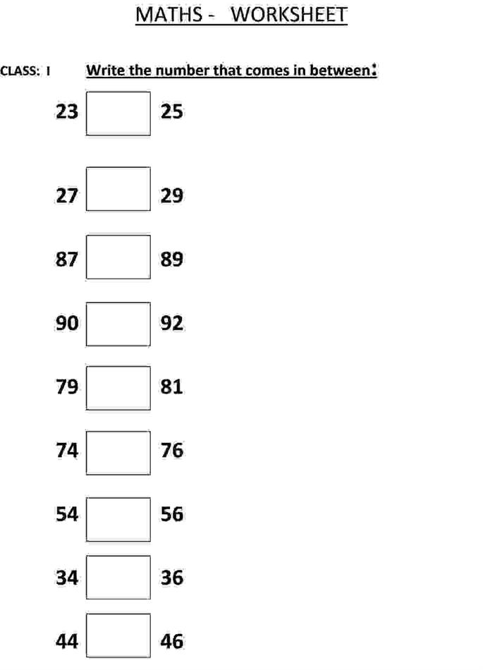

** Pakistan School, Kingdom of Bahrain**

**E- Support and Learning Material**

**Class H.KG (Topic: what comes after)**

**Subject: Math (Isa Town / Manama)**

**Student Name: ________________________________________________**

What comes after:

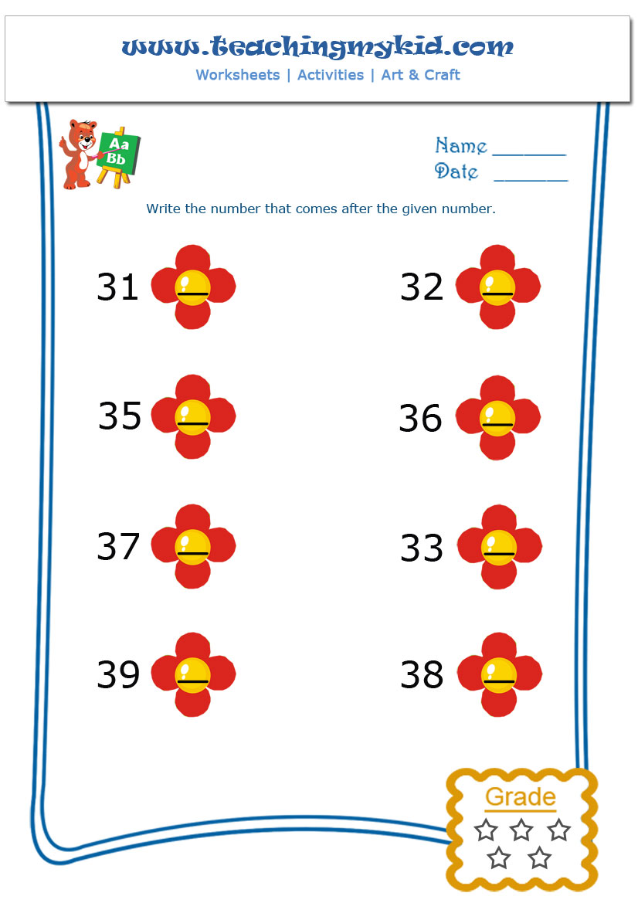

** Pakistan School, Kingdom of Bahrain**

**E- Support and Learning Material**

**Class H.KG (Topic: count the number)**

**Subject: Math (Isa Town / Manama)**

**Student Name: ________________________________________________**

**Count the picture in each group then write the correct number beside them**

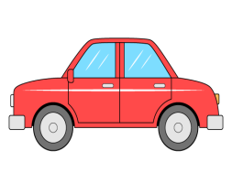1:





**2:**

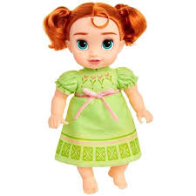

**3:**



** Pakistan School, Kingdom of Bahrain**

**E- Support and Learning Material**

**Class H.KG (Topic: circle the correct number)**

**Subject: Math (Isa Town / Manama)**

**Student Name: ________________________________________________**

How many pictures can you see in each box circle the correct number

1:

**4 5 6**

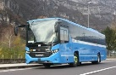

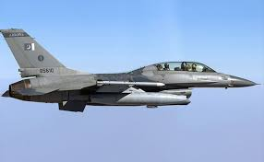

**2:**

**4 5 3**

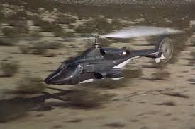

**3:**

**4 2 3**