**PAKISTAN SCHOOL, KINGDOM OF BAHRAIN**

**E-Support and Learning Material**

**Subjects: MATHS Class LKG ( )**

**TOPIC: NUMBER 15**

**Student Name: _________________________________________________**

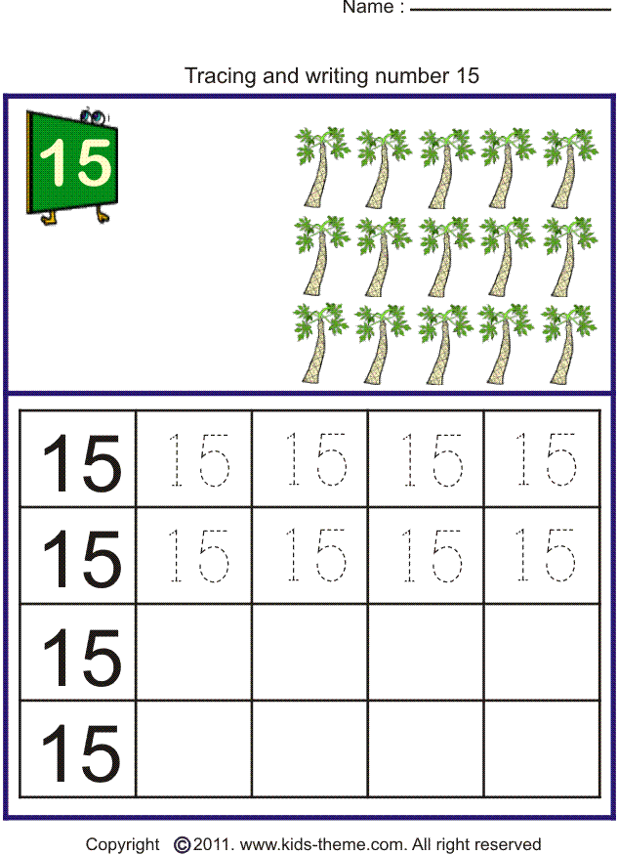

**PAKISTAN SCHOOL, KINGDOM OF BAHRAIN**

**E-Support and Learning Material**

**Subjects: MATHS Class LKG ( )**

**TOPIC: REVISION NUMBER (10- 15)**

**Student Name: _________________________________________________**

Count and write the correct number in the box

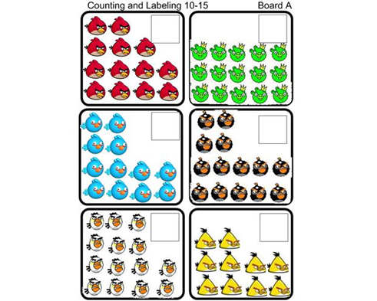

**PAKISTAN SCHOOL, KINGDOM OF BAHRAIN**

**E-Support and Learning Material**

**Subjects: MATHS Class LKG ( )**

**TOPIC: NUMBER 16**

**Student Name: _________________________________________________**

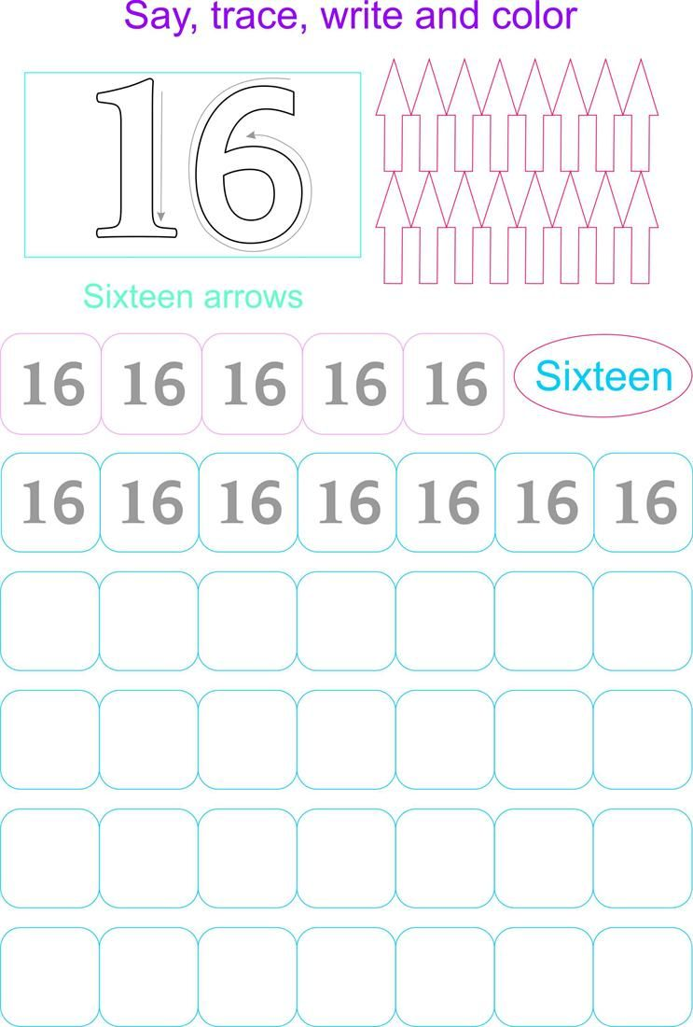

**PAKISTAN SCHOOL, KINGDOM OF BAHRAIN**

**E-Support and Learning Material**

**Subjects: MATHS Class LKG ( )**

**TOPIC: NUMBER 17**

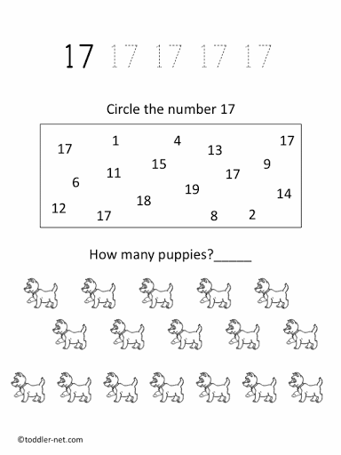**Student Name: _________________________________________________**

**PAKISTAN SCHOOL, KINGDOM OF BAHRAIN**

**E-Support and Learning Material**

**Subjects: MATHS Class LKG ( )**

**TOPIC: NUMBER 18**

**Student Name: _________________________________________________**

Count, trace and write the number 18

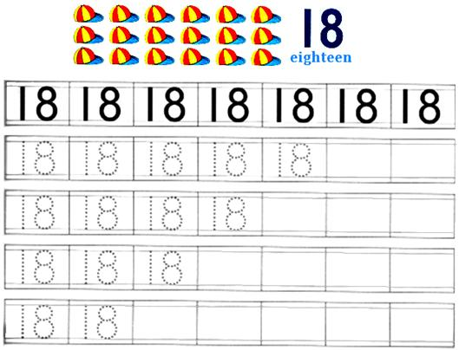

**PAKISTAN SCHOOL, KINGDOM OF BAHRAIN**

**E-Support and Learning Material**

**Subjects: MATHS Class LKG ( )**

**TOPIC: NUMBER 19**

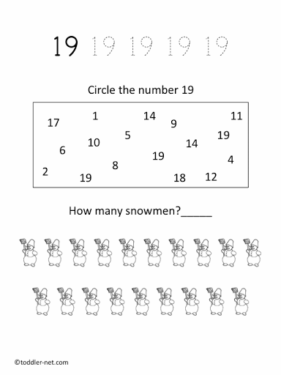**Student Name: _________________________________________________**

**PAKISTAN SCHOOL, KINGDOM OF BAHRAIN**

**E-Support and Learning Material**

**Subjects: MATHS Class LKG ( )**

**TOPIC: NUMBER 20**

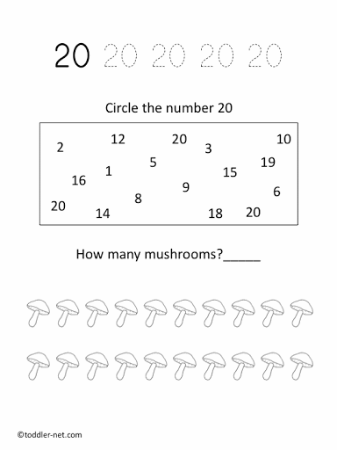**Student Name: _________________________________________________**

link; <https://youtu.be/D0Ajq682yrA>

**PAKISTAN SCHOOL, KINGDOM OF BAHRAIN**

**E-Support and Learning Material**

**Subjects: MATHS Class LKG ( )**

**TOPIC: REVISION (1-20)**

**Student Name: _________________________________________________**

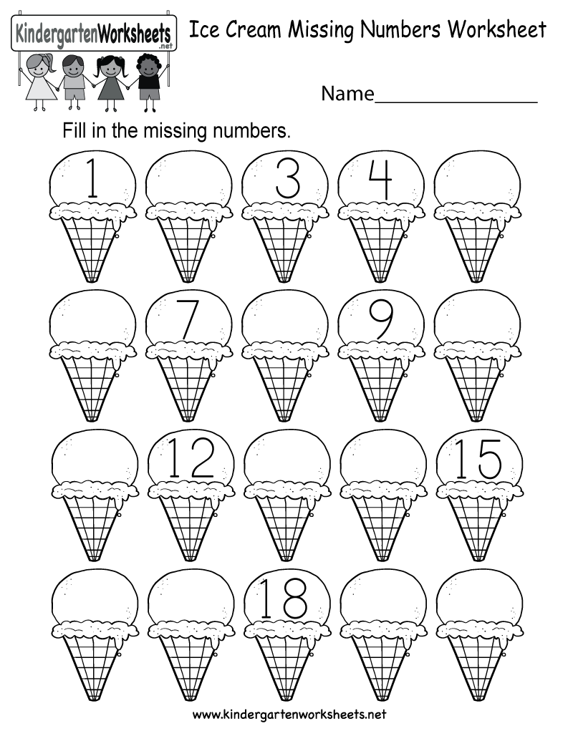Write the missing numbers

Link; <https://youtu.be/7WF8yySJjTo>