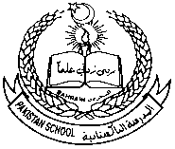  **Pakistan School, Kingdom of Bahrain**

**NURSERY RHYMES**

**Class : HKG Sec: ______ Isa Town / Manama**

**Name : _____________________________________________**

**Poem: I Have a Toothbrush**

**Listen and learn this poem**

[**https://youtu.be/iRwHAn9WRIA**](https://youtu.be/iRwHAn9WRIA%20)

|  |
| --- |
| **I HAVE A TOOTHBRUSH,**  **NEAT AND GAY,**  **TO BRUSH MY TEETH,**  **EVERYDAY,**  **I BRUSH THEM EACH MORNING,**  **I BRUSH THEM EACH NIGHT,**  **TILL ALL ARE SHINING,**  **CLEAN AND BRIGHT.**    I HAVE A TOOTHBRUSH NEAT AND GAY | 3D Nursery Rhymes Collections ... |